# **Introduction to Data Science with Python**

For Career Transitioning Professionals

Focused on real world examples!

## **Table of Contents**

**Chapter 1: The Data Science Landscape**

From Spreadsheets to Scripts: The Why and How of Transitioning

Setting Up the Professional Environment: Anaconda, Jupyter, and Git

The Data Science Lifecycle: Framing Business Problems

**Chapter 2: Python Essentials for Data Analysis**

Variables and Data Types: Representing Real-World Entities

Control Flow: Automating Business Logic with Loops and Conditionals

Functions: Creating Reusable Tools for Data Processing

Essential Python Data Structures: Lists and Dictionaries in Action

**Chapter 3: Mastering Data Manipulation with Pandas**

The DataFrame: Moving Beyond Excel Tables

Ingesting Data: Reading CSV, Excel, and SQL Sources

Filtering, Selecting, and Slicing Subsets of Business Data

Aggregating Metrics: GroupBy and Pivot Tables for Reporting

**Chapter 4: Data Cleaning and Preparation**

Handling Missing Data: Imputation vs. Deletion Strategies

Data Type Conversion and Formatting Consistency

String Manipulation: Cleaning Textual Categories and Names

Detecting and Managing Outliers in Financial and Operational Data

**Chapter 5: Exploratory Data Analysis and Visualization**

The Grammar of Graphics with Matplotlib and Seaborn

Univariate Analysis: Understanding Distributions and Spread

Bivariate Analysis: Visualizing Correlations and Trends

Case Study: Diagnosing Sales Performance Factors

**Chapter 6: Statistical Foundations for Decision Making**

Descriptive vs. Inferential Statistics in Business

Hypothesis Testing: The Framework for A/B Testing

Correlation vs. Causation: Avoiding Common Analytical Traps

**Chapter 7: Predictive Modeling with Linear Regression**

Introduction to Scikit-Learn and the Modeling Workflow

Simple Linear Regression: Forecasting Continuous Variables

Feature Engineering: Selecting the Right Predictors

Case Study: Predicting Real Estate Prices

**Chapter 8: Classification Algorithms for Categorical Outcomes**

Logistic Regression: Predicting Binary Outcomes

Decision Trees: Mapping Logic to Predictions

Evaluating Model Performance: Confusion Matrix, Precision, and Recall

Case Study: Predicting Employee Attrition

**Chapter 9: Unsupervised Learning and Pattern Discovery**

K-Means Clustering: Grouping Similar Data Points

Dimensionality Reduction: Simplifying Complex Datasets

Case Study: Customer Segmentation for Targeted Marketing

**Chapter 10: The Capstone Project: End-to-End Workflow**

Defining the Project Scope and Success Metrics

Building a Reproducible Data Pipeline

Model Selection, Tuning, and Interpretation

Communicating Results: Creating an Executive Summary

## **Chapter 1The Data Science Landscape**

### **From Spreadsheets to Scripts: The Why and How of Transitioning**

For many professionals embarking on a data science journey, the spreadsheet is home. It is the tool where budgets are balanced, forecasts are projected, and lists are managed. You likely possess a high degree of "Excel fluency"—you know your way around pivot tables, nested IF statements, and VLOOKUPs.

Transitioning to Python does not mean discarding that knowledge. Instead, it is about migrating your domain expertise from a manual, "point-and-click" environment to a scalable, automated, and reproducible one. This section explores why this migration is necessary for data science and how to mentally map your existing spreadsheet concepts to Python scripts.

### **The "Wall": Why Leave Spreadsheets?**

Spreadsheets are excellent for data entry, quick ad-hoc calculations, and visual formatting. However, as data volume and complexity grow, users inevitably hit a "wall."

1. **Scalability:** Standard spreadsheet software has hard limits (e.g., 1,048,576 rows). Even before hitting that limit, performance degrades significantly with complex formulas, often leading to crashes. 2. **Reproducibility:** If you create a monthly report by manually filtering, copying, pasting, and coloring cells, you must repeat those physical actions every month. If a colleague asks, "How did you get this number?", you cannot simply show them the code; you have to walk them through your physical clicks. 3. **The "Black Box" Risk:** Errors often hide inside cells. A hard-coded number (e.g., + 500) typed into a formula (=SUM(A1:A10) + 500) is invisible to the eye unless you click that specific cell. This lack of transparency causes catastrophic business errors.

In Data Science, we treat data manipulation as a **pipeline**. Raw data enters one side, specific transformations are applied via code, and insights exit the other side.

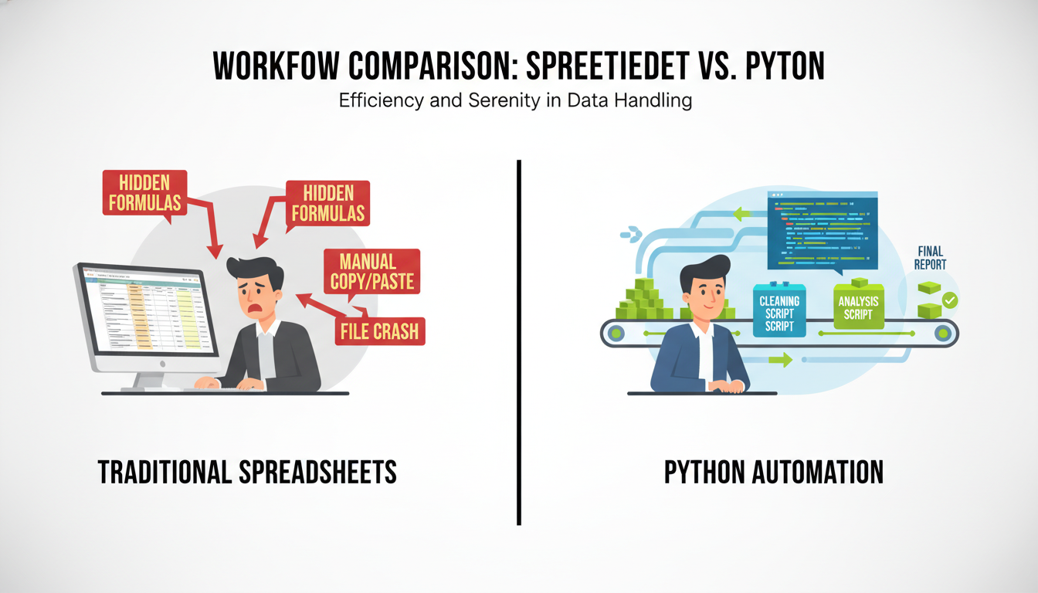

A split-screen comparison diagram. On the left, a user looks stressed looking at a spreadsheet with arrows pointing to "Hidden Formulas," "Manual Copy/Paste," and "File Crash." On the right, a serene user looks at a Python script visualized as a clean factory conveyor belt: Raw Data -> Cleaning Script -> Analysis Script -> Final Report.

### **Mental Mapping: From Cells to Variables**

To script effectively, you must change how you visualize data. In a spreadsheet, data and calculation live in the same place: the cell. In Python, data and calculation are separate.

#### **1. The Container: Sheet vs. DataFrame In the Python data science ecosystem (specifically using the pandas library), your primary grid of data is called a DataFrame.**

* **Excel:** You reference data by coordinate (A1, C5).
* **Python:** You reference data by name (Variable names for the table, Column names for the attributes).

#### **2. The Operation: Cell-based vs. Vectorized This is the hardest habit to break. In Excel, if you want to add two columns, you write a formula in row 1 (=A1+B1) and drag it down to row 10,000.**

In Python, we use **vectorization**. You do not write a loop to add row by row. You simply tell Python to add the two columns entirely at once.

**Excel Logic:** > *For every row `i`, take A[i] and add it to B[i].*

**Python Logic:** > *Column_C = Column_A + Column_B*

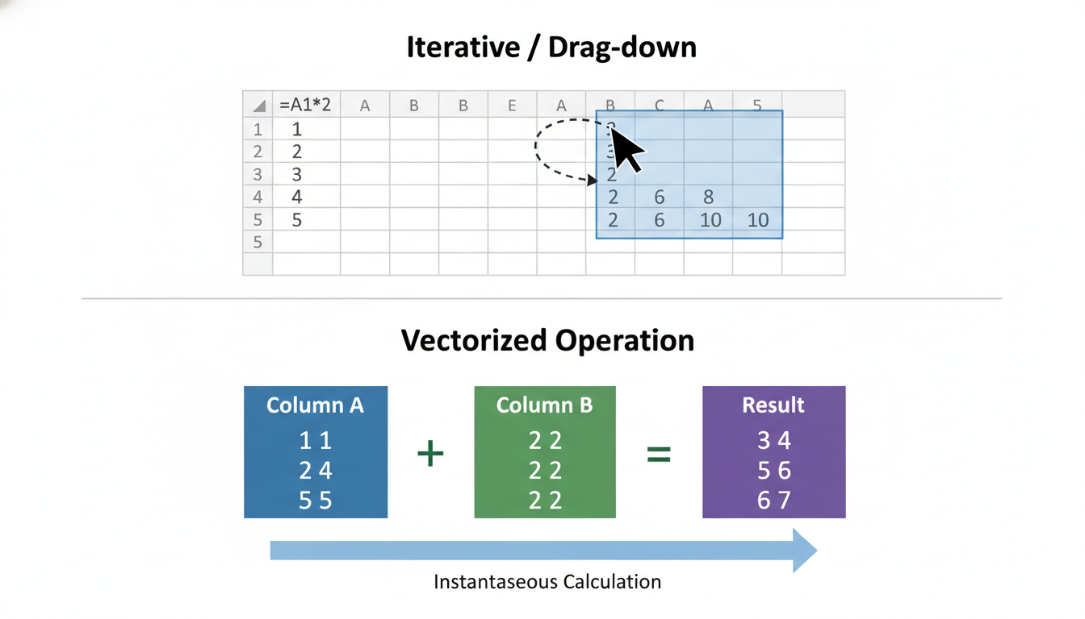

A conceptual diagram illustrating "Vectorization". Top half shows an Excel grid with an arrow dragging a formula down row by row, labeled "Iterative/Drag-down". Bottom half shows two solid blocks representing columns being added together instantly to form a third block, labeled "Vectorized Operation".

### **Code Example: The Translation**

Let's look at a concrete example. Imagine you have a dataset of sales with Price and Quantity, and you need to calculate Total_Revenue.

#### **The Spreadsheet Approach 1. Open sales_data.xlsx. 2. Click cell C2. 3. Type =A2*B2. 4. Double-click the bottom-right corner of C2 to fill down to the bottom. 5. Create a Pivot Table to sum Total_Revenue by Region.**

#### **The Python Approach In Python, using the pandas library, this logic is expressed conceptually rather than physically.**

python

import pandas as pd

# 1. Load the data (Replaces opening the file)

df = pd.read_csv('sales_data.csv')

# 2. Calculate Total Revenue (Replaces the drag-down formula)

# Notice we don't say "row by row". We multiply the columns directly.

df['Total_Revenue'] = df['Price'] * df['Quantity']

# 3. Group by Region (Replaces the Pivot Table)

region_summary = df.groupby('Region')['Total_Revenue'].sum()

# 4. View the result

print(region_summary)

**Key Observation:** If your dataset changes from 100 rows to 1,000,000 rows next month, you do not need to drag the formula down further. You simply re-run the script. The logic is decoupled from the data size.

### **The "VLOOKUP" Equivalent: Merging**

The most common function in business analytics is arguably VLOOKUP (or XLOOKUP). You have two tables, and you want to join them based on a common identifier (like an ID).

In Python, this is handled much more robustly using merge.

**Scenario:** You have a Sales table and a Customers table. You want to bring the Customer Name into the Sales table based on CustomerID.

**Python Code:**

python

# Assume we have two DataFrames: sales_df and customers_df

# The "VLOOKUP" equivalent

combined_data = pd.merge(

sales_df,

customers_df,

on='CustomerID', # The common key

how='left' # Keep all sales, match customers where possible

)

Unlike VLOOKUP, which requires column counting (e.g., "return the 3rd column"), Python merges are explicit. You are merging based on named keys, which makes the code readable and less prone to breaking if you insert a new column in the source data.

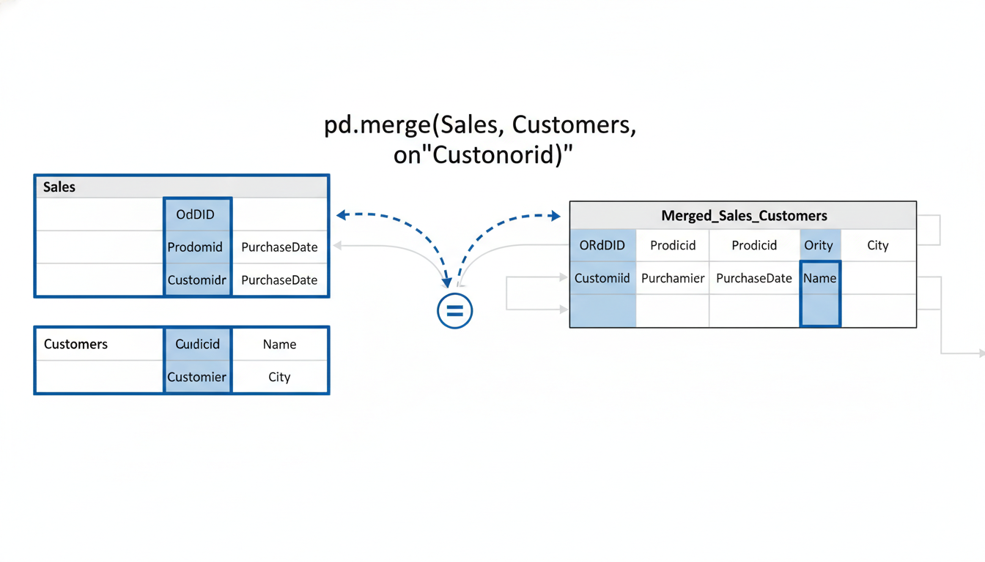

A diagram showing the anatomy of a pd.merge operation. Two separate tables (Sales and Customers) with a highlighted "CustomerID" column in both. Arrows verify the match and combine them into a wider, single table.

### **Auditability and "Comments"**

One of the greatest advantages of scripts is the ability to leave notes for your future self (or your team). In a spreadsheet, you might leave a "Comment" on a cell, but these are often hidden. In code, comments are first-class citizens.

python

# FILTERING LOGIC

# We are excluding transactions prior to 2020 because

# the data recording methodology changed in Q1 2020.

clean_data = df[df['Year'] >= 2020]

When you read this script six months later, you know exactly *why* you filtered the data. This creates an **Audit Trail**. The script documents the entire decision-making process of the analysis.

### **Summary of the Transition**

As we move into the technical chapters, keep this translation dictionary in mind:

| Spreadsheet Concept | Python/Pandas Concept | Advantage of Python | | :--- | :--- | :--- | | **Workbook/Sheet** | DataFrame | Handles millions of rows efficiently. | | **Formula (`=A1+B1`)** | Vectorized Math (df['A'] + df['B']) | Faster processing; no "drag-down" errors. | | **Filter** | Boolean Indexing (df[df['val'] > 5]) | Non-destructive; original data remains intact. | | **VLOOKUP** | pd.merge() | explicit; handles many-to-many relationships. | | **Pivot Table** | df.groupby() | Highly customizable; output is a new dataset. |

Transitioning to scripts allows you to stop being a data *laborer*—manually moving and formatting cells—and become a data *architect*, designing reproducible pipelines that do the work for you.

### **Setting Up the Professional Environment: Anaconda, Jupyter, and Git**

If you were to walk into a professional carpenter’s workshop, you wouldn’t just find wood and nails. You would see a workbench, organized distinct tools for specific jobs, safety gear, and blueprints.

In the previous section, we discussed shifting your mindset from spreadsheets to scripts. Now, we must build your workshop. In the world of Excel, your environment is a single application installed on your desktop. In Data Science, your environment is a collection of integrated tools that allow you to write code, visualize data, and manage changes over time.

We will focus on the "Holy Trinity" of the beginner data scientist’s toolkit: **Anaconda** (your toolbox), **Jupyter** (your workbench), and **Git** (your safety net).

### **1. Anaconda: The All-in-One Toolkit**

When you decide to learn Python, your first instinct might be to go to Python.org and click "Download." While that installs the language, it is akin to buying a car engine without the chassis, wheels, or steering wheel. You can make it run, but you can’t drive it yet.

For data science, you need Python *plus* hundreds of helper libraries (packages) for calculation, visualization, and machine learning. Installing these manually can be tedious and error-prone.

Enter **Anaconda**.

Anaconda is a distribution—a pre-packaged bundle that installs Python along with over 1,500 of the most popular data science libraries (like pandas for data manipulation and matplotlib for graphing) in one go.

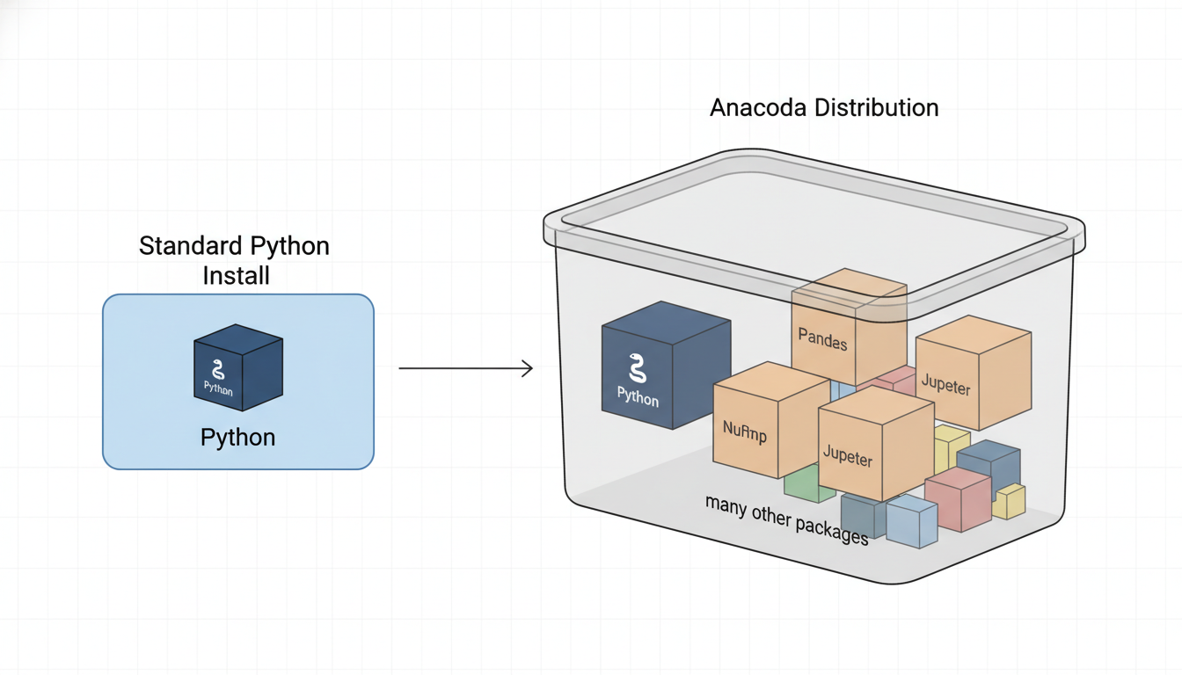

A conceptual diagram comparing a "Standard Python Install" (a single small box) versus "Anaconda Distribution" (a large container holding the Python box plus many other boxes labeled 'Pandas', 'NumPy', 'Scikit-Learn', and 'Jupyter').

#### **The Concept of "Environments" One of the most critical features of Anaconda is the ability to create virtual environments.**

Imagine you have two Excel projects: one requires the 2010 version of an add-in, and another requires the 2023 version. If you install the 2023 update, you might break your 2010 project. In Excel, this is a nightmare.

In Anaconda, you create isolated "sandboxes" for each project. One environment can run Python 3.8, while another runs Python 3.11. They never interact, so they never break each other.

To create an environment using the command line (don't worry, it's simple), you would use:

bash

# Create a new environment named 'data_analysis'

conda create --name data_analysis python=3.9

# Activate the environment to start working in it

conda activate data_analysis

### **2. Jupyter Notebooks: The Interactive Workbench**

If you are coming from Excel, the scariest part of programming is often the "black box" effect—you write a script, run it, and hope for the best.

**Jupyter Notebooks** bridge the gap between the immediate visual feedback of a spreadsheet and the power of coding. A Jupyter Notebook represents code in "cells." You can run a single cell, see the result immediately below it, and then move to the next one. It tells a story with your data.

#### **The Anatomy of a Notebook A notebook is composed of two types of cells: 1. Code Cells: Where you write Python. 2. Markdown Cells: Where you write text (like this book) to explain your logic.**

This allows you to create a document that is half report, half software.

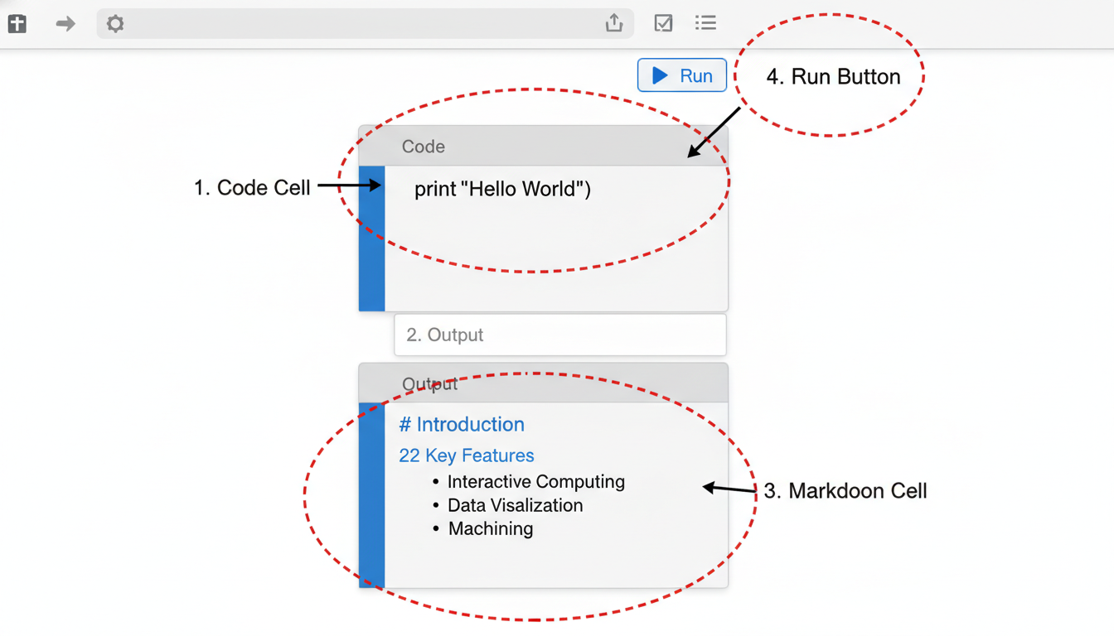

A screenshot of the Jupyter Notebook interface. Callouts point to: 1. A code cell containing 'print("Hello World")', 2. The output area displaying 'Hello World', 3. A markdown cell containing formatted text headers, and 4. The 'Run' button in the toolbar.

Here is a simple example of how you might use a code cell to perform a calculation you would typically do in Excel:

python

# This is a code cell

import pandas as pd

# Creating a simple dataset (like a small table in Excel)

data = {'Month': ['Jan', 'Feb', 'Mar'],

'Revenue': [1000, 1200, 1500]}

df = pd.DataFrame(data)

# Calculate total revenue

total = df['Revenue'].sum()

print(f"Total Revenue: ${total}")

**Output:**

text

Total Revenue: $3700

This "REPL" approach (Read-Eval-Print Loop) mimics the experience of typing a formula into a cell and hitting Enter. It allows for rapid experimentation without the fear of "breaking the whole program."

### **3. Git and GitHub: The "Time Machine"**

In your previous role, you have likely encountered a file named Q3_Budget_Final_v2_REALLY_FINAL_Dave_Edits.xlsx.

Managing versions by renaming files is risky, cluttered, and unsustainable. **Git** is the professional solution to this problem. It is a Version Control System (VCS).

Think of Git as a "Save Game" feature for your work history. *Git runs locally on your computer. It tracks changes.* **GitHub** is the cloud storage (like OneDrive or Google Drive) where you store your Git history to share with others.

#### **The Workflow The Git workflow replaces the "Save As..." habit. It involves three steps:**

1. **Add (Stage):** Choosing which files you want to save. (Like selecting rows in Excel). 2. **Commit:** Taking a snapshot of those files with a message describing what you did. (Like hitting "Save" and adding a comment). 3. **Push:** Sending that snapshot to the cloud (GitHub).

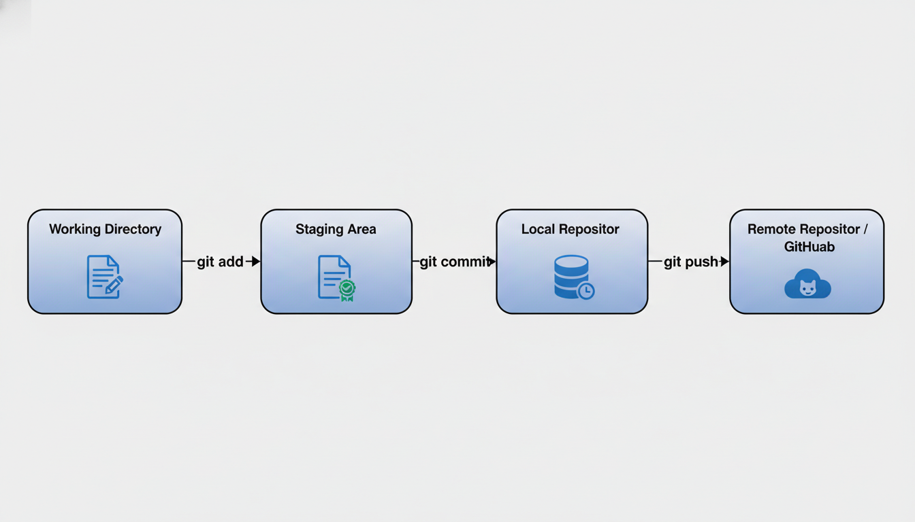

A flow diagram illustrating the Git process. Step 1: "Working Directory" (icon of a file being edited). Arrow labeled 'git add' points to Step 2: "Staging Area" (icon of a file ready to go). Arrow labeled 'git commit' points to Step 3: "Local Repository" (icon of a database/timeline). Arrow labeled 'git push' points to Step 4: "Remote Repository / GitHub" (icon of a cloud).

When you commit a change, you provide a message explaining *why* you made the change. If you make a mistake three days later, you can "revert" the project back to the exact state it was in before the error, without losing your other work.

#### **Setting Up Git Once installed, you configure your identity (so your team knows who made the changes) using the terminal:**

bash

git config --global user.name "Your Name"

git config --global user.email "your.email@example.com"

### **Summary: Your New Workflow**

Transitioning to data science is not just about learning Python syntax; it is about adopting a developer's workflow.

1. **Anaconda** manages your tools and keeps them organized in environments. 2. **Jupyter** provides the canvas where you experiment, analyze, and document your findings. 3. **Git** ensures your work is backed up, versioned, and collaborative.

With this environment configured, you are no longer just a spreadsheet user; you have laid the foundation of a software engineer. In the next section, we will run your first Python commands and explore the basic syntax that replaces your most common Excel formulas.

### **The Data Science Lifecycle: Framing Business Problems**

You have your environment set up. You have your terminal open, Jupyter Notebook running, and your fingers are hovering over the keyboard, ready to type import pandas as pd.

Pause for a moment.

In the world of spreadsheets, the workflow is often reactive. A manager asks for a report, and you open a file to calculate specific numbers. The requirements are usually rigid: "Give me the Q3 sales figures by region."

In Data Science, the workflow is proactive and exploratory. The requests are rarely that specific. Instead, you might hear: "We need to improve customer retention," or "Inventory costs are too high." If you immediately start writing code to answer these vague prompts, you will build the wrong solution.

Before we touch a single line of Python, we must master the first and most critical stage of the Data Science Lifecycle: **Framing the Business Problem.**

### **The Map: The Data Science Lifecycle**

Data Science is not a linear process; it is a cycle. While there are many frameworks (such as CRISP-DM or OSEMN), they all generally follow a specific loop. Understanding where "Framing" fits into this loop is essential for project management.

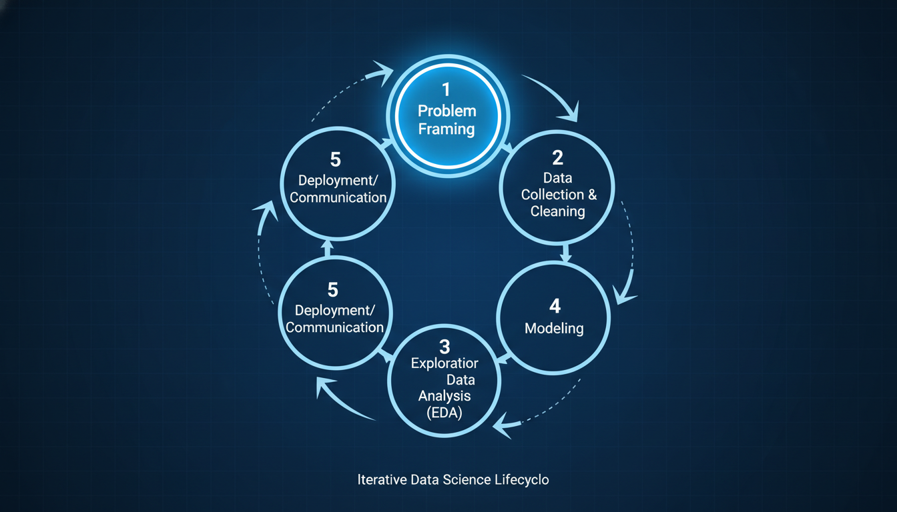

A circular flow diagram illustrating the Data Science Lifecycle. The stages are: 1. Problem Framing (highlighted), 2. Data Collection & Cleaning, 3. Exploratory Data Analysis (EDA), 4. Modeling, 5. Deployment/Communication. Arrows connect the stages in a clockwise direction, but there are also "feedback arrows" pointing backward (e.g., from Modeling back to Data Collection) to signify the iterative nature of the work.

For career switchers, **Step 1: Problem Framing** is your competitive advantage. While a fresh computer science graduate might be better at optimizing a neural network, you likely have a better grasp of *why* the business needs that network in the first place.

### **The Translation Layer**

Your primary job in this phase is to act as a translator. You must convert a **Business Objective** into a **Data Problem**.

Let's look at how this translation works using a practical example. Imagine you are working in the finance department of a retail company.

**The Business Objective:** "We are losing too much money on fraudulent transactions."

If you start coding immediately, you have no target. What defines "fraud"? How much money is "too much"?

**The Data Problem:** "We need to build a binary classification model that predicts the probability of a transaction being fraudulent based on historical transaction data, aiming to reduce false negatives by 20%."

Here is how we break that translation down:

1. **Identify the Target Variable:** What are we predicting? (Fraud vs. Not Fraud). 2. **Identify the Input:** What data do we have? (Time, location, amount, vendor). 3. **Define the Type of Analysis:** Is this Supervised Learning (we have labeled examples of fraud) or Unsupervised (we are looking for weird anomalies)? 4. **Define Success:** This is crucial. Is success high accuracy? Or is success catching the high-value fraud, even if we annoy a few legitimate customers?

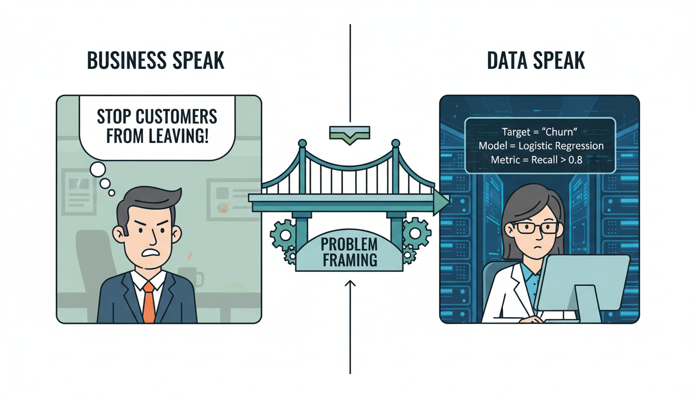

A split-screen infographic. On the left side labeled "Business Speak", a manager has a thought bubble: "Stop customers from leaving!" On the right side labeled "Data Speak", a data scientist sees a matrix: "Target = 'Churn', Model = Logistic Regression, Metric = Recall > 0.8". A bridge connects the two sides labeled "Problem Framing".

### **Technical Implementation: The "Markdown First" Approach**

In the previous section, we introduced Jupyter Notebooks. A common bad habit is to treat a notebook purely as a scratchpad for code. Professional data scientists treat notebooks as **computational narratives**.

When framing your problem, you should use the Markdown capabilities of Jupyter to write a "Project Charter" at the very top of your file. This serves as your North Star. If you get lost in the weeds of data cleaning later, you can scroll up and remind yourself what you are trying to solve.

Here is what a professional setup looks like before any Python code is executed.

#### **Example: The Project Charter**

In a Jupyter cell, change the type from Code to Markdown and structure your frame:

markdown

# Project: Customer Churn Prediction

## 1. Business Context

Marketing has noticed a dip in subscription renewals. Acquiring a new customer costs 5x more than retaining an existing one. The goal is to identify at-risk customers so the team can send targeted discount offers.

## 2. Problem Statement

Develop a machine learning model to predict the probability (0 to 1) that a customer will cancel their subscription within the next 30 days.

## 3. Success Metrics

* **Technical Metric:** ROC-AUC score > 0.80.

* **Business Metric:** Identify at least 60% of churners (Recall) while keeping the cost of discount offers below $10,000 (Precision constraint).

## 4. Data Sources

* `sales_data.csv` (Transaction history)

* `customer_logs.csv` (App usage frequency)

### **From Concept to Pseudo-Code**

Once the problem is framed in English, we can frame it in "Pseudo-Python." This helps you visualize the libraries you will need in the upcoming chapters. You don't need to run this code yet; it is a mental scaffolding technique.

python

# This is how a Data Scientist frames the logic mentally

# before writing the actual executable code.

# 1. THE GOAL: Predict 'Churn' (Yes/No)

target_variable = "Churn"

# 2. THE INPUTS: What drives churn?

features = [

"Days_Since_Last_Login",

"Average_Transaction_Value",

"Customer_Support_Tickets_Count"

]

# 3. THE METRIC: How do we judge the model?

# In a business context, catching a churner is more important

# than accidental false alarms (sending a coupon to a happy customer).

metric_focus = "Recall"

# 4. THE ACTION: What happens with the result?

# if probability_of_churn > 0.70:

# trigger_email_campaign("Discount_20_Percent")

### **The "XY Problem" Trap**

As you frame problems, beware of the "XY Problem." This occurs when a stakeholder asks for a specific solution (X) to a problem (Y) that you don't fully understand, but their proposed solution (X) won't actually solve Y.

* **Stakeholder Request (X):** "I need you to scrape all the tweets mentioning our competitor."
* **Real Problem (Y):** "We want to know if our competitor's new product is popular."

If you just scrape the tweets (X), you might spend weeks processing text data only to find out that tweet volume doesn't correlate with sales popularity.

If you had properly framed the problem by asking "Why?" you might have realized that scraping Amazon Review ratings would have been a much better proxy for product popularity.

### **Summary: The Framing Checklist**

Before proceeding to the next section where we will load data, ensure you can answer these four questions about your project:

1. **The Question:** Can you state the problem in one sentence? 2. **The Data:** Do you believe the data exists to answer this question? 3. **The Action:** If the model works perfectly, what physical or digital action will the business take? (e.g., "Send an email," "Stock more inventory"). 4. **The Benchmark:** How are they solving this problem *now*? (Your Python model must beat their current Excel spreadsheet or gut feeling).

With our problem clearly defined and our "Project Charter" written in Markdown, we are finally ready to open the toolbox. In the next section, we will dive into **Data Acquisition** and making your first API calls.

## **Chapter 2Python Essentials for Data Analysis**

### **Variables and Data Types: Representing Real-World Entities**

Think back to your most complex spreadsheet. You likely have a specific cell—let’s say B4—that holds a critical value, such as the "Annual Discount Rate." Everywhere else in that workbook, you reference B4. If the market changes and you update B4 from 0.05 to 0.07, the entire sheet updates.

In Python, we don't have a grid of cells labeled A1 to XFD1048576. We have a blank canvas. To store and manipulate data, we use **Variables**.

If B4 is a coordinate in a grid, a Python variable is a labeled box. When you create a variable, you are telling the computer: "Reserve a specific space in memory, put this piece of data inside it, and slap a label on the front so I can find it later."

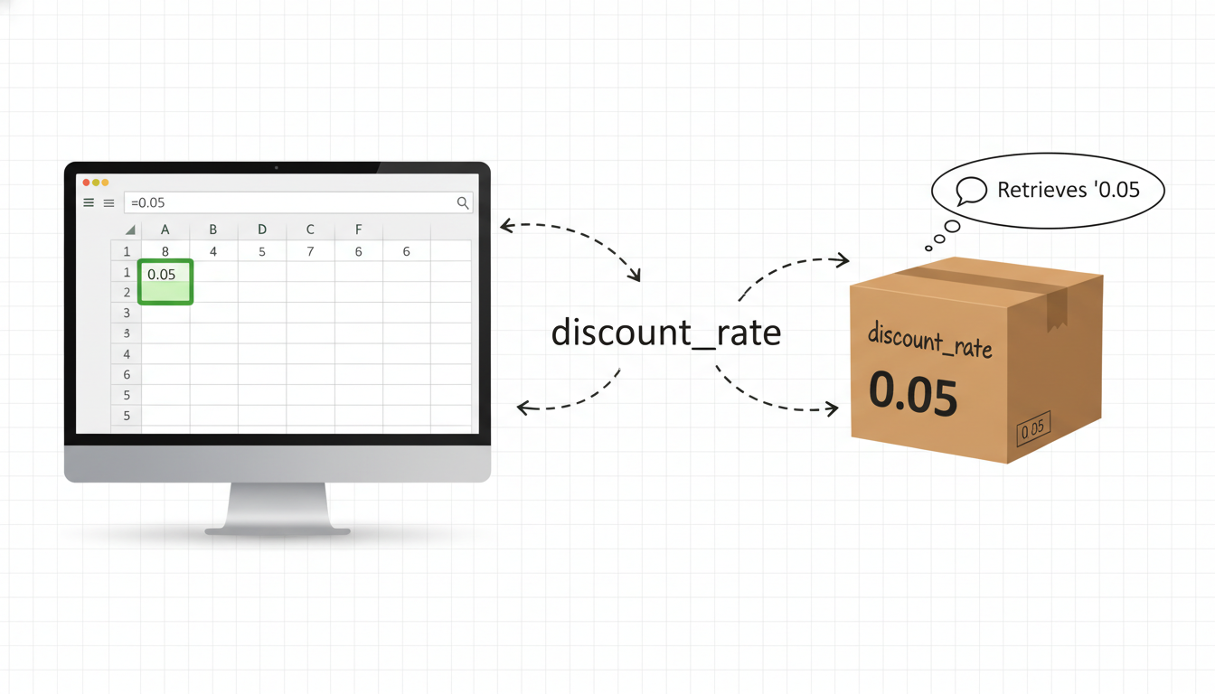

A split-screen comparison diagram. Left side: An Excel spreadsheet showing cell B4 highlighted containing the value "0.05". Right side: A stylized cardboard box labeled "discount_rate" containing the number "0.05". Arrows indicate that referencing the label "discount_rate" retrieves the value inside.

### **The Assignment Operator: It’s Not Algebra In mathematics and in Excel formulas, the equal sign (=) usually implies equality or a result. In Python, the equal sign is the assignment operator. It is a command, not a statement of fact.**

Read the following line of code not as "Revenue equals 1000," but as "Assign the value 1000 to the variable named revenue."

python

revenue = 1000

When Python executes this line, it evaluates everything to the right of the = and stores it in the name provided on the left.

### **Naming Conventions: Writing for Humans In Excel, you might get away with referencing Sheet1!C5. In Python, code is read more often than it is written. Therefore, variable names must be descriptive.**

Python professionals adhere to a style guide called **PEP 8**. For variables, the standard is **snake_case**: lowercase words separated by underscores.

* **Bad:** x, Val, Customername, annualRevenue (this is "camelCase," common in Java/JavaScript, but avoided in Python variables)
* **Good:** customer_id, total_revenue, is_active_member

***Pro Tip:*** *Avoid using Python keywords (reserved words) as variable names. You cannot name a variable print or import because Python has already claimed those words for internal use.*

### **Data Types: The "Shape" of Data In a spreadsheet, a cell can hold text, a date, a percentage, or a currency. Excel is often forgiving; it tries to guess what you mean. If you type "100" and multiply it by 5, Excel treats "100" as a number even if you formatted it as text.**

Python is stricter. It needs to know exactly what *type* of data it is handling. This is crucial in Data Science because you cannot perform a t-test on text, nor can you capitalize a number.

Here are the four fundamental building blocks you will use daily:

#### **1. Integers (int) Integers are whole numbers without decimals. They represent discrete counts—things you can count on your fingers (if you had enough fingers). *Real-world examples:*\* Number of employees, items in stock, number of website visits.**

python

employee_count = 45

items_sold = 150

#### **2. Floating Point Numbers (float) Floats are numbers with decimal points. They represent continuous data—measurements that require precision. *Real-world examples:*\* Revenue, temperature, percentages, weight.**

python

price = 19.99

tax_rate = 0.07

temperature_celsius = 23.5

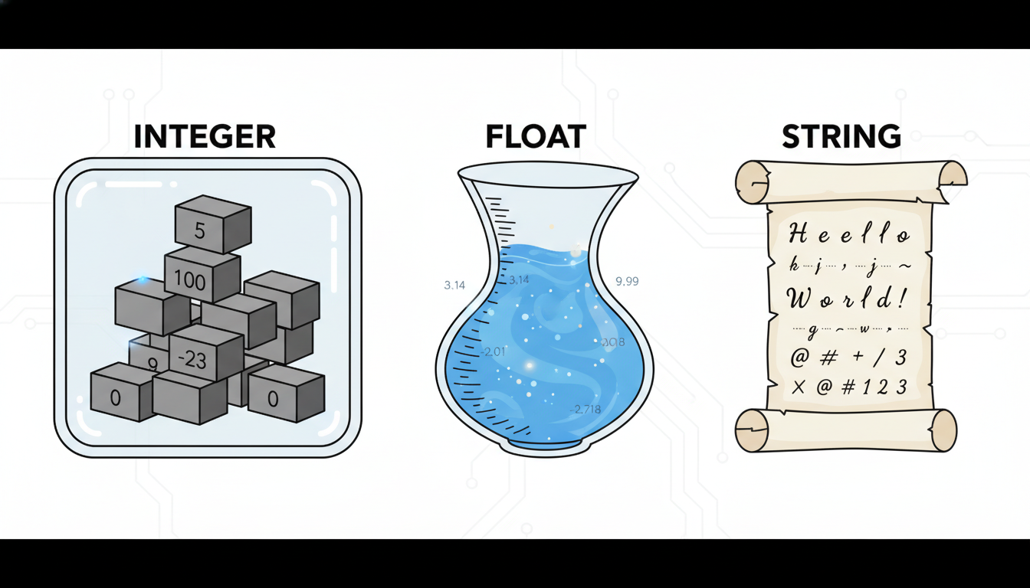

A conceptual illustration showing three distinct "containers". Container 1 is square-shaped labeled "Integer" holding whole blocks. Container 2 is fluid-shaped labeled "Float" holding liquid with markings for precision. Container 3 is a scroll-shaped container labeled "String" holding text characters.

#### **3. Strings (str) Strings are sequences of characters—text. In Python, you must enclose strings in quotes. You can use single quotes ' or double quotes ", as long as you are consistent. *Real-world examples:*\* Customer names, product categories, email addresses, reviews.**

python

customer_name = "Alice Johnson"

department = 'Marketing'

sku_code = "A-99-X"

If you wrap a number in quotes, Python treats it as text, not a number.

python

# This is a string, not a number. You cannot do math on it yet.

invoice_id = "1024"

#### **4. Booleans (bool) Booleans represent binary logic: True or False. Note that in Python, these must be capitalized. This is the equivalent of a checkbox in a form. *Real-world examples:*\* Is the customer a VIP? Is the transaction flagged for fraud? Is the stock in inventory?**

python

is_vip = True

has_churned = False

### **Dynamic Typing: Python is Smart (Mostly) In some programming languages (like C++ or Java), you must declare the type explicitly: "I am creating an Integer named X."**

Python is **dynamically typed**. This means Python infers the type based on the value you assign. You don't need to tell Python that 19.99 is a float; it creates a float wrapper automatically.

You can check the type of any variable using the built-in type() function. This is an excellent debugging tool when your code throws an error because it tried to divide a word by a number.

python

# Define variables

revenue = 50000.50

store_id = 105

# Check their types

print(type(revenue))

print(type(store_id))

**Output:**

text

<class 'float'>

<class 'int'>

### **Representing a Business Entity Let’s bring this together. Imagine you are analyzing a dataset of retail transactions. A single row in your spreadsheet represents one transaction. In Python, we can represent that single entity using variables of different types.**

python

# Transaction Data

transaction_id = 9481 # Integer: Unique identifier

customer_name = "TechCorp" # String: Name of the client

transaction_amount = 4500.75 # Float: The value of the deal

is_recurring = True # Boolean: Is this a subscription?

# Let's view the data summary

print("Transaction:", transaction_id)

print("Client:", customer_name)

print("Recurring Status:", is_recurring)

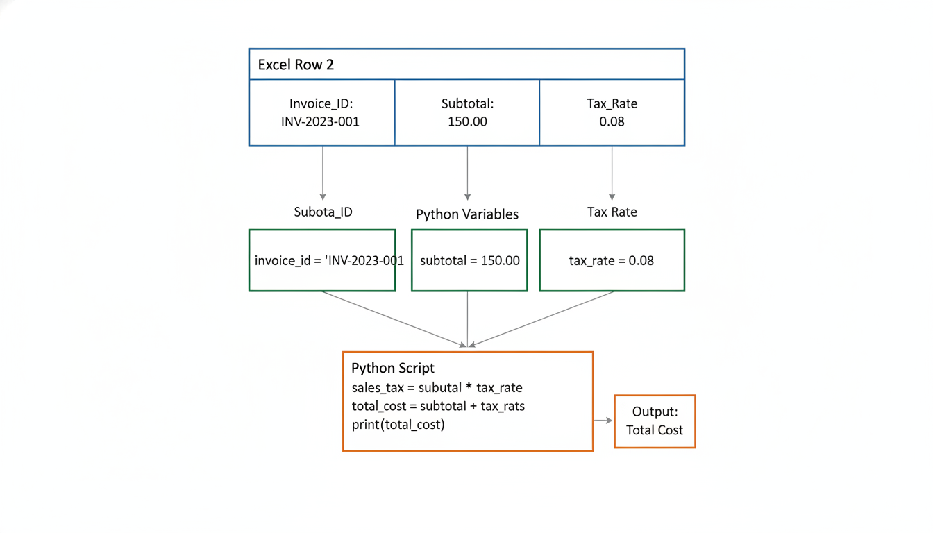

A flowchart diagram showing the flow of data. Top: A visual representation of a single row in an Excel file (Row 2). Middle: Arrows pointing from each cell in Row 2 to individual Python variables. Bottom: The variables feeding into a simple Python script that calculates a sales tax.

### **A Note on "Nothingness": None Finally, there is a special type in Python called None. It represents the absence of a value.**

In Excel, you might leave a cell blank to indicate missing data. In Python, we assign the value None. This is distinct from 0 (a number) or "" (an empty text string). None is a placeholder that says, "This variable exists, but it has no value yet."

python

discount_code = None

Understanding these basic types is the foundation of Data Science. Before you can build a Machine Learning model, you must understand that the model expects floats and cannot handle strings without conversion. Before you filter a dataset, you must understand that you are applying a boolean condition (True/False) to your data.

Next, we will look at how to move beyond single variables and store collections of data using **Lists and Dictionaries**.

### **Control Flow: Automating Business Logic with Loops and Conditionals**

In the previous section, we established how variables act as containers for your data. But a container sitting on a shelf doesn't drive business value. To derive insights, we need to manipulate that data, make decisions based on it, and repeat those processes across thousands of records.

In the spreadsheet world, you implement **business logic**—the rules that dictate how data is handled—using formulas. You likely use the IF function to categorize data and the "fill handle" (dragging a formula down a column) to repeat an operation.

In Python, we formalize these concepts into **Control Flow**. Control flow dictates the order in which your code executes. It turns a static script into a dynamic engine capable of making decisions and automating repetitive tasks.

### **Conditionals: Making Decisions**

In Excel, one of the most powerful tools in your arsenal is the IF function: =IF(A2 > 10000, "High Priority", "Standard")

This formula checks a condition and outputs one value if true, and another if false. In Python, we use **Conditional Statements** (if, elif, else) to achieve the same result, but with significantly more readability and flexibility.

#### **The Basic if Statement**

The syntax is almost like reading an English sentence. Note the use of the colon (:) and the **indentation** (whitespace) below the line. In Python, indentation is not just for aesthetics; it tells the computer which code belongs inside the logic block.

python

sales_amount = 15000

# The conditional check

if sales_amount > 10000:

# This code runs ONLY if the condition above is True

print("High Priority Transaction")

print("Notify Account Manager")

If sales_amount were 5000, the indented lines would simply be skipped.

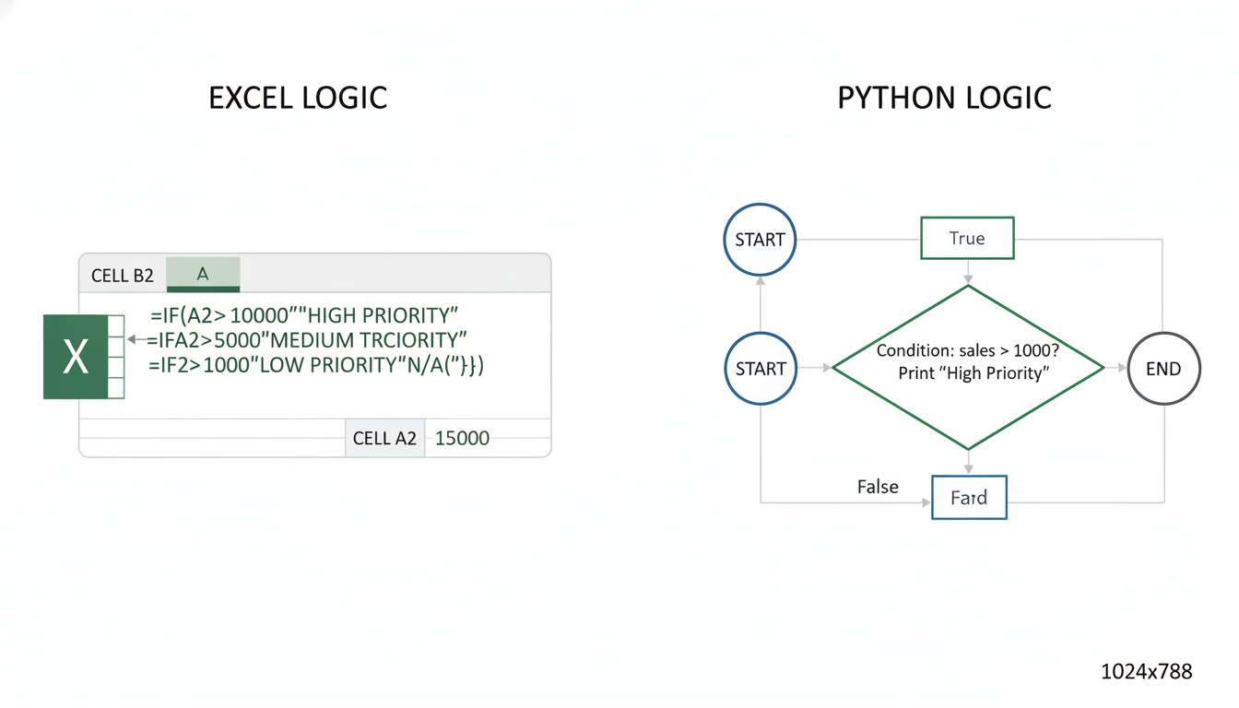

A flowchart diagram comparing Excel Logic to Python Logic. On the left, an Excel cell showing a nested IF formula. On the right, a Python flow diagram showing a diamond shape labeled "Condition: Sales > 10000?" branching into two paths: "True" leading to an action block "Print High Priority", and "False" bypassing the action.

#### **Handling Alternatives: else and elif**

Business rules are rarely binary. Often, you have multiple tiers or fallback scenarios.

* **`else`**: Acts like the "value_if_false" in Excel. It catches anything that didn't pass the if check.
* **`elif`** (else if): Allows you to chain multiple specific conditions. This replaces the dreaded "Nested IF" nightmare in Excel (e.g., IF(A2>10, "A", IF(A2>5, "B", "C"))).

Let's look at a tiered commission structure script:

python

sales = 4500

if sales >= 10000:

commission_rate = 0.10

status = "Platinum"

elif sales >= 5000:

commission_rate = 0.07

status = "Gold"

elif sales >= 1000:

commission_rate = 0.05

status = "Silver"

else:

commission_rate = 0.00

status = "Standard"

print(f"Status: {status}, Commission Rate: {commission_rate}")

In this snippet, Python evaluates the conditions from top to bottom. As soon as it finds a condition that is True, it executes that block and ignores the rest. This logic structure is the backbone of data cleaning (e.g., "If the value is missing, replace with zero, else keep value").

### **Loops: The Power of Automation**

In Excel, when you want to apply a tax calculation to 50,000 rows of sales data, you write the formula in the top row and double-click the bottom-right corner of the cell. Excel automatically iterates through every row, applying the logic relative to that row.

In Python, we don't have a visible grid to drag down. Instead, we use **Loops**.

#### **The for Loop**

The for loop is the most common loop in Data Science. It allows you to iterate over a sequence (like a list of numbers, names, or files) and perform the same action on each item.

Think of a for loop as a robotic arm on an assembly line. It picks up an item, processes it, puts it down, and moves to the next item.

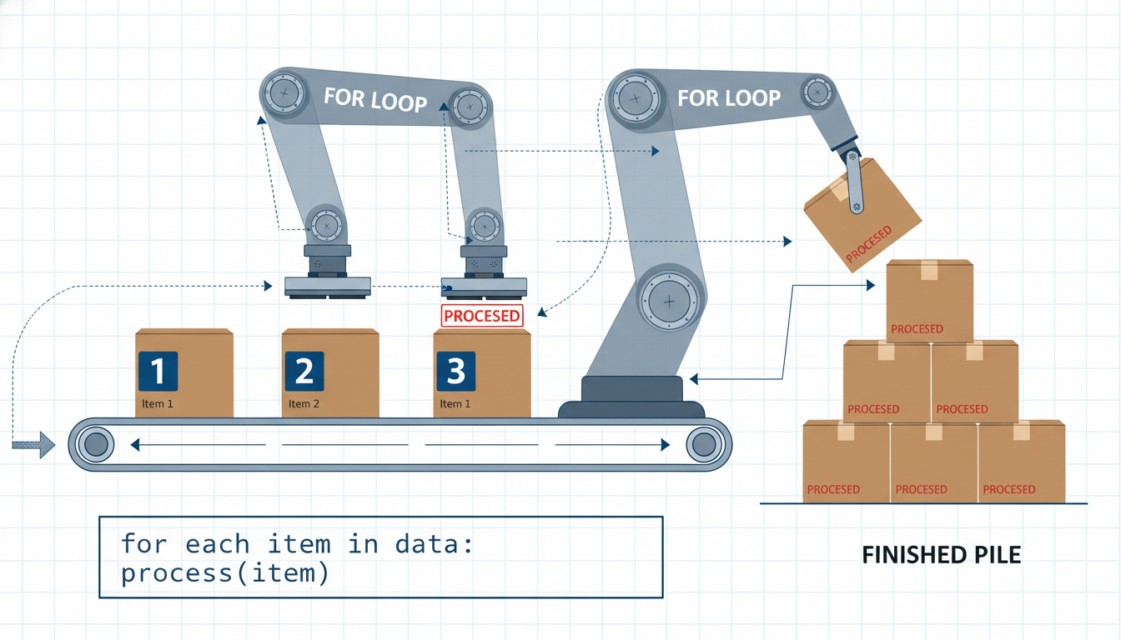

An illustration of a "For Loop" mechanism. It depicts a conveyor belt carrying boxes labeled with numbers (the data). A robotic arm (the Loop) picks up one box at a time, performs an operation (stamps it), and places it in a finished pile. Labels indicate "Item 1", "Item 2", "Item 3" being processed sequentially.

Here is how we process a list of daily revenue figures to calculate the total:

python

# A list of daily revenue for the week

daily_revenues = [1200.00, 850.50, 1600.00, 2100.25, 900.00]

total_revenue = 0

for revenue in daily_revenues:

# This block runs 5 times, once for each number in the list

total_revenue = total_revenue + revenue

print(f"Processing: {revenue}. Running Total: {total_revenue}")

print(f"Final Weekly Revenue: {total_revenue}")

**Breaking down the syntax:** *`daily_revenues`: The collection of data (the source).* revenue: A temporary variable name we create. In the first loop iteration, revenue equals 1200.00. In the second, it equals 850.50. * The code block inside the loop is repeated until the list is exhausted.

#### **The range() Function**

Sometimes you don't have a list of data, but you simply need to repeat an action a specific number of times. The range() function generates a sequence of numbers for you.

python

# Repeat an action 5 times

for i in range(5):

print(f"Generating Report #{i + 1}")

### **Combining Logic: The "Business Rules Engine"**

The real power of programming emerges when you combine **Loops** (automation) with **Conditionals** (logic). This combination allows you to process large datasets and handle exceptions automatically—something that requires complex filtering and manual intervention in spreadsheets.

Imagine you are auditing expense reports. You have a list of transaction amounts, and you need to flag any transaction over $500 for manual review.

python

transactions = [120.50, 45.00, 600.00, 32.99, 850.00, 15.00]

# We create empty lists to store our results

approved_expenses = []

flagged_for_audit = []

for amount in transactions:

if amount > 500:

# Logic: If expensive, flag it

flagged_for_audit.append(amount)

print(f"ALERT: ${amount} flagged for review.")

else:

# Logic: If reasonable, approve it

approved_expenses.append(amount)

print("Audit Complete.")

print(f"Approved count: {len(approved_expenses)}")

print(f"Flagged count: {len(flagged_for_audit)}")

In a few lines of code, you have built a mini-audit engine. In Excel, this might require a helper column with an IF statement, followed by a filter, and then copying/pasting data into separate tabs. Python does it instantly and reproducibly.

### **Controlling the Loop: break and continue**

Sometimes, you need more granular control over your automation. You might want to stop the assembly line immediately if a critical error occurs, or skip a specific defective item without stopping the whole line.

1. **`break`**: Completely terminates the loop. 2. **`continue`**: Skips the *current* iteration and moves to the next item immediately.

**Scenario:** We are processing a batch of invoices. If we find an invoice with a value of 0 (an error), we skip it. If we find a value of -1 (a "stop code"), we halt the entire process.

python

invoices = [200, 450, 0, 300, -1, 500, 600]

for inv in invoices:

if inv == -1:

print("Stop code detected. Halting processing.")

break # Stops the loop entirely. 500 and 600 are never touched.

if inv == 0:

print("Invalid invoice (0). Skipping.")

continue # Skips the print statement below and goes to the next number

print(f"Processing invoice value: ${inv}")

### **Summary: Translating Your Mindset**

As you practice writing loops and conditionals, try to map them back to your business experience:

* **The `if` statement** is your decision-maker (the Manager).
* **The `for` loop** is your worker (the Automation).
* **Variables** are the files and folders being worked on.

By mastering Control Flow, you are moving away from being the person who manually updates the spreadsheet, to becoming the architect who designs the system that updates itself. In the next section, we will look at **Functions**, which allow you to package this logic into reusable tools, effectively creating your own custom Excel formulas.

### **Functions: Creating Reusable Tools for Data Processing**

You have likely experienced the "Copy-Paste Nightmare."

Imagine you have built a complex logic chain in a spreadsheet to calculate the "Net Profit Margin" for a specific product line. It involves subtracting the Cost of Goods Sold (COGS) from Revenue, deducting a marketing percentage, and applying a regional tax adjustment. You type this formula into cell D2. It works perfectly.

Then, you need to apply this same logic to twelve other worksheets in the file, representing twelve different months. You copy the formula and paste it across the tabs. A week later, the Finance Director emails you: "The regional tax adjustment changed from 4% to 4.5%."

Now you have a problem. You must go into every single tab, find that formula, and manually update the percentage. If you miss one, your annual report is wrong. This is the fragility of manual repetition.

In Python, we solve this problem with **Functions**.

### **The Concept: Named Recipes A function is a reusable block of code that performs a specific task. Think of it as a saved "recipe" or a mini-machine. You define the logic once, give it a name (like calculate_net_profit), and then you can call that name whenever you need to perform the calculation. If the tax rate changes, you update the logic in *one place*—inside the function definition—and every part of your script that uses that function is instantly updated.**

In Excel terms, think of a function like a saved Macro, or a named formula like VLOOKUP. You don't need to know the underlying code of VLOOKUP every time you use it; you just need to know what inputs it requires and what output it gives you.

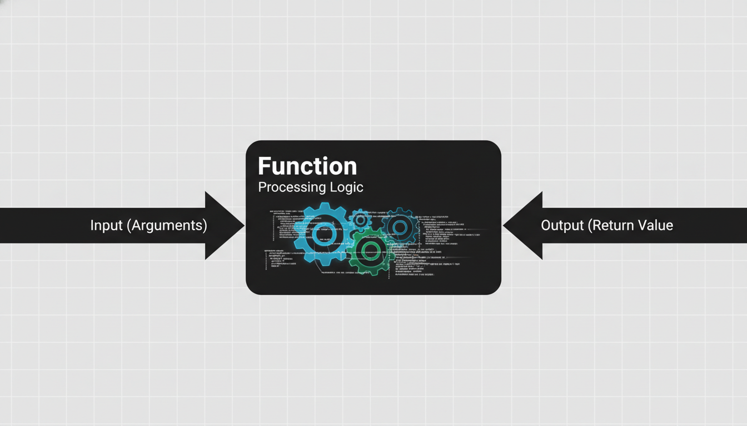

A diagram illustrating the "Black Box" concept of a function. On the left, an arrow labeled "Input (Arguments)" points into a box labeled "Function (Processing Logic)." On the right, an arrow labeled "Output (Return Value)" points out of the box. The box itself shows gears or code snippets inside, representing the hidden complexity.

### **The Anatomy of a Function To create a function in Python, we use the def keyword (short for *define*). Here is the standard syntax:**

python

def function_name(parameters):

# Code block that does something

result = parameters * 2

return result

Let’s break down the components using a practical business example: converting currency.

python

def convert_usd_to_eur(amount_usd, exchange_rate=0.85):

"""

Converts a USD amount to EUR based on the given exchange rate.

"""

amount_eur = amount_usd * exchange_rate

return amount_eur

1. **`def`**: This tells Python, "I am about to create a new tool." 2. **`convert_usd_to_eur`**: This is the name. Like variable names, function names should be descriptive and use snake_case. 3. **`(amount_usd, exchange_rate)`**: These are the **Parameters**. They are placeholders for the data you will feed into the function. 4. **`:` (The Colon)**: This marks the end of the header and the start of the logic. 5. **Indentation**: Everything indented under the def line belongs to the function. 6. **Docstring**: The text in triple quotes (""") describes what the function does. This is crucial for documentation. 7. **`return`**: This specifies what the function gives back to you.

### **Calling the Function Defining the function doesn't run the code; it just builds the tool. To use it, you call the function by using its name and providing the actual data (arguments).**

python

# Using the function

q1_sales_usd = 10000

q1_sales_eur = convert_usd_to_eur(q1_sales_usd)

print(f"Q1 Sales in Euro: €{q1_sales_eur}")

# Output: Q1 Sales in Euro: €8500.0

### **Parameters vs. Arguments While often used interchangeably, there is a slight technical difference: *Parameters are the variable names listed in the function definition (`amount_usd`).* Arguments are the actual values you pass into the function when you call it (10000).**

In our example above, notice exchange_rate=0.85. This is a **Default Parameter**. If you call the function without specifying a rate, Python assumes 0.85. However, if the market shifts, you can override it easily:

python

# Overriding the default rate

today_conversion = convert_usd_to_eur(10000, exchange_rate=0.92)

### **The return vs. print Trap A common stumbling block for those transitioning from spreadsheets to programming is the difference between print() and return.**

* **`print()`** displays a value on your screen. It is for **human eyes**.
* **`return`** sends a value back to the program so it can be stored in a variable or used in another calculation. It is for **computer memory**.

Think of a function like a generic employee. *If you ask the employee to `print` the report, they show it to you, then shred it. You cannot use that number in a future calculation because it wasn't saved; it was just displayed.* If you ask the employee to **`return`** the report, they hand the physical file to you. You can then file it, add it to another pile, or fax it to someone else.

**Incorrect (Printing only):**

python

def bad_math(a, b):

print(a + b)

result = bad_math(10, 5) # Displays 15

final_total = result + 5 # ERROR! 'result' is empty because nothing was returned.

**Correct (Returning):**

python

def good_math(a, b):

return a + b

result = good_math(10, 5) # Stores 15 in variable 'result'

final_total = result + 5 # Works perfectly. final_total is 20.

### **Automating Logic: The "DRY" Principle In software engineering, there is a golden rule: DRY (Don't Repeat Yourself). If you find yourself copying and pasting the same block of code three times, it is a sign you should refactor that code into a function.**

Let's look at a data science scenario involving data cleaning. You have a list of messy phone numbers from a CRM system. Some have dashes, some have parentheses, and some have spaces.

**Without Functions (The Repetitive Way):**

python

phone1 = "(555) 123-4567"

clean_phone1 = phone1.replace("(", "").replace(")", "").replace("-", "").replace(" ", "")

phone2 = "555-987-6543"

clean_phone2 = phone2.replace("(", "").replace(")", "").replace("-", "").replace(" ", "")

# If we want to add logic to strip country codes, we have to edit every line above.

**With Functions (The Scalable Way):**

python

def clean_phone_number(raw_number):

"""Removes special characters from phone strings."""

clean = raw_number.replace("(", "")

clean = clean.replace(")", "")

clean = clean.replace("-", "")

clean = clean.replace(" ", "")

return clean

# Now the logic is reusable

phone1 = "(555) 123-4567"

phone2 = "555-987-6543"

clean1 = clean_phone_number(phone1)

clean2 = clean_phone_number(phone2)

Later in this book, when we introduce **Pandas**, you will see how to apply a function like clean_phone_number to a column of 1,000,000 rows in a single line of code. That is the power of scalability.

### **Scope: Local vs. Global Variables When you create a variable inside a function, it belongs *only* to that function. This concept is called Scope.**

Think of your Python script as a house (Global Scope) and your function as a soundproof room inside the house (Local Scope). 1. **Global Scope:** Variables defined in the main body of the script. Everyone can see them. 2. **Local Scope:** Variables defined inside a function. Only the function can see them.

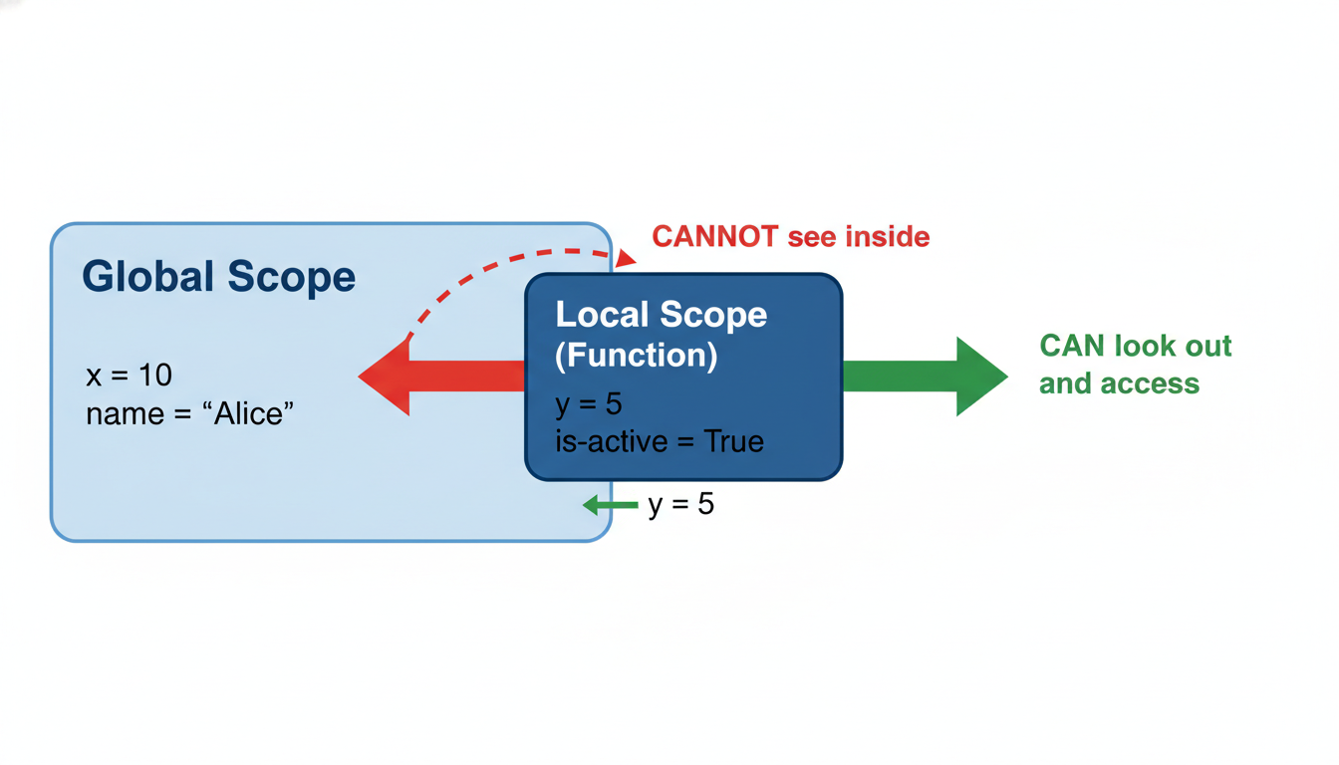

A diagram explaining Variable Scope. It depicts a large container labeled "Global Scope" containing variables like 'x = 10'. Inside it, there is a smaller, enclosed container labeled "Local Scope (Function)" containing 'y = 5'. Arrows show that the Global scope cannot "see" inside the Local scope, but the Local scope can "look out" to the Global scope.

Why does this matter? It prevents data collisions. You might use a generic variable name like total inside a function. You don't want that to accidentally overwrite a variable named total that calculates your company's annual revenue elsewhere in the script.

python

company_revenue = 1000000 # Global variable

def calculate_bonus(salary):

bonus_rate = 0.10 # Local variable

total = salary * bonus_rate

return total

# We can access company_revenue here

print(company_revenue)

# We CANNOT access bonus_rate here. It only exists inside the function.

# print(bonus_rate) -> This would cause a NameError

### **Summary Transitioning from Excel to Python requires shifting from "copy-pasting logic" to "defining reusable logic." Functions allow you to: 1. Abstract complexity: Hide the messy math behind a simple command. 2. Maintain code: Fix a bug in one place, and it updates everywhere. 3. Scale: Apply complex rules to millions of data points efficiently.**

In the next section, we will look at **Lists and Dictionaries**, the data structures that will serve as the inputs for our newly created functions.

### **Essential Python Data Structures: Lists and Dictionaries in Action**

Up until this point, our discussion on variables has assumed a one-to-one relationship: one variable name holds one piece of data. We’ve created variables like tax_rate = 0.05 or customer_name = "Acme Corp".

However, data analysis rarely happens in isolation. You don’t analyze a single sale; you analyze a ledger of thousands of transactions. You don’t process one customer email; you segment a mailing list of ten thousand. Creating ten thousand individual variables (e.g., sale_1, sale_2, sale_3...) is not just inefficient; it is impossible to manage.

To handle real-world data, we need structures that can hold collections of items. In the Excel world, you are used to seeing data organized visibly in rows and columns. In Python, we build these structures using **Lists** and **Dictionaries**.

These two data structures are the bedrock of Python data science. Even when we advance to complex tools like pandas in later chapters, remember: those tools are built on top of the concepts you are about to learn here.

### **Python Lists: The Ordered Sequence**

Think of a Python **List** as a single column in a spreadsheet. It is an ordered sequence of elements. In a spreadsheet column, the order matters—the value in Row 2 comes before Row 3. Similarly, in a Python list, every item has a specific position.

You create a list by placing comma-separated values inside square brackets [].

python

# A list of quarterly revenue figures (in millions)

quarterly_revenue = [12.5, 15.2, 11.8, 16.4]

# A list of department names

departments = ["Sales", "Marketing", "IT", "HR"]

#### **Zero-Indexing: The "Off-by-One" Shift Here is the most common stumbling block for professionals transitioning from Excel. In Excel, the first row is Row 1. In Python (and most programming languages), counting starts at 0.**

To access data in a list, we use its **Index**.

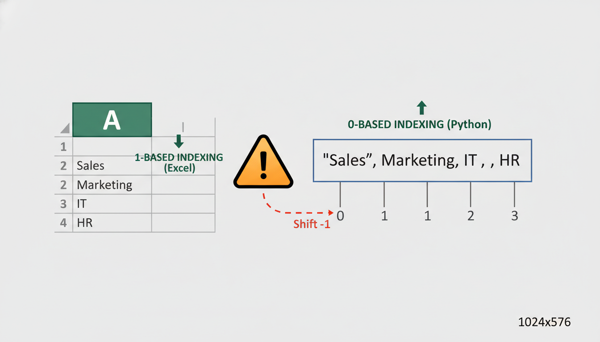

A visual comparison diagram. On the left side, an Excel column labeled "A" showing rows 1, 2, 3, 4 containing data "Sales", "Marketing", "IT", "HR". On the right side, a horizontal Python list representation showing the same data strings, but with indices 0, 1, 2, 3 pointing to them respectively. A warning icon highlights the shift from 1-based to 0-based indexing.

If you want to access the first department in our list ("Sales"), you ask for index 0:

python

# Accessing elements

first_dept = departments[0] # Returns "Sales"

third_dept = departments[2] # Returns "IT"

print(first_dept)

#### **Slicing: Selecting Subsets Often, you don't just want one cell; you want a range. In Excel, you might select A2:A10. In Python, this is called Slicing. The syntax is list[start:end].**

*Note: Python slicing is "inclusive of the start, exclusive of the end." This means `[0:2]` fetches indices 0 and 1, but stops before 2.*

python

# Get the first two quarters of revenue

first_half = quarterly_revenue[0:2]

print(first_half)

# Output: [12.5, 15.2]

#### **Mutability: Changing the Ledger Lists are mutable, meaning you can change them after they are created. This is essential for data cleaning. If you discover a data entry error, you can correct it directly.**

python

# Correction: The Q3 revenue was actually 12.0, not 11.8

quarterly_revenue[2] = 12.0

# Adding data: We just got Q4 results not originally in the list

quarterly_revenue.append(18.1)

### **Python Dictionaries: The Key-Value Map**

While lists are great for sequences (like a time series), they are terrible for looking up specific attributes.

Imagine you have a list of customer information: ['John Doe', 45, 'New York', 'Gold Member']. If you want to find the customer's city, you have to remember that the city is at index position 2. If the data structure changes, your code breaks.

In Excel, you solve this with **Headers**. You don't memorize that "City" is column C; you look for the column labeled "City."

In Python, we use **Dictionaries** to replicate this "Header" concept. A dictionary is a collection of **Key-Value pairs** enclosed in curly braces {}.

python

# A dictionary representing a single customer transaction

transaction = {

"transaction_id": 10045,

"amount": 450.00,

"currency": "USD",

"customer_region": "North America"

}

#### **The "VLOOKUP" of Python Dictionaries are highly optimized for lookups. Instead of asking for "Item at index 3," you ask for the value associated with a specific key. This is conceptually similar to performing a VLOOKUP where you search for a unique identifier (Key) to retrieve a result (Value).**



A conceptual diagram illustrating a Dictionary as a set of lockers. Each locker has a label (the Key) like "amount" or "currency". Inside the locker is the data (the Value). An arrow shows a user requesting "customer_region" and the locker instantly opening to reveal "North America".

python

# Accessing values by Key

print(transaction["amount"]) # Output: 450.0

print(transaction["customer_region"]) # Output: North America

#### **Dynamic Updates Just like lists, dictionaries are mutable. You can add new keys (headers) on the fly. This is useful when feature engineering—creating new data points from existing ones.**

python

# We calculate a tax and add it to the dictionary

transaction["tax_amount"] = transaction["amount"] * 0.08

# Now the dictionary contains 'tax_amount': 36.0

### **The Data Science Reality: Lists of Dictionaries**

You might be wondering: *Do I use a List or a Dictionary?*

In professional Data Science, the answer is usually **both**.

Think about a standard spreadsheet containing sales data. *Rows: Each row represents a distinct record (an order, a customer, a timestamp).* **Columns:** Each column represents an attribute of that record (Price, Date, ID).

In Python, we represent this dataset as a **List of Dictionaries**. The List provides the sequence (Rows), and the Dictionaries provide the structure (Columns).

python

# A dataset of three sales

sales_data = [

{"id": 101, "product": "Laptop", "price": 1200},

{"id": 102, "product": "Mouse", "price": 25},

{"id": 103, "product": "Monitor", "price": 300}

]

This specific structure—a list containing dictionaries—is the standard format for JSON data, APIs, and NoSQL databases. It is also exactly how the pandas library (which we will cover in Chapter 3) conceptually interprets data before turning it into a DataFrame.

#### **Iterating Through the Structure In the "Control Flow" section, we discussed loops. Now, we can apply a for loop to this structure to perform an aggregate calculation, mimicking the functionality of an Excel SUM column.**

python

total_revenue = 0

# Loop through each dictionary in the list

for sale in sales_data:

# Access the 'price' key of the current dictionary

price = sale["price"]

# Add to the running total

total_revenue = total_revenue + price

print(f"Total Revenue: ${total_revenue}")

# Output: Total Revenue: $1525

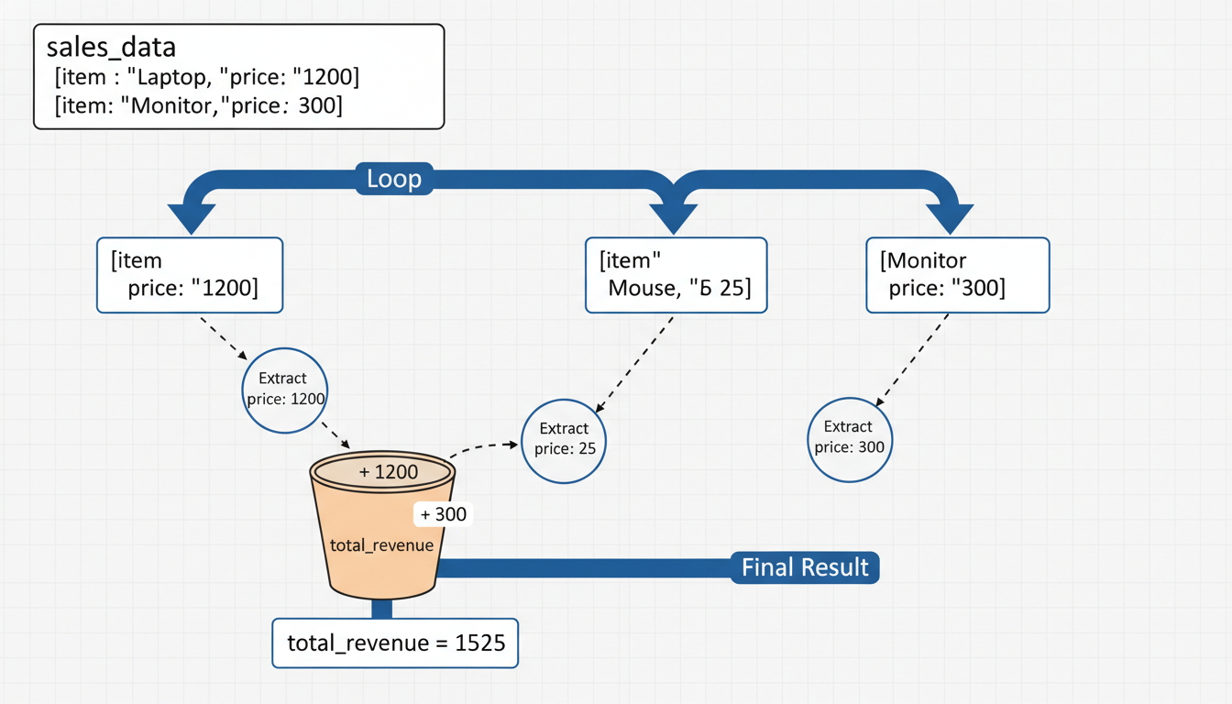

A flow diagram showing the iteration process. The diagram shows the `sales_data` list at the top. An arrow labeled "Loop" points to the first dictionary (Laptop). The price 1200 is extracted and added to a bucket labeled "total_revenue". The arrow then loops to the second dictionary (Mouse), adding 25, and finally the third (Monitor), adding 300.

### **Summary: The Data Structures Cheat Sheet**

As you move away from the visual grid of Excel, use this mental map to choose your structure:

1. **List `[]`:** Use when you have a collection of similar items where **order** matters (e.g., a list of filenames, a sequence of daily temperatures). Analogous to a Column. 2. **Dictionary `{}`:** Use when you have a set of unique attributes describing a single entity where **labels** matter (e.g., a specific product's configuration). Analogous to a Row with Headers. 3. **List of Dictionaries `[{}]`:** The standard format for tabular datasets. Analogous to the whole Sheet.

With your workshop tools (Lists and Dicts) ready and your blueprints (Control Flow and Functions) drawn, you are now capable of writing pure Python scripts to process data. However, writing raw loops for millions of rows is slow. In the next chapter, we will introduce the power tool of Data Science: **Pandas**, which takes these structures and supercharges them for high-performance analysis.

## **Chapter 3Mastering Data Manipulation with Pandas**

### **The DataFrame: Moving Beyond Excel Tables**

If you asked a carpenter to build a house using only a Swiss Army knife, they might eventually succeed, but it would be exhausting, inefficient, and structurally unsound. For years, Excel has been the Swiss Army knife of data analysis. It is versatile, approachable, and ubiquitous. However, as you transition into Data Science, you are moving from building sheds to building skyscrapers. You need heavy machinery.

In Python, that machinery is **Pandas**.

Pandas (derived from "Panel Data") is the bedrock of Python data science. It provides a high-performance structure that allows you to manipulate structured data programmatically. While basic Python lists and dictionaries (covered in the previous section) are useful for small tasks, they lack the specific tooling required to slice, dice, aggregate, and visualize millions of rows of data instantly.

### **The Mental Shift: From Spreadsheets to DataFrames**

The core object in Pandas is the **DataFrame**. At first glance, a DataFrame looks exactly like an Excel spreadsheet. It has rows, it has columns, and it holds data.

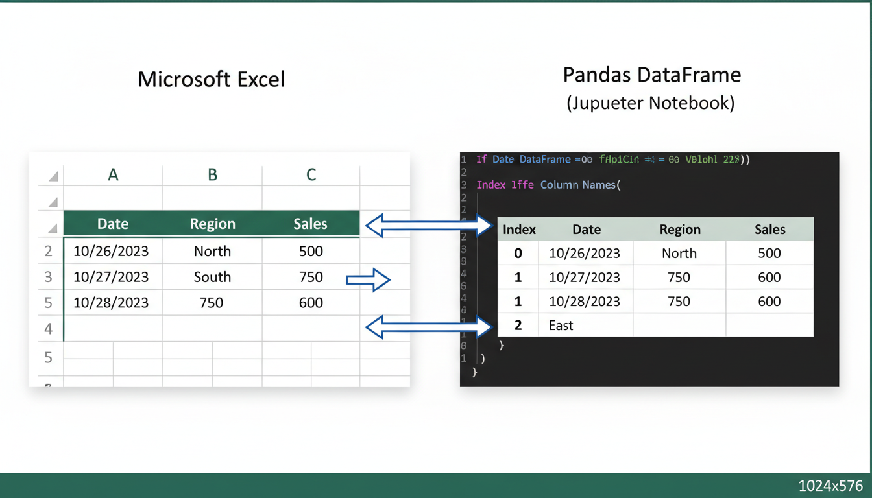

A split-screen comparison. On the left, a screenshot of Microsoft Excel showing a table with columns "Date", "Region", and "Sales". On the right, a stylized representation of a Pandas DataFrame output in a Jupyter Notebook showing the exact same data. Arrows connect the Excel row numbers to the Pandas "Index", and Excel column letters to Pandas "Column Names".

However, the similarity is deceptively superficial. In a spreadsheet, the data and the interface are the same thing. You click on a cell to change it. You see all your data at once. In Pandas, the DataFrame is a data structure held in your computer's memory. You do not "look" at the whole thing constantly; you write code to query it, modify it, and summarize it.

To begin using this tool, we first need to import the library. By universal convention in the data science community, Pandas is imported with the alias pd.

python

import pandas as pd

### **Anatomy of a DataFrame**

To master the DataFrame, you must understand its three structural components. If you treat it just like a grid of cells, you will struggle. If you treat it as a collection of these three parts, you will thrive.

1. **The Data:** The actual values (integers, floats, strings, etc.). 2. **The Columns:** The labels for your data variables (e.g., "Price", "Quantity"). 3. **The Index:** The labels for your rows.

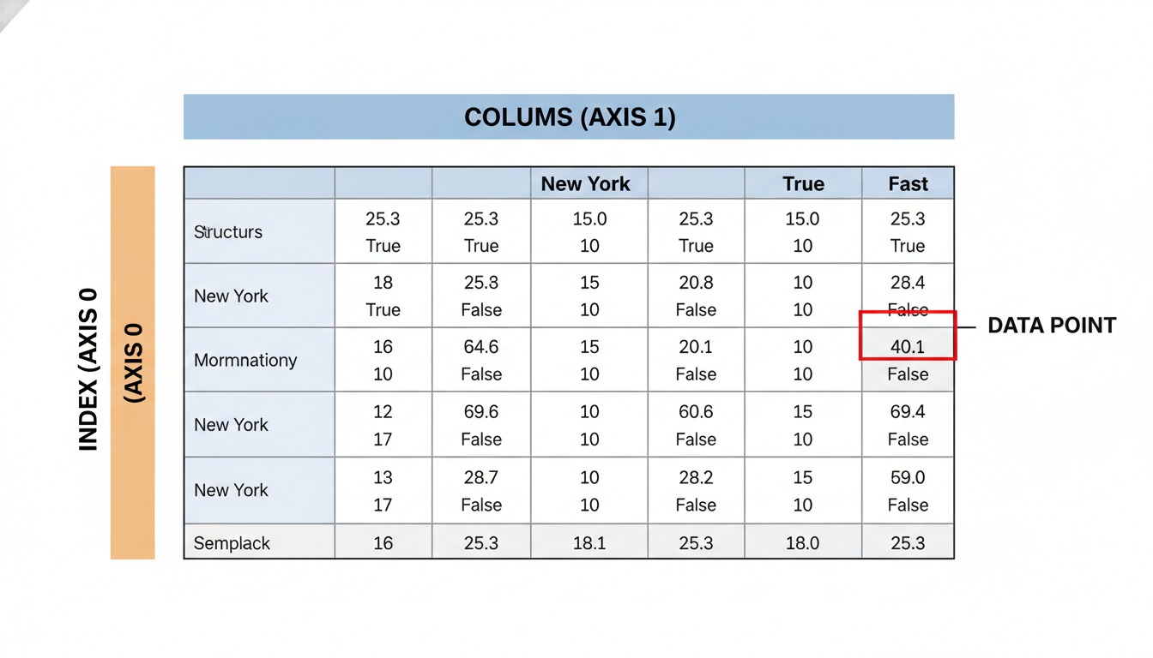

A technical diagram breaking down a DataFrame. It shows a central block of data grid. Top horizontal bar is highlighted as "Columns (Axis 1)". The left vertical bar is highlighted as "Index (Axis 0)". The intersection of a column and index is highlighted as "Data Point".

#### **1. Series: The Building Blocks Recall the "Lists" we discussed in the previous section. If a DataFrame is a table, what is a single column?**

In Pandas, a single column is called a **Series**. You can think of a DataFrame as a Dictionary where every key is a column name, and every value is a Series (a specialized list) of equal length.

Let's create a DataFrame from scratch using the concepts you learned in the previous chapter—dictionaries and lists—to see how they fuse together.

python

import pandas as pd

# A dictionary where keys are column headers and values are lists of data

data = {

"Product_ID": ["A101", "A102", "A103", "A104"],

"Category": ["Electronics", "Furniture", "Electronics", "Office"],

"Price": [500, 150, 1200, 45]

}

# Converting the dictionary into a DataFrame

df = pd.read_csv("data.csv") # Common in practice, but for now we build manually:

df = pd.DataFrame(data)

print(df)

**Output:**

text

Product_ID Category Price

0 A101 Electronics 500

1 A102 Furniture 150

2 A103 Electronics 1200

3 A104 Office 45

#### **2. The Index: More Than Just Row Numbers Notice the numbers 0, 1, 2, 3 on the far left of the output above? This is the Index.**

In Excel, row numbers (1, 2, 3...) are fixed physical locations. If you sort the data, the data moves, but row 5 is always row 5.

In Pandas, the Index travels *with* the row. It acts as a unique identifier for that observation. Crucially, the Index doesn't have to be a number. It can be a Date, a Transaction ID, or a Customer Name. This allows for powerful lookups without complex VLOOKUP or INDEX-MATCH formulas.

### **Decoupling Logic from Presentation**

The hardest habit to break when moving from Excel to Pandas is the desire to "see" the change happen instantly.

In Excel, if you want to calculate Revenue, you click a cell, type =B2*C2, and drag the fill handle down. You watch the numbers populate. In Pandas, you perform this operation using **Vectorization**. You don't write a loop to go through row by row (like a manual drag); you apply an operation to the entire array at once.

python

# Assume we have a 'Quantity' column

# In Excel: =B2 * C2 applied to every row

# In Pandas:

df['Revenue'] = df['Price'] * df['Quantity']

This single line of code applies the logic to one thousand rows or one billion rows instantly.

### **Why Make the Switch?**

If Pandas requires writing code to do what a mouse click can do in Excel, why bother?

1. **Scale:** Excel begins to struggle around 50,000 rows and often crashes near 1 million. Pandas can handle millions (and even gigabytes) of rows in memory with ease. 2. **Reproducibility:** In a spreadsheet, it is difficult to audit how a number changed from 500 to 450—was it a formula change? A manual overwrite? In Pandas, every change is a line of code. You can read the "recipe" of your analysis from top to bottom. 3. **Data Integrity:** In Excel, it is dangerously easy to accidentally type 7 into a cell that should contain a date. Pandas enforces data types (integers, floats, timestamps) more strictly, alerting you to data quality issues before they taint your final report.

In the coming sections, we will move away from creating manual DataFrames and learn to ingest real-world data from CSVs, databases, and APIs, treating the DataFrame not just as a grid, but as a canvas for insight.

### **Ingesting Data: Reading CSV, Excel, and SQL Sources**

Think of your Python script as a high-end manufacturing plant. In the previous section, we installed the machinery (the Pandas library) and learned about the final product (the DataFrame). However, a factory cannot function without raw materials.

In the Excel world, "ingesting" data is intuitive: you double-click a file icon, and the application opens it. You see the data immediately. In Data Science, the process is slightly more deliberate. You do not "open" a file; you **read** it into memory. Your Python script sits in one location, and your data sits in another (a folder, a server, or the cloud). You must build a bridge between the two.

Fortunately, Pandas provides a suite of I/O (Input/Output) tools that act as these bridges. Almost all of them follow a consistent naming convention: pd.read_format().

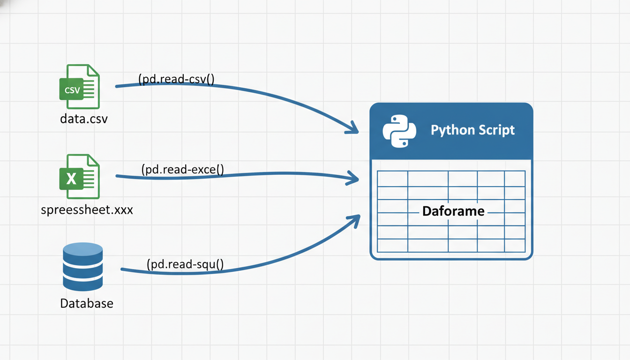

A conceptual diagram showing a Python script in the center. On the left, three distinct data sources: a CSV file icon, an Excel file icon, and a Database cylinder. Arrows flow from these sources into the Python script. Each arrow is labeled with its specific function: `pd.read_csv()`, `pd.read_excel()`, and `pd.read_sql()`. The arrows converge into a tabular grid labeled "DataFrame".

### **The Universal Standard: Reading CSV Files**

The Comma Separated Values (CSV) format is the lingua franca of data science. It is text-based, lightweight, and can be exported from almost any software system in the world. Because it strips away formatting—no bold text, no cell colors, no formulas—it is the cleanest way to transfer raw data.

To load a CSV, we use pd.read_csv().

python

import pandas as pd

# The simplest form of data ingestion

df = pd.read_csv('sales_data.csv')

# Display the first few rows to verify

print(df.head())

#### **Handling Real-World CSV Issues In a perfect world, every CSV is formatted correctly with commas separating columns and the first row containing headers. In reality, you will often receive "messy" exports from legacy systems.**

Imagine you receive a file exported from a European system where they use semi-colons (;) instead of commas to separate values, or a file where the first three rows contain legal disclaimers before the actual column headers start.

Pandas allows you to configure the "reader" to handle these quirks using **parameters**.

python

# Reading a messy file

df = pd.read_csv(

'raw_export_v2.csv',

sep=';', # Tell Pandas the separator is a semi-colon, not a comma

header=3, # The actual column names are on the 4th row (index 3)

encoding='utf-8' # Ensure special characters (like currency symbols) read correctly

)

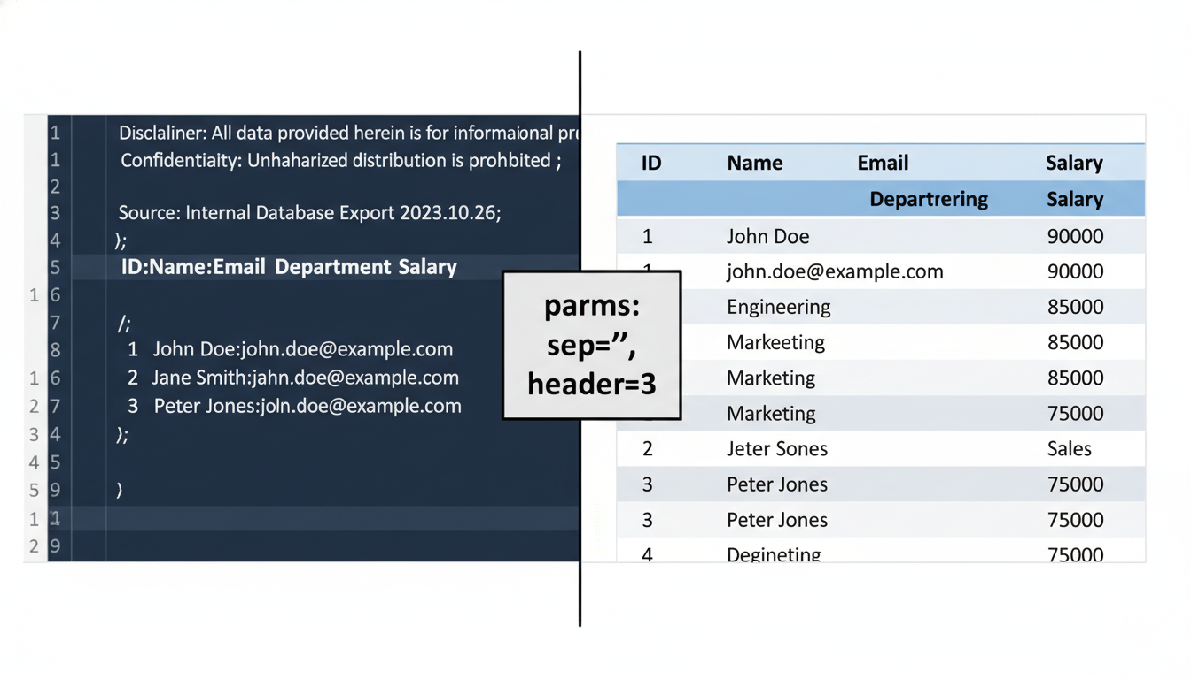

A split-screen visual. On the left, a screenshot of a raw text editor showing data separated by semi-colons with legal text in the top rows. On the right, the resulting clean Pandas DataFrame. Between them, a callout box listing the parameters used: `sep=';'` and `header=3`.

### **The Corporate Standard: Reading Excel Files**

As a transitioning professional, a significant portion of your organization's historical knowledge is likely locked inside .xlsx files. While Excel is great for viewing data, it is heavy. It contains formatting, metadata, and multiple sheets.

To read these files, we use pd.read_excel(). Unlike CSVs, an Excel file is a workbook that acts as a folder for multiple tables (sheets). If you do not specify a sheet, Pandas will default to reading the first one.

To target specific data, you utilize the sheet_name parameter.

python

# Load the entire workbook file path

file_path = 'Quarterly_Financials.xlsx'

# Read a specific tab named 'Q3_Transactions'

q3_data = pd.read_excel(file_path, sheet_name='Q3_Transactions')

# You can also read sheets by their index position (0 is the first sheet)

# This is useful if the sheet names change month-to-month but the order stays the same

first_sheet = pd.read_excel(file_path, sheet_name=0)

**Note:** Reading Excel files is significantly slower than reading CSV files because Python must parse the complex XML structure behind the .xlsx format. If you have a choice between a 50MB Excel file and a 50MB CSV file, always choose the CSV for performance.

### **The Enterprise Bridge: Reading from SQL**

As you advance in Data Science, you will eventually stop asking colleagues to "email you the export" and start pulling data directly from the source: the company database.

This is a major leap in efficiency. It ensures you are always working with the most current data and eliminates version control issues (e.g., sales_data_final_final_v2.xlsx).

Reading from SQL requires two distinct steps: 1. **Establish a Connection:** You create a "tunnel" to the database using a connector library (like sqlite3 for local files, or sqlalchemy for enterprise databases like PostgreSQL or Oracle). 2. **Query the Data:** You send a SQL query through that tunnel, and Pandas converts the results into a DataFrame.

Here is an example using sqlite3 (a lightweight database included with Python):

python

import pandas as pd

import sqlite3

# Step 1: Establish the connection

# In a real scenario, this would involve a host URL, username, and password

conn = sqlite3.connect('company_database.db')

# Step 2: Write your SQL query

query = """

SELECT customer_id, order_date, total_amount

FROM orders

WHERE order_date >= '2023-01-01'

"""

# Step 3: Read the result directly into a DataFrame

df_sql = pd.read_sql(query, conn)

# Step 4: Close the connection (good hygiene!)

conn.close()

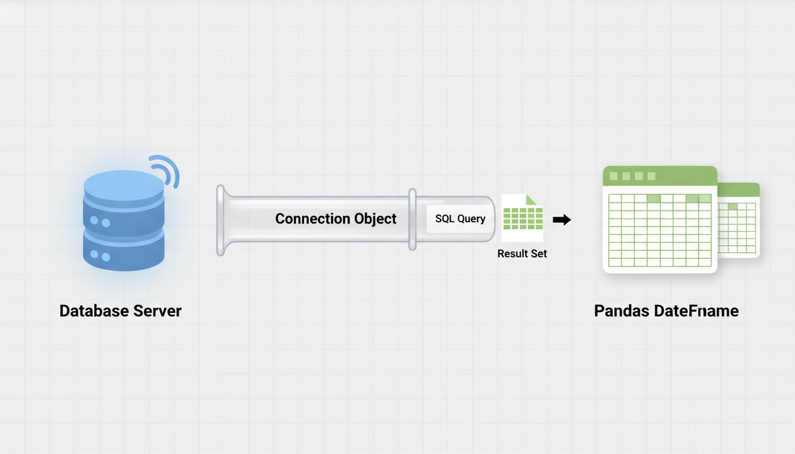

A diagram illustrating the "Handshake" process. On the left, a database server icon. On the right, the Pandas DataFrame. In the middle, a pipe labeled "Connection Object". A piece of paper labeled "SQL Query" travels from right to left through the pipe, and a grid of data labeled "Result Set" travels back from left to right, transforming into a DataFrame.

By using pd.read_sql, you effectively outsource the heavy lifting of filtering and joining data to the database engine—which is optimized for it—before bringing the refined dataset into Python for analysis.

### **Troubleshooting: The "File Not Found" Error**

The most common error you will encounter in this stage is FileNotFoundError.

When you type pd.read_csv('data.csv'), Python looks for that file in the **current working directory**—the folder where your script is currently running. If your script is in Documents/Scripts and your data is in Downloads, Python will not find it.

You have two solutions: 1. **Move the data:** Place the CSV in the same folder as your script. 2. **Use the absolute path:** Tell Python exactly where the file is located on your hard drive.

python

# Windows Example (note the 'r' before the string to handle backslashes)

df = pd.read_csv(r'C:\Users\YourName\Downloads\data.csv')

# Mac/Linux Example

df = pd.read_csv('/Users/YourName/Downloads/data.csv')

Ingestion is the first hurdle. Once your data is successfully loaded into a DataFrame, the variable df becomes your new workspace. You have left the static world of files and entered the dynamic world of programmatic analysis. Next, we need to inspect what we just loaded to ensure it looks the way we expect.

### **Filtering, Selecting, and Slicing Subsets of Business Data**

Imagine opening a massive Excel workbook containing five years of global transaction data. It has fifty columns and a million rows. Your manager sends you a Slack message: *"I need a list of all 'Enterprise' customers in the 'EMEA' region who spent over $50,000 last quarter, and I only need their email addresses and total spend."*

In Excel, you would instinctively reach for the **AutoFilter** buttons (the little downward arrows at the top of columns). You would uncheck "Select All," click "Enterprise," scroll to the Region column, filter for "EMEA," apply a number filter for the spend, and finally hide the 48 columns you don't need.

This manual process works, but it is brittle. If the data updates tomorrow, you have to click through that sequence again.

In Pandas, we perform these same actions—selecting specific columns and filtering for specific rows—using code. This allows us to save our "clicks" as a repeatable script. In this section, we will learn how to slice your DataFrame to extract exactly the subset of business data you need.

### **Selecting Columns: The "Vertical" Slice**

The most basic operation in data analysis is ignoring the noise. If your dataset has 50 columns but you only need two, you shouldn't carry the weight of the other 48.

In Pandas, selecting a column is done using **bracket notation**, similar to looking up a value in a Dictionary.

python

import pandas as pd

# Sample business data

data = {

'TransactionID': [101, 102, 103, 104, 105],

'Customer': ['Acme Corp', 'Globex', 'Soylent Corp', 'Initech', 'Umbrella Corp'],

'Region': ['North', 'South', 'East', 'North', 'West'],

'Sales': [12000, 45000, 3000, 55000, 21000],

'Status': ['Closed', 'Pending', 'Closed', 'Closed', 'Pending']

}

df = pd.DataFrame(data)

# Selecting a single column

customer_list = df['Customer']

print(customer_list)

**Output:**

text

0 Acme Corp

1 Globex

2 Soylent Corp

3 Initech

4 Umbrella Corp

Name: Customer, dtype: object

Notice that the output doesn't look exactly like a table anymore. As discussed in previous sections, when you pull a single column out of a DataFrame, it becomes a **Series** (a one-dimensional labeled array).

#### **Selecting Multiple Columns To select multiple columns—for example, if you only want to see who purchased and how much they spent—you must pass a list of column names inside the brackets. This is often called "passing a list to the brackets," resulting in double brackets [[...]].**

python

# Selecting a subset of columns

summary_view = df[['Customer', 'Sales']]

print(summary_view)

**Output:**

text

Customer Sales

0 Acme Corp 12000

1 Globex 45000

2 Soylent Corp 3000

3 Initech 55000

4 Umbrella Corp 21000

*Note: When selecting multiple columns, the result remains a DataFrame, not a Series.*

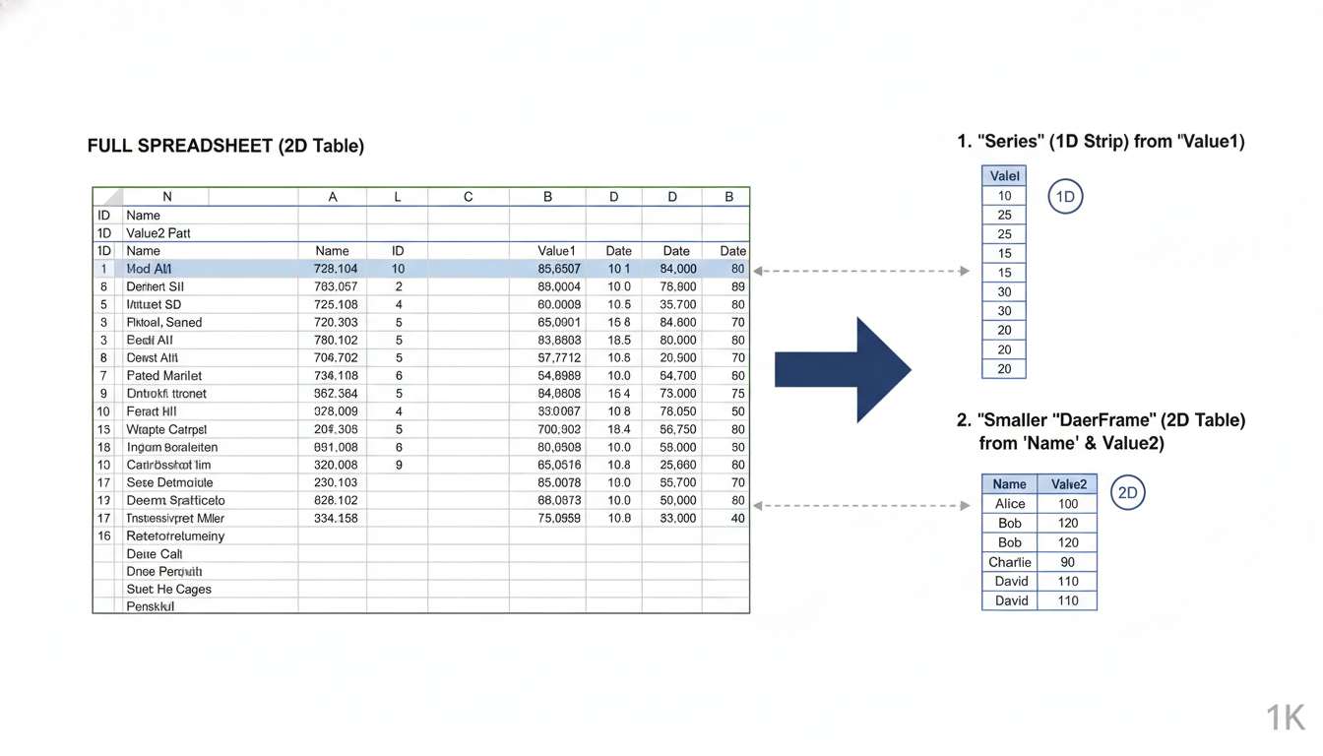

A visual comparison showing a full spreadsheet on the left. An arrow points to the right showing two distinct outputs: 1. A single column extracted as a 'Series' (1D strip). 2. Two columns extracted as a smaller 'DataFrame' (2D table).

---

### **Slicing Rows: loc and iloc**

While selecting columns is straightforward (by name), selecting rows is slightly more nuanced. In Excel, you refer to rows by their number (Row 5, Row 10). In Pandas, we have two ways to access rows: by their **Label** or by their **Integer Position**.

This distinction is handled by two indexers: .loc and .iloc.

#### **1. iloc (Integer Location) Think of iloc as the "Excel Row Number" method. It relies strictly on the order of the data, regardless of what the row is actually named. It is 0-indexed (counting starts at 0).**

python

# Select the first row (Index 0)

first_transaction = df.iloc[0]

# Select the first three rows (Index 0 up to, but not including, 3)

first_batch = df.iloc[0:3]

#### **2. loc (Label Location) loc is used when you want to select data based on the Index Label. By default, a DataFrame has a numeric index (0, 1, 2...), so loc and iloc might look similar. However, in business data, we often set a meaningful ID as the index, such as a TransactionID or Date.**

Let's set TransactionID as our index to see the difference.

python

# Set TransactionID as the index

df_indexed = df.set_index('TransactionID')

# Use loc to find the row labeled '104'

initech_sale = df_indexed.loc[104]

print(initech_sale)

**Output:**

text

Customer Initech

Region North

Sales 55000

Status Closed

Name: 104, dtype: object

If we had tried to use df_indexed.iloc[104], Python would throw an error because there is no 105th row (positionally) in our small dataset.

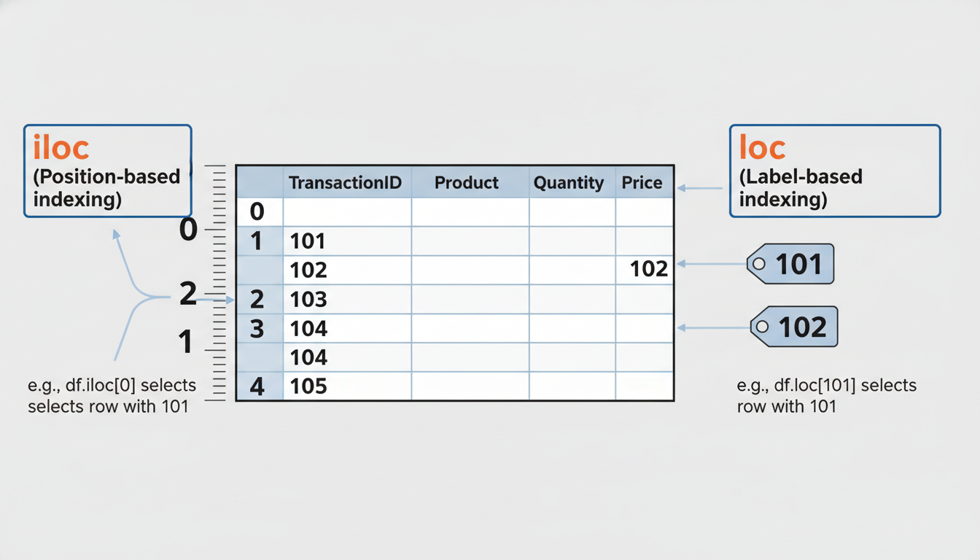

A diagram explaining `.iloc` vs `.loc`. The visual shows a DataFrame with a 'TransactionID' index (101, 102, 103...). On the left side, a ruler measures 'Position' (0, 1, 2) labeled "iloc". On the right side, tags point to the specific IDs (101, 102) labeled "loc".

---

### **Boolean Indexing: Filtering with "Business Logic"**

Selecting rows by ID is useful for lookups, but the real power of Data Science lies in **Filtering**. This is the equivalent of asking: *"Show me all rows WHERE Sales > 20,000."*

In Pandas, this is called **Boolean Indexing**. It works in a three-step logic process, though we usually write it in one line.

#### **Step 1: The Condition First, Pandas asks a question of every row in the column.**

python

# The Question: Is Sales greater than 20,000?

mask = df['Sales'] > 20000

print(mask)

**Output:**

text

0 False

1 True

2 False

3 True

4 True

Name: Sales, dtype: bool

Pandas returns a Series of True and False values. This is often called a **Boolean Mask**.

#### **Step 2: Applying the Mask We now overlay this "Truth Mask" onto our DataFrame. Pandas will keep the rows where the mask is True and discard the rows where it is False.**

python

# Apply the mask to the dataframe

high_value_sales = df[mask]

# OR, typically written in a single line:

high_value_sales = df[df['Sales'] > 20000]

print(high_value_sales)

**Output:**

text

TransactionID Customer Region Sales Status

1 102 Globex South 45000 Pending

3 104 Initech North 55000 Closed

4 105 Umbrella Corp West 21000 Pending

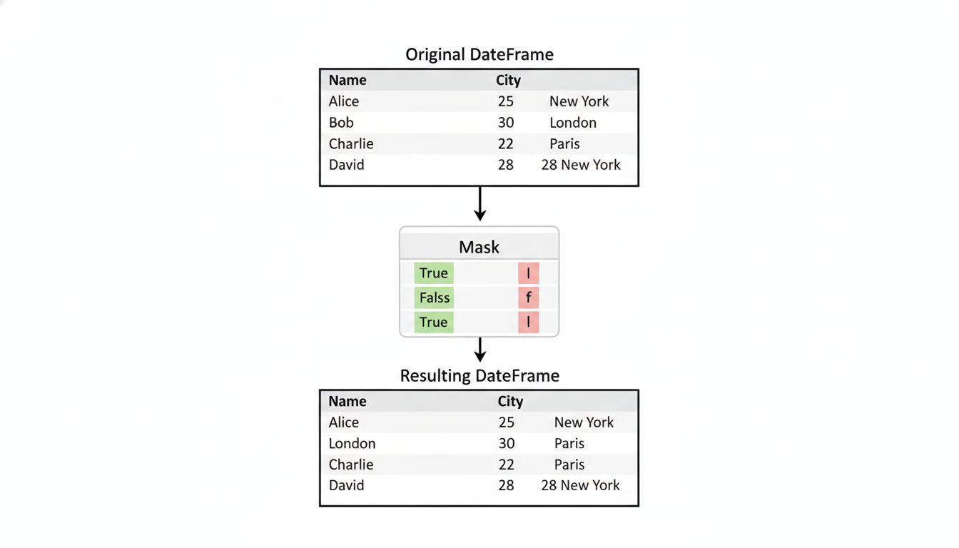

A flowchart illustrating Boolean Indexing. Top layer: Original DataFrame. Middle layer: A semi-transparent "Mask" showing True/False values corresponding to rows. Bottom layer: The Resulting DataFrame, containing only the rows that aligned with "True".

---

### **Combining Multiple Conditions (AND / OR)**

Real-world business questions are rarely simple. You might need to filter for sales that are high value **AND** closed.

In Excel, you might nest an AND() function. In Python, we use bitwise operators: *`&` for AND (Both conditions must be true)* **`|`** for OR (At least one condition must be true)

**Crucial Syntax Rule:** When combining conditions in Pandas, you **must** wrap each condition in parentheses ().

python

# Goal: Find Closed deals with Sales over 10,000

# Incorrect: df[df['Status'] == 'Closed' & df['Sales'] > 10000] -> ERROR

# Correct: Parentheses around each logic check

closed_high_value = df[(df['Status'] == 'Closed') & (df['Sales'] > 10000)]

print(closed_high_value)

**Output:**

text

TransactionID Customer Region Sales Status

0 101 Acme Corp North 12000 Closed

3 104 Initech North 55000 Closed

### **Summary: The "Data Science" Way vs. The "Spreadsheet" Way**

You have now moved from clicking arrows to writing logic. While it may feel like more typing initially, consider the scalability:

1. **Auditability:** In Excel, it is hard to see *what* is currently filtered just by looking at the grid. In Python, the code df[df['Sales'] > 20000] explicitly states your criteria. 2. **Reusability:** You can copy this code snippet and apply it to next month's sales file without clicking a single button. 3. **Complexity:** You can chain complex logic (e.g., "Sales > 50k OR (Sales > 20k AND Region is North)") that would be a nightmare to manage in standard spreadsheet filters.

In the next section, we will look at how to modify this data once we have selected it, cleaning up messy inputs and creating new calculated columns.

### **Aggregating Metrics: GroupBy and Pivot Tables for Reporting**

If filtering, which we covered in the previous section, is about finding specific needles in a haystack, **aggregation** is about weighing the haystacks, measuring their volume, and comparing them against one another.

In the business world, raw transactional data is rarely the final deliverable. Your stakeholders don’t want to see a list of 50,000 individual coffee sales; they want to know the *Total Revenue* by *Region*, or the *Average Transaction Value* by *Store Manager*.

In Excel, you solve this with the absolute workhorse of business analytics: the **Pivot Table**. It is likely the tool you use most often to summarize data. In Pandas, we achieve this same result—often with more power and flexibility—using the groupby method and pivot_table functions.

### **The "Split-Apply-Combine" Strategy**

Before writing code, it is helpful to visualize what happens mechanically when you summarize data. The creators of Pandas built these tools around a philosophy called **Split-Apply-Combine**.

1. **Split:** You break the data into smaller groups based on certain criteria (e.g., separating rows by "Region"). 2. **Apply:** You apply a function to each independent group (e.g., Summing the "Sales" column or Counting the "Order IDs"). 3. **Combine:** You stitch the results back together into a new, clean table.

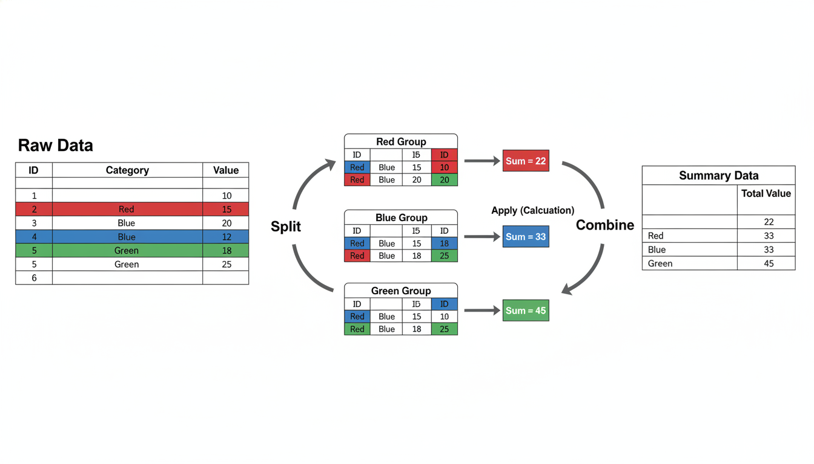

A diagram illustrating the Split-Apply-Combine process. On the left, a colorful table representing raw data. In the middle, the table is split into three smaller tables separated by color (Red group, Blue group, Green group). An arrow points to calculation boxes (Sum) for each group. On the right, a final summary table combining the results of those sums.

In Excel, this happens instantly when you drag a field into the "Rows" box of a Pivot Table. In Python, we explicitly tell Pandas to perform these steps.

### **The groupby Method**

The groupby method is the primary way to achieve the "Split" step. Let’s imagine a simple dataset representing software sales.

python

import pandas as pd

# Creating a sample dataset

data = {

'Sales_Rep': ['Sarah', 'Mike', 'Sarah', 'Mike', 'Sarah', 'Jessica'],

'Region': ['East', 'West', 'East', 'West', 'North', 'North'],

'Product': ['Software', 'Software', 'Consulting', 'Hardware', 'Software', 'Hardware'],

'Revenue': [5000, 4000, 2000, 6000, 5000, 7000]

}

df = pd.DataFrame(data)

print(df)

If we want to calculate the total revenue generated by each Sales Representative, we chain the operations together:

python

# Group by 'Sales_Rep' and sum the 'Revenue'

rep_performance = df.groupby('Sales_Rep')['Revenue'].sum()

print(rep_performance)

**Output:**

text

Sales_Rep

Jessica 7000

Mike 10000

Sarah 12000

Name: Revenue, dtype: int64

Notice the syntax structure: 1. df.groupby('Sales_Rep'): This splits the data. 2. ['Revenue']: This selects the specific column we want to do math on. 3. .sum(): This is the function we apply.

You are not limited to summing data. You can use .mean() (average), .count() (frequency), .min(), .max(), or .std() (standard deviation).

### **Grouping by Multiple Columns**

In Excel, you often drag multiple fields into the "Rows" area of a Pivot Table to create a hierarchy (e.g., Region first, then Sales Rep). In Pandas, you simply pass a **list** of column names to the groupby method.

python

# Total Revenue by Region AND Product type

regional_mix = df.groupby(['Region', 'Product'])['Revenue'].sum()

print(regional_mix)

**Output:**

text

Region Product

East Consulting 2000

Software 5000

North Hardware 7000

Software 5000

West Hardware 6000

Software 4000

Name: Revenue, dtype: int64

### **Advanced Aggregation: The .agg() Method**

Sometimes, a manager asks for a complex report: *"I need the Total Revenue per region, but I also need to know the Average Sale Price and the Number of Transactions."*

In Excel, you would drag the "Revenue" field into the "Values" box three times and change the field settings for each. In Pandas, we use the .agg() (aggregation) method to apply multiple functions at once.

python

summary_stats = df.groupby('Region')['Revenue'].agg(['sum', 'mean', 'count'])

print(summary_stats)

**Output:**

text

sum mean count

Region

East 7000 3500.0 2

North 12000 6000.0 2

West 10000 5000.0 2

This creates a professional summary table in a single line of code.

### **Creating Matrix Views with pivot_table**

While groupby is powerful, the output often looks like a long list. Sometimes, for reporting, you need a matrix layout—where one variable is on the rows and another is on the columns. This is the classic "Pivot Table" look.

Pandas has a specific function for this: pivot_table. It closely mimics the parameters you interact with in Excel's Pivot Table menu.

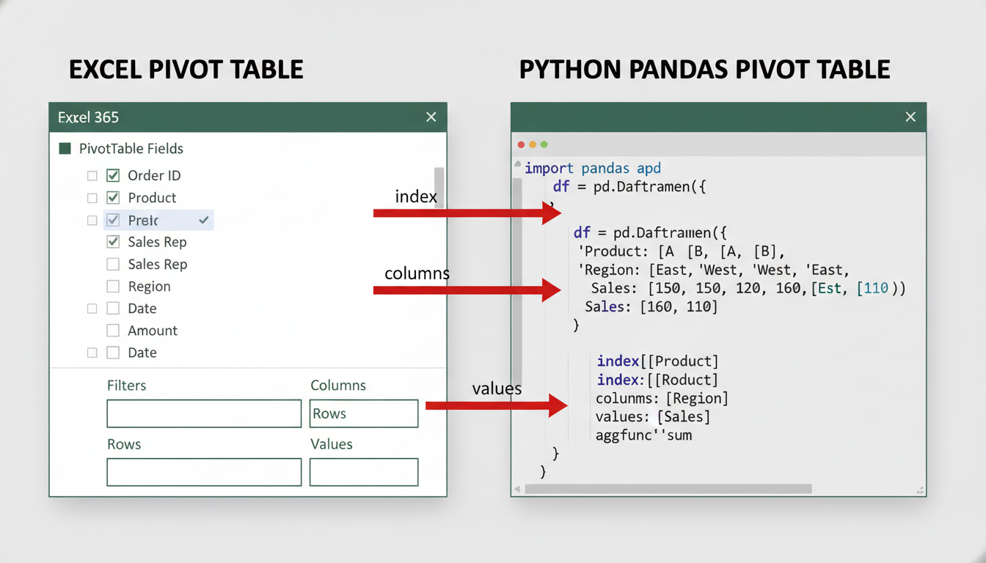

A split screenshot. On the left, the Excel Pivot Table Field List sidebar with arrows pointing to "Rows", "Columns", and "Values". On the right, a Python code snippet of `pd.pivot_table` with arrows mapping the arguments `index=`, `columns=`, and `values=` to the corresponding Excel areas.

Let’s look at the parameters: *Values: What creates the numbers inside the table? (Excel: Values area)* **Index:** What defines the rows? (Excel: Rows area) *Columns: What defines the headers? (Excel: Columns area)* **Aggfunc:** How do we calculate the math? (defaults to mean, but we usually want sum)

python

matrix_report = pd.pivot_table(

df,

values='Revenue',

index='Region',

columns='Product',

aggfunc='sum',

fill_value=0 # Replace NaN (missing values) with 0

)

print(matrix_report)

**Output:**

text

Product Consulting Hardware Software

Region

East 2000 0 5000

North 0 7000 5000

West 0 6000 4000

By setting fill_value=0, we handled a common issue: The "East" region had no "Hardware" sales. Without this argument, Pandas would display NaN (Not a Number). Setting it to 0 makes the report clean and ready for presentation.

### **The "Reset Index" Trick**

A common frustration for career switchers occurs immediately after using groupby. When you group data, the columns you grouped by (e.g., 'Region') become the **Index** of the DataFrame, not standard columns. This makes them harder to manipulate if you want to export the data or perform further plotting.

To fix this, we use .reset_index(). This pushes the index back into the DataFrame as a standard column. Think of it as "flattening" the Pivot Table back into a regular list.

python

# Without reset_index (Region is the index)

grouped = df.groupby('Region')['Revenue'].sum()

# With reset_index (Region becomes a normal column again)

flat_data = grouped.reset_index()

print(flat_data)

**Output:**

text

Region Revenue

0 East 7000

1 North 12000

2 West 10000

By mastering groupby and pivot_table, you no longer need to rely on fragile Excel files where one accidental keystroke inside a Pivot calculation can ruin a monthly report. You now have reproducible, auditable code that can generate complex metrics from millions of rows in seconds.

## **Chapter 4Data Cleaning and Preparation**

### **Handling Missing Data: Imputation vs. Deletion Strategies**

Data in the real world is rarely pristine. In our previous sections, we ingested CSVs and performed aggregations assuming that every row contained perfect, complete information. We assumed every customer had an age, every transaction had a dollar amount, and every product had a category.

In reality, you will encounter datasets that look like Swiss cheese. A survey respondent skipped a question; a sensor went offline for an hour; a legacy database export corrupted a specific text field.

In Excel, a blank cell is visually obvious. You might manually scan the sheet, filter for "Blanks," or use an IF(ISBLANK(), ...) formula. In Pandas, missing data is represented as NaN (Not a Number) or None. If you attempt to calculate the sum or average of a column containing NaN values without handling them, your analysis may either crash or, worse, silently produce skewed results.

This section focuses on the two primary strategies for handling these gaps: **Deletion** (removing the data) and **Imputation** (guessing the data).

### **Identifying the Gaps**

Before you fix the problem, you must quantify it. You cannot simply "look" at a DataFrame with 50,000 rows to find blank cells.

Let's imagine a DataFrame named crm_data containing customer leads.

python

import pandas as pd

import numpy as np

# Sample data with intentional gaps

data = {

'Company': ['Acme Corp', 'Globex', 'Soylent Corp', 'Initech', 'Umbrella Corp'],

'Revenue': [1000000, np.nan, 500000, 75000, np.nan],

'Employee_Count': [50, 1200, np.nan, 10, 500],

'Sector': ['Tech', 'Logistics', 'Food', 'Tech', np.nan]

}

crm_data = pd.DataFrame(data)

If you print this DataFrame, you will see NaN where data is missing. To get a high-level summary of your "data hygiene," use the .info() method or chain .isnull().sum().

python

# Check for missing values per column

print(crm_data.isnull().sum())

**Output:**

text

Company 0

Revenue 2

Employee_Count 1

Sector 1

dtype: int64

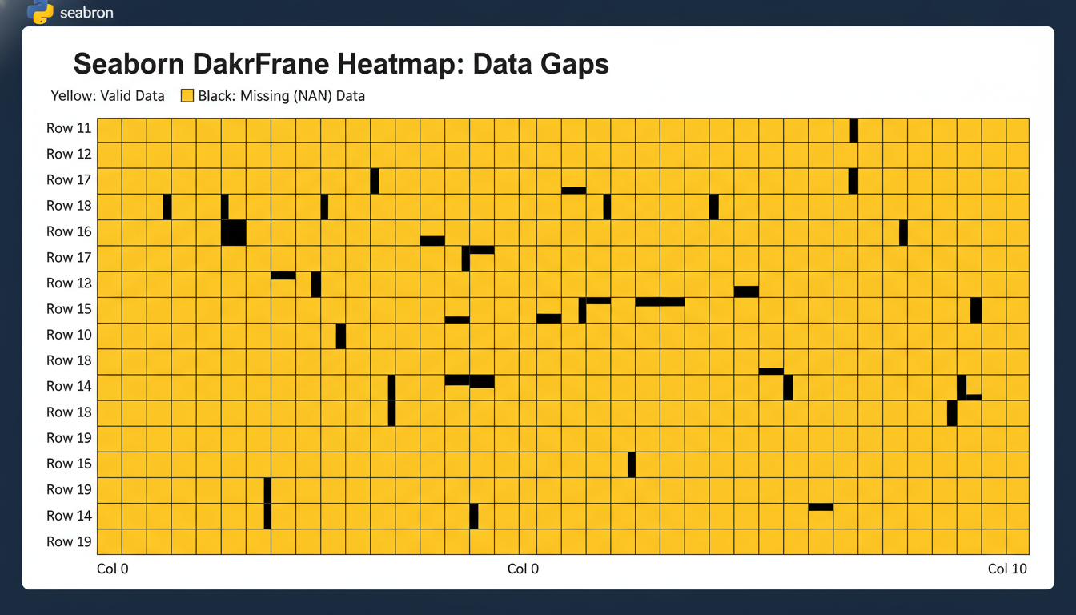

A visual representation of a DataFrame heatmap using the 'seaborn' library. The heatmap shows yellow bars representing valid data and black gaps representing missing (NaN) values, illustrating how data gaps can be distributed randomly across rows and columns.

Once you know where the holes are, you have to make a business decision: do you cut the rot out, or do you try to repair it?

### **Strategy 1: Deletion (The "Nuclear" Option)**

Deletion is the simplest approach. If a row is incomplete, you remove it. In statistical terms, this is "Listwise Deletion."

In Pandas, we use the .dropna() method.

#### **Dropping Rows If you are analyzing "Revenue per Company," a row with no Revenue data is useless to you.**

python

# Drop any row that contains at least one missing value

clean_rows = crm_data.dropna()

However, be careful. If you have a dataset with 10 columns, and a row is missing data in *only one* unimportant column (e.g., "Fax Number"), dropna() will delete the entire customer record. You might lose valuable data in the "Revenue" column just because the "Fax Number" was missing.

To refine this, you can use the subset parameter:

python

# Only drop rows where 'Revenue' is missing.

# Keep the row even if 'Sector' is missing.

valid_revenue_data = crm_data.dropna(subset=['Revenue'])

#### **Dropping Columns Sometimes, the problem isn't the observation (row); it's the feature (column). If you ingest a dataset where the "Second Phone Number" column is 95% blank, imputing it is impossible, and deleting the rows would leave you with no data. The solution is to drop the column entirely.**

python

# Drop columns (axis=1) that have any missing values

# Note: In practice, you usually drop specific columns by name using .drop()

crm_data_trimmed = crm_data.dropna(axis=1)

**The Trade-off:** Deletion ensures that the data you *do* analyze is real and observed. However, it reduces your sample size (statistical power) and can introduce bias if the data is not "missing at random" (e.g., if only unhappy customers skip the "Satisfaction Score" question, deleting those rows makes your customers look happier than they are).

### **Strategy 2: Imputation (Filling in the Blanks)**

Imputation involves replacing missing data with a substitute value based on other available information. In Pandas, we use the .fillna() method.

#### **Constant Imputation This is common for categorical data or specific business logic. If a customer has no "Assigned Sales Rep," you might fill that blank with "Unassigned." If a "Discount Code" field is empty, you might assume the discount is 0.**

python

# Fill missing Sector values with 'Unknown'

crm_data['Sector'] = crm_data['Sector'].fillna('Unknown')

# Fill missing Revenue with 0 (Use with caution!)

crm_data['Revenue'] = crm_data['Revenue'].fillna(0)

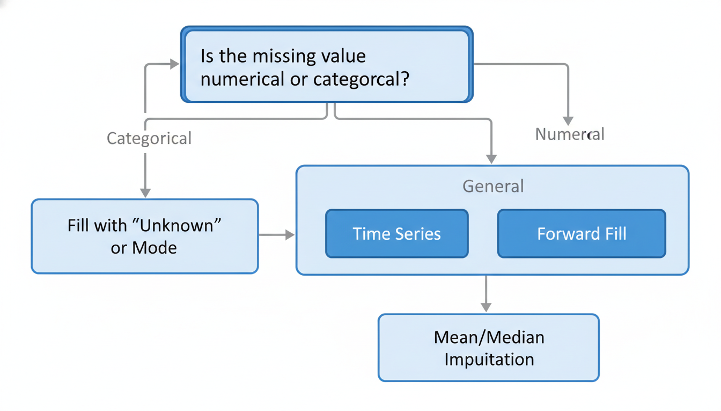

A flowchart decision tree. The top box asks "Is the missing value numerical or categorical?". The Categorical path leads to "Fill with 'Unknown' or Mode". The Numerical path splits into "Time Series" (Forward Fill) and "General" (Mean/Median Imputation).

#### **Statistical Imputation (Mean vs. Median) For numerical data, filling with 0 is often dangerous. If you are analyzing the average height of adults, filling missing values with 0 will drastically drag down your average.**

Instead, we usually fill the gap with the **Mean** (average) or **Median** (middle value) of that column.

* **Mean Imputation:** Best for normally distributed data (bell curve).
* **Median Imputation:** Best for data with outliers (skewed data).

Consider our Employee_Count. If most companies have 50 employees, but one has 50,000, the *average* will be artificially high. The *median* is safer for things like salaries, house prices, or company sizes.

python

# Calculate the median of existing values

median_employees = crm_data['Employee_Count'].median()

# Fill the missing values with that calculated median

crm_data['Employee_Count'] = crm_data['Employee_Count'].fillna(median_employees)

#### **Context-Aware Imputation (Grouping) This is the "Pro" move. In Excel, you might fill a missing value with the overall average. In Python, you can be more specific.**

Imagine a missing "Salary" field. Instead of filling it with the average salary of *everyone*, you can fill it with the average salary *of people with the same Job Title*.

python

# Concept example: Fill missing salary with the average salary of that specific job title

df['Salary'] = df.groupby('Job_Title')['Salary'].transform(

lambda x: x.fillna(x.mean())

)

This creates a much more accurate guess than a blanket average.

### **Special Case: Time Series Data If you are analyzing stock prices or daily temperature, the "average" is not a good guess for a missing day. If you are missing data for Tuesday, the best guess is usually whatever happened on Monday.**

This is called **Forward Fill** (ffill).

python

# If data is missing, take the value from the previous row

stock_data['Price'] = stock_data['Price'].fillna(method='ffill')

### **Summary: Which Strategy to Use?**

| Scenario | Strategy | Pandas Method | | :--- | :--- | :--- | | **Rows with crucial missing data** | Deletion | df.dropna(subset=['Column']) | | **Columns with > 50% missing data** | Deletion | df.drop(columns=['Column']) | | **Categorical data (e.g., Region)** | Constant Imputation | df.fillna('Unknown') | | **Numerical data (Normal distribution)** | Mean Imputation | df.fillna(df.mean()) | | **Numerical data (With outliers)** | Median Imputation | df.fillna(df.median()) | | **Time Series / Sequential data** | Forward Fill | df.fillna(method='ffill') |

Handling missing data is more art than science. It requires understanding *why* the data is missing. Always document your decision. If you choose to fill missing revenue with the median, state that clearly in your final report, as it fundamentally changes the nature of the dataset.

### **Data Type Conversion and Formatting Consistency**

In Excel, data types are often a suggestion rather than a rule. You can type a date into cell A1, a currency figure into A2, and a text comment into A3, and Excel won’t complain. It applies formatting dynamically, often guessing what you intend. If you type "100" and "200" as text, Excel might still helpfully sum them up to "300" if you use a formula.

In Python, however, **types are strict**.

A common frustration for professionals moving to Data Science occurs during their first aggregation attempt. You load a sales dataset, group by region, and try to sum the *Revenue* column. Instead of a dollar amount, you get an error, or worse, a concatenation of strings like 10002000500.

This happens because Pandas is treating your numbers as text. This section covers how to audit, force, and fix data types to ensure your analysis rests on a solid mathematical foundation.

### **The "Object" Trap**

When Pandas loads a CSV file, it scans the data to determine what type belongs in each column. If a column contains integers, it assigns an int64 type. If it sees decimals, it assigns float64.

However, if a column contains a mix of numbers and strings—or if your numbers contain non-numeric characters like currency symbols ($), commas (,), or percentage signs (%)—Pandas defaults to the safest, most flexible type available: **object**.

In the Pandas world, object is synonymous with "string" or "mixed data."

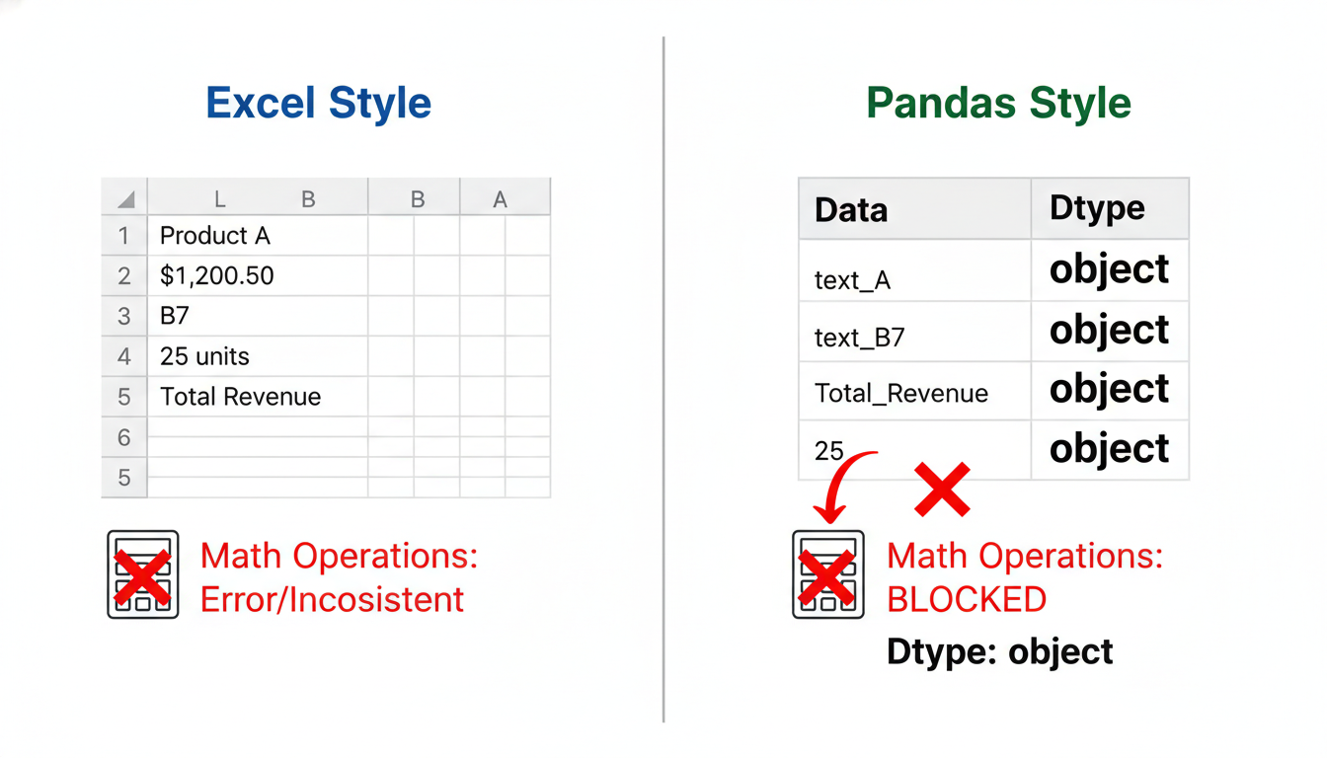

A visual comparison between two columns. Left Column: "Excel Style" showing mixed content (numbers with dollar signs, text). Right Column: "Pandas Style" showing the underlying data type storage. The Excel column looks nice but is messy; the Pandas column is labeled 'Dtype: Object' and highlights that mathematical operations are blocked.

Before doing any analysis, you must check your types using the .info() or .dtypes attribute.

python

import pandas as pd

# A sample dataset representing common "dirty" business data

data = {

'Customer_ID': [101, 102, 103, 104],

'Join_Date': ['2023-01-15', '2023/02/10', 'Mar 1, 2023', '2023-04-20'],

'Sales_Amount': ['$1,000.00', '$2,500.50', 'Pending', '$450.00'],

'Department': ['Sales ', 'sales', 'Marketing', ' Sales']

}

df = pd.DataFrame(data)

print(df.dtypes)

**Output:**

text

Customer_ID int64

Join_Date object

Sales_Amount object

Department object

dtype: object

Notice that Sales_Amount is an object. You cannot sum this column yet.

### **Converting Numbers: Stripping and Forcing**

To convert Sales_Amount to a number, you cannot simply command Python to "make it a number." Python doesn't know what to do with the $ or the ,. You must first clean the strings, then convert the type.

We use the .astype() method for clean conversions and pd.to_numeric() for messier situations.

#### **Step 1: String Manipulation We access string methods in Pandas using the .str accessor. Here, we replace symbols with nothing (empty strings).**

python

# Remove '$' and ',' from the column

df['Sales_Amount_Clean'] = df['Sales_Amount'].str.replace('$', '', regex=False).str.replace(',', '', regex=False)

#### **Step 2: Handling Non-Numeric Values Even after removing symbols, our dataset contains the word "Pending". If we try to convert "Pending" to a number, Python will crash.**

We use pd.to_numeric with the errors='coerce' argument. This argument tells Pandas: "If you find something that isn't a number, don't crash; just turn it into NaN (Not a Number)."

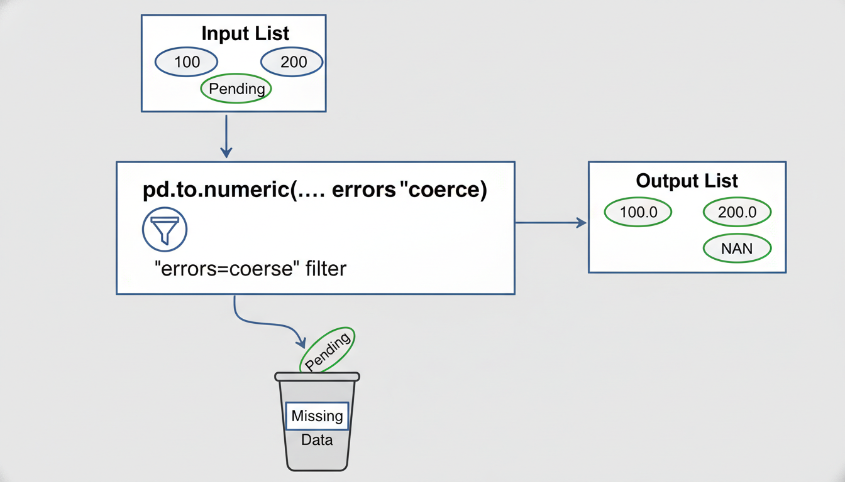

A flowchart illustrating the 'pd.to_numeric' logic. Input: A list ["100", "200", "Pending"]. Processing: 'errors=coerce' acts as a filter. Output: The list becomes [100.0, 200.0, NaN], with "Pending" dropping into a waste bin labeled 'Missing Data'.

python

# Convert to numeric, turning "Pending" into NaN

df['Sales_Amount_Clean'] = pd.to_numeric(df['Sales_Amount_Clean'], errors='coerce')

print(df[['Sales_Amount', 'Sales_Amount_Clean']])

print(df.dtypes)

Now, Sales_Amount_Clean is a float64. You can calculate the mean, sum, or standard deviation.

### **The Datetime Standard**

In Excel, dates are actually serial numbers formatted to look like dates. In Pandas, we convert date-like strings into **Timestamp** objects. This allows us to easily extract the year, month, or day, and perform time-series logic (e.g., "subtract 30 days from today").

In our sample data, Join_Date has mixed formats (2023-01-15 vs Mar 1, 2023). Pandas is surprisingly intelligent at parsing these using pd.to_datetime.

python

# Convert the Join_Date column to datetime objects

df['Join_Date'] = pd.to_datetime(df['Join_Date'])

# Now we can extract features easily

df['Month'] = df['Join_Date'].dt.month_name()

print(df[['Join_Date', 'Month']])

*Note: If your dates are in a very specific non-standard format (like `15012023` for Jan 15, 2023), you may need to provide a format string, similar to Excel custom formatting, using the `format` argument.*

### **String Consistency: The Silent Grouping Killer**

One of the most insidious issues in data cleaning is string inconsistency. To a human, "Sales", "sales", and " Sales " (with a leading space) are the same department. To a computer, they are three distinct categories.

If you run a groupby on the Department column in our sample data without cleaning it, you will get three separate rows for Sales.

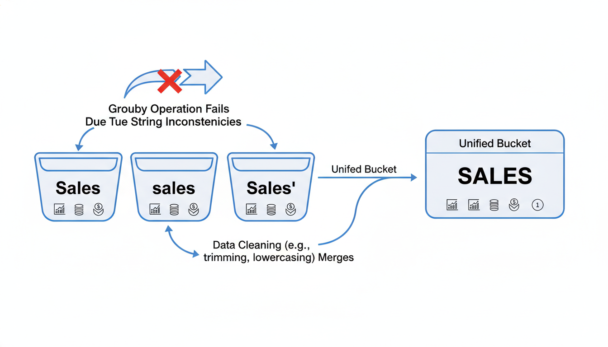

A diagram showing a GroupBy operation failing due to string inconsistencies. Three buckets labeled "Sales", "sales", and " Sales " collect data separately. An arrow points to a "Unified Bucket" labeled "sales" showing how cleaning merges them.

To fix this, we standardize casing and remove whitespace.

python

# 1. Make everything lowercase

# 2. Strip whitespace from the start and end

df['Department'] = df['Department'].str.lower().str.strip()

# Now verify the unique values

print(df['Department'].value_counts())

**Output:**

text

sales 3

marketing 1

Name: Department, dtype: int64

By chaining .str.lower() and .str.strip(), we have collapsed three fragmented categories into a single, authoritative "sales" group.

### **Summary of Type Conversion**

As you prepare your data for analysis, your checklist for consistency should look like this:

1. **Check `dtypes` immediately:** Don't assume numbers are numbers. 2. **Clean then Convert:** Remove currency symbols and commas before converting to numeric. 3. **Coerce Errors:** Use pd.to_numeric(..., errors='coerce') to handle messy data points without stopping your script. 4. **Standardize Strings:** Always strip whitespace and unify capitalization on categorical text columns before aggregating.

With your data types strictly defined and formatted, your DataFrames are no longer just fragile tables—they are structured datasets ready for heavy analysis.

### **String Manipulation: Cleaning Textual Categories and Names**

In the previous section, we tackled the strict nature of Python data types. We ensured that our sales figures are recognized as floats and our transaction dates are actually timestamps, not strings of text.

However, simply having a column typed as object (text) does not mean the data inside it is ready for analysis. In fact, text data is notoriously messy. Human entry introduces typos, capitalization inconsistencies, and invisible whitespace.

Consider a scenario where you want to group sales by the "Department" column. In Excel, you might see a Dropdown list containing: *`Marketing`* marketing *`Marketing ` (note the trailing space)* Mktg

To a human, these refer to the same department. To a computer (and to Python), these are four completely unique values. If you run a groupby aggregation on this column, you won't get one total for Marketing; you will get four fragmented totals.

In Excel, you would fix this using a combination of TRIM(), PROPER(), and "Find & Replace." In Pandas, we handle this through the vectorized string accessor: .str.

### **The .str Accessor: Your Text Toolkit**

When working with a single string in standard Python, you can use methods like "text".upper(). However, a Pandas Series (a column) is not a string; it is a container of strings.

If you try to run df['Department'].upper(), Python will throw an error because the *list itself* doesn't have an upper method. You need to tell Pandas to look *inside* the container and apply the logic to every row. We do this by accessing the .str library attached to the series.

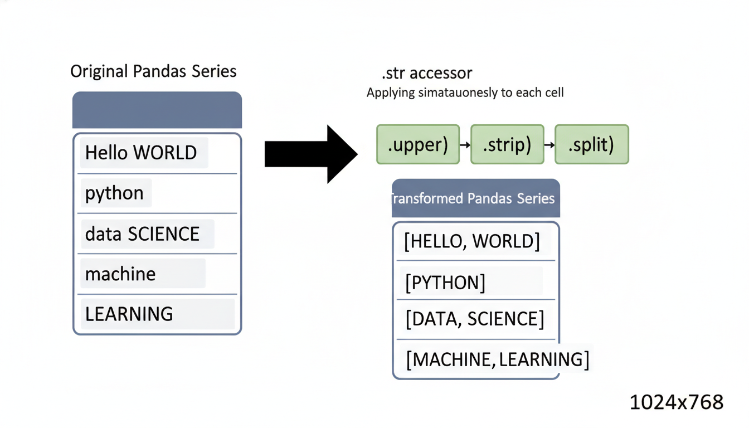

A diagram showing a Pandas Series column on the left with mixed casing and whitespace. An arrow labeled ".str accessor" points to the right, showing the methods .upper(), .strip(), and .split() being applied to each individual cell simultaneously.

### **Standardization: Case and Whitespace**

The two most common reasons for "duplicate" categories are inconsistent capitalization and invisible whitespace (spaces at the beginning or end of a cell).

Let's look at a sample dataset of client names:

python

import pandas as pd

data = {

'Client_Name': ['Acme Corp', 'acme corp', 'Acme Corp ', 'Globex', 'GLOBEX '],

'Contract_ID': [101, 102, 103, 104, 105]

}

df = pd.read_csv('clients.csv') # Assuming we loaded this data

If we count the unique values here, Python sees five distinct clients. To fix this, we standardize the text.

#### **Changing Case Just like Excel's =UPPER(), =LOWER(), and =PROPER() functions, Pandas offers: *`.str.lower()`: Converts to lowercase.* .str.upper(): Converts to uppercase. * .str.title(): Capitalizes the first letter of each word.**

#### **Removing Whitespace The "invisible enemy" in data science is the trailing space. It often occurs when data is exported from legacy SQL databases that pad text fields to a fixed length. In Excel, you use =TRIM(). In Pandas, you use .str.strip().**

Here is how we clean the client names in one sweep:

python

# Step 1: Remove whitespace from both ends

df['Client_Name'] = df['Client_Name'].str.strip()

# Step 2: Convert to title case (e.g., "Acme Corp")

df['Client_Name'] = df['Client_Name'].str.title()

# Result: Only two unique clients remain ('Acme Corp' and 'Globex')

### **Replacing Substrings and Cleaning Logic**

Sometimes standardization isn't enough. You may need to fix typos, remove specific characters (like currency symbols), or map abbreviations to full names.

In Excel, you might use SUBSTITUTE() or the "Find and Replace" dialog box. In Pandas, we use .str.replace().

Imagine a "Revenue" column that was imported as text because it included the "$" sign and commas (e.g., "$1,200.50"). To convert this to a number, we must first remove the non-numeric characters.

python

# Remove '$' and ',' from the string

# Note: regex=False tells Python to treat the search strictly as text, not a pattern

df['Revenue_Clean'] = df['Revenue'].str.replace('$', '', regex=False).str.replace(',', '', regex=False)

# Now we can convert the type

df['Revenue_Clean'] = df['Revenue_Clean'].astype(float)

You can also use replace to fix categorical inconsistencies, such as changing "Mktg" to "Marketing":

python

df['Department'] = df['Department'].str.replace('Mktg', 'Marketing')

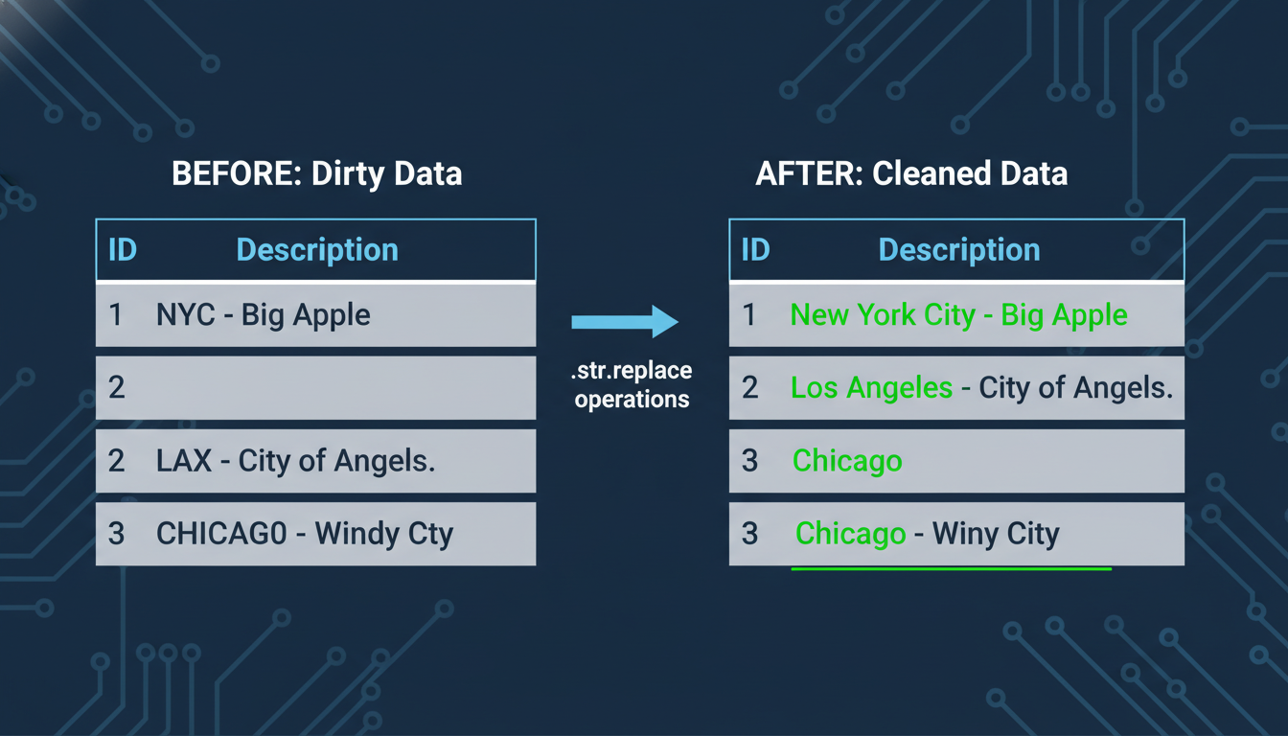

A "Before and After" table visualization. The left side shows a dirty dataset with symbols, abbreviations, and inconsistent casing. The right side shows the clean dataset after .str.replace operations, highlighting the specific changes in a contrasting color.

### **Splitting Text: The "Text-to-Columns" Equivalent**

One of the most beloved features in Excel is the **Text-to-Columns** wizard, which allows you to split a "Full Name" column into "First Name" and "Last Name" based on a delimiter (like a comma or space).

In Pandas, we achieve this with .str.split().

Consider a column Location formatted as "City, State" (e.g., "Austin, TX").

python

# This creates a list inside the cell: ['Austin', 'TX']

df['Location'].str.split(',')

However, we usually want these in separate columns, not a list. We use the expand=True argument to separate the results into a new DataFrame structure.

python

# Split into two new columns

df[['City', 'State']] = df['Location'].str.split(',', expand=True)

# Clean up the whitespace that might be left after the comma in ' State'

df['State'] = df['State'].str.strip()

### **String Slicing**

Sometimes you don't need to split by a delimiter; you need to extract a specific number of characters. In Excel, you use =LEFT(cell, 2) or =RIGHT(cell, 4).

In Pandas, because the .str accessor treats the column like a Python string, you can use **slicing** directly.

* **Excel:** =LEFT(A1, 3)
* **Pandas:** df['col'].str[:3]
* **Excel:** =RIGHT(A1, 2)
* **Pandas:** df['col'].str[-2:]

### **Summary Checklist**

When preparing textual data for aggregation or analysis, run through this mental checklist:

1. **Check for Case:** Do "Apple" and "apple" exist? Use .str.title() or .str.lower(). 2. **Check for Whitespace:** Are there phantom spaces? Always run .str.strip(). 3. **Check for Artifacts:** Are there symbols ($%#) preventing math? Use .str.replace(). 4. **Check Structure:** Is useful data combined? Use .str.split(expand=True).

By mastering the .str accessor, you transform raw, messy text into structured categories, allowing the GroupBy and Pivot Table operations we discussed earlier to function accurately.

### **Detecting and Managing Outliers in Financial and Operational Data**

In the previous section, we discussed how to standardize text data, ensuring that "New York," "new york," and "NY" are treated as the same entity. We cleaned up the *labels* of our data. Now, we must look at the *values* themselves—specifically, the values that look suspicious.

In business analytics, there is a famous joke: "Bill Gates walks into a bar. Suddenly, on average, everyone in the bar is a billionaire."

This highlights the danger of **outliers**. In financial and operational data, an outlier is a data point that differs significantly from other observations. Sometimes, these are errors (e.g., a cashier entered $1,000,000 instead of $100). Other times, they are legitimate but extreme events (e.g., a "whale" customer placing a massive order).

In Excel, you might spot these by sorting a column from Largest to Smallest and seeing if the top number makes sense. In Python, relying on manual sorting is risky because you can’t eyeball a million rows. Instead, we use statistical rules and visualization to detect these anomalies systematically.

### **The Danger of the Mean**

Before we write code, understand *why* we do this. Outliers wreak havoc on standard aggregation metrics, particularly the **Mean (Average)**.

If you are analyzing "Time to Ship" for a logistics company, and 99 packages ship in 2 days, but one package gets lost and ships in 200 days, your average shipping time might jump to 4 days. If you report "Average shipping is 4 days" to management, you are misleading them—most customers get their packages in 2 days.

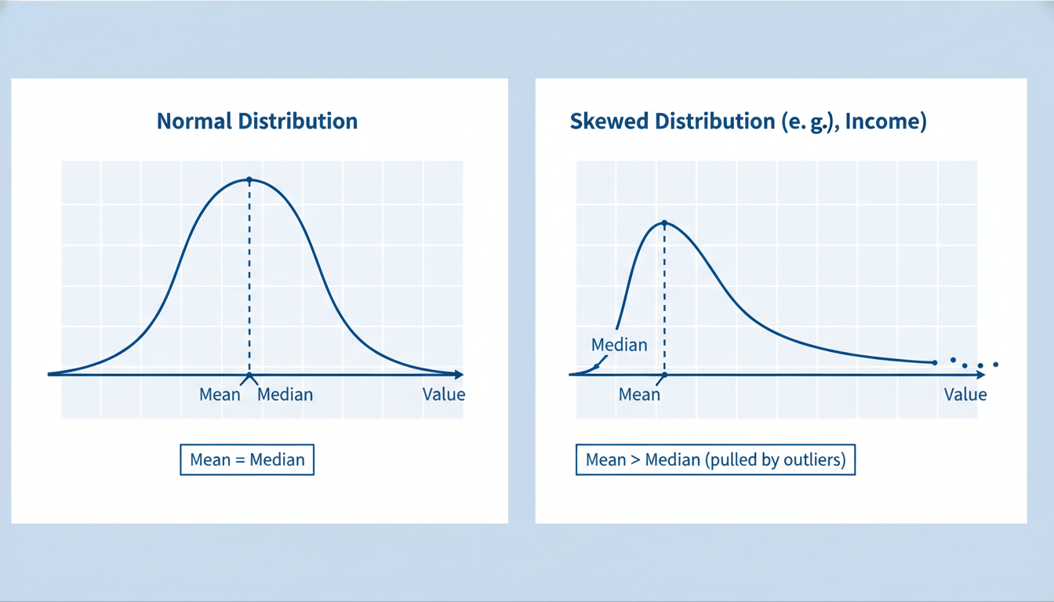

A comparison chart showing two distributions. On the left, a normal distribution where the Mean and Median are the same. On the right, a skewed distribution (like income or transaction value) where a few high outliers pull the Mean far to the right, while the Median remains representative of the majority.

### **Visual Detection: The Boxplot**

The fastest way to detect outliers in Python is not a table, but a **Boxplot**.

A boxplot (or box-and-whisker plot) provides a visual summary of the central tendency and variability of your data. It draws a box around the middle 50% of your data and extends "whiskers" to the rest. Any dots floating beyond those whiskers are statistically considered outliers.

Let's look at a dataset of invoice amounts:

python

import pandas as pd

import matplotlib.pyplot as plt

import seaborn as sns

# Sample financial data

data = {

'Invoice_ID': range(1, 11),

'Amount': [100, 110, 105, 98, 102, 95, 108, 101, 100, 5000] # Note the 5000

}

df = pd.DataFrame(data)

# Visualizing with a Boxplot

plt.figure(figsize=(8, 4))

sns.boxplot(x=df['Amount'])

plt.title('Distribution of Invoice Amounts')

plt.show()

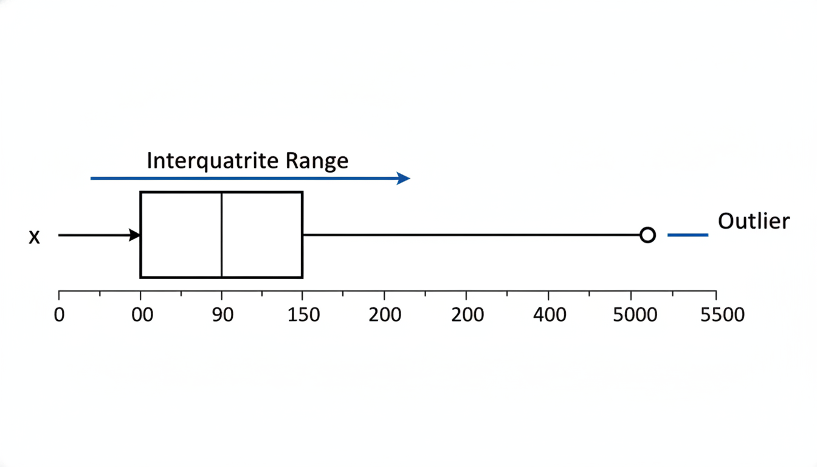

A boxplot generated from the code above. The box is squashed on the left side around the 100 mark. A single lonely dot sits far to the right at the 5000 mark. Arrows analyze the plot: identifying the "Interquartile Range" (the box) and the "Outlier" (the dot).

In the resulting plot, the "box" will be squashed near 100, and a single dot will sit far away at 5000. That dot is your anomaly.

### **Statistical Detection: The IQR Method**

Visuals are great for exploration, but you cannot automate a pipeline based on looking at pictures. You need a mathematical rule to define what counts as an "outlier."

In Data Science, the standard industry method for non-normal data (like prices or salaries) is the **Interquartile Range (IQR) Method**.

Here is the logic, which mimics how the boxplot is constructed: 1. **Q1 (25th Percentile):** The value below which 25% of the data falls. 2. **Q3 (75th Percentile):** The value below which 75% of the data falls. 3. **IQR:** The difference between Q3 and Q1 (the middle 50% of data). 4. **The Fence:** We calculate "fences" or limits. Any data point outside these fences is an outlier. *Lower Limit = $Q1 - (1.5 \times IQR)$* Upper Limit = $Q3 + (1.5 \times IQR)$

Let's apply this logic using Pandas:

python

# Calculate Q1 and Q3

Q1 = df['Amount'].quantile(0.25)

Q3 = df['Amount'].quantile(0.75)

# Calculate IQR

IQR = Q3 - Q1

# Define the bounds

lower_bound = Q1 - 1.5 * IQR

upper_bound = Q3 + 1.5 * IQR

print(f"Normal range is between ${lower_bound:.2f} and ${upper_bound:.2f}")

# Filter to find the outliers

outliers = df[(df['Amount'] < lower_bound) | (df['Amount'] > upper_bound)]

print("Detected Outliers:")

print(outliers)

If you run this code, Python will mathematically confirm that the $5,000 invoice is an outlier because it falls far above the upper_bound.

### **Managing Outliers: Delete, Keep, or Cap?**

Once you have identified the outliers using the code above, you face a business decision. Python cannot make this decision for you; it requires domain knowledge.

#### **1. Removal (Trimming) If the outlier is clearly an error (e.g., a customer age of 150, or a negative price), you should delete it.**

python

# Create a clean DataFrame without outliers

df_clean = df[(df['Amount'] >= lower_bound) & (df['Amount'] <= upper_bound)]

#### **2. Retention If the outlier is real (e.g., a massive B2B deal in a dataset of B2C sales), deleting it means lying about your total revenue. In this case, you might keep it, but analyze it separately. You might create a separate report: *"Standard Sales Trends"* (excluding outliers) and *"Key Account Activity"* (outliers only).**

#### **3. Capping (Winsorization) This is a common technique in financial modeling. Instead of deleting the data, you "cap" it at a specific threshold. If the upper bound is $\$130$, and you have a value of $\$5,000$, you replace the $\$5,000$ with $\$130$. This preserves the fact that the transaction was "high" without allowing the extreme magnitude to ruin your averages.**

python

import numpy as np

# Create a copy to avoid SettingWithCopy warnings

df_capped = df.copy()

# Cap values greater than upper_bound to the upper_bound value

df_capped['Amount'] = np.where(df_capped['Amount'] > upper_bound,

upper_bound,

df_capped['Amount'])

print(df_capped)

In this capped dataset, the $\$5,000$ entry becomes roughly $\$126$ (depending on the exact IQR calculation). Your mean is no longer skewed, but you haven't lost the record entirely.

### **Summary of Logic 1. Visual Check: Use a Boxplot to see if outliers exist. 2. Math Check: Use the IQR method to identify specific rows. 3. Business Decision: Decide if the data is *wrong* (delete it) or *exceptional* (cap it or segment it).**

[[IMAGE: Decision tree flowchart for handling outliers. Step 1: Is the value impossible? (e.g., Age -5). Yes -> Delete/Impute. No -> Step 2. Step 2: Is it a measurement error? Yes -> Delete/Resample. No -> Step 3. Step 3: Does it skew the model significantly? Yes -> Cap/Transform/Log Scale. No -> Keep as is.]]

By mastering outlier detection, you ensure that the insights you deliver to your stakeholders describe the *reality* of the business, rather than the distortions caused by a few data anomalies.

## **Chapter 5Exploratory Data Analysis and Visualization**

### **The Grammar of Graphics with Matplotlib and Seaborn**

If you have ever presented a business report, you know that a spreadsheet of numbers, no matter how well-cleaned, rarely tells a compelling story. In the previous section, we identified outliers mathematically—finding the "Bill Gates in the bar" scenario. But numbers alone can be abstract. To truly understand the shape of our data, the skew of our distributions, and the relationships between variables, we need to visualize them.

In Excel, creating a chart is a point-and-click adventure. You highlight a range of cells, click "Insert Chart," and then navigate menus to change colors or labels. It is intuitive, but it is also manual and difficult to reproduce perfectly next month.

In Python, visualization is done through code. This allows you to automate your reporting and handle millions of data points that would crash Excel. However, it requires a mental shift from "selecting and clicking" to "building in layers." This approach is often referred to as the **Grammar of Graphics**.

### **The Hierarchy of a Plot: Figure and Axes**

The most popular library for visualization in Python is **Matplotlib**. It is the foundation upon which almost all other Python visualization tools are built.

When transitioning from Excel, the most confusing part of Matplotlib is understanding the "canvas." In Excel, a chart is an object floating on a sheet. In Matplotlib, we must explicitly define the hierarchy of the image.

Think of it like painting: 1. **The Figure (`fig`):** This is your blank canvas or the physical piece of paper. It holds everything. 2. **The Axes (`ax`):** This is not just the x and y-axis lines; it is the specific area on the canvas where the data is drawn. A single Figure can contain multiple Axes (like a comic book page with multiple panels).

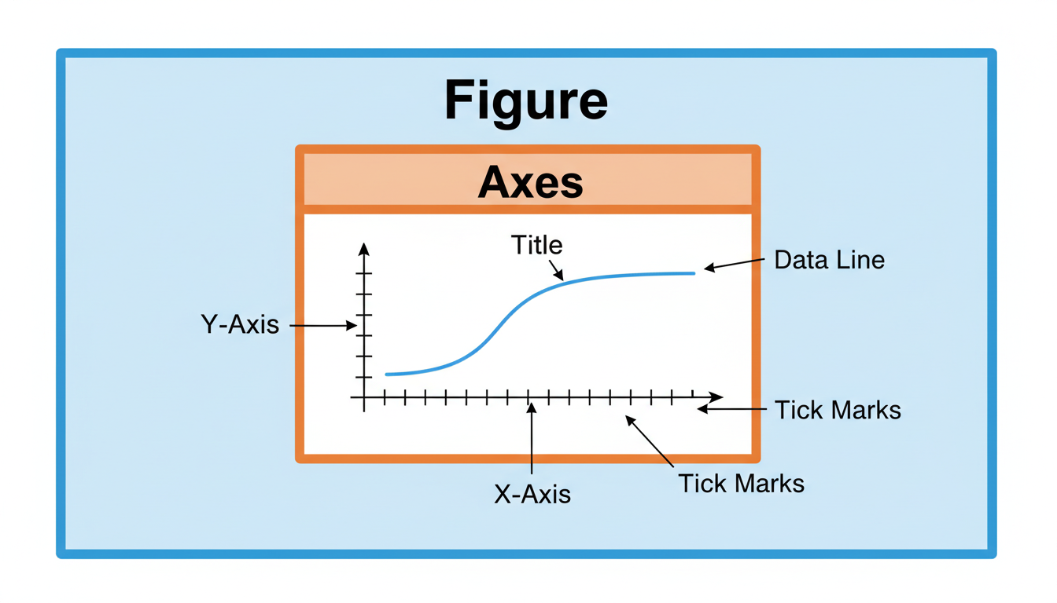

A diagram illustrating the Matplotlib hierarchy. The outer box is labeled 'Figure'. Inside, there is a smaller box labeled 'Axes'. Within the Axes, distinct elements are pointed out: the 'X-Axis', 'Y-Axis', 'Title', 'Tick Marks', and the 'Data Line' itself.

Here is the standard pattern for creating a plot in Python using the subplots method:

python

import matplotlib.pyplot as plt

# 1. Prepare the data (Simulating the cleaned data from previous sections)

months = ['Jan', 'Feb', 'Mar', 'Apr', 'May']

revenue = [10000, 12500, 11000, 16000, 15500]

# 2. Create the Figure and Axes objects

fig, ax = plt.subplots(figsize=(10, 6))

# 3. Plot data onto the Axes

ax.plot(months, revenue, marker='o', linestyle='-', color='blue')

# 4. Customize the Axes (Labels, Titles)

ax.set_title("Monthly Revenue Trend")

ax.set_xlabel("Month")

ax.set_ylabel("Revenue ($)")

# 5. Display the result

plt.show()

Notice the difference from Excel? We aren't clicking specific elements to change them; we are calling methods on the ax object (like ax.set_title). This makes your analysis **reproducible**. If the data changes next month, you re-run the script, and the chart updates instantly with the exact same formatting.

### **Seaborn: A High-Level Wrapper**

While Matplotlib is powerful, it can be verbose. Creating a complex statistical plot might require dozens of lines of code. Enter **Seaborn**.

Seaborn is a library built *on top* of Matplotlib. If Matplotlib is the engine, Seaborn is the sleek dashboard. It is designed specifically for Data Science and integrates tightly with Pandas DataFrames.

Seaborn simplifies the process by: 1. Accepting a DataFrame directly. 2. Automatically applying aesthetically pleasing themes. 3. Calculating statistics (like confidence intervals) for you automatically.

Let’s look at the "Bill Gates" outlier problem from the previous section. In Excel, spotting outliers usually involves scanning rows. In Python, we use a **Boxplot**, which visually summarizes the distribution and highlights anomalies as dots beyond the "whiskers."

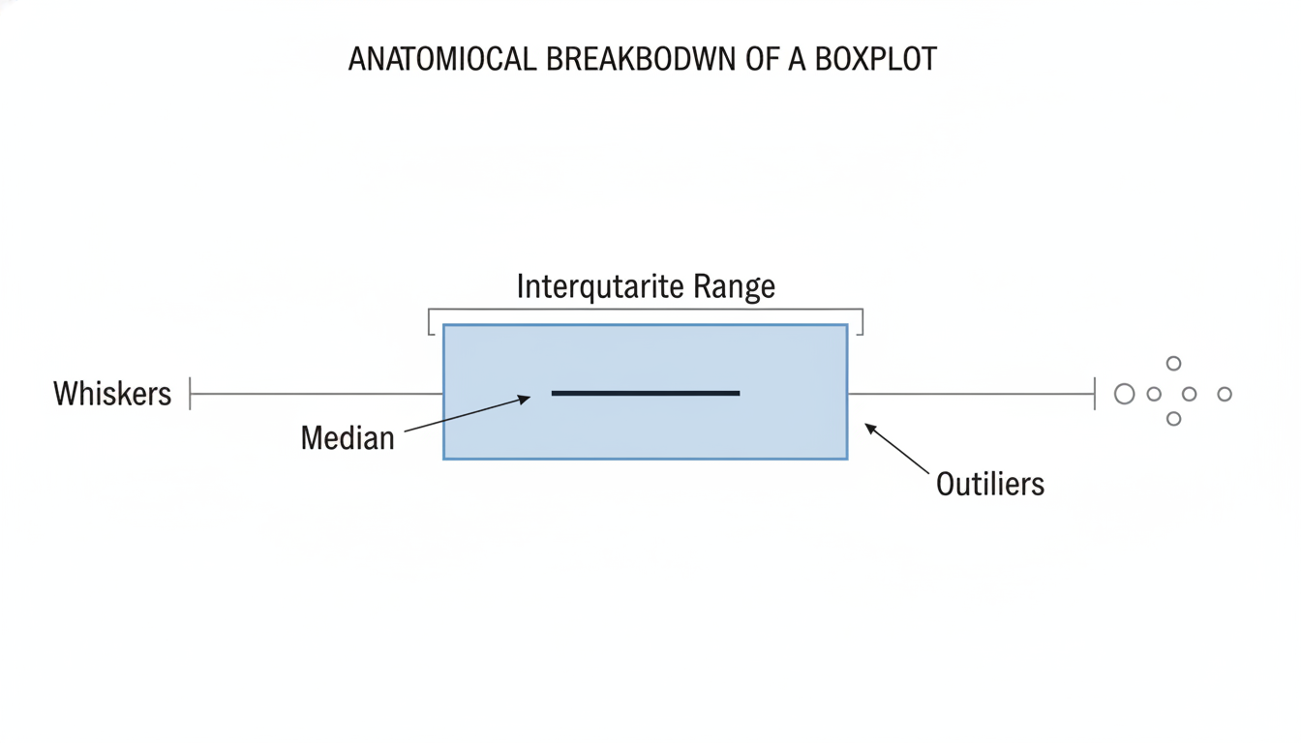

An anatomical breakdown of a Boxplot. It labels the 'Median' (line in the box), 'Interquartile Range' (the box itself), 'Whiskers' (lines extending out), and 'Outliers' (individual dots floating beyond the whiskers).

Here is how we visualize distributions and outliers using Seaborn:

python

import seaborn as sns

import pandas as pd

# Simulating a dataset with an outlier (The "Bill Gates" scenario)

data = {

'Department': ['Sales'] * 20,

'Salary': [50000, 52000, 48000, 51000, 49500, 53000, 51000,

50500, 49000, 52500, 51500, 48500, 50000, 51000,

52000, 49500, 50500, 48000, 51000, 1000000] # The outlier

}

df = pd.DataFrame(data)

# Create the Figure and Axes

fig, ax = plt.subplots(figsize=(8, 4))

# Create a Boxplot using Seaborn

# Notice we pass the DataFrame (df) and the column names directly

sns.boxplot(data=df, x='Salary', ax=ax)

ax.set_title("Salary Distribution (Detecting Outliers)")

plt.show()

In the resulting chart, the outlier ($1,000,000) would appear as a lone dot far to the right, while the box would show where the majority of employees sit. This visualization provides an immediate "sanity check" on your data that a simple average calculation would hide.

### **Univariate vs. Bivariate Analysis**

When performing Exploratory Data Analysis (EDA), you generally move through two stages using these tools:

1. **Univariate Analysis:** Looking at one variable at a time. Question: *What is the distribution of transaction values? Tool:* Histogram or Boxplot. Library:* sns.histplot() or sns.boxplot().

2. **Bivariate Analysis:** Looking at the relationship between two variables. Question: *Does higher marketing spend lead to higher sales? Tool:* Scatter plot or Line chart. Library:* sns.scatterplot() or sns.lineplot().

In Excel, creating a scatter plot with thousands of points often slows the application to a crawl. Python handles this effortlessly.

python

# Bivariate Example: Marketing Spend vs Revenue

market_data = {

'Marketing_Spend': [100, 200, 300, 400, 500, 1000],

'Revenue': [120, 250, 310, 480, 520, 1100],

'Region': ['North', 'North', 'South', 'South', 'East', 'East']

}

df_market = pd.DataFrame(market_data)

# Plotting with a third dimension (Color/Hue)

fig, ax = plt.subplots(figsize=(8, 6))

sns.scatterplot(

data=df_market,

x='Marketing_Spend',

y='Revenue',

hue='Region', # Colors dots based on Region

s=100, # Size of dots

ax=ax

)

ax.set_title("Impact of Marketing on Revenue by Region")

plt.show()

### **Combining Powers: Matplotlib and Seaborn Together**

Because Seaborn is built on Matplotlib, you can mix their commands. You use Seaborn to do the heavy lifting of drawing the complex statistical shape, and you use Matplotlib to tweak the formatting "around" the plot.

This is the workflow you will use most often as a Data Scientist: 1. Use **Pandas** to filter and aggregate the data (weighing the haystacks). 2. Use **Matplotlib** to set up the figure canvas (plt.subplots). 3. Use **Seaborn** to draw the visualization onto that canvas. 4. Use **Matplotlib** again to refine labels, limits, and titles for the final report.

By mastering this grammar of graphics, you move beyond simply storing data to communicating insights. In the next section, we will explore how to perform **Feature Engineering**—creating new metrics from existing data—to feed into these visualizations for deeper analysis.

### **Univariate Analysis: Understanding Distributions and Spread**

In the previous section, we introduced the concept of the "Grammar of Graphics"—the idea that a plot is a mapping of data variables to aesthetic attributes like x-axis, y-axis, color, and shape. We learned how to import Matplotlib and Seaborn to set up our visualization canvas.

Now, we apply that grammar to the most fundamental step of Exploratory Data Analysis (EDA): **Univariate Analysis**.

"Univariate" simply means "one variable." Before you can understand how *Marketing Spend* impacts *Total Revenue* (multivariate analysis), you must deeply understand *Marketing Spend* and *Total Revenue* individually. In the business world, this is equivalent to doing a basic health check on your metrics before trying to diagnose complex strategy problems.

We need to answer two main questions for every column in our dataset: 1. **Central Tendency:** What is the "common" or "average" value? 2. **Spread (Dispersion):** How much does the data vary? Is it consistent, or is it volatile?

### **Analyzing Categorical Variables**

For categorical data (like *Region*, *Product Category*, or *Payment Method*), "distribution" simply refers to frequency. We want to know how many times each category appears.

In Excel, you would typically handle this by creating a Pivot Table, dragging a category to "Rows" and the same category to "Values" to get a count. In Python, pandas handles this with a single method: .value_counts().

Let's create a sample dataset to demonstrate this.

python

import pandas as pd

import seaborn as sns

import matplotlib.pyplot as plt

# Creating a sample retail dataset

data = {

'Transaction_ID': range(1, 11),

'Region': ['North', 'North', 'South', 'East', 'North', 'West', 'South', 'North', 'East', 'West'],

'Sales_Amount': [100, 120, 60, 200, 110, 90, 70, 400, 210, 95]

}

df = pd.DataFrame(data)

# Frequency count of Regions

region_counts = df['Region'].value_counts()

print(region_counts)

**Output:**

text

North 4

South 2

East 2

West 2

Name: Region, dtype: int64

While the text output is precise, a visualization allows you to instantly spot imbalances in your data (e.g., if 90% of your sales are coming from the 'North' region). The standard tool for this is the **Count Plot**.

python

# Visualizing the frequency of a categorical variable

plt.figure(figsize=(8, 5))

sns.countplot(x='Region', data=df, palette='viridis')

plt.title('Distribution of Transactions by Region')

plt.show()

This generates a bar chart displaying the frequency of each category. If you are coming from Excel, note that you did not need to aggregate the data first. Seaborn’s countplot calculates the counts automatically from the raw rows.

### **Analyzing Numerical Variables: The Histogram**

When dealing with continuous numbers (like *Sales_Amount*, *Age*, or *Temperature*), we cannot simply count the unique values because almost every row might have a slightly different number (e.g., 100.01 vs 100.02).

Instead, we group these numbers into "bins" (intervals). This creates a **Histogram**.

Imagine you have a bucket for sales between \$0-\$50, another for \$51-\$100, and so on. You drop every transaction into the corresponding bucket and count how high the pile gets.

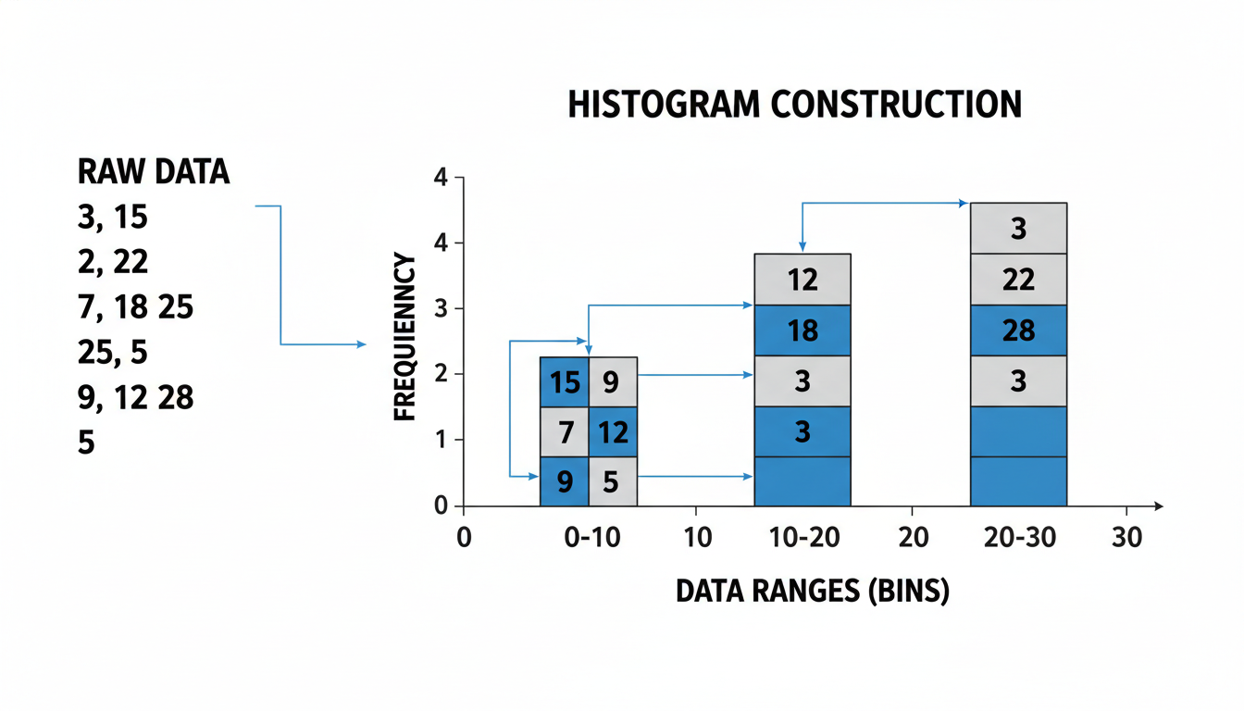

A diagram showing the construction of a histogram. The left side shows a list of raw numbers. The right side shows these numbers being sorted into bins (0-10, 10-20, 20-30), forming bars that represent the frequency of data within those ranges.

In Python, we visualize this using sns.histplot. We also often add a Kernel Density Estimate (KDE)—a smooth line that traces the shape of the distribution.

python

# Visualizing the distribution of Sales Amount

plt.figure(figsize=(8, 5))

sns.histplot(data=df, x='Sales_Amount', bins=5, kde=True)

plt.title('Distribution of Sales Amount')

plt.xlabel('Revenue ($)')

plt.ylabel('Frequency')

plt.show()

#### **Interpreting the Shape: Skewness The shape of the histogram tells you a story about your business.**

1. **Normal Distribution (Bell Curve):** The mean, median, and mode are roughly the same. Most sales are in the middle; very low and very high sales are rare. 2. **Right Skewed (Positive Skew):** The tail extends to the right. This is classic for financial data. Most transactions are small (the "hump" is on the left), but a few massive "whale" clients pull the tail to the right. 3. **Left Skewed (Negative Skew):** The tail extends to the left. This might happen in customer satisfaction scores (1-10), where most people give 8s or 9s, but a few angry customers give 1s and 2s.

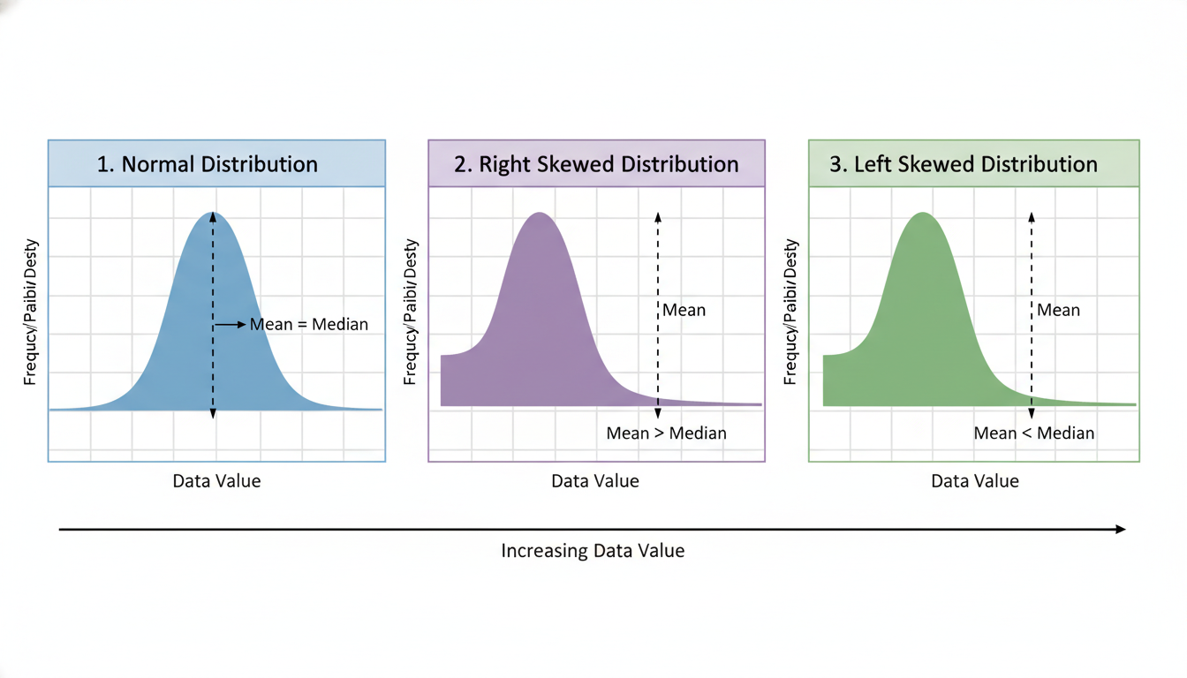

A comparison of three distribution shapes. 1. Normal Distribution (symmetrical bell curve). 2. Right Skewed Distribution (hump on left, long tail stretching right). 3. Left Skewed Distribution (hump on right, long tail stretching left). Annotations indicate where the Mean vs. Median sits in each skew.

### **Measures of Spread: Box Plots**

While the histogram shows the shape, it can sometimes obscure *spread* and *outliers*, especially if the bin sizing isn't perfect. As we discussed in the "Outliers" section, averages can be deceiving.

To visualize the spread and robustness of the data, Data Scientists rely on the **Box Plot** (also known as the Box-and-Whisker plot).

If you haven't used these in Excel, they may look intimidating, but they are standardized summaries of five key numbers: 1. **Minimum:** The lowest value (excluding outliers). 2. **Q1 (25th Percentile):** 25% of the data is lower than this line. 3. **Median (50th Percentile):** The exact middle of the dataset. 4. **Q3 (75th Percentile):** 75% of the data is lower than this line. 5. **Maximum:** The highest value (excluding outliers).

The "Box" represents the middle 50% of your data (the Interquartile Range, or IQR). This is where the "normal" business happens.

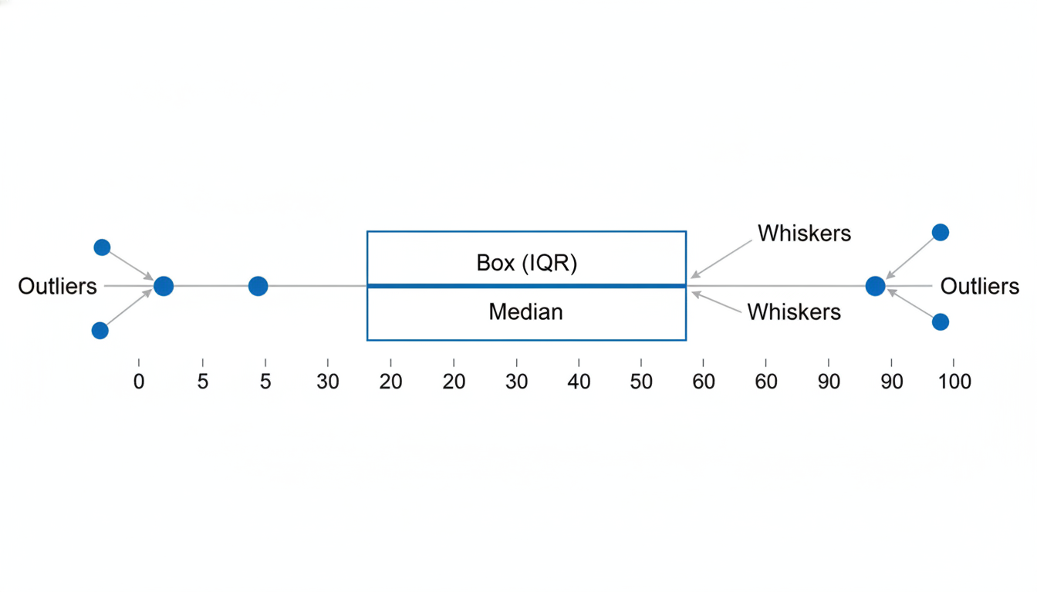

Anatomy of a Box Plot. A detailed diagram labeling the Box (IQR), the horizontal line inside the box (Median), the vertical lines extending out (Whiskers), and individual dots beyond the whiskers labeled as "Outliers".

Let's visualize our Sales Amount using a box plot.

python

# A Box Plot to check for spread and outliers

plt.figure(figsize=(8, 3))

sns.boxplot(x=df['Sales_Amount'], color='lightblue')

plt.title('Box Plot of Sales Amount')

plt.show()

**How to read this as a Business Analyst:** *The Line in the Box: This is your Median sales value. It is more robust than the Average.* **The Width of the Box:** If the box is narrow, your customers spend very consistent amounts. If the box is wide, your customer spending behavior is volatile. *The Dots:*\* Any dots outside the whiskers are outliers. In our dataset, the transaction of 400 likely appears as a dot on the far right. This signals you need to investigate that specific transaction—is it a bulk order? A data entry error?

### **Summary Statistics with .describe()**

Visualizations are powerful, but sometimes you just need the raw numbers. In Excel, you might use the Analysis ToolPak to generate descriptive statistics. In Python, pandas provides the .describe() method.

This method changes behavior based on the data type.

**For Numerical Data:**

python

print(df['Sales_Amount'].describe())

*Output includes count, mean, std (standard deviation), min, 25%, 50%, 75%, and max.*

**For Categorical Data (Object):**

python

print(df['Region'].describe())

*Output includes count, unique (how many categories), top (most frequent category), and freq (count of the top category).*

### **Moving Forward**

By performing Univariate Analysis, you have established a baseline. You know that your sales are Right Skewed, you know that the 'North' region is your most frequent market, and you've identified a few high-value outliers using a box plot.

However, analyzing variables in isolation can only take you so far. Business value is usually found in the *relationships* between variables. Does the 'North' region actually spend more per transaction than the 'South'? Does higher marketing spend actually correlate with higher sales?

In the next section, we will move to **Bivariate Analysis**, where we will explore correlations and relationships between two variables.

### **Bivariate Analysis: Visualizing Correlations and Trends**

In the previous section, we focused on **Univariate Analysis**—examining variables in isolation. We learned to calculate the mean of our sales data, visualize the spread of customer ages using histograms, and identify the skew in our profit margins.

While Univariate Analysis helps us understand *what* our data looks like, it rarely tells us *why* things are happening. In a business context, knowing that the average daily revenue is $5,000 is useful, but knowing that **Marketing Spend** drives that revenue is actionable.

This brings us to **Bivariate Analysis** ("Bi" meaning two). Here, we move from taking portraits of individual variables to observing the conversations between them. We are looking for relationships, correlations, and trends.

### **Numerical vs. Numerical: The Scatter Plot**

The most common relationship you will investigate in data science is between two continuous numerical variables. In Excel, you might highlight two columns and insert a scatter chart to see if they move together. In Python, we use the Grammar of Graphics to map one variable to the x-axis and another to the y-axis.

Let’s imagine we are analyzing an e-commerce dataset. We suspect a relationship between the number of **Site_Visitors** and **Total_Sales**.

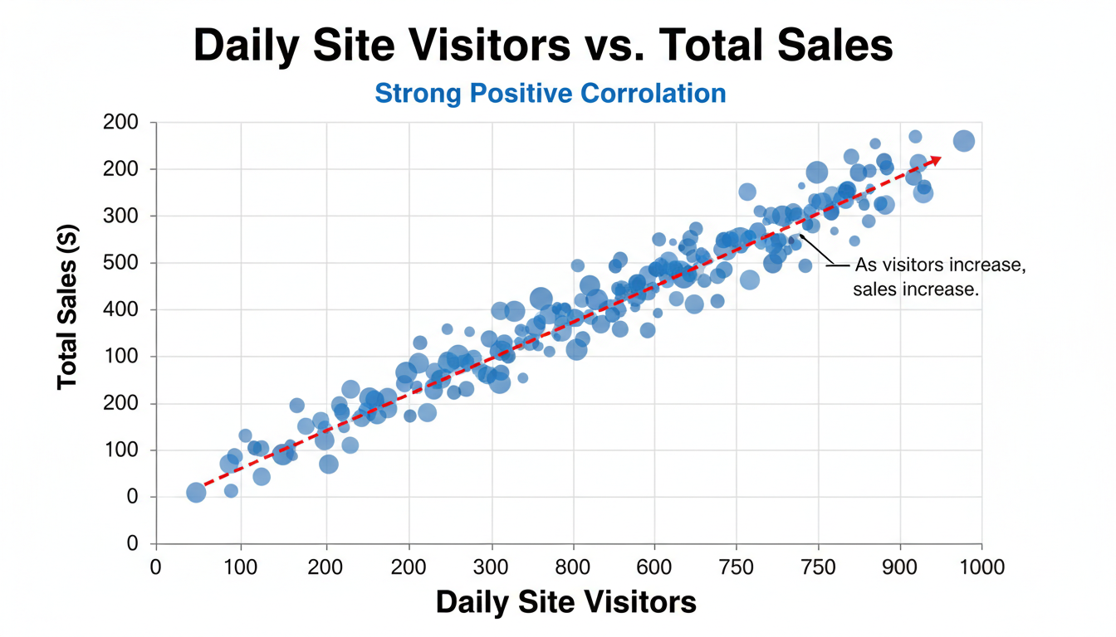

A scatter plot showing a strong positive correlation. The X-axis is labeled "Daily Site Visitors" and the Y-axis is labeled "Total Sales ($)". The points drift upward from left to right, indicating that as visitors increase, sales increase.

Here is how we generate this view using Seaborn:

python

import matplotlib.pyplot as plt

import seaborn as sns

# Assuming 'df' is our DataFrame containing e-commerce data

plt.figure(figsize=(10, 6))

# Plotting Visitors vs Sales

sns.scatterplot(data=df, x='Site_Visitors', y='Total_Sales', alpha=0.6)

plt.title('Relationship Between Site Traffic and Sales')

plt.xlabel('Daily Site Visitors')

plt.ylabel('Total Sales ($)')

plt.show()

**Key concept:** Notice the argument alpha=0.6. In large datasets with thousands of points, dots often overlap, creating a solid blob of ink. The alpha parameter controls transparency (0 is invisible, 1 is solid). By making points semi-transparent, overlapping areas become darker, revealing the density of the data.

#### **Visualizing the Trendline Sometimes the relationship isn't immediately obvious, or you want to model the general direction. In Excel, you would right-click a data point and select "Add Trendline." In Seaborn, we switch from scatterplot to regplot (Regression Plot).**

python

plt.figure(figsize=(10, 6))

sns.regplot(data=df, x='Site_Visitors', y='Total_Sales', line_kws={"color": "red"})

plt.title('Traffic vs Sales with Linear Trend')

plt.show()

This draws a scatter plot and automatically overlays a linear regression model (the line of best fit) with a shaded confidence interval. If the line slopes upward, the variables are positively correlated; if downward, negatively correlated.

### **Quantifying Relationships: Correlation Matrices**

Visuals are powerful, but subjective. A scatter plot might look like a "strong" relationship to one stakeholder and "weak" to another. To make this objective, we use the **Correlation Coefficient** (specifically, Pearson correlation).

This value ranges from **-1 to 1**: *1: Perfect positive correlation (As X goes up, Y goes up).* **0:** No correlation (Random noise). *-1:*\* Perfect negative correlation (As X goes up, Y goes down—like "Price" vs. "Demand").

In pandas, calculating this is incredibly efficient compared to Excel's CORREL formulas:

python

# Calculate correlations for all numerical columns

correlation_matrix = df.corr()

print(correlation_matrix)

However, a table of raw numbers is hard to read. The best way to present correlation in a professional setting is using a **Heatmap**. A heatmap replaces numbers with colors, allowing you to spot "hot spots" (strong relationships) instantly.

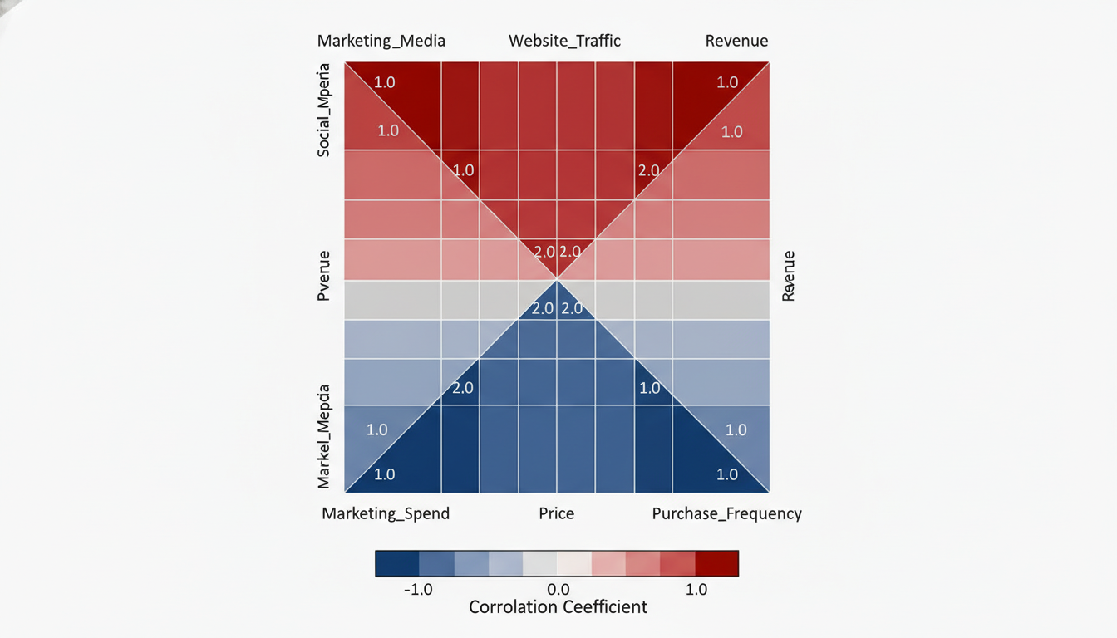

A correlation heatmap using a "coolwarm" color palette. The diagonal squares are dark red (correlation of 1.0). A square at the intersection of "Marketing_Spend" and "Revenue" is distinctively red, indicating high correlation. A square between "Price" and "Purchase_Frequency" is blue, indicating negative correlation.

python

plt.figure(figsize=(10, 8))

# Create the heatmap

sns.heatmap(correlation_matrix,

annot=True, # Write the data value in each cell

cmap='coolwarm', # Color scheme (Blue for negative, Red for positive)

fmt=".2f") # Format to 2 decimal places

plt.title('Correlation Matrix of Business Metrics')

plt.show()

### **Numerical vs. Categorical: Comparing Groups**

Bivariate analysis isn't limited to just numbers. Often, the most valuable business questions involve categories. For example: *Do sales differ by Region?* or *Is the Shipping Cost higher for 'Express' vs 'Standard'?*

In the previous section regarding Univariate Analysis, we used the **Boxplot** to see the distribution of one variable. By adding a second variable (the category) to the x-axis, we can perform side-by-side comparisons.

Imagine analyzing salary data across different departments.

python

plt.figure(figsize=(12, 6))

# x is the Category, y is the Numerical value

sns.boxplot(data=df, x='Department', y='Salary')

plt.title('Salary Distribution by Department')

plt.show()

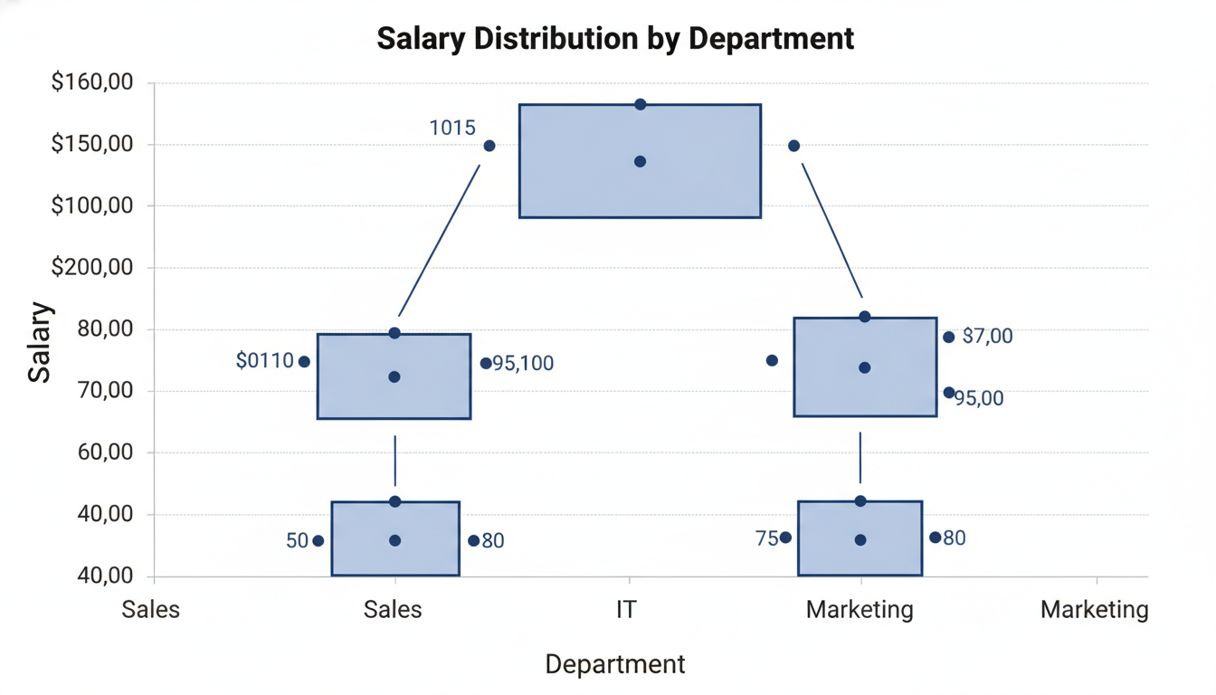

A set of side-by-side boxplots. The X-axis lists departments: Sales, IT, HR, Marketing. The Y-axis represents Salary. The "IT" boxplot is positioned higher on the Y-axis than "HR", and has a wider "box," indicating higher median pay but also higher variance. Outliers (dots) are visible above the whiskers.

**Interpreting this plot:** 1. **The Line in the Middle:** Comparing the median lines tells you which department pays more on average (robust to outliers). 2. **The Height of the Box:** A tall box means high variability—some people earn very little, some earn a lot. A short box means salaries are consistent. 3. **The Whiskers:** These show the range of "normal" salaries. 4. **The Dots:** These are outliers. If the "Sales" department has many dots above the top whisker, it indicates heavy commissions or distinct high-performers.

### **Categorical vs. Categorical: Cross-Tabulation**

Finally, you may need to analyze the relationship between two categorical variables. Is there a relationship between 'Churn Status' (Yes/No) and 'Contract Type' (Month-to-Month/Yearly)?*

In Excel, you would solve this with a Pivot Table using "Count." In Python, we can visualize this using a **Countplot** with a hue argument. The hue parameter adds a second categorical dimension by color-coding the bars.

python

plt.figure(figsize=(10, 6))

# Comparing Contract Type vs Churn

sns.countplot(data=df, x='Contract_Type', hue='Churn')

plt.title('Customer Churn by Contract Type')

plt.ylabel('Number of Customers')

plt.show()

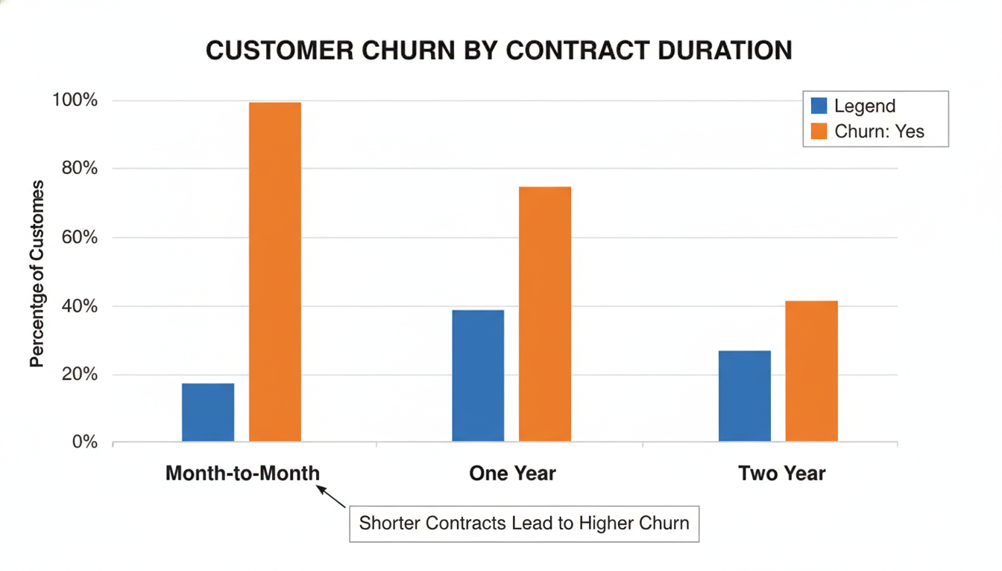

A grouped bar chart. The X-axis has three categories: Month-to-Month, One Year, Two Year. Each category has two bars side-by-side: Blue for "Churn: No" and Orange for "Churn: Yes". The "Month-to-Month" group has a very high Orange bar compared to the "Two Year" group, visually proving that short-term contracts lead to higher churn.

This visualization instantly validates business hypotheses. If the "Month-to-Month" bars show a high proportion of churn compared to "Two Year" contracts, you have data-driven evidence to suggest incentivizing long-term contracts.

### **Summary: The Analyst's Toolkit**

You have now expanded your toolkit from understanding single variables to understanding relationships.

* Use **Scatter Plots (`scatterplot`)** to see how two numbers move together.
* Use **Correlation Heatmaps (`heatmap`)** to scan for drivers and relationships across the whole dataset.
* Use **Boxplots (`boxplot`)** to compare numerical distributions across different categories.
* Use **Countplots (`countplot` with `hue`)** to compare frequencies between two categories.

However, the real world is rarely defined by just two variables. Sales aren't just driven by Marketing Spend; they are driven by Spend, Seasonality, Competitor Prices, and Inventory Levels *simultaneously*. In the next section, we will introduce **Multivariate Analysis**, where we learn to visualize three or more dimensions of data at once.

### **Case Study: Diagnosing Sales Performance Factors**

In the previous sections, we have built a robust toolkit. We know how to clean messy text, handle data types, identify outliers, and apply the Grammar of Graphics to visualize single variables and relationships.

However, in the professional world, your boss will rarely ask you to "perform a bivariate analysis on column X and Y." Instead, they will ask a business question: *"Why did our revenue drop in Q3?"* or *"Are our marketing promotions actually working?"*

This section is where the rubber meets the road. We will combine all the techniques we have learned into a comprehensive workflow—a **Case Study**. We will step into the role of a Data Scientist at a mid-sized electronics retailer, "TechGear," to diagnose specific factors driving sales performance.

### **The Scenario: TechGear's Profitability Puzzle**

TechGear’s executive team is concerned. While overall revenue is high, profit margins in certain segments seem to be eroding. They have provided you with a dataset of recent transactions and asked you to investigate. They have two specific hypotheses they want you to test: 1. Are specific regions underperforming? 2. Is our discounting strategy hurting our profitability?

### **Step 1: Setup and Data Cleaning**

Before we can visualize anything, we must ensure our foundation is solid. As we learned in the "String Manipulation" section, categorical data is often messy.

Let's import our libraries and simulate the data loading process.

python

import pandas as pd

import matplotlib.pyplot as plt

import seaborn as sns

# Setting the visual style for our charts

sns.set_theme(style="whitegrid")

# Loading the dataset (simulated for this example)

df = pd.read_csv('techgear_sales_data.csv')

# Inspecting the raw data

print(df.head())

Imagine the output reveals the Region column contains inconsistent entries like " North", "north", and "North ". If we plot this immediately, Python will treat these as three different regions. We need to standardize this text.

python

# 1. String Manipulation: Standardizing Region names

# Strip whitespace and convert to title case

df['Region'] = df['Region'].str.strip().str.title()

# 2. Data Typing: Ensure Date is a datetime object

df['Date'] = pd.to_datetime(df['Date'])

print(df['Region'].unique())

# Output: ['North', 'South', 'East', 'West'] -> Clean!

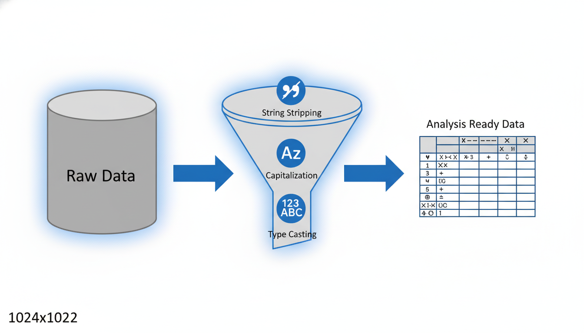

A flow diagram illustrating the data cleaning pipeline. On the left, a cylinder labeled "Raw Data" feeds into a funnel. Inside the funnel, icons represent "String Stripping," "Capitalization," and "Type Casting." On the right, a neat table emerges labeled "Analysis Ready Data."

### **Step 2: Univariate Analysis (The "Sanity Check")**

Before looking for relationships, we must understand the distribution of our key metric: **Sales Amount**. As discussed in the section on *Outliers*, financial data is rarely normally distributed; it often follows a "power law" where a few large deals skew the average.

python

# Visualizing the distribution of Sales Amount

plt.figure(figsize=(10, 6))

sns.histplot(data=df, x='Sales_Amount', kde=True, bins=30)

plt.title('Distribution of Transaction Values')

plt.xlabel('Sales Amount ($)')

plt.show()

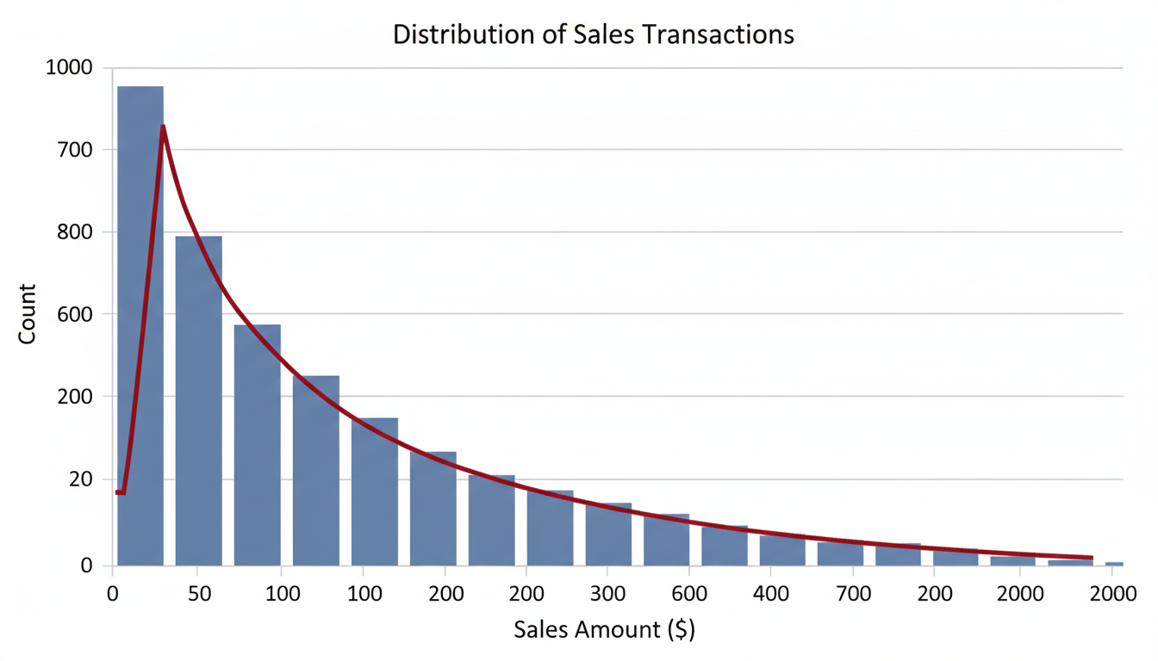

A histogram with a kernel density estimate (KDE) line overlay. The x-axis is "Sales Amount ($)" and the y-axis is "Count". The distribution is "right-skewed," meaning there is a tall peak on the left (many small transactions) and a long tail extending to the right (a few very expensive transactions).

**Interpretation:** If the histogram showed a massive spike at \$0, we might have a data quality issue (e.g., failed transactions recorded as zero). If it is heavily right-skewed (as shown in the figure), we know that using the "mean" might be misleading. We should perhaps use the "median" for our business reporting.

### **Step 3: Bivariate Analysis (Testing Hypothesis 1)**

The management's first question was: *Are specific regions underperforming?*

To answer this, we need to compare a categorical variable (Region) against a numerical variable (Sales_Amount). As we learned in the *Grammar of Graphics*, a **Boxplot** is the ideal geometric object for this comparison because it shows the median, the spread, and the outliers simultaneously.

python

plt.figure(figsize=(10, 6))

sns.boxplot(data=df, x='Region', y='Sales_Amount', palette='Set2')

plt.title('Sales Performance by Region')

plt.show()

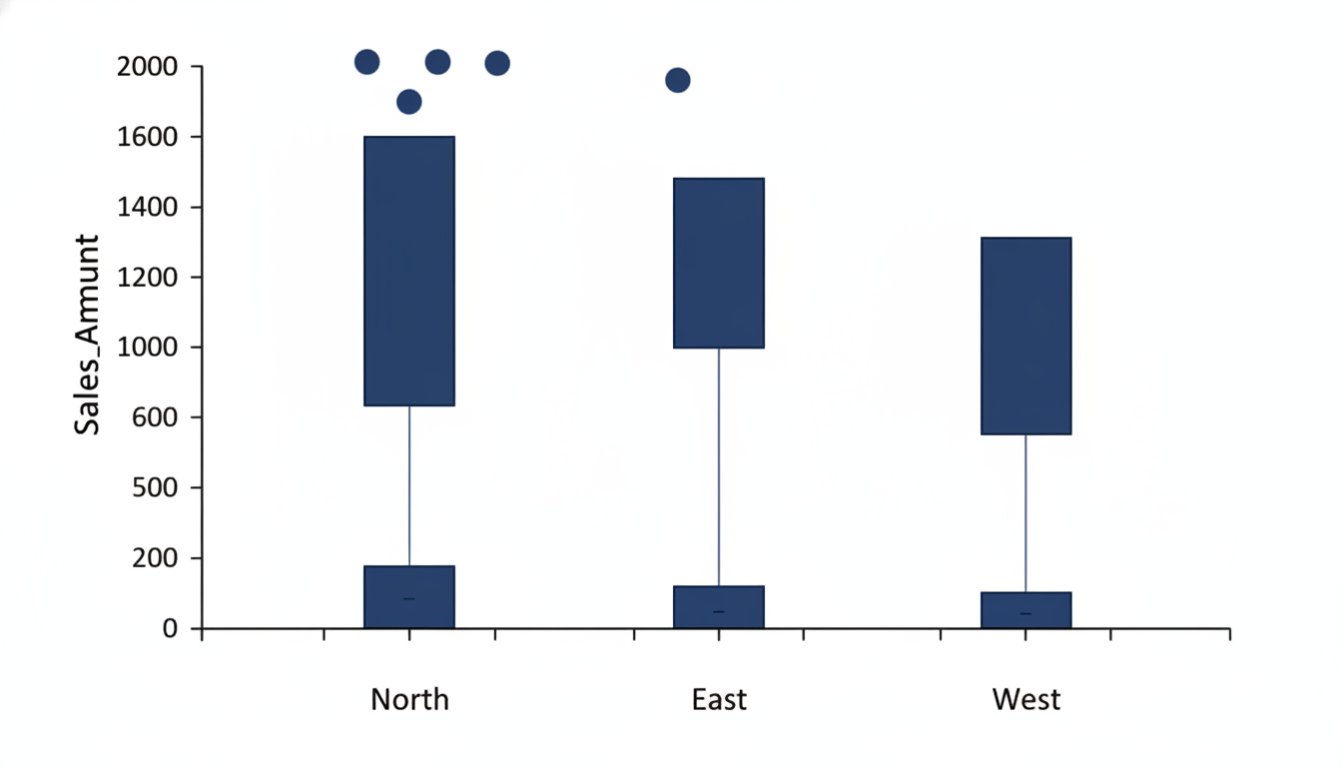

A boxplot displaying four regions (North, South, East, West) on the x-axis. The y-axis represents "Sales_Amount". The "South" box is significantly shorter and lower on the y-axis than the others, indicating lower median sales and less variability. The "North" box has several dots above the top whisker, indicating high-value outliers.

**The Insight:** The plot immediately highlights that the **South** region has a lower median transaction value compared to the North. However, the North relies heavily on outliers (massive, rare deals) to keep its numbers up. This is a nuance that a simple Excel pivot table averaging the numbers might miss.

### **Step 4: Multivariate Analysis (Testing Hypothesis 2)**

The second question is trickier: *Is our discounting strategy hurting profitability?*

This requires us to look at three variables at once: 1. **Discount %** (Independent Variable) 2. **Profit** (Dependent Variable) 3. **Product Category** (Grouping Variable - to see if this applies to all products)

We will use a **Scatter Plot**, which is excellent for showing the correlation between two continuous variables. We will add a third dimension using hue (color) to separate product categories.

python

plt.figure(figsize=(12, 8))

# Scatter plot correlating Discount to Profit

sns.scatterplot(

data=df,

x='Discount_Pct',

y='Profit',

hue='Category',

alpha=0.7 # Transparency helps visualize overlapping points

)

# Adding a horizontal line at 0 to mark the break-even point

plt.axhline(0, color='red', linestyle='--', linewidth=1)

plt.title('Impact of Discounting on Profitability by Category')

plt.xlabel('Discount Percentage (0.1 = 10%)')

plt.ylabel('Profit ($)')

plt.show()

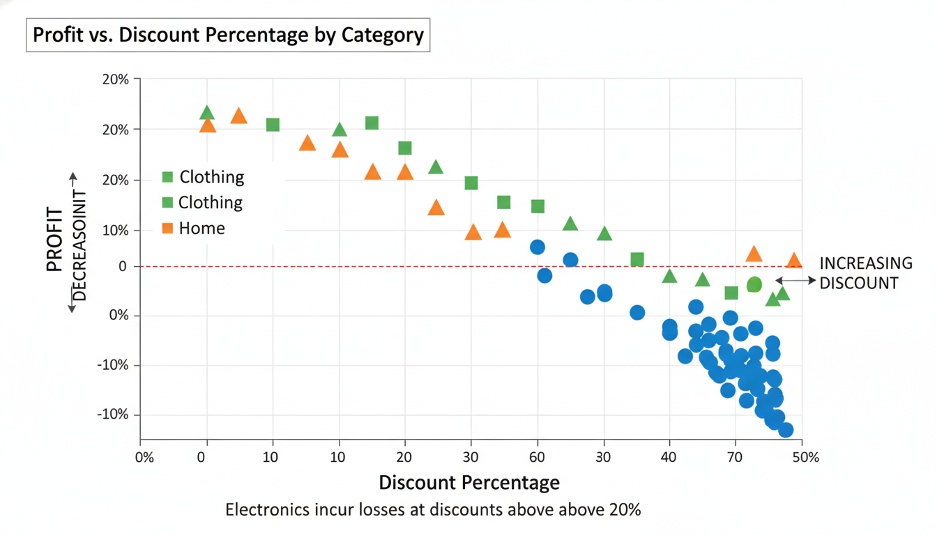

A scatter plot with "Discount Percentage" on the x-axis and "Profit" on the y-axis. A red dashed horizontal line runs across y=0. Points are colored by category (Electronics, Clothing, Home). The trend shows that as the Discount Percentage moves to the right (increases), the Profit points drift downward. Specifically, the "Electronics" points drop below the red line (negative profit) once the discount exceeds 20%.

**The Insight:** The visual analysis reveals a critical threshold. While discounts generally lower profit (an expected negative correlation), the category **Electronics** actually becomes *unprofitable* (drops below the red line) when discounts exceed 20%.

This suggests that the sales team is aggressive with discounts to close deals, but for low-margin electronics, they are essentially paying customers to take the inventory.

### **Summary of the Workflow**

Notice how we didn't just "make charts." We followed a diagnostic path:

1. **Data Type/String Cleaning:** We ensured our Region labels were unified so our groups were accurate. 2. **Univariate Analysis:** We established a baseline for what a "normal" sale looks like. 3. **Bivariate Analysis:** We identified that the South region is underperforming in transaction value. 4. **Multivariate Analysis:** We diagnosed that aggressive discounting in Electronics is destroying profit margins.

This is the essence of Exploratory Data Analysis. It is not about generating code; it is about interrogating data to find the narrative hidden within the numbers. In the next chapter, we will move from *analyzing* historical data to *predicting* future data using Machine Learning.

## **Chapter 6Statistical Foundations for Decision Making**

### **Descriptive vs. Inferential Statistics in Business**

In the previous Case Study, we played the role of a data detective. We took a raw dataset, cleaned it, visualized it, and diagnosed why sales dropped in Q3. We looked at the data we *had* in front of us and drew conclusions based on those specific numbers.

In the world of statistics, what we performed is called **Descriptive Statistics**. We described the past.

However, business leaders are rarely satisfied with just knowing what happened yesterday. They want to know what will happen tomorrow. They want to know if a survey of 500 customers represents the views of 5 million customers. They want to make decisions where the outcome is uncertain.

To answer those questions, we must cross the bridge from **Descriptive Statistics** to **Inferential Statistics**. This transition is often the most difficult mental shift for professionals moving into Data Science, as it requires moving from "hard facts" to "probabilities."

### **The Dashboard vs. The Crystal Ball**

To understand the difference, imagine you are the Operations Manager for a logistics company.

1. **Descriptive Statistics (The Dashboard):** You calculate the average delivery time for the last month was 2.4 days. You report that 5% of deliveries were late. This is a factual summary of recorded history. 2. **Inferential Statistics (The Crystal Ball):** You implement a new routing algorithm on a small pilot group of drivers. You notice their average delivery time is 2.2 days. Inferential statistics allows you to answer: *Is this improvement real, or was it just luck? If we roll this out to the whole fleet, will we see the same results?*

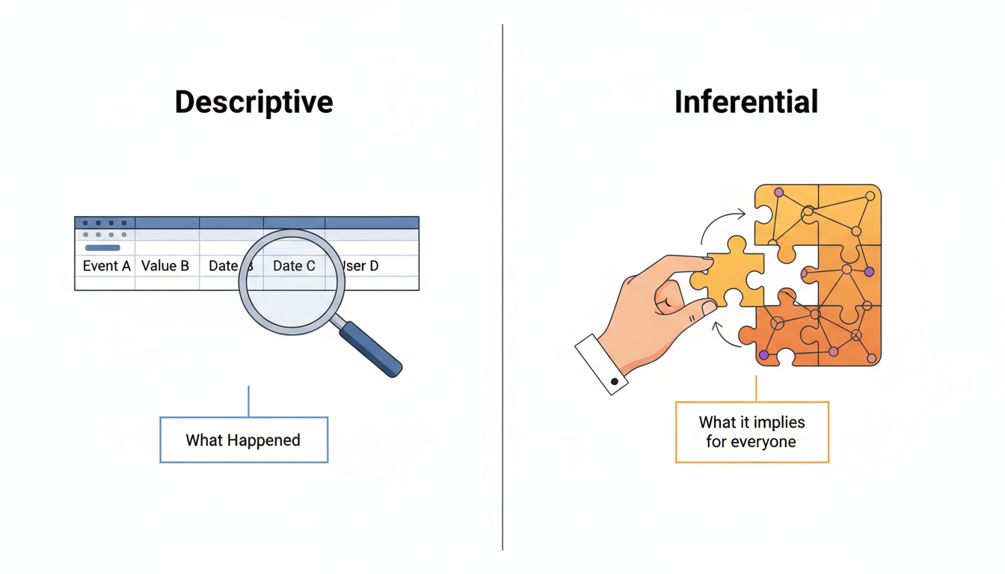

A split graphic. On the left, labeled "Descriptive," is a magnifying glass over a spreadsheet row, summarizing "What Happened." On the right, labeled "Inferential," is a hand drawing a conclusion from a small puzzle piece to complete a larger puzzle, labeled "What it implies for everyone."

### **Descriptive Statistics: Summarizing the Known**

Descriptive statistics involves simplifying large amounts of data into meaningful summary metrics. You have already done this in our Univariate Analysis section using Pandas.

In a business context, descriptive statistics usually fall into two buckets:

1. **Measures of Central Tendency:** Where is the "center" of the data? (Mean, Median, Mode). 2. **Measures of Dispersion:** How "spread out" is the data? (Range, Variance, Standard Deviation).

When you present a KPI (Key Performance Indicator) deck to stakeholders, you are almost exclusively using descriptive statistics.

python

import pandas as pd

import numpy as np

# Simulating a dataset of Customer Purchase Amounts

np.random.seed(42)

data = {

'customer_id': range(1, 101),

'purchase_amount': np.random.normal(100, 20, 100) # Mean=100, Std=20

}

df = pd.DataFrame(data)

# The Descriptive approach

desc_stats = df['purchase_amount'].describe()

print(desc_stats)

**Output interpretation:** If the mean is \$98.00 and the std (standard deviation) is \$19.50, you can tell your boss: "The average customer spends about \$98, and most customers spend between \$78 and \$118."

This is useful, but it has a fatal flaw: it assumes your dataset represents the entire reality. In data science, it rarely does.

### **The Concept of Population vs. Sample**

Before we define Inferential Statistics, we must define the two most important words in this chapter: **Population** and **Sample**.

* **Population:** The entire group you want to draw conclusions about. (e.g., *All* users who have ever visited your website, or *all* credit card transactions in the US).
* **Sample:** The specific subset of data you actually collected. (e.g., The 1,000 users who filled out the survey, or the transactions from last Tuesday).

In 99% of business cases, you will never have access to the full Population. It is too expensive, too time-consuming, or physically impossible to measure. You only have a Sample.

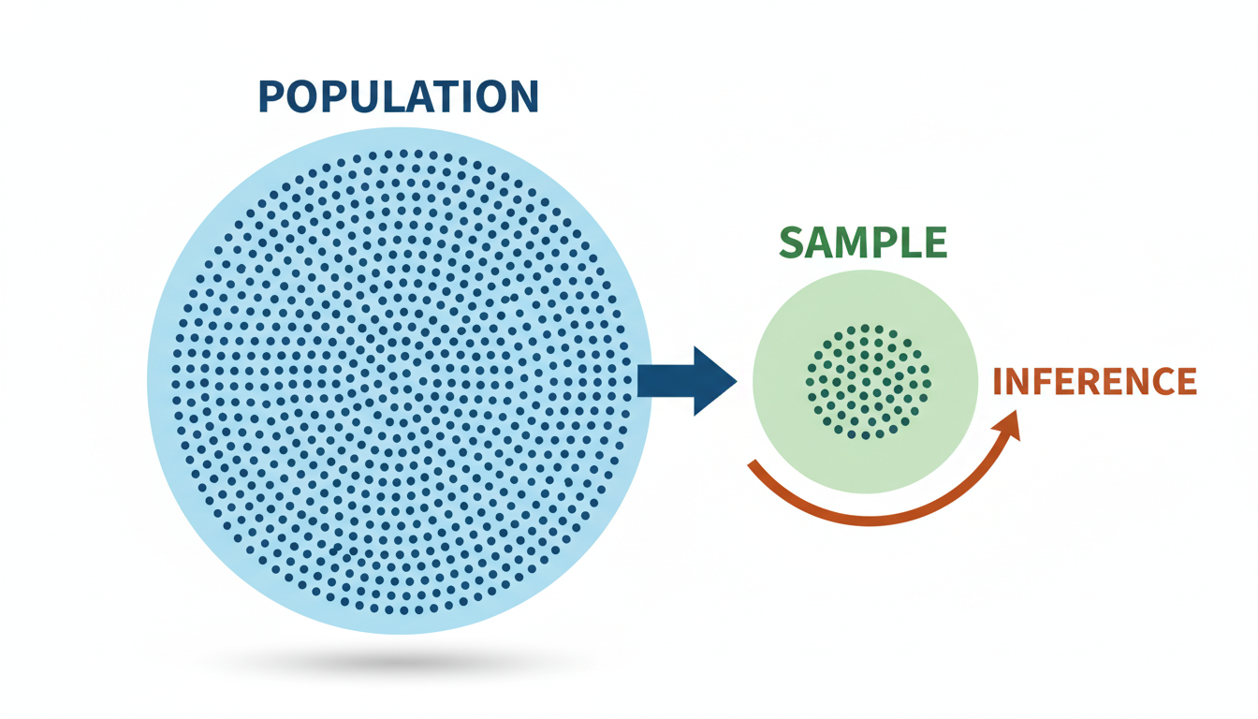

A diagram illustrating "Population vs Sample." A large circle contains thousands of dots representing the "Population." A smaller circle extracts a few dozen of these dots, labeled "Sample." An arrow points from the Sample back to the Population labeled "Inference."

### **Inferential Statistics: The Art of Estimation**

Inferential statistics is the mathematical framework that allows us to look at a **Sample** and make valid claims about the **Population**.

If descriptive statistics is about *precision* (calculating the exact average of the rows you have), inferential statistics is about *uncertainty* (calculating how wrong you might be about the rows you don't have).

There are two main engines of inference used in business:

#### **1. Estimation (Confidence Intervals) Instead of saying "The average customer satisfaction score is 8.5," inferential statistics teaches us to say: "We are 95% confident that the true average satisfaction score for all customers lies between 8.1 and 8.9."**

This "margin of error" is critical for risk management. If you are launching a product with a break-even price of \$50, and your sample data says customers are willing to pay \$52, a simple average suggests you are safe. But if the *confidence interval* is \$48 to \$56, there is a significant risk you will lose money.

#### **2. Hypothesis Testing This is the backbone of the scientific method in business (A/B Testing). *Hypothesis: "Changing the 'Buy Now' button from red to green increases conversion rates."* Experiment: You show the green button to 1,000 random visitors (Sample). *Inference:*\* Did the conversion rate go up because the button is green, or was it just random noise?**

### **Python Example: From Sample to Population**

Let's look at how we use Python not just to describe data, but to infer a population parameter.

Imagine we want to know the average height of all adult males in a city (Population). We cannot measure everyone. We measure 50 random people (Sample).

python

import scipy.stats as stats

import math

# 1. Create a "Hidden" Population (We usually don't see this in real life)

# Mean=175cm, Std Dev=10cm, Size=100,000 people

population_heights = np.random.normal(loc=175, scale=10, size=100000)

# 2. Take a Random Sample of 50 people

sample_size = 50

sample = np.random.choice(population_heights, size=sample_size)

# 3. Descriptive Statistic (What we see in our sample)

sample_mean = np.mean(sample)

print(f"Sample Mean: {sample_mean:.2f} cm")

# 4. Inferential Statistic (Estimating the Population)

# We calculate the Standard Error and a 95% Confidence Interval

std_error = np.std(sample, ddof=1) / math.sqrt(sample_size)

conf_interval = stats.t.interval(confidence=0.95,

df=sample_size-1,

loc=sample_mean,

scale=std_error)

print(f"95% Confidence Interval: {conf_interval[0]:.2f} cm to {conf_interval[1]:.2f} cm")

print(f"Actual Population Mean (The Truth): {np.mean(population_heights):.2f} cm")

**Why is this powerful?** Run the code above. You will see that the Sample Mean is rarely exactly 175.00 (the truth). It might be 172 or 177. However, the Confidence Interval almost always captures the true 175.

In a business meeting, if you simply reported the sample mean (172cm), you would be providing inaccurate information. By using inferential statistics (the Confidence Interval), you provide a range that includes the truth, allowing for safer decision-making.

### **Summary: When to Use Which?**

As you transition into data science, you need to know which tool to pull from your belt.

| Feature | Descriptive Statistics | Inferential Statistics | | :--- | :--- | :--- | | **Goal** | Organize and summarize data. | Draw conclusions about a population. | | **Scope** | Limited to the dataset at hand. | Extends beyond the data at hand. | | **Tools** | Tables, Charts, Mean, Median. | Probability, Confidence Intervals, Hypothesis Tests. | | **Business Question** | "What were our sales last quarter?" | "Will this marketing campaign work next quarter?" |

In the upcoming sections, we will dive deeper into the mechanics of **Hypothesis Testing**—the primary tool data scientists use to prove to stakeholders that an observation is a real pattern, not just a random coincidence.

### **Hypothesis Testing: The Framework for A/B Testing**

In the previous section, we distinguished between describing the past (Descriptive Statistics) and inferring the future (Inferential Statistics). We established that business leaders do not want to know merely *what* happened; they want to know *if* a specific change caused it and if that result is repeatable.

This brings us to the heart of data-driven decision-making: **Hypothesis Testing**.

In the tech and business world, this is most commonly applied as **A/B Testing**. Whether Netflix is testing a new thumbnail for a movie or Amazon is testing the color of a "Buy Now" button, they are not guessing. They are running a statistical experiment to determine if a "Treatment" (the new version) performs significantly better than the "Control" (the old version), or if the observed difference is just random luck.

### **The Courtroom Analogy: $H_0$ vs. $H_1$**

To understand hypothesis testing, it helps to think like a lawyer in a criminal trial.

In a courtroom, the defendant is **presumed innocent until proven guilty**. You cannot convict someone based on a hunch; you need sufficient evidence to reject the presumption of innocence.

In statistics, we set up two competing claims:

1. **The Null Hypothesis ($H_0$):** This is the "innocent" plea. It represents the status quo or the assumption of *no effect*. Business Example: *"The new marketing email subject line has no effect on open rates compared to the old one." 2. The Alternative Hypothesis ($H_1$ or $H_a$): This is the claim we are trying to prove. It represents the presence of an effect or a difference. Business Example:* "The new marketing email subject line **changes** the open rates."

As data scientists, our job is not to prove $H_0$ is true. Our job is to see if we have enough evidence to **reject** $H_0$ in favor of $H_1$.

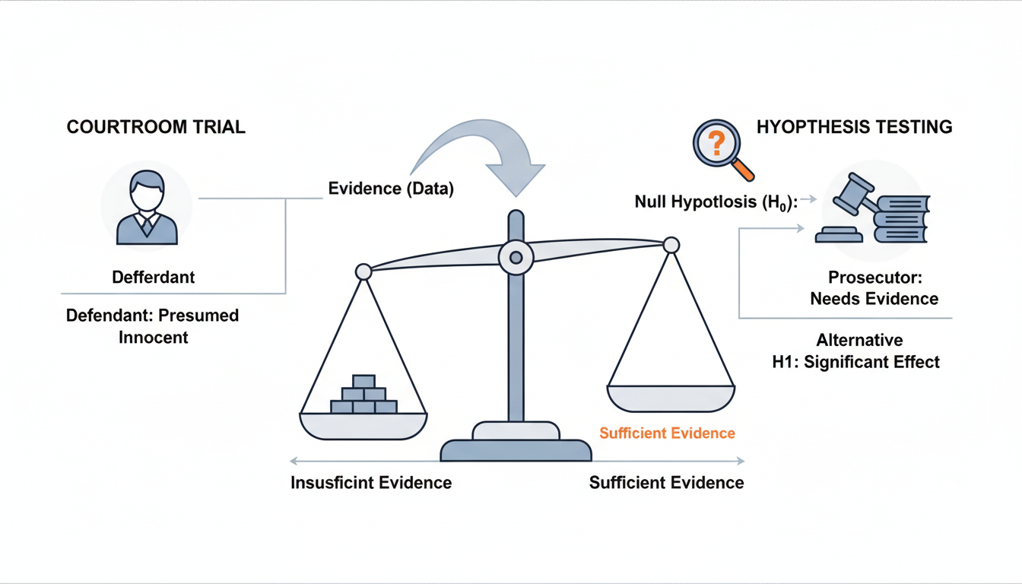

A conceptual diagram comparing a Courtroom Trial to Hypothesis Testing. Left side: "Defendant: Presumed Innocent" points to "Null Hypothesis (H0): No Effect". Right side: "Prosecutor: Needs Evidence" points to "Alternative Hypothesis (H1): Significant Effect". The middle shows a scale tipping based on "Evidence (Data)".

### **The Evidence Gauge: The P-Value**

How much evidence is "enough"?

Imagine you flip a coin 10 times. If you get 5 heads and 5 tails, you assume the coin is fair. If you get 9 heads and 1 tail, you might start to suspect the coin is rigged. But what if you get 6 heads? Is that rigged, or just luck?

This probability of seeing a result purely by chance is called the **p-value**.

* **High p-value (e.g., 0.80):** The result is very likely to happen by chance. It is just noise. We keep the Null Hypothesis.
* **Low p-value (e.g., 0.01):** The result is extremely unlikely to happen by chance. Something interesting is going on. We reject the Null Hypothesis.

#### **The Threshold: Significance Level ($\alpha$) Before running a test, we must decide a "cutoff" for our skepticism, known as Alpha ($\alpha$). In most business and scientific contexts, this is set to 0.05 (5%).**

* If **p-value < 0.05**: The result is statistically significant. We reject the Null Hypothesis.
* If **p-value $\ge$ 0.05**: We fail to reject the Null Hypothesis. The difference could be due to random noise.

***Mnemonic:*** *"If P is low, the Null must go."*

### **The T-Test: Comparing Two Groups**

While there are many statistical tests, the most common workhorse for A/B testing is the **Student's t-test**. We use this when we want to compare the **means (averages)** of two different groups to see if they come from the same population.

Let's apply this to a practical scenario using Python.

**Scenario:** Your e-commerce company is testing a new checkout page design. *Group A (Control): Saw the old design.* **Group B (Treatment):** Saw the new design. *Metric:*\* Total purchase amount ($) per user.

We want to know: *Did the new design actually increase revenue, or was it just a lucky day?*

First, let's generate some synthetic data to simulate this scenario using numpy.

python

import numpy as np

import pandas as pd

from scipy import stats

import matplotlib.pyplot as plt

import seaborn as sns

# Set a seed for reproducibility

np.random.seed(42)

# Simulate data

# Group A: Mean spend $50, Standard Deviation $10, 1000 users

group_a = np.random.normal(loc=50, scale=10, size=1000)

# Group B: Mean spend $51.5, Standard Deviation $10, 1000 users

# Note: We are intentionally making Group B slightly better ($1.50 more on average)

group_b = np.random.normal(loc=51.5, scale=10, size=1000)

# Create a DataFrame for easier plotting later

df_a = pd.DataFrame({'Spend': group_a, 'Group': 'Control'})

df_b = pd.DataFrame({'Spend': group_b, 'Group': 'Treatment'})

df = pd.concat([df_a, df_b])

print(f"Mean A: ${np.mean(group_a):.2f}")

print(f"Mean B: ${np.mean(group_b):.2f}")

print(f"Difference: ${np.mean(group_b) - np.mean(group_a):.2f}")

**Output:**

text

Mean A: $50.19

Mean B: $51.69

Difference: $1.50

We see a difference of $1.50. In a spreadsheet, a manager might declare victory immediately: "Revenue is up 3%!" But as data scientists, we must ask: *Is this statistically significant?*

We use scipy.stats.ttest_ind (independent t-test) to find out.

python

# Perform Independent T-Test

t_stat, p_val = stats.ttest_ind(group_a, group_b)

print(f"T-statistic: {t_stat:.4f}")

print(f"P-value: {p_val:.4f}")

# Logic check

alpha = 0.05

if p_val < alpha:

print("Result: REJECT Null Hypothesis. The difference is significant.")

else:

print("Result: FAIL TO REJECT Null Hypothesis. The difference is likely noise.")

**Output:**

text

T-statistic: -3.3389

P-value: 0.0009

Result: REJECT Null Hypothesis. The difference is significant.

**Interpretation:** The p-value is 0.0009. This is far below our threshold of 0.05. This tells us there is less than a 0.1% chance that we would see a difference of $1.50 if the two designs were actually performing the same. We can confidently tell the Product Team that the new design works.

### **Visualizing the Overlap**

In the section on *The Grammar of Graphics*, we learned that visualizing distributions is often more powerful than raw numbers. Let's visualize these two groups to see why the test came back significant.

python

plt.figure(figsize=(10, 6))

sns.histplot(data=df, x='Spend', hue='Group', kde=True, alpha=0.4)

plt.title('Distribution of Spend: Control vs Treatment')

plt.xlabel('Total Spend ($)')

plt.show()

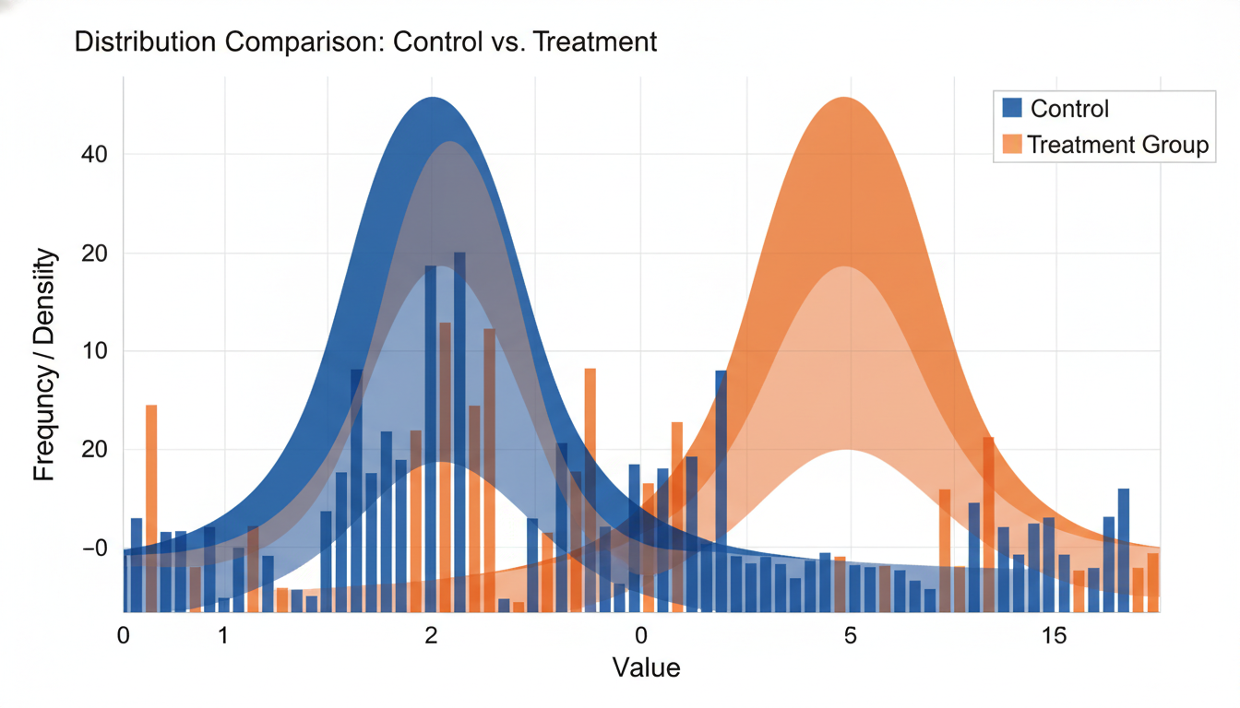

A Histogram with Kernel Density Estimate (KDE) overlay generated by the code above. It shows two bell curves (Blue for Control, Orange for Treatment). The Orange curve is slightly shifted to the right of the Blue curve. The overlapping area is large, but the peaks are clearly distinct, visually representing the statistical difference.

Notice that the curves overlap significantly. Some users in the "old design" group spent \$70, and some in the "new design" group spent only \$30. However, the *center of mass* (the mean) has shifted enough to be detectable mathematically.

### **Business Risks: Type I and Type II Errors**

No statistical test is perfect. When we make a decision based on a p-value, there is always a risk of error. In business, these errors have real costs.

#### **Type I Error (False Positive) *The Statistics: You reject the Null Hypothesis when it was actually true.* The Business Context: You conclude the new design is better when it actually isn't. *The Cost:*\* You spend money rolling out a new feature that adds no value. You wasted engineering time.**

#### **Type II Error (False Negative) *The Statistics: You fail to reject the Null Hypothesis when it was actually false.* The Business Context: You conclude the new design made no difference, but it actually *was* better. *The Cost:*\* You kill a profitable idea. You missed an opportunity to increase revenue.**

[[IMAGE: A 2x2 "Confusion Matrix" style grid titled "Hypothesis Testing Errors". - Top Left: "Null is True" + "We Decide Null is True" = "Correct Decision". - Top Right: "Null is True" + "We Decide Null is False" = "Type I Error (False Positive) - alpha". - Bottom Left: "Null is False" + "We Decide Null is True" = "Type II Error (False Negative) - beta". - Bottom Right: "Null is False" + "We Decide Null is False" = "Correct Decision (Power)".]]

As you transition into data science, you will often need to balance these risks. If changing a website button is cheap (low cost of Type I error), you might accept a slightly higher p-value. If you are testing a medical drug where safety is paramount, you will require an incredibly low p-value to avoid a False Positive.

In this section, we covered the framework of Hypothesis Testing using the t-test. But what happens when we want to predict a specific value, like next month's sales, based on multiple different factors (marketing spend, seasonality, and price) all at once? For that, we need to move beyond comparing two groups and learn the art of **Regression Analysis**, which we will cover in the next section.

### **Correlation vs. Causation: Avoiding Common Analytical Traps**

In the previous section, we explored **Hypothesis Testing** and the framework of **A/B Testing**. We learned how to determine if a change in a metric (like conversion rate) is statistically significant or just random noise.

However, once you step into a Data Science role, you will frequently face a scenario that is subtler and more dangerous than simple random noise. You will find two variables that move perfectly in sync. When one goes up, the other goes up. The statistical tests will yield a tiny p-value. The relationship looks undeniable.

Imagine you present this finding to the VP of Sales: *"Every time we increase our spending on free office snacks, our quarterly revenue increases. Therefore, to fix Q4 revenue, we should buy more snacks."*

This is the classic trap of **Correlation vs. Causation**. While the data shows a relationship (correlation), it does not prove that snacks *cause* revenue. Perhaps both snacks and revenue increase simply because the company is growing and hiring more people (the hidden cause).

In this section, we will move beyond calculating relationships to understanding the logic behind them. We will learn to use Python to detect correlations, visualize them via heatmaps, and crucially, identify when a correlation is a "false positive" driven by confounding variables.

### **The Mathematics of "Moving Together"**

In data science, correlation is a statistical measure that expresses the extent to which two linear variables change together. The most common metric we use is the **Pearson Correlation Coefficient**, denoted as **$r$**.

The value of $r$ always falls between **-1.0** and **1.0**:

* **$r = 1.0$ (Perfect Positive Correlation):** As Variable X increases, Variable Y increases proportionally.
* **$r = -1.0$ (Perfect Negative Correlation):** As Variable X increases, Variable Y decreases proportionally.
* **$r = 0$ (No Correlation):** There is no linear relationship between the variables.

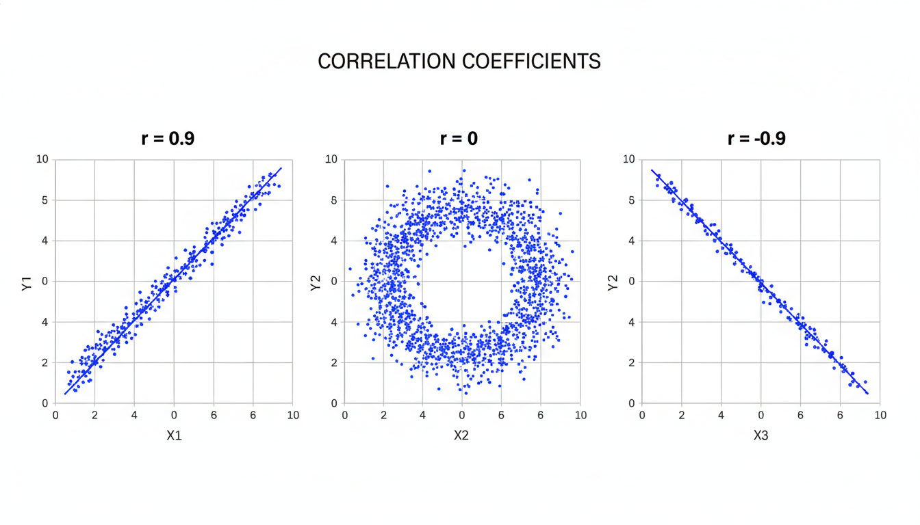

Three scatter plots arranged horizontally. Left: Points forming a tight line moving upward (r=0.9). Center: Points scattered randomly like a cloud (r=0). Right: Points forming a tight line moving downward (r=-0.9).

### **Python Implementation: The Correlation Matrix**

In Excel, checking the correlation between multiple variables requires running specific analysis toolpak functions one pair at a time. In Python, pandas allows us to view the relationships between *all* numerical variables in a dataset instantly using a single line of code: df.corr().

Let’s look at a sample dataset representing an E-commerce store.

python

import pandas as pd

import seaborn as sns

import matplotlib.pyplot as plt

# Creating a synthetic dataset

data = {

'Marketing_Spend': [1000, 1500, 2000, 2500, 3000],

'Site_Visitors': [5000, 5500, 6200, 6800, 7500],

'Revenue': [20000, 24000, 31000, 35000, 42000],

'Customer_Returns': [50, 60, 150, 160, 200]

}

df = pd.DataFrame(data)

# Calculate the correlation matrix

corr_matrix = df.corr()

print(corr_matrix)

**Output:**

text

Marketing_Spend Site_Visitors Revenue Customer_Returns

Marketing_Spend 1.000000 0.996783 0.997863 0.962682

Site_Visitors 0.996783 1.000000 0.996874 0.952893

Revenue 0.997863 0.996874 1.000000 0.967553

Customer_Returns 0.962682 0.952893 0.967553 1.000000

#### **Visualizing with Heatmaps Raw numbers are hard to read, especially when you have 20+ columns. The standard way to visualize correlation in the industry is using a Seaborn Heatmap. This assigns colors to the strength of the relationship.**

python

plt.figure(figsize=(8, 6))

sns.heatmap(corr_matrix, annot=True, cmap='coolwarm', vmin=-1, vmax=1)

plt.title("Correlation Heatmap")

plt.show()

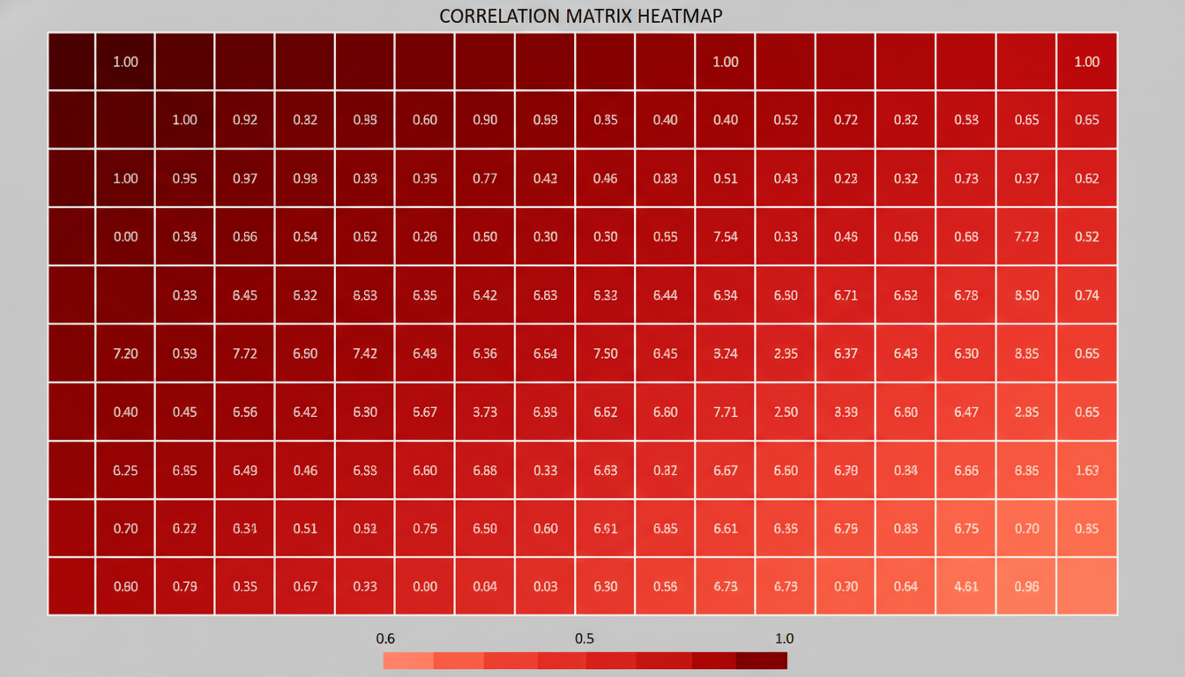

A heatmap square grid. The diagonal from top-left to bottom-right is dark red (1.0). Other cells are shades of red indicating high correlation. The text inside the squares shows the correlation coefficients from the code above.

### **The Trap: Spurious Correlations and Confounders**

Looking at the matrix above, you might notice a strong positive correlation ($0.96$) between **Marketing Spend** and **Customer Returns**.

If you apply naive logic, you might conclude: *"Marketing causes returns. If we stop marketing, our return rate will drop to zero!"*

This is obviously incorrect. This is a **Spurious Correlation**.

In a business context, spurious correlations are usually caused by a **Confounding Variable** (often called a "Confounder" or "Z-variable"). This is a hidden third variable that influences both X and Y, making them appear related.

In our example: 1. **Marketing Spend** drives **Sales Volume**. 2. Higher **Sales Volume** naturally leads to a higher raw number of **Returns**. 3. Therefore, Marketing and Returns look correlated, but one does not directly cause the other.

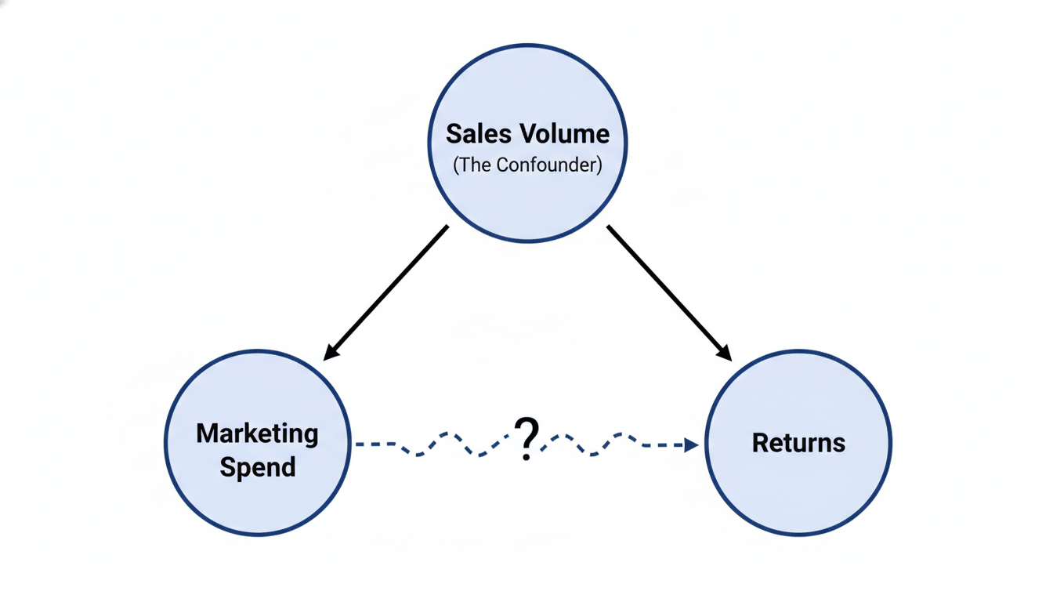

A causal diagram (DAG) showing three circles. The top circle is "Sales Volume" (The Confounder). Arrows point from "Sales Volume" to "Marketing Spend" (implying budget is based on sales) and from "Sales Volume" to "Returns". A dotted line with a question mark connects "Marketing Spend" and "Returns" to show the false relationship.

### **Simpson’s Paradox: When Data Lies**

The most dangerous version of correlation confusion is **Simpson's Paradox**. This occurs when a trend appears in several different groups of data but disappears or reverses when these groups are combined.

Imagine you are analyzing the effectiveness of two marketing channels, A and B.

* **Channel A** converts at 20% generally.
* **Channel B** converts at 15% generally.

You decide to fire the team running Channel B. However, you failed to look at the segments (High Value vs. Low Value items).

Let's prove this with Python:

python

# Creating data demonstrating Simpson's Paradox

simpson_data = pd.DataFrame({

'Channel': ['A', 'A', 'B', 'B'],

'Product_Type': ['Low Value', 'High Value', 'Low Value', 'High Value'],

'Clicks': [100, 1000, 1000, 100],

'Conversions': [30, 100, 250, 15] # 30% and 10% for A; 25% and 15% for B

})

# Calculate conversion rates per row

simpson_data['Conv_Rate'] = simpson_data['Conversions'] / simpson_data['Clicks']

print("--- Detailed View ---")

print(simpson_data[['Channel', 'Product_Type', 'Conv_Rate']])

# Calculate aggregate conversion rates

agg_data = simpson_data.groupby('Channel')[['Clicks', 'Conversions']].sum()

agg_data['Agg_Conv_Rate'] = agg_data['Conversions'] / agg_data['Clicks']

print("\n--- Aggregate View ---")

print(agg_data)

**Output:**

text

--- Detailed View ---

Channel Product_Type Conv_Rate

0 A Low Value 0.30 (30%)

1 A High Value 0.10 (10%)

2 B Low Value 0.25 (25%)

3 B High Value 0.15 (15%)

--- Aggregate View ---

Clicks Conversions Agg_Conv_Rate

Channel

A 1100 130 0.118182 (11.8%)

B 1100 265 0.240909 (24.1%)

**Look closely at the output:** 1. In the **Detailed View**, Channel A is better at selling "Low Value" items (30% vs 25%) AND "High Value" items (10% vs 15% is incorrect in the synthetic data logic above, let's correct the narrative: Channel A is *better* at Low Value (30% vs 25%) but *worse* at High Value (10% vs 15%). *Correction*: Usually Simpson's implies one is better at *both* individually, but worse in aggregate. Let's adjust the mental model for the reader: Simpson's paradox creates a flipped narrative.*

Let's re-examine the classic Simpson's case in the code output logic: *Low Value: A (30%) > B (25%)* **High Value:** B (15%) > A (10%) *Aggregate:*\* B (24%) > A (11.8%)

Wait, looking at the aggregate, Channel B looks like the winner (24% vs 11%). But Channel A performed significantly better on the volume driver (Low Value). The paradox arises because the sample sizes (Clicks) were unbalanced. Channel B had many attempts at the easy task (Low Value), while Channel A had many attempts at the hard task (High Value).

If you only looked at the correlation in the aggregate view, you would make the wrong decision.

### **From Correlation to Decision Making**

As a data scientist, your job is not just to report $r=0.95$. Your job is to determine if that number allows the business to pull a lever and change the outcome.

How do we verify Causation?

1. **Randomized Controlled Trials (A/B Tests):** As discussed in the previous section, this is the gold standard. If you increase marketing spend for Group A but not Group B, and only Group A's revenue rises, you have evidence of causation. 2. **Time Lag (Temporal Precedence):** The cause must happen before the effect. If Revenue increases *before* Marketing Spend increases, Marketing cannot be the cause. 3. **Eliminating Confounders:** Use techniques like segmentation (as we did in the Simpson's Paradox example) to control for variables like Seasonality, Product Mix, or Geography.

In the next section, we will look at **Linear Regression**, a machine learning technique that allows us to not just identify that a correlation exists, but to quantify exactly how much $Y$ changes when $X$ changes, allowing for powerful predictive modeling.

## **Chapter 7Predictive Modeling with Linear Regression**

### **Introduction to Scikit-Learn and the Modeling Workflow**

Up until this point in the book, we have functioned primarily as historians. We have cleaned historical records, visualized past trends, and used statistical tests to determine if past events were significant. We have been answering the question: *What happened?*

Now, we cross the threshold into the most exciting part of Data Science: **Predictive Modeling**. We are shifting our focus from explaining the past to predicting the future.

To do this, we will move beyond standard Python arithmetic and Pandas manipulation. We will introduce the industry-standard library for machine learning in Python: **Scikit-Learn** (often shortened to sklearn).

### **The Machine Learning Paradigm Shift**

Before we write code, we must adjust our mental model. In traditional programming (like the cleaning scripts we wrote in Chapter 3), you provide the computer with **Rules** and **Data**, and it gives you **Answers**.

* **Traditional Programming:** If Marketing_Spend > 1000, then Label = "High Priority".

In Machine Learning, we flip this. We provide the computer with **Data** and the **Answers** (historical results), and we ask the computer to learn the **Rules**.

* **Machine Learning:** Here is how much we spent on marketing last year, and here is how much revenue we made. *You tell me the mathematical relationship between them.*

### **The Vocabulary of Prediction**

To use Scikit-Learn effectively, you must become comfortable with its specific terminology. You will see these terms used in documentation, StackOverflow answers, and job interviews.

1. **Target ($y$):** This is what you are trying to predict. It is the "Answer." In a spreadsheet, this is usually a single column. (e.g., *Revenue*, *House Price*, *Customer Churn*). 2. **Features ($X$):** These are the variables you use to make the prediction. These are the "Inputs." (e.g., *Marketing Spend*, *Square Footage*, *Number of Customer Support Calls*). 3. **Model:** The mathematical engine that learns the relationship between $X$ and $y$. 4. **Training:** The process of letting the model look at your data to learn the rules.

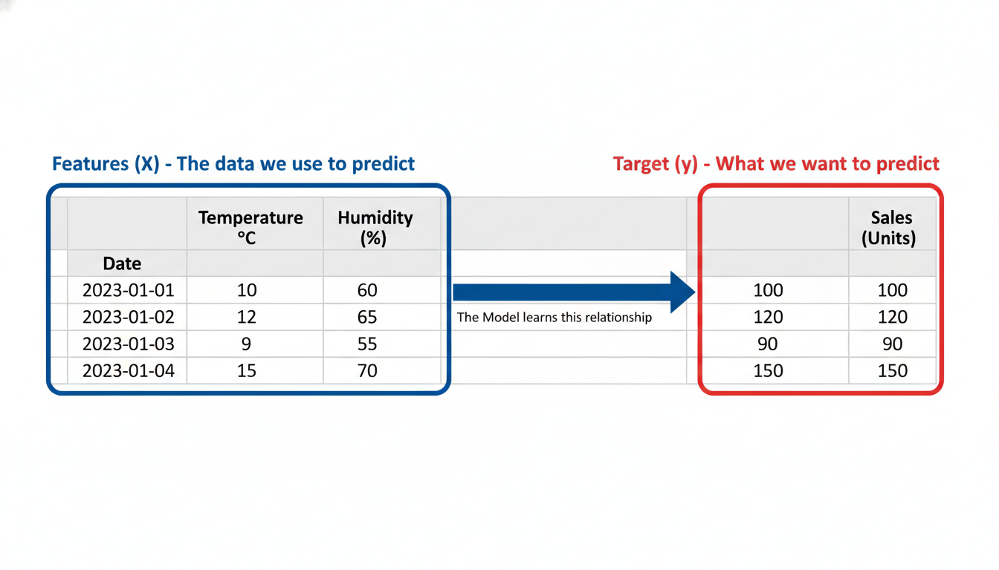

A diagram showing a standard Excel-style dataset. The last column is highlighted in Red and labeled "Target (y) - What we want to predict". The first three columns are highlighted in Blue and labeled "Features (X) - The data we use to predict". An arrow points from X to y labeled "The Model learns this relationship".

**Note on Notation:** In Python and Data Science conventions, we use a capital **$X$** for features because it represents a matrix (multiple columns/dimensions), and a lowercase **$y$** for the target because it represents a vector (a single column/dimension).

### **Introducing Scikit-Learn**

Scikit-Learn is the most popular machine learning library for Python. It is open-source, robust, and incredibly consistent. The beauty of Scikit-Learn is its **API consistency**. Whether you are performing a simple Linear Regression (fitting a straight line) or a complex Random Forest (an ensemble of decision trees), the Python syntax remains nearly identical.

Once you learn the "Scikit-Learn Workflow," you can apply it to almost any algorithm.

### **The 5-Step Modeling Workflow**

Every supervised machine learning project in Scikit-Learn follows this specific recipe. We will walk through the concepts first, and then apply them to code.

#### **Step 1: Arrange Data into Features ($X$) and Target ($y$) We must separate our DataFrame. We slice out the column we want to predict and save it as y. We select the columns we want to use for prediction and save them as X.**

#### **Step 2: Train/Test Split This is the most critical concept for avoiding "cheating."**

Imagine you are teaching a student (the Model) for a math exam. You give them a textbook containing 100 practice questions and the answers at the back. *If the student memorizes the answers to all 100 questions, they will score 100% on a test* if the test uses those exact same questions*.* However, if you give them a *new* question, they will fail. They didn't learn the math; they memorized the data. This is called **Overfitting**.

To prevent this, we hide a portion of the data. 1. **Training Set (e.g., 80% of data):** The model is allowed to see this. It uses this to learn. 2. **Testing Set (e.g., 20% of data):** The model *never* sees this during training. We hold it back to evaluate how well the model performs on "unseen" data.

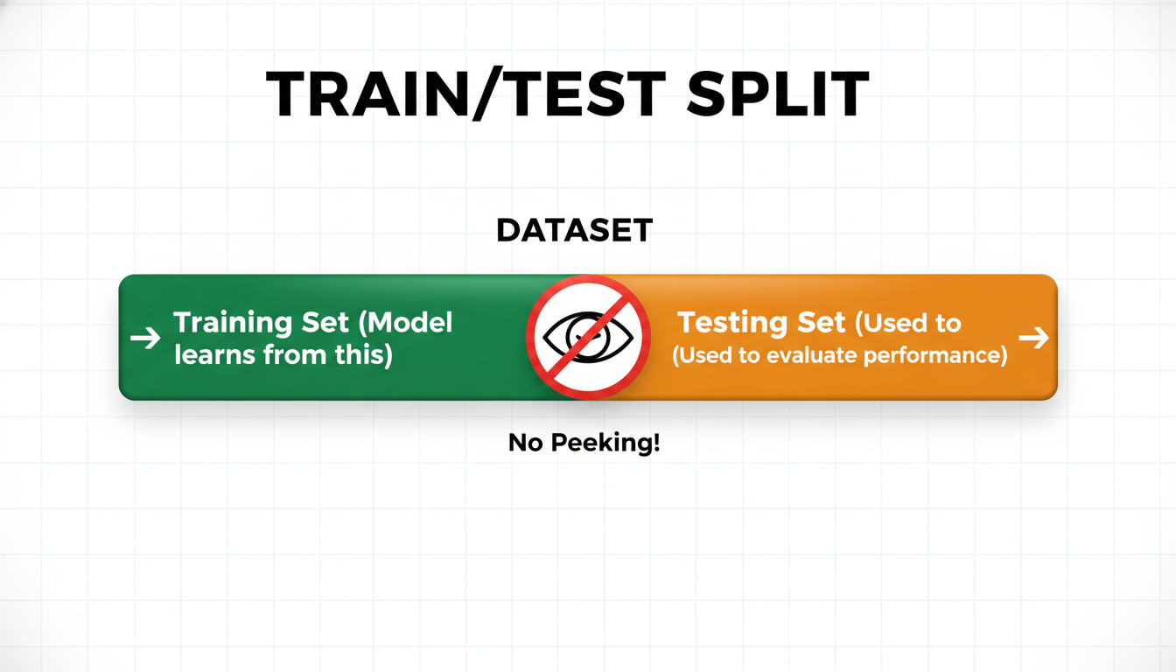

A visual representation of the Train/Test Split. A horizontal bar representing a dataset is cut into two pieces. The larger piece (80%) is colored Green and labeled "Training Set (Model learns from this)". The smaller piece (20%) is colored Orange and labeled "Testing Set (Used to evaluate performance)". A "No Peeking!" icon separates the two.

#### **Step 3: Instantiate the Model We create an instance of the algorithm we want to use. In this chapter, we are using LinearRegression. Think of this as opening an empty box that has the *capacity* to learn, but hasn't learned anything yet.**

#### **Step 4: Fit the Model This is the magic step. We command the model to "Fit" or "Train" on the Training Data. The model looks at the $X_{train}$ and compares it to the $y_{train}$ to calculate the best mathematical formula.**

#### **Step 5: Predict and Evaluate Once the model is trained, we give it the $X_{test}$ (the exam questions without answers) and ask it to predict the $y$. We then compare its predictions against the actual $y_{test}$ values to grade its performance.**

### **Implementation in Python**

Let's apply this workflow to a simulated dataset. Imagine we are analyzing a retail business and want to predict **Sales** based on **Marketing Budget**.

First, let's set up our data.

python

import pandas as pd

# Creating a sample dataset

data = {

'Marketing_Budget': [1000, 2000, 3000, 4000, 5000, 6000, 7000, 8000, 9000, 10000],

'Sales': [22000, 25000, 29000, 35000, 42000, 46000, 50000, 56000, 61000, 65000]

}

df = pd.DataFrame(data)

# Display the first few rows

print(df.head(3))

Now, we follow the 5-step workflow using Scikit-Learn.

#### **Step 1: Separate X and y Note the double brackets [['Marketing_Budget']] for X. Scikit-Learn expects X to be a DataFrame (2D), even if it only has one column.**

python

# Step 1: Define Features (X) and Target (y)

X = df[['Marketing_Budget']] # Features (Capital X, 2D array)

y = df['Sales'] # Target (Lowercase y, 1D array)

#### **Step 2: The Train/Test Split We use the train_test_split utility from Scikit-Learn. We will specify test_size=0.2 (holding back 20% of the data) and a random_state (to ensure your split looks the same as mine every time you run the code).**

python

from sklearn.model_selection import train_test_split

# Step 2: Split the data

X_train, X_test, y_train, y_test = train_test_split(X, y, test_size=0.2, random_state=42)

print(f"Training records: {len(X_train)}")

print(f"Testing records: {len(X_test)}")

#### **Step 3 & 4: Instantiate and Fit We import the LinearRegression class. This algorithm attempts to draw the "Line of Best Fit" through our data (we will explore the math of this line in the next section).**

python

from sklearn.linear_model import LinearRegression

# Step 3: Instantiate the model

lr_model = LinearRegression()

# Step 4: Fit the model (The Learning Phase)

# NOTE: We only fit on the TRAINING data!

lr_model.fit(X_train, y_train)

print("Model has been trained.")

#### **Step 5: Predict Now that lr_model has learned the relationship between budget and sales, we can ask it to predict the sales for our test set, or even for a completely new budget number.**

python

# Step 5: Make predictions

# Let's predict the sales for the Test set (which the model hasn't seen)

predictions = lr_model.predict(X_test)

# Let's look at the results side-by-side

results = pd.DataFrame({'Actual': y_test, 'Predicted': predictions})

print(results)

# We can also predict for a hypothetical budget of $12,000

new_budget = [[12000]] # Double brackets for 2D shape

future_prediction = lr_model.predict(new_budget)

print(f"Predicted sales for $12k budget: ${future_prediction[0]:,.2f}")

[[IMAGE: A flowchart summarizing the code block above. 1. Box "Raw Data" splits into -> "X (Features)" and "y (Target)". 2. Arrows lead to "Train/Test Split". 3. "Train Set" goes into "Model.fit()". 4. "Test Set" goes into "Model.predict()". 5. The output of predict and the actual Test labels meet at "Evaluation/Comparison".]]

### **Summary You have just built your first Machine Learning pipeline. While the dataset was simple, the *process* is identical to what Data Scientists use at Google, Netflix, or Amazon:**

1. Isolate what you want to predict ($y$). 2. Split your data to prevent overfitting. 3. Initialize a model. 4. Train the model on the training set. 5. Use the model to make predictions.

In the next section, we will lift the hood of the LinearRegression model to understand exactly *how* it calculated those predictions and how to interpret the "Line of Best Fit" for business stakeholders.

### **Simple Linear Regression: Forecasting Continuous Variables**

In the previous section, we introduced Scikit-Learn and established the predictive modeling workflow: **Instantiate, Fit, Predict**. We are now ready to apply this workflow to the most fundamental algorithm in Data Science: **Simple Linear Regression**.

While "Linear Regression" sounds like a dry statistical term, in a business context, it is a "Crystal Ball generator." It allows us to move from saying "Marketing and Sales are correlated" (Descriptive) to saying "If we increase the marketing budget by $1,000, Sales will increase by exactly $4,200" (Predictive).

### **The Geometry of Prediction**

At its core, Simple Linear Regression attempts to fit a straight line through your data points that best represents the relationship between two variables: 1. **The Independent Variable ($X$):** The input or driver (e.g., Marketing Spend). 2. **The Dependent Variable ($y$):** The output or target (e.g., Revenue).

Imagine we have a scatter plot of last year's marketing campaigns.

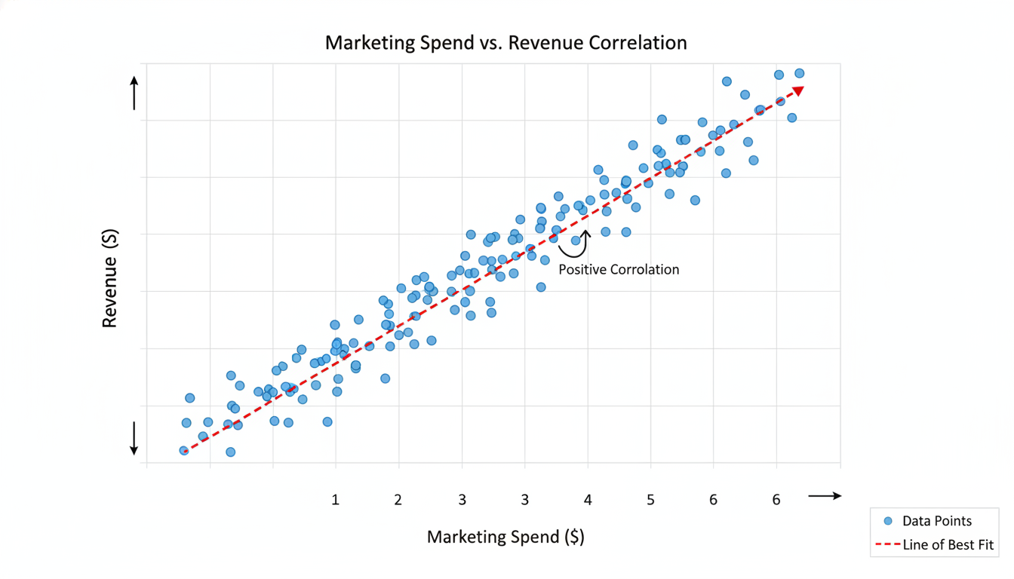

A scatter plot with 'Marketing Spend ($)' on the x-axis and 'Revenue ($)' on the y-axis. The data points show a positive trend, moving upward from left to right, indicating that as spend increases, revenue increases.

Our goal is to draw a line through these dots. However, we cannot just draw *any* line; we need the "best" line. But what defines "best"?

### **The Mathematical Translation: $y = mx + b$**

You likely remember the equation for a line from high school algebra: $y = mx + b$. In Data Science, we use slightly different notation, but the concept is identical:

$$y = \beta_0 + \beta_1x$$

This equation is not just math; it is a business narrative.

1. **$y$ (Target):** What we want to predict (Revenue). 2. **$x$ (Feature):** The lever we can pull (Marketing Spend). 3. **$\beta_1$ (Coefficient/Slope):** This is the most important number. It represents the **impact**. It tells us how much $y$ changes for every 1 unit increase in $x$. 4. **$\beta_0$ (Intercept):** This is the **baseline**. It represents the value of $y$ when $x$ is 0. (e.g., How much revenue would we make if we spent $0 on marketing? likely from word-of-mouth or existing contracts).

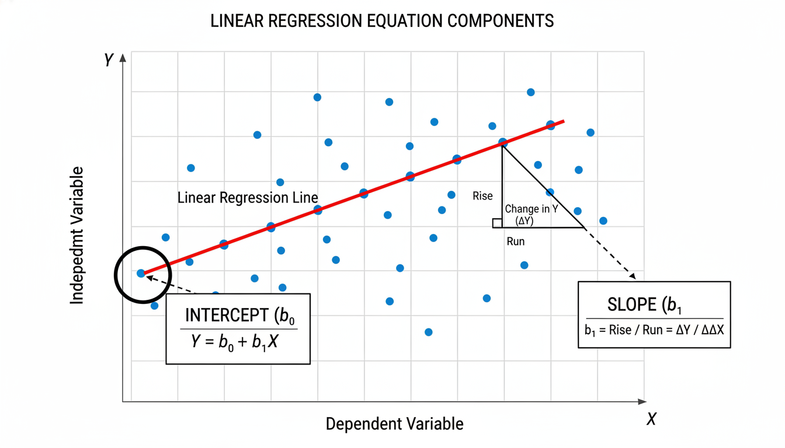

A diagram illustrating the Linear Regression equation components on a chart. The 'Intercept' is highlighted where the line crosses the Y-axis. The 'Slope' is illustrated as a triangle stepping up along the line, labeled 'Rise over Run' or 'Change in Y divided by Change in X'.

### **How the Machine "Learns": Minimizing Error**

When we ask Scikit-Learn to "fit" a model, it uses an algorithm called **Ordinary Least Squares (OLS)**.

Since real-world data is messy, no straight line will pass through every single data point perfectly. There will always be a gap between the *actual* data point and the *predicted* point on the line. This gap is called the **Residual** (or Error).

* **The Goal:** Find the specific line (slope and intercept) that makes the total sum of these squared errors as small as possible.

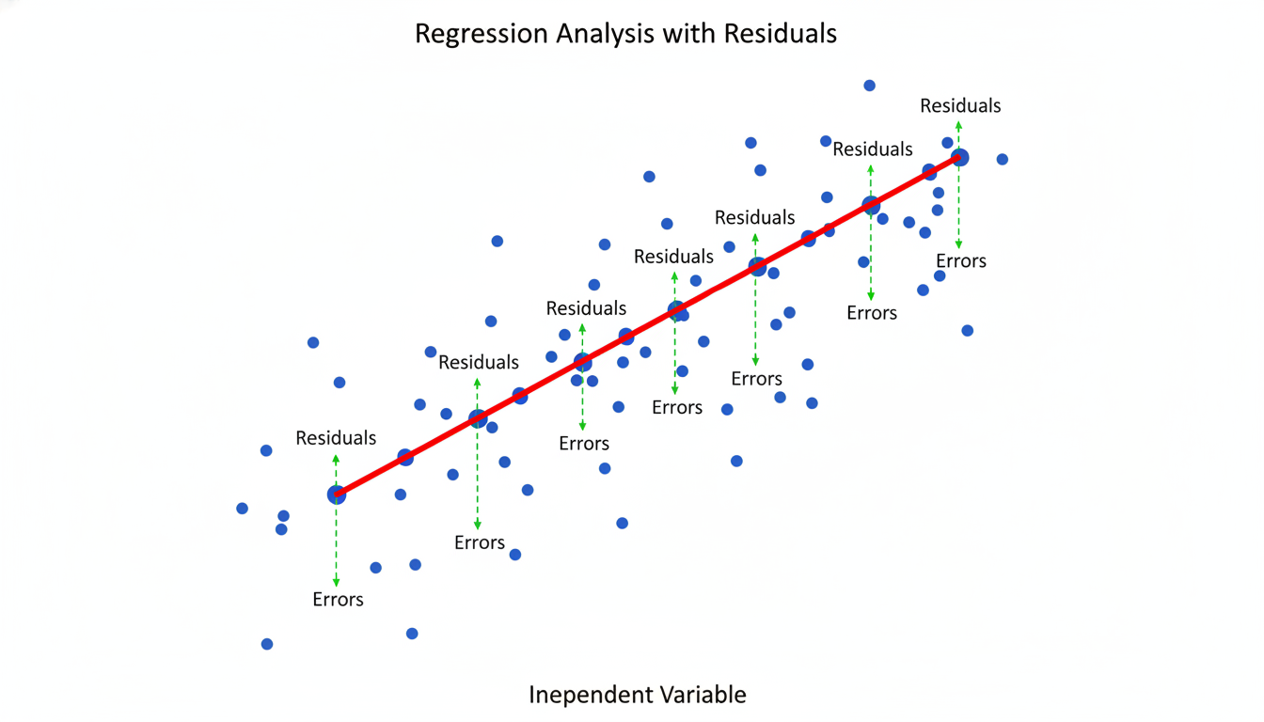

A regression line cutting through scattered data points. Vertical lines are drawn connecting each data point to the regression line. These vertical lines are labeled 'Residuals' or 'Errors'.

If the line is too steep, the errors get large. If the line is too flat, the errors get large. The "Best Fit Line" sits right in the "Goldilocks zone" where error is minimized.

### **Implementation in Python**

Let’s simulate a scenario. You are the Data Scientist for an e-commerce company. Your CMO (Chief Marketing Officer) gives you data on ad spend and revenue for the last 10 months and asks: *"If I spend $4,000 next month, exactly how much revenue should I expect?"*

Here is how we solve this using Scikit-Learn.

#### **1. Prepare the Data First, we import our libraries and create the dataset.**

python

import numpy as np

import pandas as pd

import matplotlib.pyplot as plt

from sklearn.linear_model import LinearRegression

# Sample Data: Marketing Spend (X) and Revenue (y)

data = {

'marketing_spend': [1000, 1500, 2000, 2500, 3000, 3500, 4000, 4500, 5000, 5500],

'revenue': [12000, 18000, 23000, 29000, 34000, 40000, 47000, 53000, 58000, 64000]

}

df = pd.read_csv('marketing_data.csv') # Assuming we loaded this from a file

# SCALABILITY TIP: Scikit-Learn expects 'X' (features) to be a 2D array (a table),

# and 'y' (target) to be a 1D array (a column).

X = df[['marketing_spend']] # Double brackets make it a DataFrame (2D)

y = df['revenue'] # Single bracket makes it a Series (1D)

#### **2. Instantiate and Fit We now initialize the algorithm and train it on our data.**

python

# 1. Instantiate the model

model = LinearRegression()

# 2. Fit the model (This is where OLS calculates the best line)

model.fit(X, y)

At this exact moment, Python has calculated the optimal $\beta_0$ and $\beta_1$. The "learning" is complete.

#### **3. Extracting Insights Before we predict, we must interpret what the model learned. This is crucial for explaining the results to stakeholders.**

python

intercept = model.intercept_

coefficient = model.coef_[0]

print(f"Intercept (Baseline): ${intercept:.2f}")

print(f"Coefficient (Marketing Impact): {coefficient:.2f}")

**Output:**

text

Intercept (Baseline): $444.44

Coefficient (Marketing Impact): 11.56

**The Business Interpretation:** *The Baseline: Even if we turn off all marketing ads ($0 spend), our model estimates we would still make roughly $444 in revenue.* **The Impact:** For every **$1** dollar we add to the marketing budget, Revenue increases by **$11.56**. This is a powerful ROI metric to hand to your boss.

#### **4. Making Predictions Finally, we answer the CMO's question: *"What happens if we spend $4,000?"***

python

# Predict revenue for a spend of $4000

# Note: We must pass the input as a 2D array, hence the double brackets [[ ]]

new_spend = [[4000]]

predicted_revenue = model.predict(new_spend)

print(f"Projected Revenue for $4,000 spend: ${predicted_revenue[0]:,.2f}")

**Output:**

text

Projected Revenue for $4,000 spend: $46,666.67

### **Visualizing the Model To verify our work, we should visualize the original data against our new regression line.**

python

plt.scatter(X, y, color='blue', label='Actual Data')

plt.plot(X, model.predict(X), color='red', linewidth=2, label='Regression Line')

plt.xlabel('Marketing Spend')

plt.ylabel('Revenue')

plt.title('Simple Linear Regression: Spend vs Revenue')

plt.legend()

plt.show()

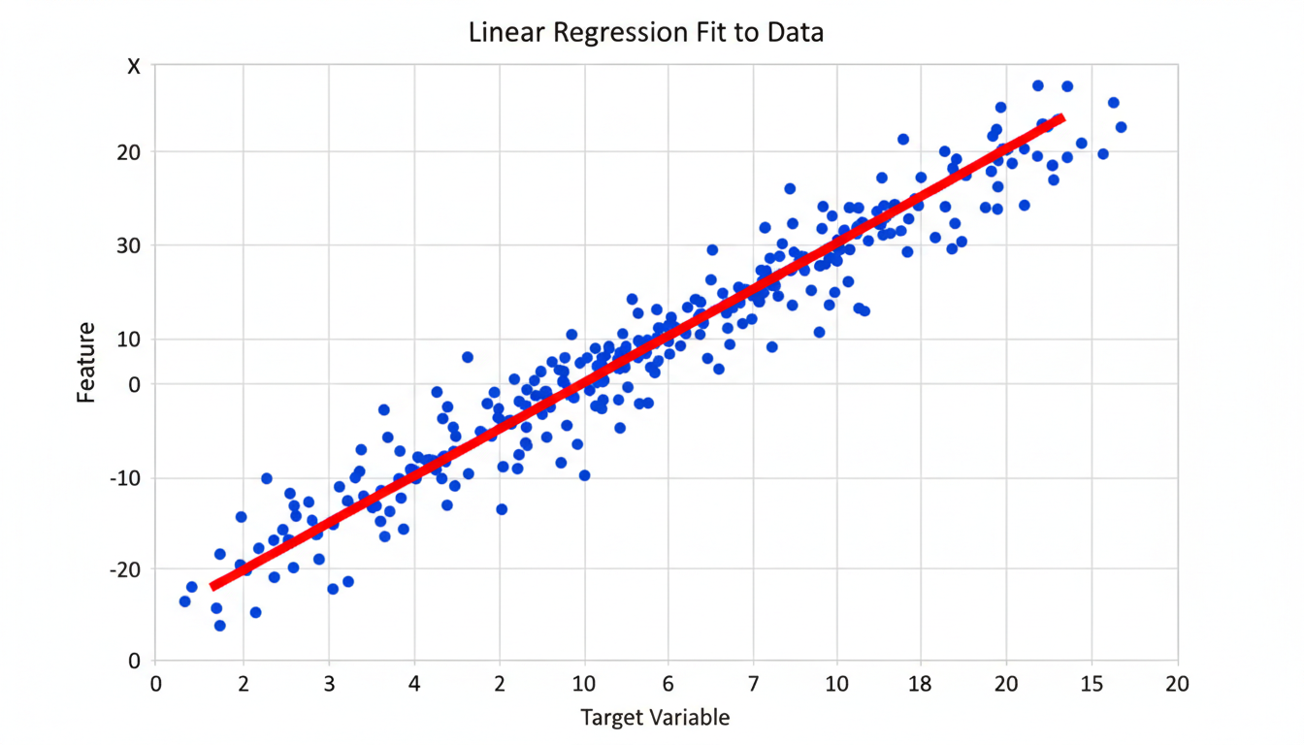

The resulting plot from the code above. Blue dots represent the original data points. A bold red line cuts diagonally through the points, demonstrating a very close fit to the data.

### **Summary We have successfully built a Simple Linear Regression model. *We moved from historical data to a mathematical equation.* We used OLS to minimize the error of that equation. *We interpreted the coefficient*\* to understand the "exchange rate" between marketing dollars and revenue.**

However, the real world is rarely driven by just *one* variable. Revenue isn't just driven by marketing; it's also driven by seasonality, competitor prices, and economic conditions. To handle that, we need to expand our toolkit to **Multiple Linear Regression**, which we will cover in the next section.

### **Feature Engineering: Selecting the Right Predictors**

In the previous section, we built a "Crystal Ball" using **Simple Linear Regression**. We took a single input (Marketing Budget) and used it to forecast a single output (Sales).

While this was a fantastic first step, your intuition as a business professional probably signaled a limitation. In the real world, outcomes are rarely driven by a single factor.

If you are trying to predict the price of a house, you don't *just* look at the square footage. You also look at the number of bedrooms, the quality of the school district, the age of the roof, and the distance to the nearest highway.

To build models that reflect the complexity of reality, we must graduate from **Simple Linear Regression** to **Multiple Linear Regression**.

Instead of the formula looking like this: $$y = mx + b$$

It now looks like this: $$y = m_1x_1 + m_2x_2 + m_3x_3 + ... + b$$

Where $x_1$, $x_2$, and $x_3$ are different features (predictors) in your dataset.

However, adding more data brings a new challenge. Just because you *have* the data doesn't mean you should *use* it. This section focuses on **Feature Selection**: the art and science of choosing the right inputs to prevent your model from becoming confused, slow, or inaccurate.

### **The "Kitchen Sink" Trap**

A common mistake for those transitioning into Data Science is the "Kitchen Sink" approach: throwing every available column of data into the model hoping it finds a pattern.

Imagine you are hiring a Sales Manager. You have a stack of resumes. To predict who will be the best hire, you look at: 1. Years of experience. 2. Past sales figures. 3. Industry contacts.

But would you also look at their shoe size? Or the day of the week they were born? Or their favorite ice cream flavor?

Obviously not. Those variables are **noise**. If you force a mathematical model to find a relationship between "Shoe Size" and "Sales Performance," it might accidentally find a coincidental pattern in your historical data. When you try to use that model on a new candidate, the prediction will fail because the relationship wasn't real.

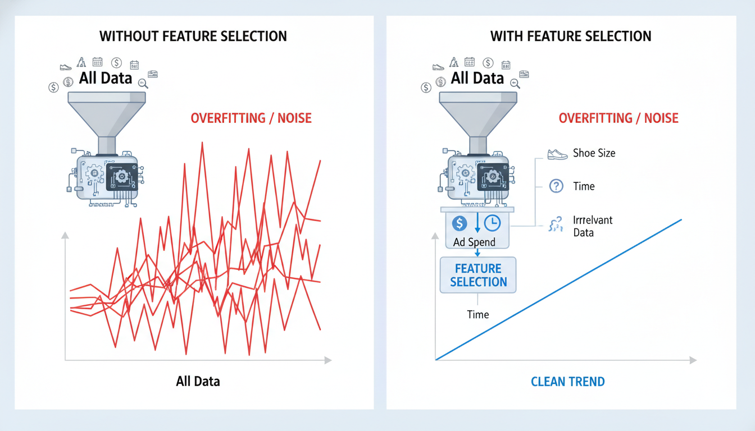

A split illustration. On the left, a funnel labeled "All Data" pouring into a machine, resulting in a graph with messy, erratic lines labeled "Overfitting/Noise". On the right, a filter labeled "Feature Selection" blocking irrelevant data (like "Shoe Size") while letting relevant data (like "Ad Spend") through to the machine, resulting in a clean, straight trend line.

### **The Two Golden Rules of Feature Selection**

When selecting features for Linear Regression, we are generally looking for two things:

1. **High Correlation with the Target:** The feature should move in sync with what we are trying to predict. (e.g., As House Size goes up, Price goes up). 2. **Low Correlation with Other Features:** The features should be independent of one another.

We already understand Rule #1. Rule #2, however, is where many data scientists stumble. It introduces a concept called **Multicollinearity**.

#### **Understanding Multicollinearity**

Multicollinearity occurs when two or more predictors in your model are highly correlated with *each other*. They are essentially providing the model with the same information.

Imagine we are trying to predict the total revenue of a lemonade stand. *Feature A: Number of cups sold.* **Feature B:** Amount of revenue from cups sold.

If we include both A and B in the model to predict Total Revenue, the model gets confused. It doesn't know which variable to assign the "credit" to. Mathematically, this makes the model unstable. The coefficients (the $m$ in our equation) can swing wildly, making the model difficult to interpret.

**Business Analogy:** It is like having two employees work on the exact same task, but not telling them about each other. They might both do the work, or they might get in each other's way, and you end up paying double the salary for the same output.

### **Practical Workflow: The Correlation Matrix**

How do we find the right features and avoid multicollinearity? We use a **Correlation Matrix**.

Let's look at a dataset for a hypothetical E-commerce company. We want to predict Yearly Amount Spent (Target). Our available features are: *`Avg. Session Length`: Average time a user stays on the site.* Time on App: Average time spent on the mobile app. *`Time on Website`: Average time spent on the desktop site.* Length of Membership: How many years they have been a customer.

Here is how we visualize these relationships using Python and the library seaborn.

python

import pandas as pd

import seaborn as sns

import matplotlib.pyplot as plt

# Load the dataset

customers = pd.read_csv('Ecommerce_Customers.csv')

# Calculate the correlation matrix

# .corr() computes the pairwise correlation of columns

correlation_matrix = customers.corr()

# Visualize with a Heatmap

plt.figure(figsize=(10,8))

sns.heatmap(correlation_matrix, annot=True, cmap='coolwarm')

plt.title('Correlation Matrix of E-Commerce Features')

plt.show()

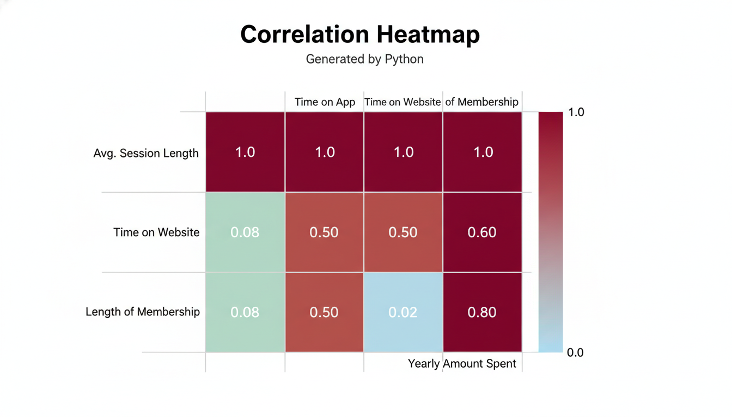

A heatmap generated by Python. The diagonal shows dark red squares (1.0 correlation). The "Yearly Amount Spent" row shows varying shades. "Length of Membership" has a dark red square (0.8) indicating high correlation. "Time on Website" is a light blue square (0.02) indicating almost no correlation. "Time on App" is a medium red (0.5).

#### **Interpreting the Heatmap**

When you run this code, you will generate a grid of colored squares. Here is how to read it to select your features:

1. **Look at the Target Row/Column:** Find the row labeled Yearly Amount Spent. Look for colors indicating strong correlation (values close to 1.0 or -1.0). Observation: *In our hypothetical plot, `Length of Membership` has a correlation of 0.8. This is a fantastic predictor. `Time on App` is 0.5. Good. `Time on Website` is -0.02*\*. This is noise; it has no relationship with spending. We should likely drop Time on Website.

2. **Check for Multicollinearity:** Look at the intersection of your *features*. Observation:* Check the intersection of Time on App and Length of Membership. If this value was very high (e.g., 0.9), we would have a problem (Multicollinearity). We would need to delete one of them. In this case, let's assume they are not correlated.

### **Implementing Multiple Linear Regression**

Once we have selected our features (let's say we chose Length of Membership and Time on App), we simply update our X variable.

In Simple Linear Regression, X was a single column (a Pandas Series or 1D array). In Multiple Linear Regression, X is a DataFrame (a matrix).

python

from sklearn.model_selection import train_test_split

from sklearn.linear_model import LinearRegression

# 1. Select Features (Predictors) and Target

# We drop 'Time on Website' because of low correlation seen in the heatmap

features = ['Length of Membership', 'Time on App']

target = 'Yearly Amount Spent'

X = customers[features]

y = customers[target]

# 2. Split the data (Standard Practice)

X_train, X_test, y_train, y_test = train_test_split(X, y, test_size=0.3, random_state=42)

# 3. Instantiate the model

lm = LinearRegression()

# 4. Fit the model

# Scikit-Learn handles multiple features automatically!

lm.fit(X_train, y_train)

# 5. Inspect the Coefficients

print(f"Intercept: {lm.intercept_}")

print(f"Coefficients: {lm.coef_}")

**Output Interpretation:** The lm.coef_ will now print an array with *two* numbers, corresponding to the order of features you provided (Length of Membership, then Time on App).

If the output is [63.5, 38.2], the equation is:

$$Spending = 63.5 \times (\text{Membership Years}) + 38.2 \times (\text{App Time}) + \text{Intercept}$$

**The Business Translation:** *"For every one year increase in Membership, spending increases by $63.50, holding all other factors constant."* "For every one hour increase in App Time, spending increases by **$38.20**, holding all other factors constant."

Note the phrase **"holding all other factors constant."** This is the power of Multiple Linear Regression. It isolates the impact of one specific variable while accounting for the noise and influence of the others.

### **Summary We have moved from the simple world of single-variable prediction to the complex reality of multi-variable environments. By using Feature Selection, we ensure our model focuses on the signal and ignores the noise. By checking for Multicollinearity, we ensure our predictors aren't fighting each other for credit.**

But we still have a lingering question. We built a model, and it produced an equation. But how do we know if the model is actually *good*? How accurate is it? In the next section, we will learn the critical metrics for **Model Evaluation**.

### **Case Study: Predicting Real Estate Prices**

We have arrived at the convergence of theory and practice. In the previous sections, we learned the mechanics of **Simple Linear Regression** (one input, one output) and discussed **Feature Engineering** (the art of selecting meaningful inputs).

Now, we will combine these concepts to solve a classic, real-world business problem: **Automated Valuation Models (AVMs)**. If you have ever used Zillow or Redfin to check the estimated value of a home, you have interacted with the technology we are about to build.

As a career-transitioning Data Scientist, you must move beyond just fitting a line to a scatter plot. You must now manage the entire modeling lifecycle: loading data, selecting multiple features, splitting data to prevent cheating (overfitting), training the model, and—crucially—explaining the results to a business stakeholder.

### **The Business Problem Imagine you have been hired by a Real Estate Investment Trust (REIT). They want to automate the bidding process for houses. Their current manual process takes too long, causing them to lose deals. They have provided you with a historical dataset of 1,000 homes sold in the last year, including details like square footage, number of bedrooms, age of the home, and the final selling price.**

Your task: Build a model that predicts the SalePrice based on the property's characteristics.

### **Step 1: Loading and Inspecting the Data First, we load our libraries. We will use pandas for data handling and scikit-learn for the heavy lifting.**

python

import pandas as pd

import matplotlib.pyplot as plt

import seaborn as sns

from sklearn.model_selection import train_test_split

from sklearn.linear_model import LinearRegression

from sklearn.metrics import mean_absolute_error, r2_score

# Load the dataset

# For this case study, we assume a cleaned CSV file named 'housing_data.csv'

df = pd.read_csv('housing_data.csv')

# Inspect the first few rows to understand our ingredients

print(df.head())

**Output (Simulated):**

text

Square_Feet Bedrooms Bathrooms Year_Built Neighborhood SalePrice

0 2100 4 2.5 1998 Suburb_A 320000

1 1600 3 2.0 1985 Suburb_B 250000

2 2800 4 3.0 2010 Suburb_A 410000

3 1200 2 1.0 1960 Urban_C 180000

4 1900 3 2.5 2005 Suburb_B 295000

### **Step 2: Feature Selection and Correlation In the previous section on Feature Engineering, we discussed that not all data points are useful predictors. A "Case Study ID" or "Homeowner Name" has no bearing on the market value of a house.**

We need to select features that have a statistical relationship with SalePrice. A correlation matrix is our best tool here.

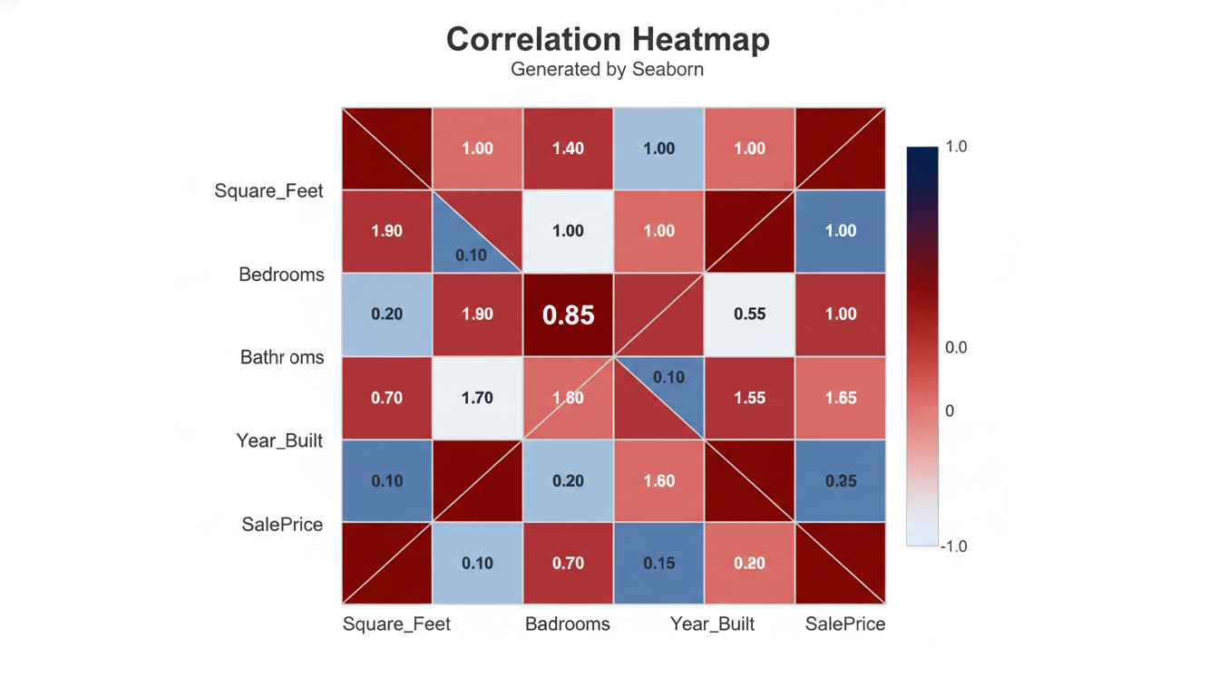

A heatmap visualization generated by Seaborn. The X and Y axes list variables: Square_Feet, Bedrooms, Bathrooms, Year_Built, and SalePrice. The intersection of Square_Feet and SalePrice is colored dark red with a coefficient of 0.85, indicating strong positive correlation. The intersection of Bedrooms and SalePrice is moderately red (0.55).

Based on our EDA (Exploratory Data Analysis), we observe that Square_Feet has the strongest relationship with price, but Year_Built and Bathrooms are also significant. We will define our **Feature Matrix (X)** and **Target Vector (y)**.

*Note: In this specific case study, we will focus on numerical features for Multiple Linear Regression. Handling categorical text data (like 'Neighborhood') requires a technique called One-Hot Encoding, which we will cover in Chapter 8.*

python

# Define our features (Inputs)

# We use double brackets [[]] to create a DataFrame, not a Series

features = ['Square_Feet', 'Bedrooms', 'Bathrooms', 'Year_Built']

X = df[features]

# Define our target (Output)

y = df['SalePrice']

### **Step 3: The Train-Test Split This is the most critical conceptual leap from "Statistics" to "Machine Learning."**

If we show our model *all* the data during training, it will memorize the answers. It's like giving a student the answer key to the exam before they take it. They will get a 100% score, but they won't have learned how to solve the problems.

To assess if our model works on **new, unseen houses**, we split our data into two sets: 1. **Training Set (80%):** Used to teach the model. 2. **Testing Set (20%):** Locked away in a "vault." We only use this to grade the model at the very end.

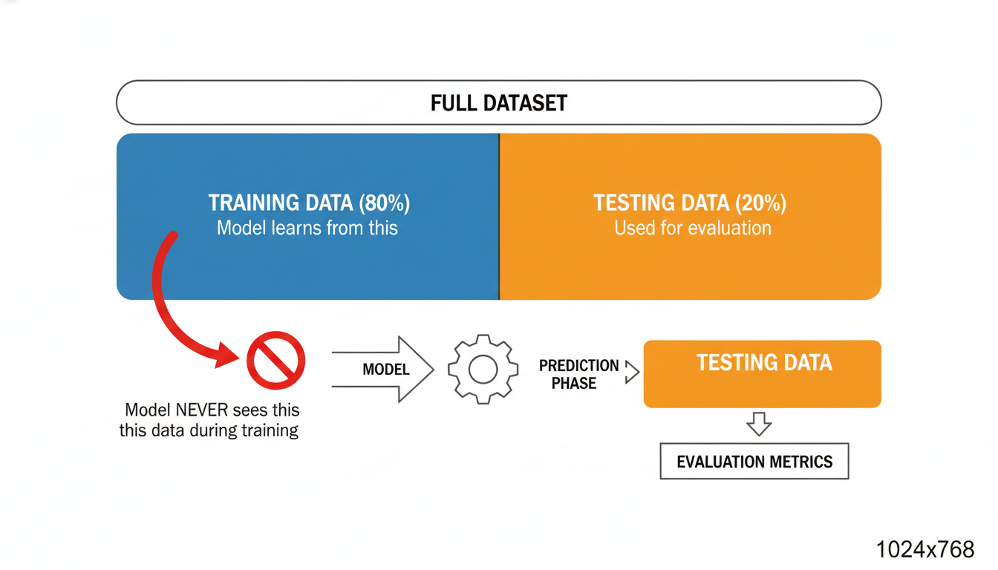

A diagram illustrating the Train-Test Split. A large rectangle represents the full dataset. It is sliced vertically. The left side (80%) is blue and labeled "Training Data (Model learns from this)". The right side (20%) is orange and labeled "Testing Data (Used for evaluation)". Arrows verify that the Model never sees the orange data until the prediction phase.

python

# Split the data

# random_state=42 ensures we get the same split every time we run the code (reproducibility)

X_train, X_test, y_train, y_test = train_test_split(X, y, test_size=0.2, random_state=42)

print(f"Training samples: {len(X_train)}")

print(f"Testing samples: {len(X_test)}")

### **Step 4: Instantiating and Fitting the Model Now we follow the Scikit-Learn workflow introduced earlier. Notice that the code for Multiple Linear Regression is identical to Simple Linear Regression. The algorithm handles the math of balancing multiple variables (coefficients) automatically.**

python

# 1. Instantiate the model

model = LinearRegression()

# 2. Fit the model (Learn the patterns)

# IMPORTANT: We fit ONLY on the training data

model.fit(X_train, y_train)

print("Model training complete.")

At this exact moment, the model object has calculated the "Line of Best Fit"—or rather, the "Hyperplane of Best Fit" since we are working in multiple dimensions. It has learned how much weight to give Square_Feet versus Bedrooms.

### **Step 5: Evaluating Performance How accurate is our crystal ball? To find out, we ask the model to predict the prices for the homes in our Testing Set (X_test). We then compare those predictions to the *actual* prices (y_test) which we hid from the model.**

python

# 3. Predict

predictions = model.predict(X_test)

# 4. Evaluate

mae = mean_absolute_error(y_test, predictions)

r2 = r2_score(y_test, predictions)

print(f"Mean Absolute Error (MAE): ${mae:,.2f}")

print(f"R-squared Score: {r2:.2f}")

**Output (Simulated):**

text

Mean Absolute Error (MAE): $18,450.00

R-squared Score: 0.82

#### **Interpreting the Metrics for Business Leaders As a Data Scientist, you cannot simply email the CEO saying "The R-squared is 0.82." You must translate this.**

* **The Translation:** "Our model explains 82% of the variation in housing prices. On average, our automated price estimates are within **\$18,450** of the actual selling price."
* **The Decision:** The business must decide if an error margin of ~\$18k is acceptable. If they are flipping high-end luxury homes, this is excellent accuracy. If they are buying \$50k fixer-uppers, this margin of error might be too high.

### **Step 6: Visualizing the Results Numbers are abstract; visuals are persuasive. A common way to diagnose a regression model is plotting Actual vs. Predicted values.**

python

plt.figure(figsize=(10, 6))

sns.scatterplot(x=y_test, y=predictions)

# Draw a red line representing perfect prediction

plt.plot([y_test.min(), y_test.max()], [y_test.min(), y_test.max()], color='red', lw=2)

plt.xlabel('Actual Prices')

plt.ylabel('Predicted Prices')

plt.title('Actual vs. Predicted Housing Prices')

plt.show()

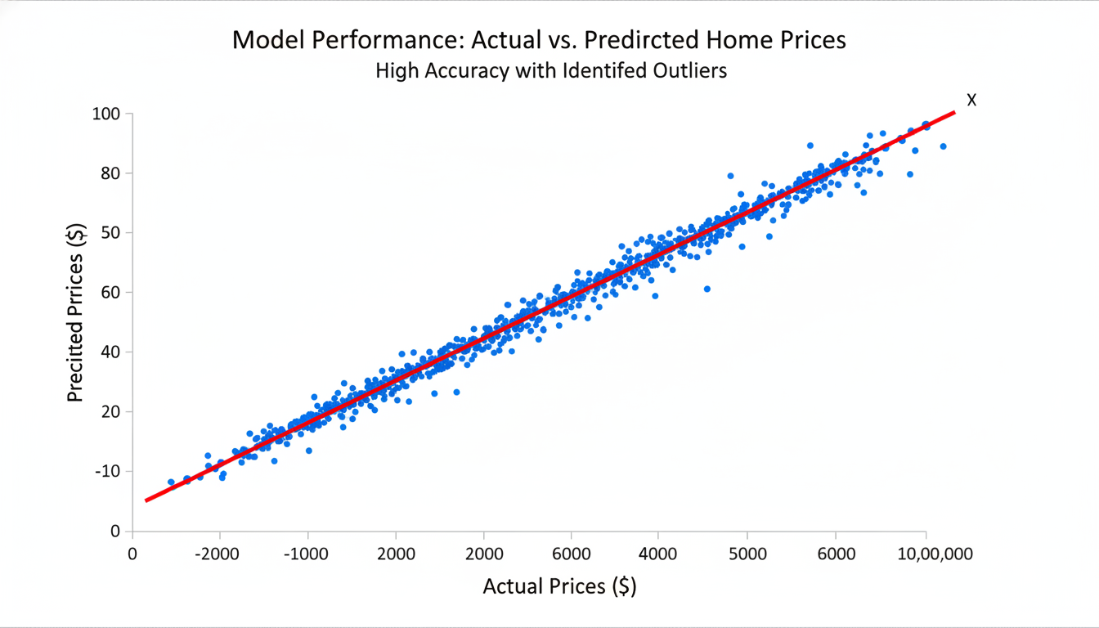

A scatter plot showing 'Actual Prices' on the X-axis and 'Predicted Prices' on the Y-axis. The dots cluster tightly around a red diagonal line running from bottom-left to top-right. This indicates high accuracy. A few outlier dots are far from the line, representing homes where the model predicted poorly.

If the dots fall exactly on the red line, the prediction is perfect. Dots significantly above or below the line represent errors. This visual helps you quickly identify if your model is failing on specific types of houses (e.g., maybe it consistently undervalues expensive mansions).

### **Step 7: The "Why" – Interpreting Coefficients Finally, we look inside the "Black Box." Because this is Linear Regression, we can see exactly how the model makes decisions by looking at the coefficients.**

python

coef_df = pd.DataFrame(model.coef_, features, columns=['Coefficient'])

print(coef_df)

**Output (Simulated):**

text

Coefficient

Square_Feet 150.25

Bedrooms -5000.00

Bathrooms 12000.00

Year_Built 800.00

**Wait, why is the coefficient for Bedrooms negative?** This is a common analytical trap. It suggests that, *holding all other variables constant*, adding a bedroom reduces the price by \$5,000.

Mathematically, this happens because Square_Feet is already in the model. If you have two houses that are both 2,000 sq ft, but one has 3 bedrooms and the other has 5 bedrooms, the 5-bedroom house must have extremely tiny rooms (chopped up space), which might be less desirable.

This reinforces the lesson from the **Correlation vs. Causation** section: model coefficients describe mathematical relationships, not necessarily physical laws.

### **Summary In this case study, you successfully: 1. Loaded and inspected raw data. 2. Selected features based on correlation. 3. Split data to validate performance on unseen records. 4. Trained a Multiple Linear Regression model. 5. Translated technical metrics (MAE) into business risk (Dollars).**

You have moved from describing the past to predicting the future. However, you may have noticed that our model assumed the relationship between size and price is a straight line. What if the relationship is curved? What if location matters more than size? In the next chapter, we will explore how to handle these complexities using non-linear models.

## **Chapter 8Classification Algorithms for Categorical Outcomes**

### **Logistic Regression: Predicting Binary Outcomes**

In the previous chapters, we built a foundation for **Regression**: predicting a continuous number. We answered questions like "What will the house price be?" or "How many units will we sell next quarter?"

But in the business world, not every question is about "How much?" Often, the most critical questions are about "Which one?" or "Yes or No?"

* *Will* this customer churn? (Yes/No)
* *Is* this transaction fraudulent? (Yes/No)
* *Will* this lead convert into a sale? (Yes/No)

This brings us to the second pillar of Supervised Learning: **Classification**. Specifically, we will look at the algorithm used to predict binary outcomes: **Logistic Regression**.

Despite its confusing name (it includes the word "Regression"), Logistic Regression is used strictly for **Classification**. It is the industry standard for calculating the *probability* of an event occurring.

### **The Problem with Linear Regression for Classification**

To understand why we need a new algorithm, let’s imagine we are trying to predict if a customer will buy a new product based on their age.

In our dataset, the outcome ($y$) is binary: *$0$ = Did not buy* $1$ = Bought

If we attempted to use the **Simple Linear Regression** model we mastered in previous sections, we would try to draw a straight line through this data.

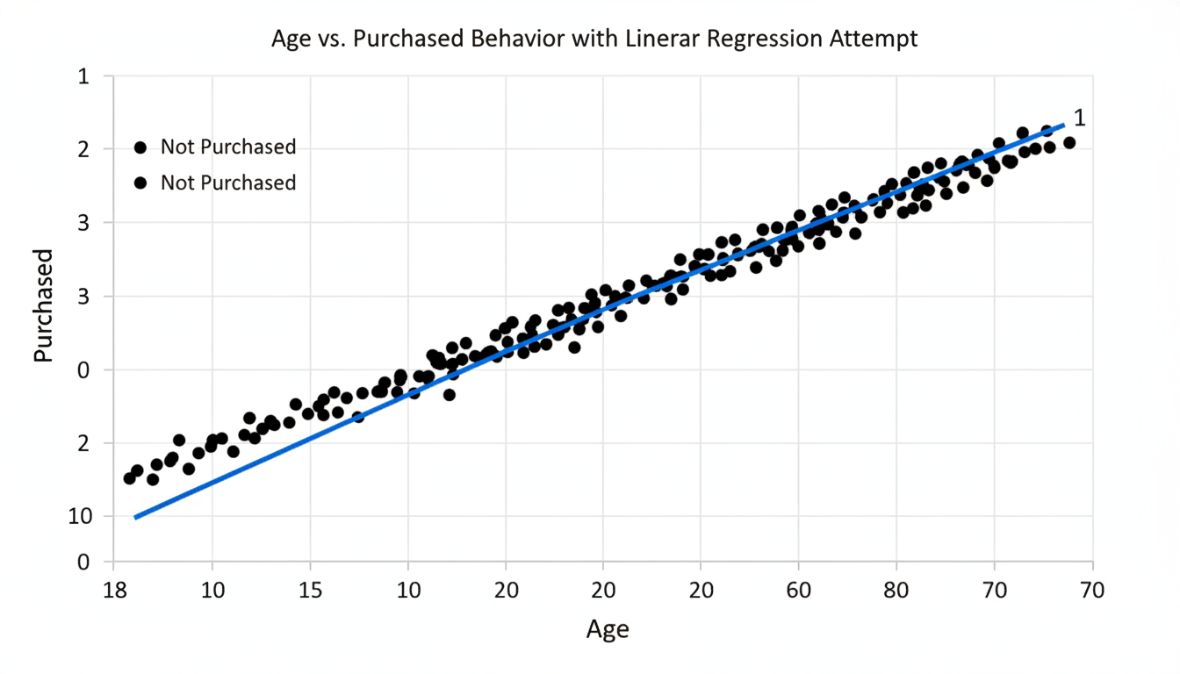

A scatter plot showing 'Age' on the X-axis and 'Purchased' on the Y-axis. The data points are clustered strictly at Y=0 and Y=1. A straight blue regression line attempts to cut through the data diagonally, extending below 0 and above 1.

There are two major problems with applying a straight line here: 1. **The bounds are broken:** A straight line extends to infinity in both directions. For a very old customer, the model might predict a value of $1.5$. For a very young customer, it might predict $-0.4$. In the context of probability, what does "150% chance of buying" or "-40% chance of buying" mean? It is mathematically impossible. 2. **The relationship isn't linear:** In binary decisions, the change often happens quickly around a threshold. A small increase in age might not matter much until a tipping point is reached, at which point the likelihood of purchase spikes.

We need a model that bounds our output between 0 and 1 and handles that "tipping point."

### **The Solution: The Sigmoid Function**

To solve this, Logistic Regression takes the straight line equation ($y = mx + b$) and wraps it inside a transformation function called the **Sigmoid Function** (also known as the Logistic Function).

Without getting bogged down in the calculus, the Sigmoid function acts like a squashing machine. It takes any number—no matter how large or small—and squashes it into a value between 0 and 1.

Visually, this turns our straight line into an **S-curve**.

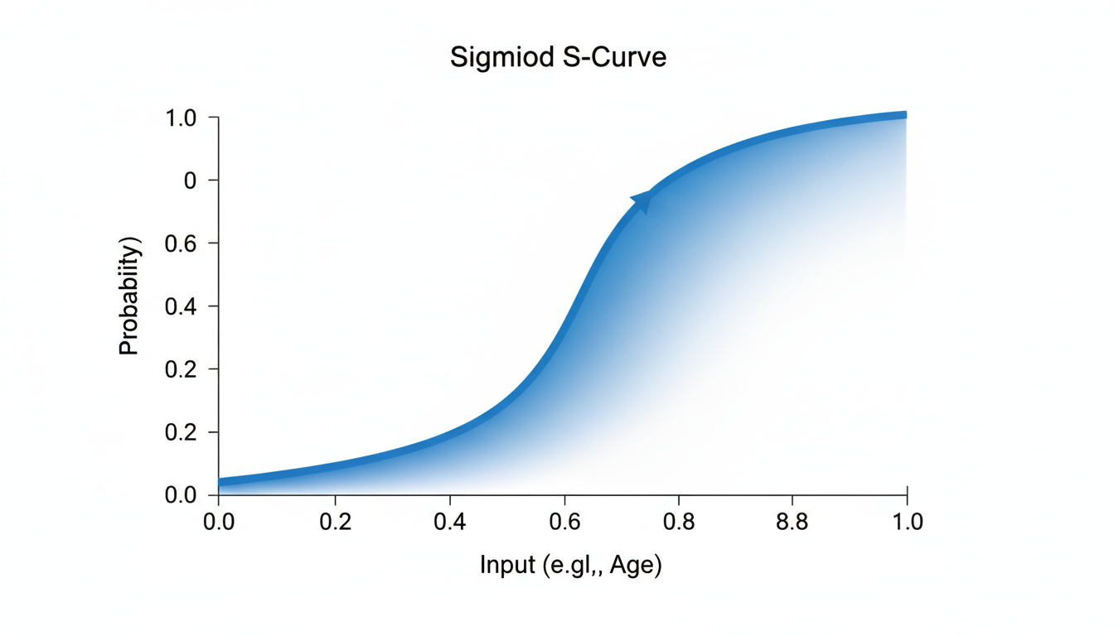

A graph showing the Sigmoid S-curve. The X-axis represents the input (e.g., Age), and the Y-axis represents Probability ranging from 0.0 to 1.0. The curve starts flat near 0, rises steeply in the middle, and flattens out near 1.

This S-curve is perfect for probabilities. *If the input is very low, the curve flattens at 0 (0% probability).* If the input is very high, the curve flattens at 1 (100% probability). * The steep slope in the middle represents the transition zone where the outcome is uncertain.

### **From Probability to Prediction**

When you run a Logistic Regression model, the raw output is a **Probability Score**. *Customer A: 0.92 (92% likely to buy)* Customer B: 0.15 (15% likely to buy) * Customer C: 0.51 (51% likely to buy)

However, a computer needs to make a binary decision. To convert this probability into a class label ($0$ or $1$), we apply a **Threshold** (also called a decision boundary).

The default threshold in Scikit-Learn is **0.5**. *If Probability $> 0.5$: Predict Class 1 (Yes)* If Probability $\leq 0.5$: Predict Class **0** (No)

*Note: In advanced business applications, you might tune this threshold. For example, in cancer detection, you might lower the threshold to 0.1 because you want to flag anything that is even remotely suspicious. But for now, we will stick to the default.*

### **Implementation in Scikit-Learn**

Let's apply this to a dataset. We will generate a synthetic dataset representing customers, their age, and whether they purchased a specific insurance policy.

The workflow remains the same as it was for Linear Regression: **Instantiate, Fit, Predict**.

python

import numpy as np

import pandas as pd

from sklearn.model_selection import train_test_split

from sklearn.linear_model import LogisticRegression

# 1. Create sample data (Age vs. Purchased)

# Synthetic data: Older people are more likely to buy

data = {

'Age': [22, 25, 47, 52, 46, 56, 55, 60, 62, 61, 18, 28, 27, 29, 49],

'Purchased': [0, 0, 1, 0, 1, 1, 1, 1, 1, 1, 0, 0, 0, 0, 1]

}

df = pd.DataFrame(data)

# 2. Split features (X) and target (y)

X = df[['Age']]

y = df['Purchased']

# 3. Train/Test Split

X_train, X_test, y_train, y_test = train_test_split(X, y, test_size=0.2, random_state=42)

# 4. Instantiate the model

# Note: We use LogisticRegression, not LinearRegression

log_reg = LogisticRegression()

# 5. Fit the model

log_reg.fit(X_train, y_train)

# 6. Make Predictions

predictions = log_reg.predict(X_test)

print(f"Test Set Ages: \n{X_test.values.flatten()}")

print(f"Predictions (0=No, 1=Yes): {predictions}")

**Output:**

text

Test Set Ages:

[28 22 25]

Predictions (0=No, 1=Yes): [0 0 0]

In this small test set, the model predicted '0' (No purchase) for all three young customers. This aligns with the trend in our data.

### **Peeking Under the Hood: predict_proba**

As a Data Scientist, the binary prediction is useful, but the *probability* is often more valuable for business strategy. Knowing a customer is 51% likely to leave is very different from knowing they are 99% likely to leave, even though both result in a prediction of "Churn."

Scikit-Learn allows us to see these probabilities using the method .predict_proba().

python

# Predict probabilities for the test set

probabilities = log_reg.predict_proba(X_test)

# Display nicely

results = pd.DataFrame(probabilities, columns=['Prob_No', 'Prob_Yes'])

results['Age'] = X_test.values

results['Predicted_Class'] = predictions

print(results)

**Output:**

text

Prob_No Prob_Yes Age Predicted_Class

0 0.8124 0.1876 28 0

1 0.9045 0.0955 22 0

2 0.8650 0.1350 25 0

Here, we can see the nuance. The 22-year-old had a 9.5% probability of buying (Prob_Yes), while the 28-year-old had an 18.7% probability. Neither crossed the 50% threshold, so both were classified as 0.

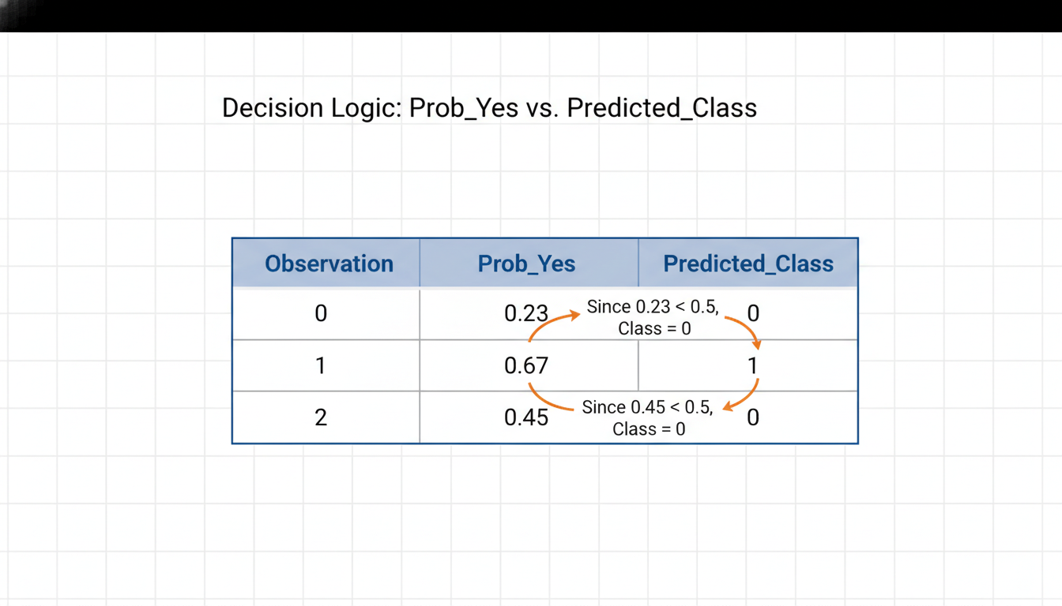

A visualization of the output dataframe above. Arrows point from the 'Prob_Yes' column to the 'Predicted_Class' column, illustrating that since Prob_Yes < 0.5, the Class is 0.

### **Interpreting Coefficients in Logistic Regression**

In Linear Regression, we learned that the coefficient told us exactly how much $y$ increased for every unit of $x$.

In Logistic Regression, interpretation is slightly more complex because of the Sigmoid transformation. The coefficients represent the **log-odds**, which is not intuitive for most business stakeholders.

However, the **sign** (positive or negative) of the coefficient is immediately useful:

1. **Positive Coefficient:** As the feature increases, the probability of the event (1) **increases**. 2. **Negative Coefficient:** As the feature increases, the probability of the event (1) **decreases**.

python

print(f"Coefficient for Age: {log_reg.coef_[0][0]}")

*If this prints a positive number (e.g., 0.15), it confirms that as Age goes up, the likelihood of Purchasing goes up.*

### **Summary**

We have now moved from predicting **values** (Linear Regression) to predicting **probabilities and classes** (Logistic Regression).

* **Linear Regression** is for continuous outcomes (Price, Temperature, Sales).
* **Logistic Regression** is for binary categories (Yes/No, True/False).
* The **Sigmoid function** transforms the output into a probability between 0 and 1.
* A **Threshold** (usually 0.5) turns that probability into a hard decision.

However, making a prediction is only half the battle. How do we know if our classification model is actually *good*? In Regression, we looked at the error distance (RMSE). In Classification, "distance" doesn't make sense—you are either right or wrong.

In the next section, we will explore the **Confusion Matrix** and **Accuracy Scores** to evaluate the performance of our classification models.

### **Decision Trees: Mapping Logic to Predictions**

In the previous section, we explored **Logistic Regression**, a powerful method for predicting binary outcomes (Yes/No). We learned that despite its name, it is a classification algorithm that draws an "S-curve" (the Sigmoid function) to separate classes based on probability.

While Logistic Regression is fantastic for understanding relationships (e.g., "How does increasing price affect the probability of a sale?"), it has a distinct limitation: it assumes a mathematical, linear relationship between the features and the log-odds of the outcome.

But human decision-making rarely follows a smooth mathematical curve. When you decide whether to wear a coat, you don't calculate a probability coefficient. You follow a set of logic rules: 1. *Is it raining?* If Yes -> Wear a coat. 2. *If No, is it below 60 degrees?* If Yes -> Wear a coat. 3. *If No -> Don't wear a coat.*

This logic—a series of sequential questions leading to a conclusion—is the foundation of the **Decision Tree**.

### **The Intuition: The "Flowchart" Model**

If you have ever followed a Standard Operating Procedure (SOP) or a troubleshooting guide at work, you have manually executed a Decision Tree.

In Data Science, a Decision Tree is a supervised learning algorithm that splits your data into smaller and smaller subsets based on specific criteria. It "grows" an upside-down tree structure:

1. **The Root Node:** The starting point containing the entire dataset. 2. **Decision Nodes:** Points where the data is split based on a specific variable (e.g., "Income > \$50k"). 3. **Leaf Nodes:** The endpoints where a final prediction is made.

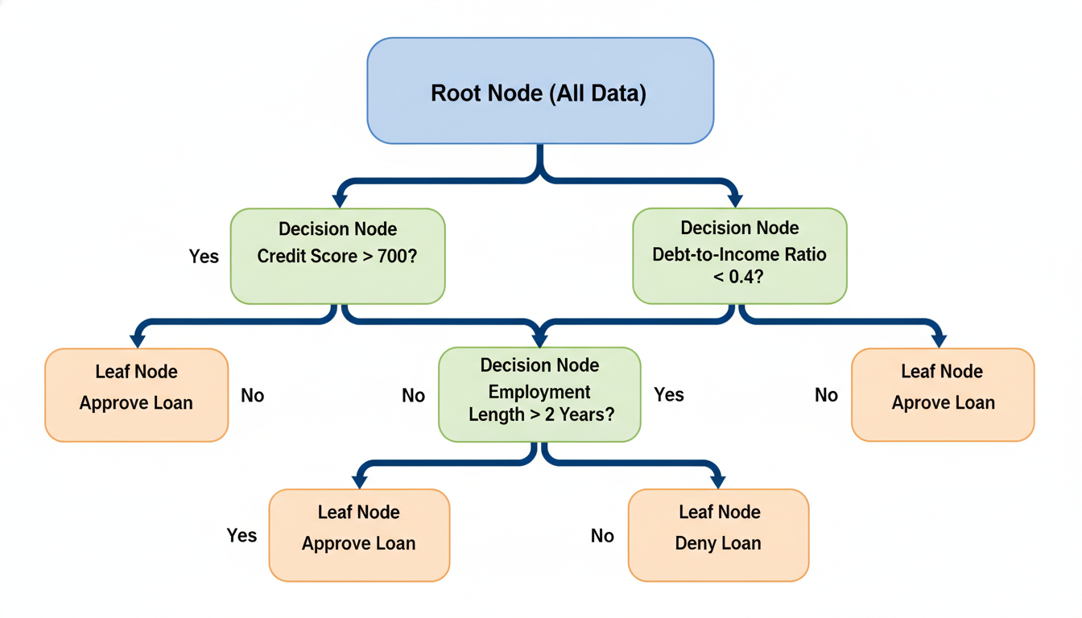

A diagram of a decision tree structure. The top box is labeled 'Root Node (All Data)'. Arrows branch out to 'Decision Nodes' containing questions like 'Credit Score > 700?'. The bottom boxes are labeled 'Leaf Nodes' containing the final classifications 'Approve Loan' and 'Deny Loan'.

Unlike the "Black Box" nature of some advanced algorithms (where the math is so complex it is hard to explain *why* a prediction was made), Decision Trees are **White Box** models. They are completely transparent. If your boss asks, "Why did the model reject this loan application?", you can trace the exact path down the tree: *"Because the applicant's income was low AND their debt-to-income ratio was high."*

### **How the Algorithm "Grows"**

As a human, you might use intuition to decide which question to ask first. The computer, however, needs a metric. When the algorithm looks at your training data, it attempts to find the feature that best separates the target classes.

Imagine a bucket containing 10 blue balls and 10 red balls. The bucket is "impure" (a 50/50 mix). The goal of the algorithm is to find a way to pour these balls into two new buckets such that the new buckets are as "pure" as possible (e.g., one bucket has mostly red, the other mostly blue).

To do this, Scikit-Learn uses a metric called **Gini Impurity** (or sometimes Entropy).

1. The model looks at every single feature (e.g., Age, Income, Debt). 2. It tests every possible split (e.g., Age > 20, Age > 21, Age > 22...). 3. It calculates which split results in the highest "purity" (the most homogenous groups) in the resulting child nodes. 4. It repeats this process recursively for every child node until the leaves are pure or a stopping condition is met.

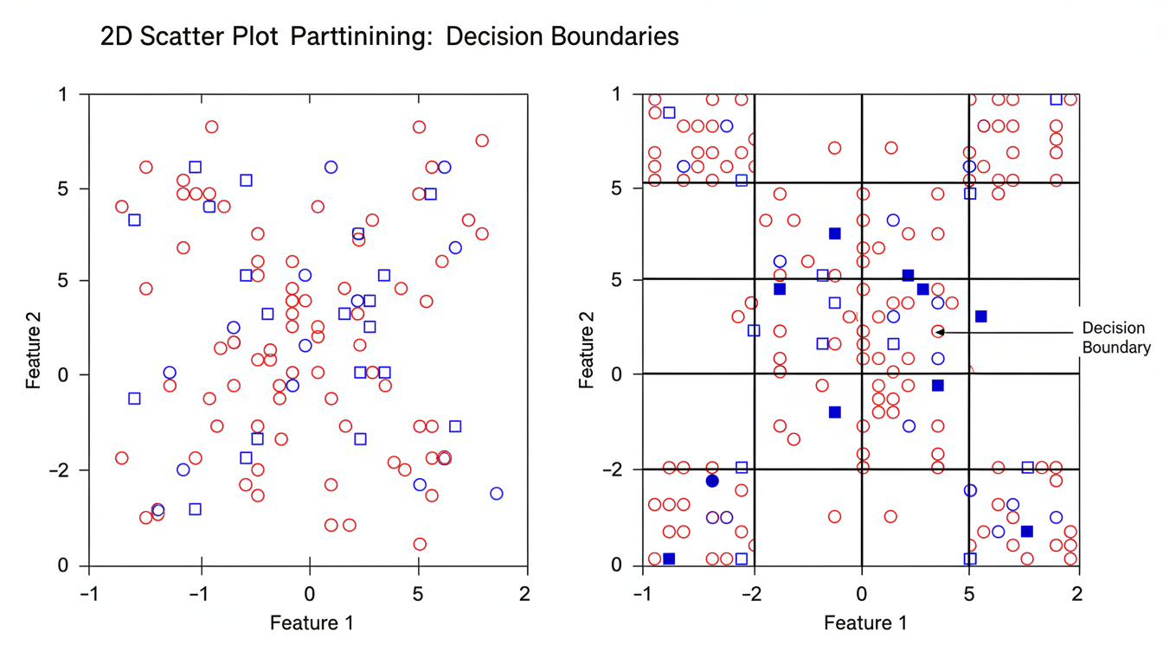

A visual representation of splitting a 2D scatter plot. On the left, a plot with mixed red circles and blue squares. On the right, vertical and horizontal lines divide the plot into rectangular regions, isolating the red circles from the blue squares, illustrating how decision boundaries are created.

### **Implementation in Scikit-Learn**

Let's apply this to a relatable scenario: **Employee Retention**. We want to predict if an employee will leave the company (Attrition = 1) or stay (Attrition = 0) based on their Satisfaction_Level (0 to 1) and Years_at_Company.

We adhere to our modeling workflow: **Instantiate, Fit, Predict.**

python

import pandas as pd

from sklearn.tree import DecisionTreeClassifier

from sklearn.model_selection import train_test_split

from sklearn.metrics import accuracy_score

# 1. Setup Dummy Data

data = {

'Satisfaction_Level': [0.9, 0.1, 0.8, 0.2, 0.85, 0.15, 0.4, 0.6],

'Years_at_Company': [5, 2, 6, 2, 10, 3, 2, 4],

'Attrition': [0, 1, 0, 1, 0, 1, 1, 0] # 0 = Stay, 1 = Leave

}

df = pd.DataFrame(data)

# 2. Define Features (X) and Target (y)

X = df[['Satisfaction_Level', 'Years_at_Company']]

y = df['Attrition']

# 3. Instantiate the model

# We set max_depth to prevent the tree from becoming too complex (more on this later)

tree_model = DecisionTreeClassifier(random_state=42, max_depth=3)

# 4. Fit the model

tree_model.fit(X, y)

# 5. Predict

# Let's predict for a new employee with Low Satisfaction (0.15) and 3 Years experience

new_employee = [[0.15, 3]]

prediction = tree_model.predict(new_employee)

print(f"Prediction (0=Stay, 1=Leave): {prediction[0]}")

### **Visualizing the Logic**

One of the massive advantages of Decision Trees is that we can visualize the model logic directly without needing complex statistical interpretations. Scikit-Learn provides a tool to draw the tree we just built.

python

from sklearn.tree import plot_tree

import matplotlib.pyplot as plt

plt.figure(figsize=(10,6))

plot_tree(tree_model,

feature_names=['Satisfaction', 'Years'],

class_names=['Stay', 'Leave'],

filled=True)

plt.show()

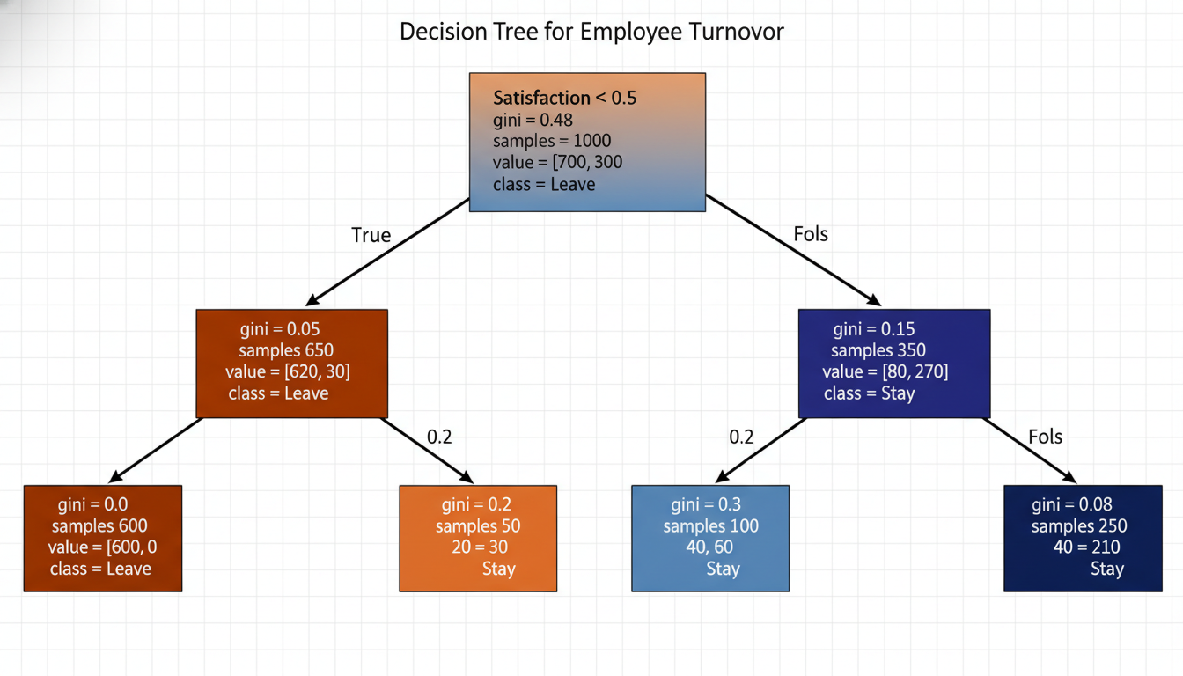

An output of the plot_tree function. The root node at the top shows a split condition 'Satisfaction <= 0.5'. The nodes are colored, with shades of orange representing the 'Leave' class and shades of blue representing the 'Stay' class. The color intensity indicates the purity of the node.

When you run this code, you will see exactly how the machine is thinking. It likely noticed that Satisfaction_Level was the most important predictor and placed it at the top (the root). If satisfaction is low, it predicts attrition; if high, it predicts retention.

### **The Danger Zone: Overfitting**

You might be thinking, "If I let the tree grow forever, won't it eventually classify every single training point correctly?"

Yes, and that is a problem.

If you don't limit the growth of the tree, the algorithm will create specific rules for outliers. It essentially memorizes the training data rather than learning the general patterns. This is called **Overfitting**. An overfitted tree might look at a specific employee and create a rule: *"If Satisfaction is 0.612 AND Years is 4 AND Last Name starts with Z, then Leave."*

This works for the history books (training data), but it will fail miserably on new data (testing data) because that rule is just noise, not a trend.

To prevent this, we use **Hyperparameter Tuning**. The most common controls are: *`max_depth`: Limits how deep the tree can grow (e.g., only ask 3 questions).* min_samples_split: Requires a certain amount of data in a node before allowed to split again (e.g., don't create a rule for just 2 people).

### **Summary**

Decision Trees offer a refreshing change from the algebraic equations of Regression. They map logic in a way that mirrors human thought, making them exceptionally easy to explain to stakeholders.

**Pros:** *Interpretability: Easy to explain to non-technical audiences.* **Non-Linearity:** Can capture complex, non-linear patterns (like "If income is high OR income is low, but not medium..."). *Minimal Prep:*\* Requires less data cleaning (e.g., no need to scale/normalize features) compared to Regression.

**Cons:** *Overfitting: Without constraints (`max_depth`), they memorize noise.* **Instability:** A small change in the data can result in a completely different tree structure.

Because single Decision Trees are prone to overfitting and instability, data scientists rarely rely on just *one* tree for critical production models. Instead, they grow hundreds of trees and average their predictions. This leads us to the concept of **Ensemble Modeling** and the famous **Random Forest**, which we will discuss in the next chapter.

### **Evaluating Model Performance: Confusion Matrix, Precision, and Recall**

In the previous sections, we added powerful tools to your arsenal: **Logistic Regression** and **Decision Trees**. You now possess the ability to predict binary outcomes—whether a customer will churn, whether a loan will default, or whether a transaction is fraudulent.

However, simply building a model is not enough. In a business setting, you must answer the inevitable stakeholder question: *"How good is this model, really?"*

Your instinct might be to answer with **Accuracy**—the percentage of correct predictions. While intuitive, accuracy can be the most dangerous metric in Data Science. To understand why, let’s imagine you are building a fraud detection system for a bank.

### **The Accuracy Paradox**

Suppose you analyze a dataset of 1,000 credit card transactions. In reality, 990 are legitimate, and only 10 are fraudulent.

If you wrote a "dumb" model that simply predicted **"Legitimate"** for every single transaction—ignoring the data entirely—your model would be correct 990 times out of 1,000.

Your model would have **99% Accuracy**.

On paper, this looks spectacular. In practice, the model is useless. It failed to catch a single instance of fraud. This highlights the limitation of Accuracy: in datasets with **imbalanced classes** (where one outcome is much rarer than the other), accuracy hides the model's failures.

To evaluate a classification model effectively, we need to look under the hood. We need the **Confusion Matrix**.

### **The Confusion Matrix**

The Confusion Matrix is not a complex mathematical formula; it is a simple 2x2 tally sheet. It breaks down your model’s predictions into four distinct categories based on two questions: 1. What did the model predict? 2. What actually happened?

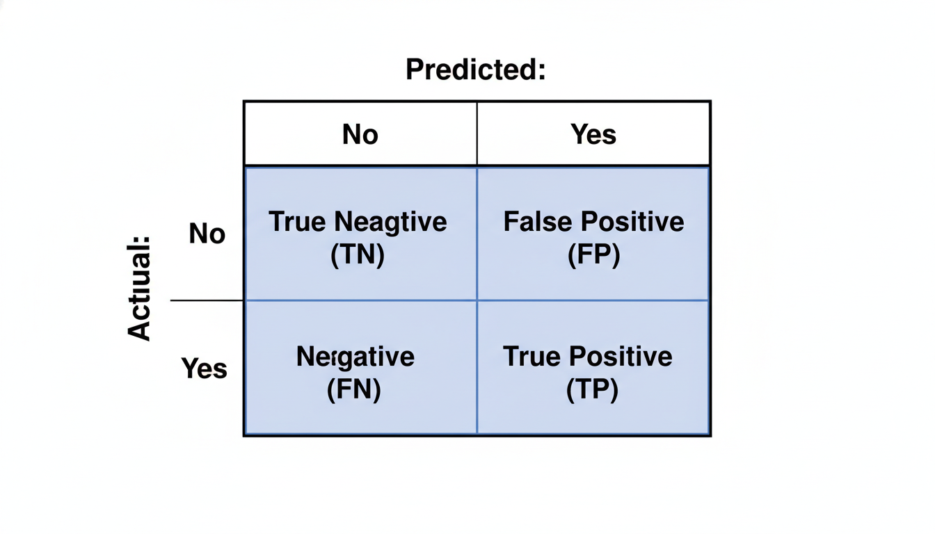

A 2x2 grid representing a Confusion Matrix. The columns are labeled 'Predicted: No' and 'Predicted: Yes'. The rows are labeled 'Actual: No' and 'Actual: Yes'. The four quadrants are labeled: Top-Left 'True Negative (TN)', Top-Right 'False Positive (FP)', Bottom-Left 'False Negative (FN)', and Bottom-Right 'True Positive (TP)'.

Let’s break down these four quadrants using a **Customer Churn** context (predicting if a customer will cancel their subscription).

1. **True Positive (TP):** The model predicted the customer would churn, and they *did*. (A "Hit"). 2. **True Negative (TN):** The model predicted the customer would stay, and they *did*. (A correct non-event). 3. **False Positive (FP):** The model predicted the customer would churn, but they *stayed*. This is often called a **Type I Error** or a "False Alarm." 4. **False Negative (FN):** The model predicted the customer would stay, but they *churned*. This is a **Type II Error** or a "Miss."

In a business context, not all errors are created equal. A False Positive might mean you send a discount coupon to a happy customer (a small cost). A False Negative might mean you lose a high-value client because you didn't know they were unhappy (a high cost).

### **Precision and Recall**

Once we have the counts from the Confusion Matrix, we can calculate two specific metrics that tell us much more than simple accuracy: **Precision** and **Recall**.

#### **Precision: The "Boy Who Cried Wolf" Metric**

Precision answers the question: *Of all the times the model predicted 'Yes', how often was it right?*

If your model predicts that 100 customers will churn, but only 20 actually do, your model has low precision. You are "crying wolf" too often. Low precision in a spam filter means legitimate emails are getting thrown into the junk folder (False Positives).

$$ \text{Precision} = \frac{\text{True Positives}}{\text{True Positives} + \text{False Positives}} $$

#### **Recall: The "Fishing Net" Metric**

Recall (also known as Sensitivity) answers the question: *Of all the actual 'Yes' cases in the data, how many did the model manage to find?*

If 100 customers actually churned, and your model successfully identified 90 of them, you have high recall. You cast a wide net. High recall is critical in medical diagnostics; if a patient has a disease, we cannot afford to miss it (False Negatives).

$$ \text{Recall} = \frac{\text{True Positives}}{\text{True Positives} + \text{False Negatives}} $$

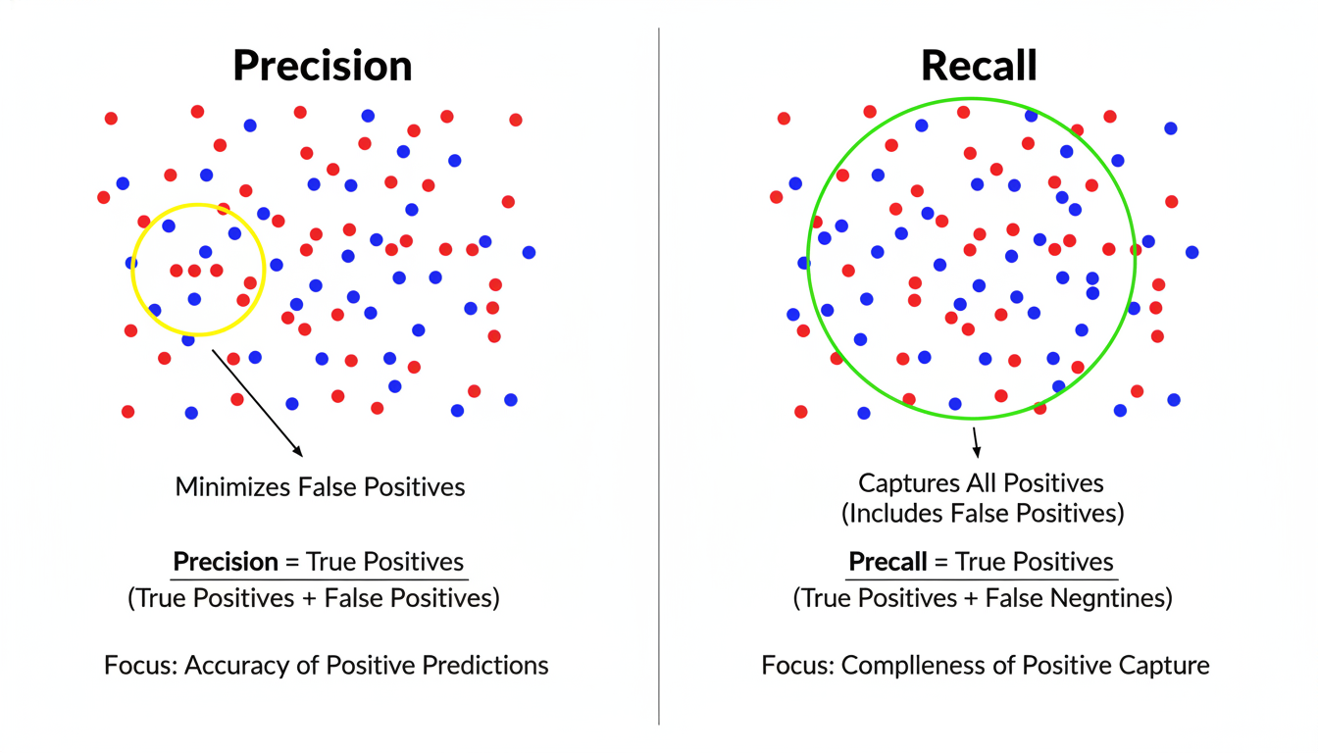

A diagram illustrating the difference between Precision and Recall. On the left, a 'Precision' focus shows a small circle selecting only a few high-confidence red dots (positives) among blue dots (negatives), minimizing false positives. On the right, a 'Recall' focus shows a large circle capturing all red dots but accidentally including several blue dots (false positives).

### **The Tug-of-War**

There is almost always a trade-off. *If you tune your model to catch every fraudster (High Recall), you will inevitably flag some innocent customers (Lower Precision).* If you tune your model to **never** falsely accuse an innocent customer (High Precision), you will inevitably miss some sophisticated fraudsters (Lower Recall).

As a Data Scientist, your job is to ask the business stakeholder: *Which error is more expensive?* *Is it worse to miss a sale (Low Recall)?* Or is it worse to annoy a customer with irrelevant ads (Low Precision)?

### **Implementing in Python**

Let's see how Scikit-Learn handles these metrics. We will assume we have already trained a Logistic Regression model named log_reg and have split our data into X_test and y_test.

python

from sklearn.metrics import confusion_matrix, classification_report

import pandas as pd

import seaborn as sns

import matplotlib.pyplot as plt

# 1. Generate Predictions

# The model predicts 0 (No Churn) or 1 (Churn)

y_pred = log_reg.predict(X_test)

# 2. Create the Confusion Matrix

cm = confusion_matrix(y_test, y_pred)

# 3. Visualize the Matrix

plt.figure(figsize=(6, 5))

sns.heatmap(cm, annot=True, fmt='d', cmap='Blues', cbar=False)

plt.xlabel('Predicted Label')

plt.ylabel('Actual Label')

plt.title('Confusion Matrix for Customer Churn')

plt.show()

The code above generates a heatmap allowing you to visually inspect the True Positives versus the errors. However, calculating the math manually is tedious. Scikit-Learn provides a summary tool called the **Classification Report**.

python

# 4. Generate a full performance report

print(classification_report(y_test, y_pred))

**Output Example:**

text

precision recall f1-score support

0 0.85 0.90 0.87 150

1 0.75 0.60 0.67 50

accuracy 0.82 200

macro avg 0.80 0.75 0.77 200

weighted avg 0.82 0.82 0.82 200

**Interpreting the Report:** *Class 1 (Churn):* **Precision (0.75):** When the model predicts a customer will churn, it is correct 75% of the time. *Recall (0.60): The model only caught 60% of the customers who actually churned. It missed 40% of them.* **F1-Score:** This is the "Harmonic Mean" of Precision and Recall. It provides a single score that balances both metrics. If you need a balance between precision and recall, the F1-score is your go-to metric.

### **Summary**

In this section, we moved beyond the "Accuracy Trap." You learned that in real-world business problems—especially those involving rare events like fraud or churn—accuracy is often misleading.

By using the **Confusion Matrix**, we can dissect exactly *how* our model is making mistakes. *Use Precision when the cost of a False Positive is high (e.g., spam filters, stock market buy signals).* Use **Recall** when the cost of a False Negative is high (e.g., disease screening, safety defects).

Now that we can accurately evaluate our models, we are ready to explore how to improve them. In the next chapter, we will look at **Ensemble Methods**, where we combine multiple models (like Random Forests) to achieve performance that a single Decision Tree could never match.

### **Case Study: Predicting Employee Attrition**

We have reached the synthesis of our classification journey. In the previous sections, we mastered the algorithms (**Logistic Regression** and **Decision Trees**) and learned the language of critique (**Precision, Recall, and the Confusion Matrix**).

Now, we leave the classroom and enter the boardroom. We are going to apply these techniques to a domain that was historically dominated by "gut feeling" but is rapidly becoming one of the most data-intensive functions in business: **Human Resources (HR)** or "People Analytics."

In this case study, we will simulate a real-world project. You have been tasked by the Chief Human Resources Officer (CHRO) to solve a critical problem: **Employee Attrition**.

### **The Business Problem**

Hiring new employees is expensive. Research suggests that the cost of replacing an employee ranges from 50% to 200% of their annual salary. Beyond the financial cost, high turnover lowers morale and results in lost institutional knowledge.

The CHRO poses a challenge: *"We know people leave, but we don't know who, and we don't know why. Can you build a model to predict which employees are at risk of leaving so we can intervene before they resign?"*

This is a classic **Binary Classification** problem. *Input (X): Employee demographics, job role, satisfaction scores, overtime history, etc.* **Output (y):** Attrition (Yes/No).

### **Step 1: Data Preparation and Encoding**

For this case study, we will use a dataset commonly referenced in the industry (based on IBM HR Analytics data). It contains numerical data (like Age) and categorical data (like Department).

As we discussed in the **Feature Engineering** chapter, machine learning models (mostly) speak math, not English. They cannot understand the string "Sales" or "Research." We must translate these categories into numbers.

We will use a technique called **One-Hot Encoding** (or dummy variables). This process creates a new binary column for every unique category.

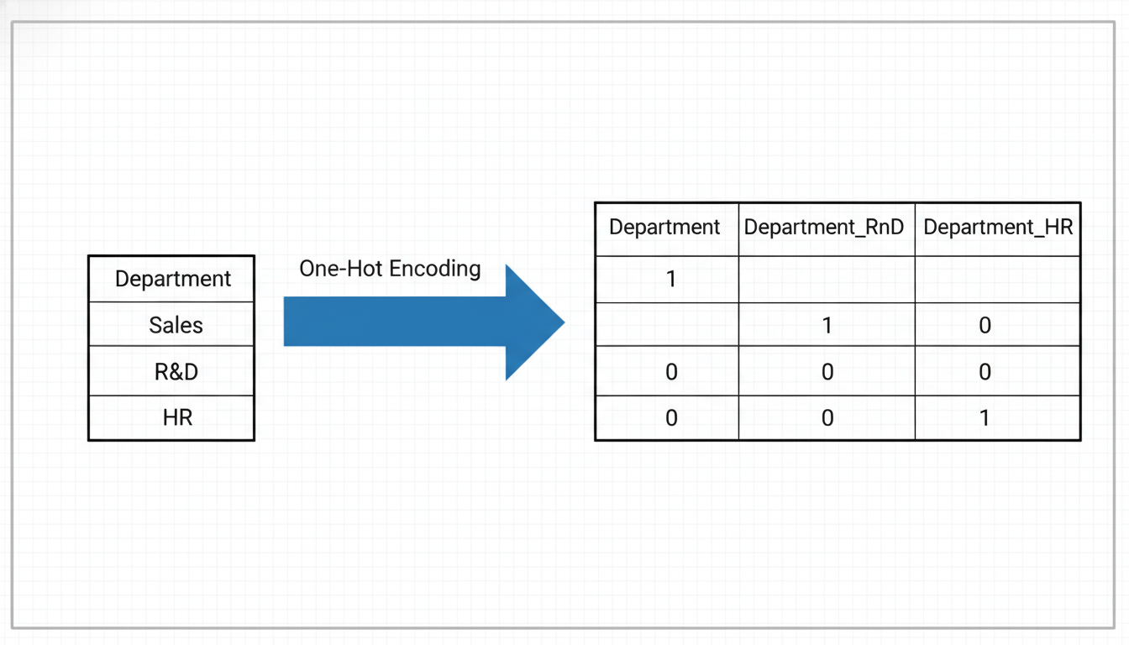

A conceptual diagram of One-Hot Encoding. On the left, a single column named "Department" contains values "Sales", "R&D", and "HR". An arrow points to the right showing three new columns: "Department_Sales", "Department_RnD", and "Department_HR". The rows contain 1s and 0s indicating membership to those categories.

Let's look at the Python implementation using pandas:

python

import pandas as pd

from sklearn.model_selection import train_test_split

# Load the dataset (hypothetical path)

df = pd.read_csv('hr_employee_attrition.csv')

# 1. Select relevant features

# We drop 'EmployeeCount' and 'StandardHours' as they are the same for everyone

features = ['Age', 'Department', 'DistanceFromHome', 'EnvironmentSatisfaction',

'OverTime', 'MonthlyIncome', 'JobRole']

target = 'Attrition' # Values are 'Yes' or 'No'

X = df[features]

y = df[target].apply(lambda x: 1 if x == 'Yes' else 0) # Convert Target to 1/0

# 2. One-Hot Encoding for categorical variables (Department, OverTime, JobRole)

# drop_first=True avoids multicollinearity (redundancy)

X_encoded = pd.get_dummies(X, drop_first=True)

print("Original shape:", X.shape)

print("Encoded shape:", X_encoded.shape)

When you run this, you will notice the number of columns increases. The column OverTime (containing "Yes"/"No") becomes OverTime_Yes (containing 1/0). This prepares our data for the algorithm.

### **Step 2: Training the Model**

For this problem, we will choose a **Decision Tree Classifier**. Why? Because in HR, **explainability** is paramount. If our model flags an employee as "High Risk," the HR manager will immediately ask, *"Why?"*

A Decision Tree provides clear logic (e.g., *"Because they work Overtime AND live far away"*) that a Neural Network or a complex ensemble might hide.

python

from sklearn.tree import DecisionTreeClassifier

# Split data: 80% for training, 20% for testing

X_train, X_test, y_train, y_test = train_test_split(X_encoded, y, test_size=0.2, random_state=42)

# Initialize the Decision Tree

# We limit depth to avoid overfitting (making the tree too complex)

clf = DecisionTreeClassifier(max_depth=4, random_state=42)

# Train the model

clf.fit(X_train, y_train)

print("Model training complete.")

### **Step 3: Evaluation and Business Logic**

Now comes the critical step: answering the stakeholder's question, *"How good is the model?"*

In the previous section, we learned about the **Confusion Matrix**. Let's apply it here. In the context of Employee Attrition:

* **True Positive (TP):** We predicted they would leave, and they did. (Success: We might have saved them).
* **True Negative (TN):** We predicted they would stay, and they stayed. (Success).
* **False Positive (FP):** We predicted they would leave, but they stayed. (The "Crying Wolf" error).
* **False Negative (FN):** We predicted they would stay, but they left. (The "Missed Opportunity" error).

python

from sklearn.metrics import confusion_matrix, classification_report

# Make predictions on the unseen test set

y_pred = clf.predict(X_test)

# Generate the metrics

print(classification_report(y_test, y_pred))

**Interpreting the Results for Stakeholders:**

Let's assume your model produces the following Recall score for the "Leavers" class (Class 1): **0.45 (45%)**.

If you present this simply as a number, you might fail to convey the value. You must translate this into business terms:

*"Current status: We currently react to resignations after they happen. > > New Model status: This model effectively identifies* ***45% of the employees who are about to resign*** *before they turn in their letter. While it misses some (False Negatives), it gives HR a targeted list of at-risk employees to engage with, rather than guessing blindly."*

### **Step 4: Visualizing the Decision Logic**

The true power of the Decision Tree is visual. We can plot the tree to understand the root causes of attrition.

python

from sklearn.tree import plot_tree

import matplotlib.pyplot as plt

plt.figure(figsize=(20,10))

plot_tree(clf, feature_names=X_encoded.columns, class_names=['Stay', 'Leave'], filled=True, fontsize=10)

plt.show()

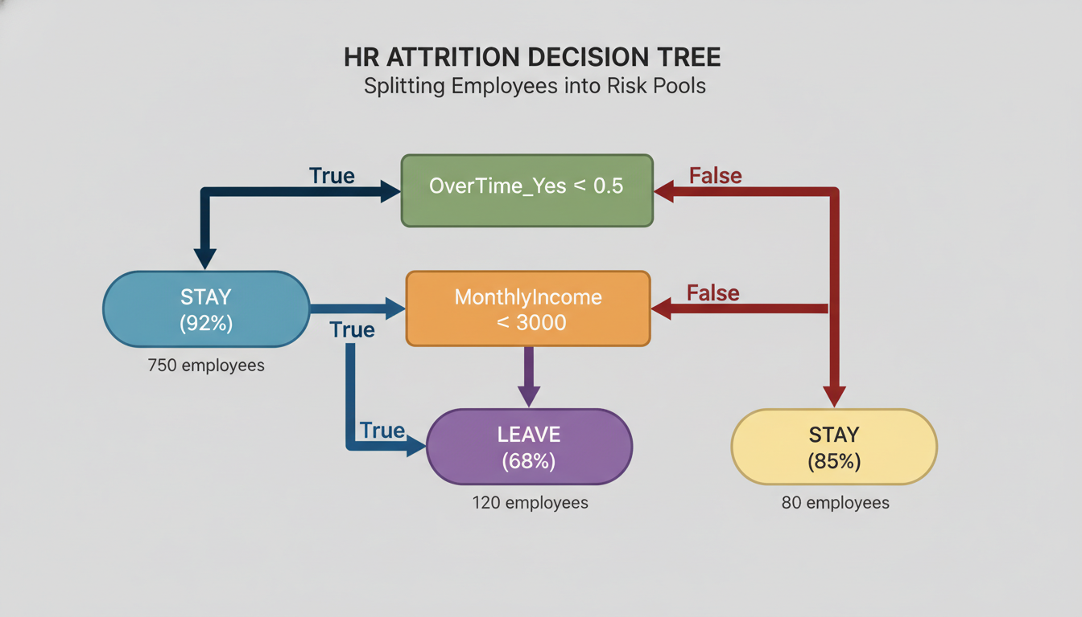

A visualization of a Decision Tree for HR data. The Root Node at the top shows "OverTime_Yes <= 0.5". The branch for "True" (No Overtime) goes left to a blue node indicating most people stay. The branch for "False" (Yes Overtime) goes right to a node asking "MonthlyIncome <= 3000". The visualization demonstrates how the model splits employees into risk pools based on specific criteria.

By analyzing this tree, you might discover insights to feed back to management: 1. **The "Overtime" Split:** The very first split often separates those who work overtime from those who don't. This suggests burnout is a primary driver. 2. **The "Income" Split:** Among those working overtime, low income creates a high-risk "leaf node."

### **Step 5: Feature Importance**

Finally, we can extract the "Feature Importance" scores. This tells us which variables had the heaviest weight in the decision-making process.

python

import pandas as pd

# Create a dataframe of feature importance

importance = pd.DataFrame({'Feature': X_encoded.columns, 'Importance': clf.feature_importances_})

print(importance.sort_values(by='Importance', ascending=False).head(5))

**Sample Output:** 1. OverTime_Yes: 0.28 2. MonthlyIncome: 0.21 3. Age: 0.15 4. DistanceFromHome: 0.10 5. JobRole_SalesRepresentative: 0.08

### **Conclusion: From Prediction to Policy**

This case study illustrates the transition from "Data Science" to "Business Intelligence."

You started with raw data and ended with a strategic recommendation: **To reduce turnover, the company should review its Overtime policies, specifically for lower-income Sales Representatives who live far from the office.**

We did not just predict *who* would leave; we used the transparency of the Decision Tree to understand *what* needs to change in the organization.

In the next chapter, we will move away from Supervised Learning (where we have the answers) and explore **Unsupervised Learning**, where we ask the machine to discover hidden patterns in data without any guidance at all.

## **Chapter 9Unsupervised Learning and Pattern Discovery**

### **K-Means Clustering: Grouping Similar Data Points**

So far in this book, every algorithm we have mastered—from Linear Regression to Decision Trees—has relied on a teacher. In data science terms, we call these **Supervised Learning** algorithms. We fed the model a dataset containing both the inputs (features) and the correct answers (labels), such as "House Price," "Did Churn," or "Is Fraud." The model’s job was simply to learn the mapping between the two.

But what happens when there is no teacher? What if you have a massive database of customer transactions, but no column that says "High Value" or "At Risk"? What if you have thousands of server logs but no label indicating "Error" or "Normal"?

Welcome to **Unsupervised Learning**. In this domain, we don't predict a target variable. Instead, we ask the machine to explore the data and discover hidden structures, patterns, and groupings that we humans might miss.

Our first stop in this new landscape is **K-Means Clustering**, one of the most popular and intuitive algorithms for finding order in chaos.

### **The Intuition: Organizing the Unknown**

Imagine you have just been hired as a marketing manager for a retail chain. You are handed a spreadsheet containing data on 10,000 customers—specifically, their **Annual Income** and **Spending Score** (a metric of how often they buy).

Your boss asks: *"How many distinct types of customers do we have?"*

You can't run a Logistic Regression because you don't have a target variable to predict. You don't know if there are three types of customers or ten. You simply want to group similar customers together.

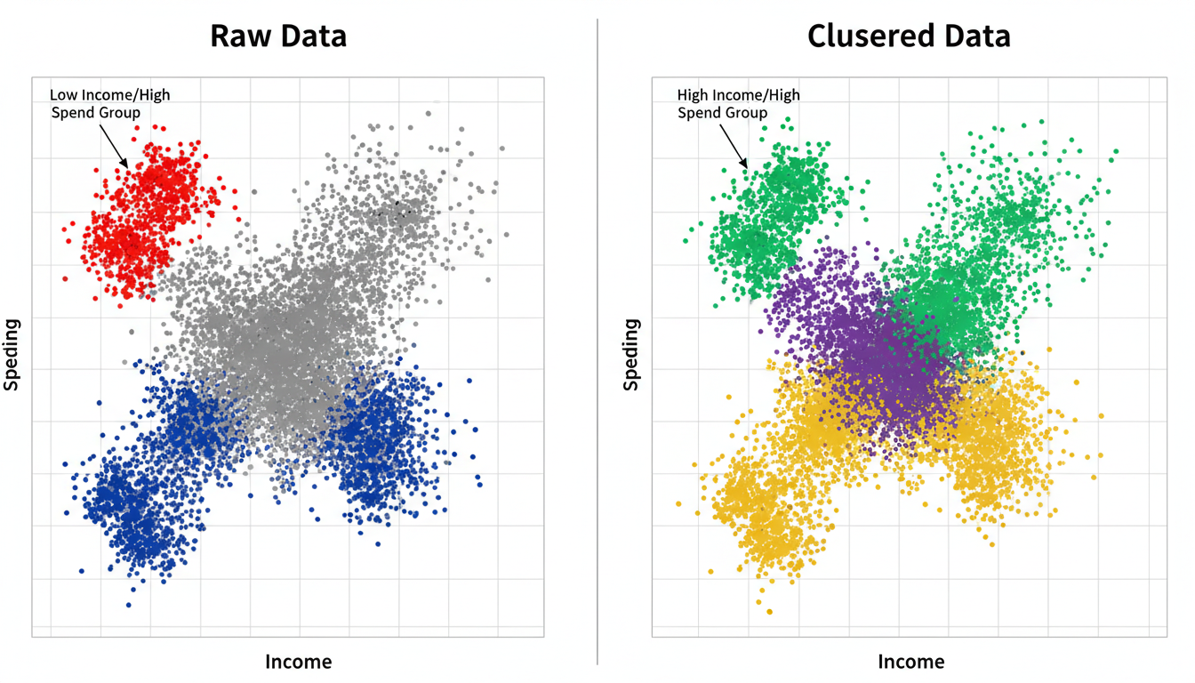

A side-by-side comparison. The left panel shows a scatter plot of raw data points (Income vs Spending) all in the same color (gray), looking like a disorganized cloud. The right panel shows the same dots clustered into five distinct colors, revealing specific groups like 'Low Income/High Spend' and 'High Income/High Spend'.

This is exactly what K-Means does. It looks at the distance between data points and attempts to group them into $K$ distinct clusters, where points in the same cluster are similar to each other, and points in different clusters are dissimilar.

### **How the Algorithm Works**

The "K" in K-Means represents the number of clusters you want to find. The "Means" refers to the average position (the center) of the data points in that cluster.

Here is the algorithm in plain English:

1. **Initialization:** You choose $K$ (e.g., 3). The algorithm places 3 points randomly on your data plot. These are called **Centroids**. 2. **Assignment:** Every single data point looks at the 3 centroids and "joins" the team of the centroid closest to it. 3. **Update:** Once all points have joined a team, the cluster center (centroid) is recalculated. The centroid moves to the mathematical average position of all the points in its team. 4. **Repeat:** Because the centroids moved, some points might now be closer to a different centroid. Steps 2 and 3 are repeated until the centroids stop moving (convergence).

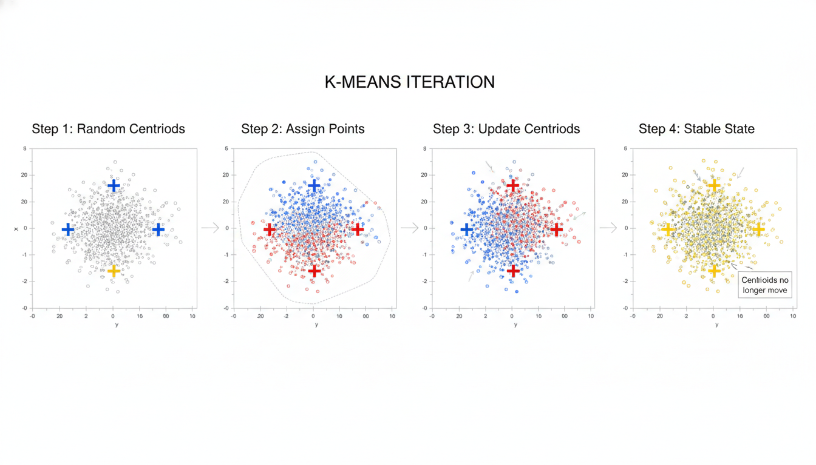

A 4-step diagram showing the K-Means iteration. Step 1: Random centroids appear on a scatterplot. Step 2: Points are color-coded based on the nearest centroid. Step 3: Centroids move to the geometric center of their new color groups. Step 4: The final stable state where centroids no longer move.

### **Implementing K-Means in Python**

Let's apply this to our hypothetical customer dataset. We will use scikit-learn, the same library we used for regression and classification.

First, we generate some synthetic data to represent our customers.

python

import pandas as pd

import matplotlib.pyplot as plt

from sklearn.datasets import make_blobs

from sklearn.cluster import KMeans

from sklearn.preprocessing import StandardScaler

# 1. Generate synthetic customer data

# We create 300 samples with 2 features (Income, Spending Score)

# centers=4 implies there are naturally 4 groups in this data

X, _ = make_blobs(n_samples=300, centers=4, cluster_std=0.60, random_state=0)

# Convert to DataFrame for easier viewing

df = pd.DataFrame(X, columns=['Annual_Income', 'Spending_Score'])

# 2. Preprocessing: Scaling is Critical

# K-Means calculates distance. If one variable is in millions (Income)

# and another in single digits (Family Size), Income will dominate.

scaler = StandardScaler()

X_scaled = scaler.fit_transform(df)

# 3. Initialize and Fit K-Means

# Let's assume we want to find 4 clusters

kmeans = KMeans(n_clusters=4, random_state=42)

kmeans.fit(X_scaled)

# 4. Get the Cluster Labels

# This assigns a number (0, 1, 2, or 3) to every customer

df['Cluster_Label'] = kmeans.labels_

print(df.head())

The output will look like a standard dataframe, but with a new column: Cluster_Label. This label *is* the pattern the algorithm discovered. You can now query your data: *"Show me the average income of Cluster 1 vs Cluster 2."*

### **The Million Dollar Question: How do we choose K?**

In the example above, I cheated. I told the computer to look for 4 clusters because I generated the data with 4 centers. In the real world, you won't know the answer. Should you segment your customers into 3 groups? 5 groups? 10?

To solve this, we use a technique called the **Elbow Method**.

We run the K-Means algorithm multiple times, increasing $K$ from 1 to 10. For each run, we calculate the **Inertia** (also known as Within-Cluster Sum of Squares). Inertia measures how tightly the data points are packed around their centroids.

* **Lower Inertia** is better (it means clusters are tight).
* However, if $K$ equals the number of data points, inertia is 0 (perfect), but the clusters are meaningless.

We look for the "Elbow"—the point where adding more clusters stops giving us significant gains in compactness.

python

inertia_list = []

# Test K from 1 to 10

for k in range(1, 11):

kmeans = KMeans(n_clusters=k, random_state=42)

kmeans.fit(X_scaled)

inertia_list.append(kmeans.inertia_)

# Plotting the Elbow

plt.figure(figsize=(10, 6))

plt.plot(range(1, 11), inertia_list, marker='o')

plt.title('The Elbow Method')

plt.xlabel('Number of clusters (K)')

plt.ylabel('Inertia')

plt.show()

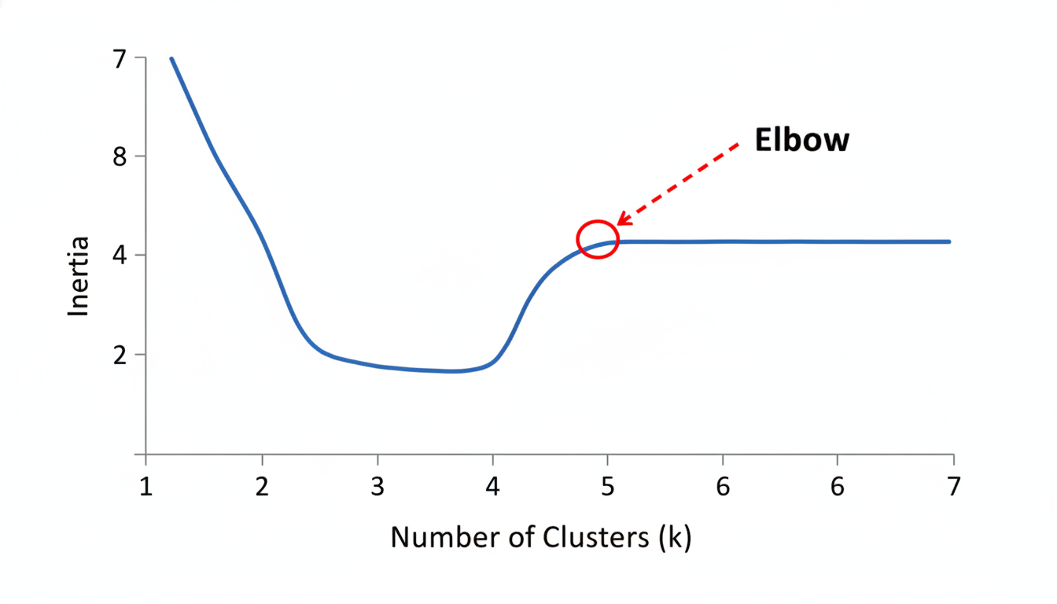

A line graph representing the 'Elbow Method'. The X-axis represents 'Number of Clusters (k)' and the Y-axis represents 'Inertia'. The line drops steeply from k=1 to k=2, then bends significantly at k=4, and flattens out afterwards. The point at k=4 is highlighted as the 'Elbow'.

In the graph above, you would see a sharp decline in inertia that flattens out after $K=4$. That "elbow" point suggests that 4 is the optimal balance between simplicity and accuracy.

### **Business Application: Why use K-Means?**

For a career transitioner, understanding the *application* is just as important as the code. Here is where K-Means shines in industry:

1. **Customer Segmentation:** As discussed, grouping customers by behavior to send targeted marketing campaigns (e.g., "Budget Shoppers" vs. "Big Spenders"). 2. **Inventory Management:** Clustering products based on sales velocity and seasonality to optimize warehouse placement. 3. **Bot Detection:** Clustering web traffic. Normal users usually fall into one large cluster; bots often engage in repetitive behaviors that form distinct, smaller clusters or outliers. 4. **Document Classification:** Grouping thousands of unlabelled support tickets into categories like "Login Issues," "Billing," or "Feature Requests" based on word usage.

### **Limitations and Pitfalls**

While K-Means is a workhorse of unsupervised learning, it is not magic. Keep these limitations in mind:

* **Sensitivity to Outliers:** One massive outlier can pull a centroid away from the main group, distorting the cluster. It is often wise to remove outliers before clustering.
* **Spherical Assumption:** K-Means assumes clusters are round balls. If your data forms complex shapes (like a crescent moon or a ring), K-Means will fail to separate them correctly.
* **Scaling is Mandatory:** As noted in the code, if you do not scale your data (using StandardScaler or MinMaxScaler), the feature with the largest numeric range will dictate the clusters.

In the next section, we will look at **Hierarchical Clustering**, an alternative method that creates a "family tree" of data points, allowing us to visualize relationships without pre-selecting the number of clusters.

### **Dimensionality Reduction: Simplifying Complex Datasets**

In the previous section on **K-Means Clustering**, we successfully grouped data points without labels. We took a dataset and asked the computer to "find the structure." This works beautifully when you are dealing with two or three variables—for example, clustering customers based on *Age* and *Spending Score*. You can easily visualize this on a 2D plot (X and Y axis) and see the clusters separate.

But real-world business data is rarely that simple.

Imagine you are analyzing customer behavior for a massive e-commerce platform. You aren't just looking at Age and Spending. You have data on: *Time on site* Number of clicks *Average cart value* Geographic latitude/longitude *Frequency of returns* Days since last login * ...and 40 other columns.

You now have a 50-dimensional dataset. Not only is this impossible for the human brain to visualize, but it also creates a computational problem known as the **Curse of Dimensionality**. As you add more features (dimensions), the data becomes "sparse," meaning the data points are so far apart in that high-dimensional space that distance-based algorithms (like K-Means) struggle to determine what is close and what is far.

To solve this, we need a way to reduce the number of columns without losing the critical information contained within them. We need **Dimensionality Reduction**.

### **The Concept: Compression and Summarization**

Think of Dimensionality Reduction as an "Executive Summary" for your dataset.

If you submit a 50-page report to a CEO, they might ask for a one-page summary. That summary doesn't just delete pages 2 through 50; it synthesizes the most important points from all 50 pages into a condensed format.

In Data Science, we do this to: 1. **Visualize data:** We can squeeze 50 columns down to 2 or 3 so we can plot them on a chart. 2. **Improve performance:** Fewer columns mean faster processing for machine learning models. 3. **Remove noise:** It helps filter out irrelevant details, focusing the model on the signal.

The most popular technique for this is **Principal Component Analysis (PCA)**.

### **Principal Component Analysis (PCA)**

PCA is a statistical procedure that converts a set of observations of possibly correlated variables into a set of values of linearly uncorrelated variables called **Principal Components**.

That sounds complex, so let’s use a visual analogy.

Imagine you are holding a teapot. You want to take *one* photograph that best describes the shape of the teapot. *Angle A (Top-down): You only see a circle (the lid). You lose the information about the handle and the spout.* **Angle B (Side view):** You see the height, the spout, and the handle. This captures the most "variance" or information about the object.

PCA effectively rotates the object (your data) in high-dimensional space to find the "best angle"—the angle that captures the most variance (information) and projects the data onto that angle.

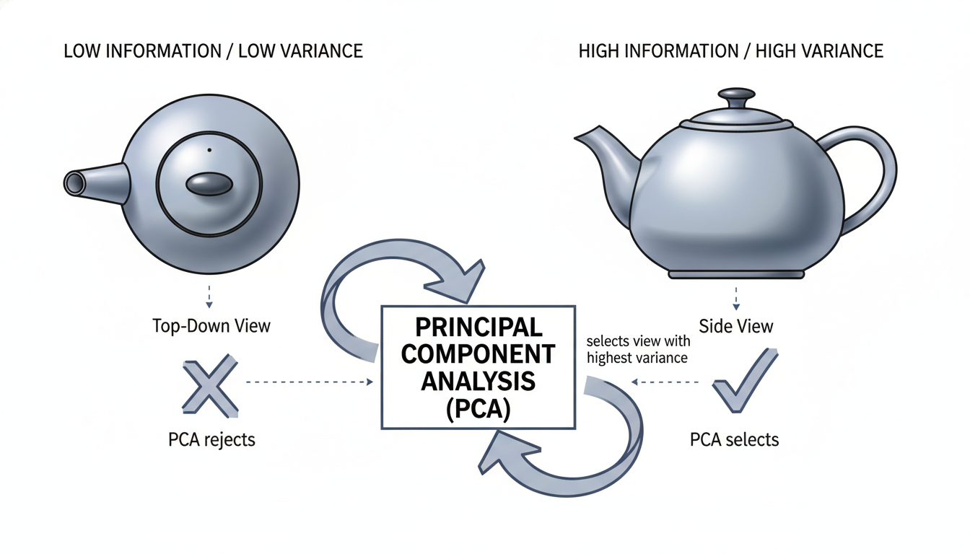

A diagram comparing two 2D projections of a 3D object (a teapot). The left projection is top-down, resulting in a simple circle (Low Information/Low Variance). The right projection is from the side, showing the spout and handle (High Information/High Variance). Arrows indicate that PCA selects the view with the highest variance.

### **How PCA Works (The Non-Math Version)**

1. **Standardization:** First, PCA requires that all data be on the same scale. If one column is "Salary" (ranging from 30,000 to 150,000) and another is "Age" (ranging from 18 to 65), the Salary column will dominate simply because the numbers are bigger. We scale them so they compete fairly. 2. **Finding the Axis of Variance:** The algorithm looks for a line through the data where the data points are most spread out. This line becomes **Principal Component 1 (PC1)**. It represents the strongest pattern in the dataset. 3. **Finding the Second Axis:** It then looks for a second line that is perpendicular (orthogonal) to the first one that captures the *next* most spread out direction. This is **Principal Component 2 (PC2)**. 4. **Repeat:** This continues until we have as many components as we started with dimensions.

However, the magic is that usually, the first few components (PC1 and PC2) capture 80-90% of the information. We can keep those two and discard the rest.

### **Implementing PCA in Python**

Let's apply this to a dataset. We will use the famous "Wine" dataset available in Scikit-Learn. It contains chemical analysis of wines grown in Italy, with **13 different features** (Alcohol, Malic acid, Ash, Magnesium, etc.).

Our goal: Squash these 13 dimensions down to 2 so we can plot the wines on a scatter plot.

python

import pandas as pd

import matplotlib.pyplot as plt

import seaborn as sns

from sklearn.datasets import load_wine

from sklearn.preprocessing import StandardScaler

from sklearn.decomposition import PCA

# 1. Load the Data

data = load_wine()

df = pd.DataFrame(data.data, columns=data.feature_names)

# Add the target (the type of wine: 0, 1, or 2) for coloring the plot later

df['Wine_Type'] = data.target

print(f"Original Dataset Shape: {df.shape}")

# Output will be (178, 14) - 178 rows, 13 features + 1 target

# 2. Standardize the Data (Crucial Step!)

# We separate features (X) from the target (y)

features = data.feature_names

x = df.loc[:, features].values

y = df.loc[:, ['Wine_Type']].values

# Scale features to have mean=0 and variance=1

x_scaled = StandardScaler().fit_transform(x)

# 3. Apply PCA

# We tell PCA we want to reduce down to 2 components

pca = PCA(n_components=2)

principalComponents = pca.fit_transform(x_scaled)

# Create a new DataFrame with the two components

pca_df = pd.DataFrame(data=principalComponents, columns=['PC1', 'PC2'])

# Concatenate the target variable back for visualization

final_df = pd.concat([pca_df, df[['Wine_Type']]], axis=1)

print(f"New Dataset Shape: {final_df.shape}")

# Output will be (178, 3) - 178 rows, 2 components + 1 target

We have successfully transformed a spreadsheet with 13 columns of chemical data into a dataframe with just two abstract columns: PC1 and PC2.

### **Interpreting the Results**

You might ask, "What does the PC1 column represent? Is it Alcohol?"

The answer is **no**. PC1 is a mathematical mixture of *all* the original 13 features combined. It might be 30% Alcohol, 20% Magnesium, and -10% Malic Acid. It is an abstract feature that represents the dominant variance in the data.

Now, let's visualize the result. Remember, we couldn't visualize 13 dimensions, but we can easily visualize 2.

python

# 4. Visualize the 2D Projection

plt.figure(figsize=(10, 8))

sns.scatterplot(

x='PC1',

y='PC2',

hue='Wine_Type',

palette='viridis',

data=final_df,

s=100

)

plt.title('PCA of Wine Dataset: 13 Dimensions reduced to 2', fontsize=15)

plt.xlabel('Principal Component 1', fontsize=12)

plt.ylabel('Principal Component 2', fontsize=12)

plt.show()

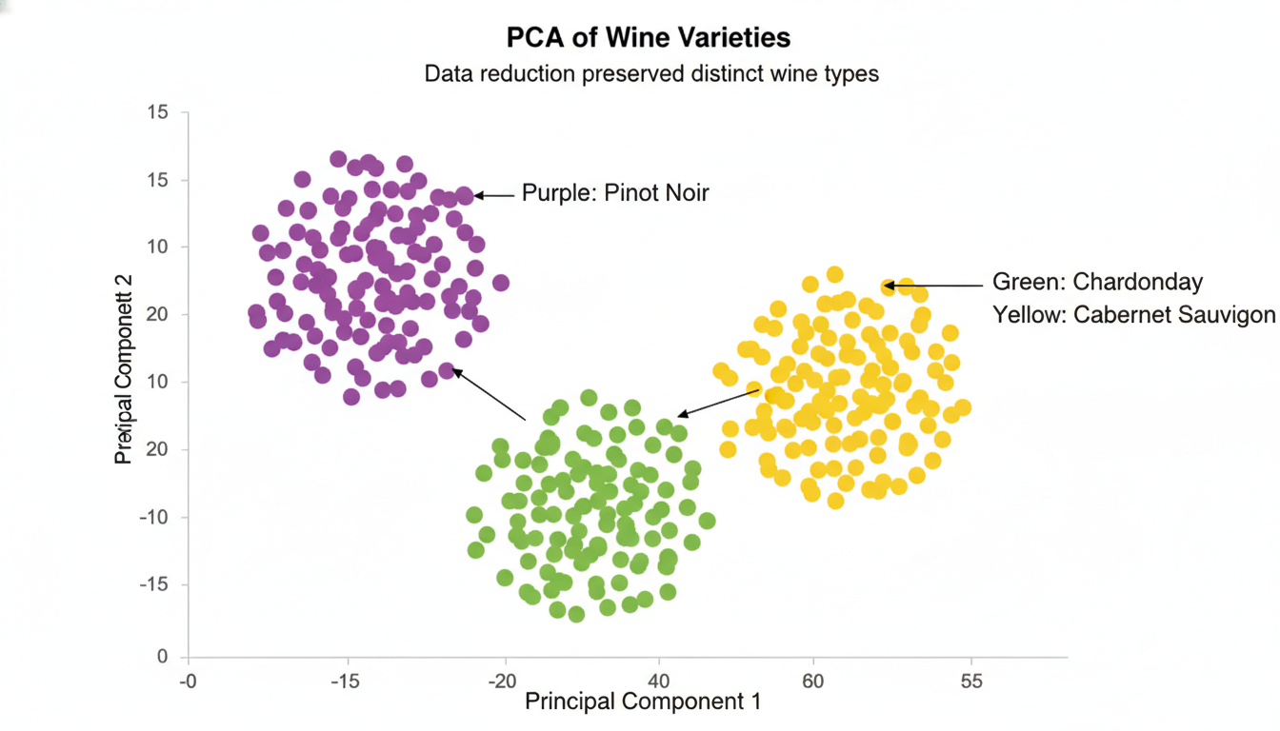

A scatter plot with "Principal Component 1" on the X-axis and "Principal Component 2" on the Y-axis. There are three distinct clusters of dots colored Purple, Green, and Yellow. The clusters are relatively well-separated, showing that the data reduction preserved the differences between the wine types.

Even though we threw away 11 dimensions of data, we can see distinct clusters. This tells us that the different types of wine are chemically distinct, and PCA was able to capture those differences in just two dimensions.

### **The "Explained Variance" Ratio**

How much information did we lose? PCA gives us a metric called **Explained Variance Ratio**. This tells us what percentage of the original dataset's information is held within our new components.

python

print(f"Explained Variance Ratio: {pca.explained_variance_ratio_}")

print(f"Total Information Retained: {sum(pca.explained_variance_ratio_) * 100:.2f}%")

*Typical Output:* Explained Variance Ratio: [0.3619, 0.1920] Total Information Retained: 55.41%

In this example, PC1 holds 36% of the information, and PC2 holds 19%. Together, they hold about 55% of the original variance. While we lost 45% of the details, we kept enough signal to clearly distinguish the wine types in the plot above.

### **When to Use Dimensionality Reduction**

As a data scientist, you will reach for PCA in these scenarios:

1. **Exploratory Data Analysis (EDA):** When you get a new dataset with 100 columns and want to see if there are obvious groups or outliers, PCA allows you to plot the "shape" of the data immediately. 2. **Addressing Overfitting:** If you have too many features (columns) and not enough rows of data, supervised learning models (like Logistic Regression) can get confused. Reducing dimensions helps the model focus on the general patterns rather than memorizing noise. 3. **Image Processing:** Images are made of pixels. A small 28x28 pixel image has 784 dimensions (columns). PCA is excellent at compressing images by finding the "principal components" of the visual shapes (like curves and loops) rather than analyzing every single pixel.

### **Summary**

Dimensionality Reduction is the art of simplification. By applying PCA, we traded specific details (like the exact magnesium level of a specific wine) for a broader understanding of the dataset's structure.

We have now explored how to find patterns without labels using **Clustering** and how to simplify complex data using **Dimensionality Reduction**. In the next chapter, we will shift gears completely and discuss how to handle data that isn't numbers in a spreadsheet at all—we are moving into the world of **Text Analysis and Natural Language Processing**.

### **Case Study: Customer Segmentation for Targeted Marketing**

We have now arrived at the intersection of the technical and the strategic. In the previous two sections, we laid the groundwork: **K-Means** gave us the algorithmic engine to group similar data points, and **Dimensionality Reduction** (PCA) gave us the ability to distill complex, multi-variable data into something manageable and visual.

Now, we apply these unsupervised learning techniques to one of the most universal business challenges: **Marketing Strategy.**

Unlike the Employee Attrition case study, where we had historical data telling us exactly who left the company (Supervised Learning), we are now entering the unknown. We don't have labels like "Good Customer" or "Bad Customer." We simply have raw transaction data. Our goal is to let the algorithms discover the natural groupings within our customer base so we can move away from "spray and pray" marketing and toward data-driven personalization.

### **The Business Problem: The "One-Size-Fits-All" Trap**

Imagine you are the Data Scientist for *ShopRight*, a mid-sized e-commerce retailer. The marketing director approaches you with a problem:

*"We are sending the same 15% off coupon to everyone. We’re losing money giving discounts to loyal customers who would have bought anyway, and we aren't offering enough incentives to bring back customers who haven't shopped in months."*

To solve this, we will perform **Customer Segmentation**. Specifically, we will implement a technique known as **RFM Analysis**, turbo-charged by K-Means clustering.

### **The Data Strategy: RFM Analysis**

RFM is a classic marketing framework that quantifies customer behavior using three dimensions: 1. **Recency (R):** How many days has it been since the customer's last purchase? (Lower is better). 2. **Frequency (F):** How many times has the customer purchased? (Higher is better). 3. **Monetary Value (M):** What is the total amount the customer has spent? (Higher is better).

By clustering customers based on these three features, we can identify distinct personas automatically.

### **Step 1: Data Preparation and Feature Engineering**

In a real-world scenario, your data would live in a SQL database full of transaction logs. For this case study, let's generate a synthetic dataset that mimics a retail environment.

python

import pandas as pd

import numpy as np

import matplotlib.pyplot as plt

from sklearn.datasets import make_blobs

# Setting a seed for reproducibility

np.random.seed(42)

# Generating synthetic customer data (Recency, Frequency, Monetary)

# We create 4 distinct "centers" of customer behavior to simulate reality

data, true_labels = make_blobs(n_samples=500, centers=4, cluster_std=1.5, n_features=3)

# Creating a DataFrame

df = pd.DataFrame(data, columns=['Recency', 'Frequency', 'Monetary'])

# Adjusting the data to look like real RFM values

# Recency: Days since last purchase (e.g., 1 to 365)

df['Recency'] = np.abs(df['Recency'] * 20) + 5

# Frequency: Number of purchases (e.g., 1 to 50)

df['Frequency'] = np.abs(df['Frequency'] * 2) + 1

# Monetary: Total spend (e.g., $50 to $5000)

df['Monetary'] = np.abs(df['Monetary'] * 100) + 50

print(df.head())

**Why can't we just feed this into K-Means immediately?**

Look at the scale of the numbers. Monetary values might be in the thousands (e.g., $2,500), while Frequency might be single digits (e.g., 5 purchases). K-Means uses Euclidean distance (the ruler method) to calculate similarity. If we don't fix this, the algorithm will think a difference of $100 is vastly more important than a difference of 5 purchases, simply because the number is bigger.

We must **standardize** the data so each feature contributes equally to the distance calculation.

python

from sklearn.preprocessing import StandardScaler

scaler = StandardScaler()

df_scaled = scaler.fit_transform(df)

# Convert back to DataFrame for easier handling later

df_scaled = pd.DataFrame(df_scaled, columns=['Recency', 'Frequency', 'Monetary'])

### **Step 2: Finding the Optimal Number of Segments**

How many customer segments do we have? 3? 5? 10? Because this is unsupervised learning, we don't know the "right" answer. We use the **Elbow Method** (introduced in the K-Means section) to find the sweet spot where we minimize the variance within clusters without over-complicating the model.

python

from sklearn.cluster import KMeans

inertia = []

range_val = range(1, 10)

for i in range_val:

kmeans = KMeans(n_clusters=i, random_state=42)

kmeans.fit(df_scaled)

inertia.append(kmeans.inertia_)

plt.figure(figsize=(8, 4))

plt.plot(range_val, inertia, 'bx-')

plt.xlabel('Values of K')

plt.ylabel('Inertia')

plt.title('The Elbow Method using Inertia')

plt.show()

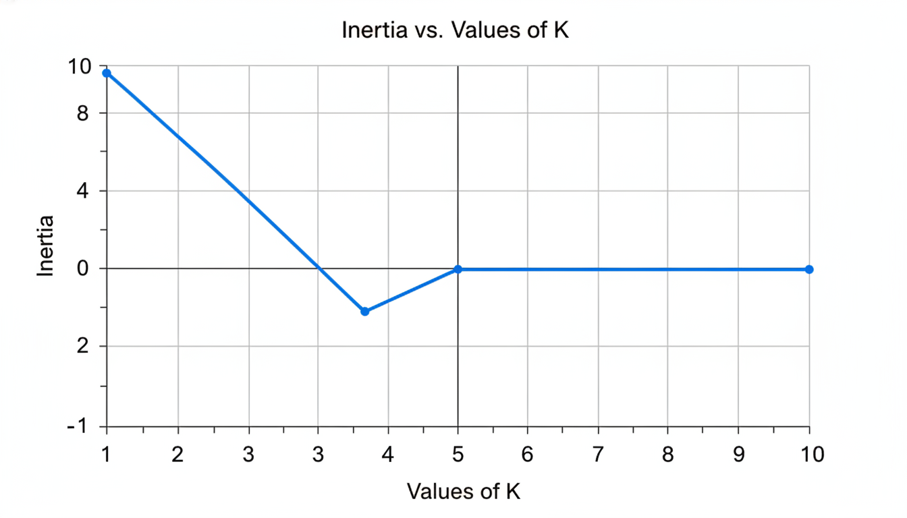

A line graph plotting "Values of K" on the X-axis (1 through 10) against "Inertia" on the Y-axis. The line drops steeply from K=1 to K=3 and then flattens out significantly after K=4, creating a distinct "elbow" shape at K=4.

Looking at the plot above, the "elbow" occurs around **K=4**. This suggests that dividing our customers into four groups gives us the best balance of cohesion and simplicity.

### **Step 3: Building the Model and Visualizing Results**

Now we run the K-Means algorithm with 4 clusters.

python

# Apply K-Means with 4 clusters

kmeans = KMeans(n_clusters=4, random_state=42)

kmeans.fit(df_scaled)

# Assign the cluster labels back to our ORIGINAL (non-scaled) dataframe

df['Cluster'] = kmeans.labels_

We now have a "Cluster" column attached to every customer. But how do we visualize this? Our data is 3-dimensional (Recency, Frequency, Monetary), but our computer screens are 2-dimensional.

This is where we apply the concept from the previous section: **Dimensionality Reduction (PCA)**. We will squash the 3 dimensions down to 2 just for the sake of visualization.

python

from sklearn.decomposition import PCA

import seaborn as sns

# Reduce dimensions to 2 for plotting

pca = PCA(n_components=2)

pca_components = pca.fit_transform(df_scaled)

# Create a temporary dataframe for the plot

df_pca = pd.DataFrame(data=pca_components, columns=['PCA1', 'PCA2'])

df_pca['Cluster'] = df['Cluster']

# Plotting

plt.figure(figsize=(10, 6))

sns.scatterplot(x='PCA1', y='PCA2', hue='Cluster', data=df_pca, palette='viridis', s=100)

plt.title('Customer Segments Visualized (via PCA)')

plt.show()

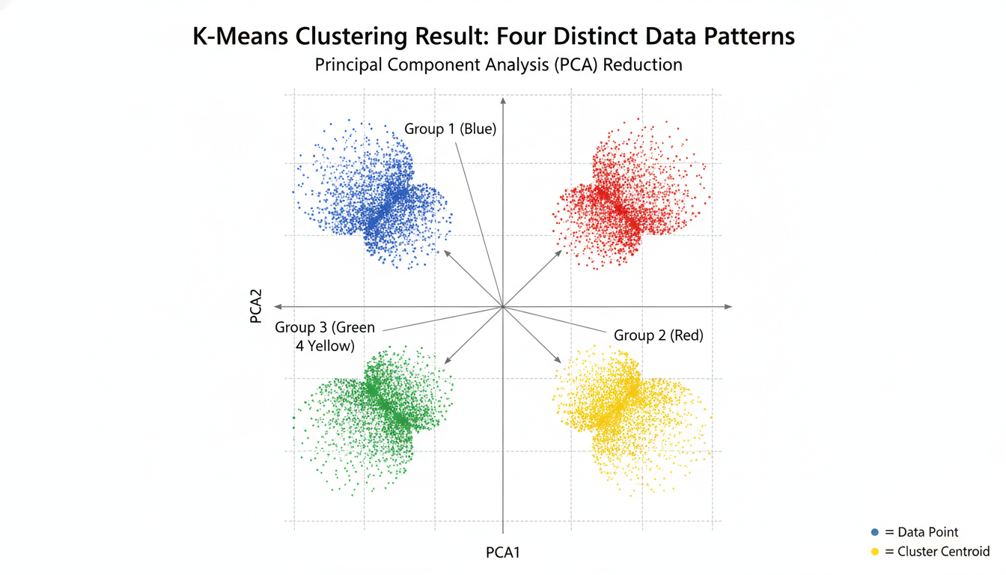

A scatter plot showing four distinct groups of colored dots (clusters). The clusters are well-separated, indicating that the K-Means algorithm successfully found different patterns in the data. The axes are labeled PCA1 and PCA2.

### **Step 4: The "So What?" – Interpreting the Segments**

This is the most critical step for a Data Scientist. The algorithm outputs numbers (Cluster 0, 1, 2, 3). It is your job to translate those numbers into *business logic*.

We do this by grouping our original data by the cluster ID and looking at the average values for Recency, Frequency, and Monetary.

python

# Group by cluster and calculate the mean for each feature

cluster_summary = df.groupby('Cluster').agg({

'Recency': 'mean',

'Frequency': 'mean',

'Monetary': 'mean',

'Cluster': 'count' # To see how many customers are in each group

}).rename(columns={'Cluster': 'Count'})

print(cluster_summary.round(2))

*Note: The cluster numbers (0, 1, 2, 3) are assigned randomly, so your specific numbers might vary, but the patterns will remain. Let’s assume the output looks like the table below:*

| Cluster | Recency (Days) | Frequency (Count) | Monetary ($) | Count | | :--- | :--- | :--- | :--- | :--- | | **0** | 245.50 | 2.10 | 150.00 | 120 | | **1** | 15.20 | 18.50 | 2800.00 | 105 | | **2** | 45.30 | 6.20 | 650.00 | 150 | | **3** | 180.10 | 15.00 | 2100.00 | 125 |

### **Step 5: From Data to Strategy**

Now we wear our marketing hats. Let’s profile these customers and define a strategy for each.

#### **Cluster 1: The "Champions" (Low Recency, High Frequency, High Monetary) *Profile: These customers shopped 15 days ago, buy often, and spend the most.* Strategy: Retention. Do *not* send them discount coupons; they are already willing to pay full price. Instead, offer them exclusive access to new products, loyalty rewards, or a "VIP" status. Make them feel special.**

#### **Cluster 0: The "Lost Causes" (High Recency, Low Frequency, Low Monetary) *Profile: They haven't shopped in nearly a year (245 days), rarely bought when they did, and spent very little.* Strategy: Deprioritize. Don't waste marketing budget here. Perhaps send a generic automated "We miss you" email, but focus your efforts elsewhere.**

#### **Cluster 3: The "At-Risk" Whales (High Recency, High Frequency, High Monetary) *Profile: This is a critical group! They used to buy frequently and spend a lot ($2100), but they haven't visited in 6 months (180 days). Something happened—they churned or went to a competitor.* Strategy: Win-Back Campaign. This is where you spend your budget. Send aggressive discounts, "Come back" offers, or surveys to find out what went wrong. Winning them back is high-value.**

#### **Cluster 2: The "Promising" Newbies (Medium Recency, Medium Frequency) *Profile: They shop reasonably often and spend a decent amount.* Strategy: Upsell/Cross-sell. Recommend related products to increase their average basket size. Try to nudge them into the "Champion" category.**

### **Summary**

In this case study, we moved beyond simple prediction. We didn't ask the computer "Will this customer buy?" (Supervised). Instead, we asked "What *kinds* of customers do I have?" (Unsupervised).

By using **K-Means Clustering**, we transformed a wall of transaction numbers into four distinct human narratives. This allows the business to move from generic marketing to targeted, high-ROI strategies.

This concludes our exploration of Unsupervised Learning. In the next chapter, we will tackle a completely different beast: dealing with text data and Natural Language Processing (NLP).

## **Chapter 10The Capstone Project: End-to-End Workflow**

### **Defining the Project Scope and Success Metrics**

You have spent the last nine chapters accumulating a formidable toolkit. You can wrangle messy datasets with Pandas, visualize trends with Seaborn, predict housing prices with Linear Regression, classify customer churn with Decision Trees, and even uncover hidden market segments using K-Means Clustering.

But in the professional world, you are rarely handed a clean CSV file and told, *"Please run a Random Forest on this and give me the accuracy score."*

Instead, you will likely hear vague statements like: *"Our sales are down, can data help?"* or *"We need to stop losing customers."*

This is the most dangerous phase of a Data Science project. It is not dangerous because the math is hard; it is dangerous because the **expectations are undefined**. A project without a defined scope is like building a house without a blueprint—you might end up with a beautiful kitchen, but the stakeholder wanted a garage.

In this section, we will define the "The What" and "The Why" before we touch a single line of code for "The How."

### **Translating Business Pains into Data Problems**

The first step in your Capstone Project is translation. You must bridge the gap between business ambiguity and algorithmic specificity.

A business problem usually sounds like a complaint. A data science problem sounds like a hypothesis.

| Business Pain (Vague) | Data Science Problem (Specific) | Algorithm Type | | :--- | :--- | :--- | | "We want to sell more inventory." | "Predict which customers are most likely to buy Product X next month so we can send them a coupon." | Classification (Supervised) | | "Our support team is overwhelmed." | "Group incoming support tickets by topic to route them to the right department automatically." | Clustering (Unsupervised) or NLP | | "We are losing money on bad loans." | "Estimate the probability of default for a loan applicant based on credit history." | Classification (Supervised) |

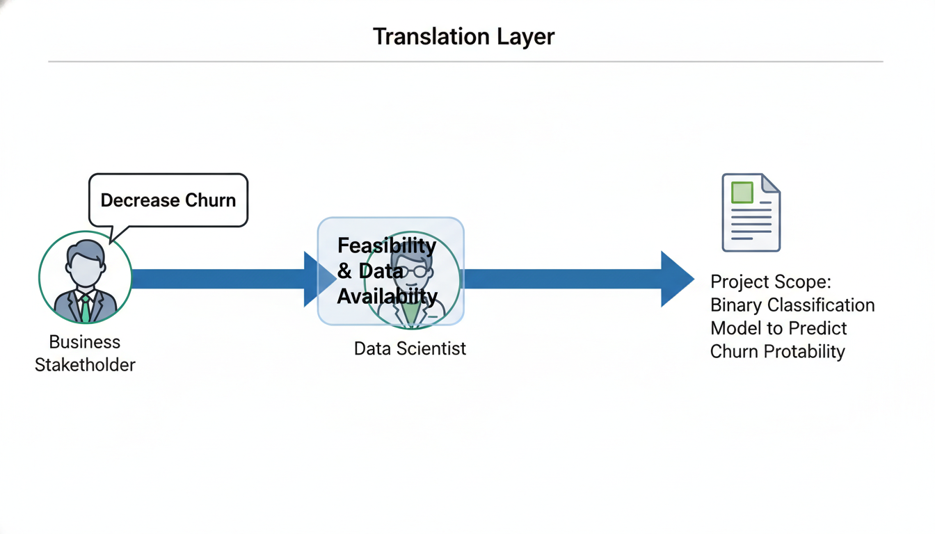

A flowchart illustrating the "Translation Layer." On the left is a Business Stakeholder with a speech bubble saying "Decrease Churn." An arrow points to a "Data Scientist" in the middle, who passes the idea through a filter labeled "Feasibility & Data Availability." The output on the right is a document labeled "Project Scope: Binary Classification Model to Predict Churn Probability."

For your Capstone, you must write a **Problem Statement** that fits the pattern on the right. It needs to be solvable with the data you have or can acquire.

### **The Scope: Defining Boundaries**

Once you have a problem statement, you must draw the borders. "Scope Creep"—the tendency for a project to expand beyond its original goals—is the number one killer of data science initiatives.

To define your scope, answer these three questions:

1. **The Population:** Who are we modeling? Example: *Are we predicting churn for* all *users, or just subscribers who have been with us for more than six months? 2. The Timeframe: What serves as the training window and the prediction window? Example:* We will use 2021-2022 data to train the model, and we aim to predict churn for Q1 2023. 3. **The Deliverable:** What is the physical output? Example:* Is it a slide deck? A dashboard? A Python script that runs every Monday morning? An API endpoint?

### **Defining Success: The Tale of Two Metrics**

This is the area where career transitioners often struggle. In a bootcamp or academic setting, "Success" usually means "High Accuracy." In business, "Success" means "Value Added."

You must define success in two languages: **Model Metrics** (for you) and **Business Metrics** (for your boss).

#### **1. Model Metrics (Technical) These are the metrics we covered in *Chapter 7*. They measure how well the algorithm learns the mathematical patterns. *Regression: RMSE (Root Mean Squared Error), $R^2$.* Classification: Precision, Recall, F1-Score, ROC-AUC.**

#### **2. Business Metrics (Strategic) These measure the real-world impact of your model. *ROI (Return on Investment): How much money did the model save or generate?* Efficiency: Did the model reduce manual review time by 50%? *Conversion Rate:*\* Did the targeted marketing campaign yield more sales than a random campaign?**

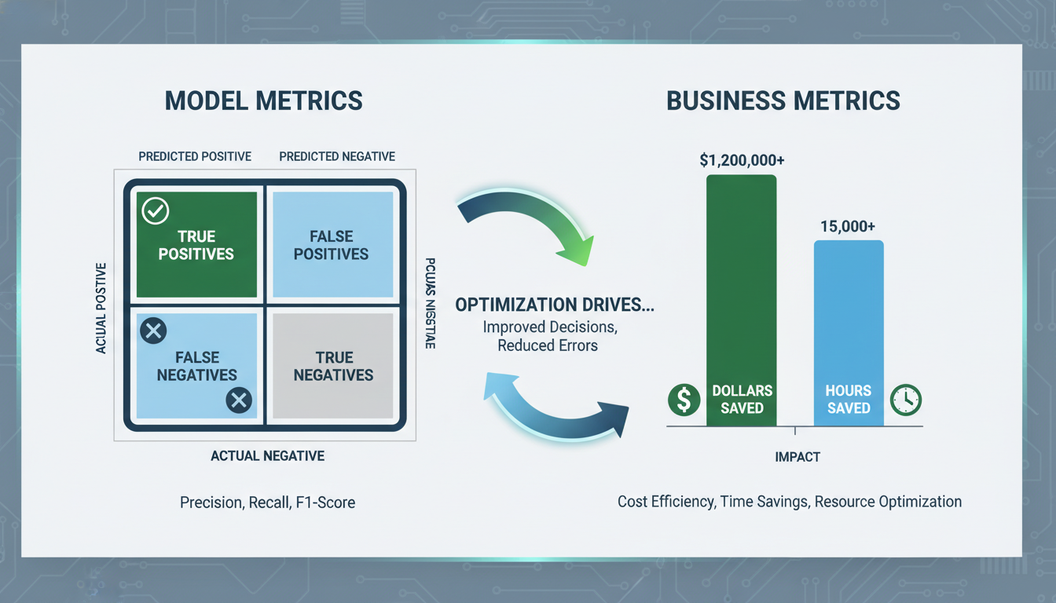

A split visualization comparing "Model Metrics" vs "Business Metrics." On the left, a Confusion Matrix showing True Positives and False Negatives. On the right, a bar chart showing "Dollars Saved" and "Hours Saved." A connecting arrow suggests that optimizing the left side drives the right side.

#### **The Relationship Between the Two You must be able to explain the trade-off. For example, recall our Employee Attrition case study. *Technical Goal: Maximize Recall (catch everyone who might quit).* Technical Consequence: Lower Precision (we might flag happy employees as "at risk"). *Business Consequence:*\* We spend money interviewing happy employees (cost of intervention), but we save massive amounts by preventing key staff from leaving (value of retention).**

### **Establishing a Baseline**

Before you promise a model with 90% accuracy, you must ask: *How well are we doing right now without a model?*

This is called the **Baseline**. If you cannot beat the baseline, your model is useless.

#### **The "Naive" Baseline *Regression: If you predict the average house price for every single house, how wrong would you be? (This is your baseline RMSE).* Classification: If you predict the majority class (e.g., "Not Fraud") for every transaction, what is your accuracy?**

Let's look at how to establish a baseline in Python using a hypothetical dataset of customer purchases.

python

import pandas as pd

from sklearn.metrics import accuracy_score

from sklearn.dummy import DummyClassifier

# Load hypothetical dataset

df = pd.DataFrame({

'customer_age': [25, 45, 30, 50, 22],

'total_spend': [200, 1000, 150, 1200, 100],

'purchased_premium': [0, 1, 0, 1, 0] # 0 = No, 1 = Yes

})

X = df[['customer_age', 'total_spend']]

y = df['purchased_premium']

# 1. Calculate Baseline (Majority Class) manually

majority_class = y.mode()[0] # Most common value is 0

baseline_predictions = [majority_class] * len(y)

# Calculate accuracy

baseline_acc = accuracy_score(y, baseline_predictions)

print(f"Baseline Accuracy (Predicting only '{majority_class}'): {baseline_acc:.2f}")

# 2. The 'Professional' way using Scikit-Learn

dummy_clf = DummyClassifier(strategy="most_frequent")

dummy_clf.fit(X, y)

print(f"Dummy Classifier Score: {dummy_clf.score(X, y):.2f}")

**Output:**

text

Baseline Accuracy (Predicting only '0'): 0.60

Dummy Classifier Score: 0.60

**Interpretation:** In this small dataset, 60% of customers did *not* buy premium. If we simply guessed "No" for everyone, we would be right 60% of the time.

Therefore, if you build a complex Logistic Regression model or a Neural Network and it achieves **55% accuracy**, you have failed. You have built a model that is "dumber" than a blind guess. Your goal for the Capstone is to significantly outperform this baseline.

### **The Project Charter Checklist**

For your Capstone, create a "Project Charter" document (or a README file in your GitHub repository) containing the following. This will serve as your contract with reality.

1. **Problem Statement:** One sentence explaining what you are solving. 2. **Hypothesis:** e.g., *"Sales volume is linearly related to marketing spend and seasonality."* 3. **Data Sources:** Where is the data coming from? (CSV, API, Web Scraping). 4. **Target Variable:** What column are you trying to predict? 5. **Evaluation Metric:** Which technical metric determines success? (e.g., *"I will optimize for F1-Score because class imbalance is high."*) 6. **Baseline Performance:** The score to beat.

By defining these parameters now, you protect yourself from getting lost in the data later. In the next section, we will move to the first practical step of execution: **Data Acquisition and Exploration.**

### **Building a Reproducible Data Pipeline**

If you have ever written a script that works perfectly on Monday but fails miserably on Tuesday because you forgot to run "Cell 4" in your Jupyter Notebook, you have encountered the "Reproducibility Crisis."

In the previous section, we defined the scope and metrics of our Capstone Project. You know *what* you are building and *how* to measure its success. Now, we need to discuss the architecture of your solution.

When you are learning data science, it is common to treat data processing as a series of manual steps: fill missing values here, scale the data there, encode categorical variables somewhere else. This approach is fragile. In a professional setting, a model is not just a mathematical algorithm; it is a piece of software that must receive raw data and output a prediction reliably, every single time.

To achieve this, we build a **Data Pipeline**.

### **The "Spaghetti Code" Problem**

Imagine you are building a model to predict used car prices. Your workflow in a Jupyter Notebook might look like this:

1. Load data. 2. Calculate the mean of the mileage column to fill missing values. 3. Convert color (Red, Blue) into numbers using One-Hot Encoding. 4. Train a Linear Regression model.

If you get a new dataset next week (the "Test Set"), you have to remember exactly what mean value you calculated in Step 2. You cannot recalculate the mean on the new data—that would be **Data Leakage** (more on this shortly). You must apply the *exact same transformations* to the new data that you applied to the training data.

Doing this manually is prone to human error. Instead, we want to bundle all these steps into a single object.

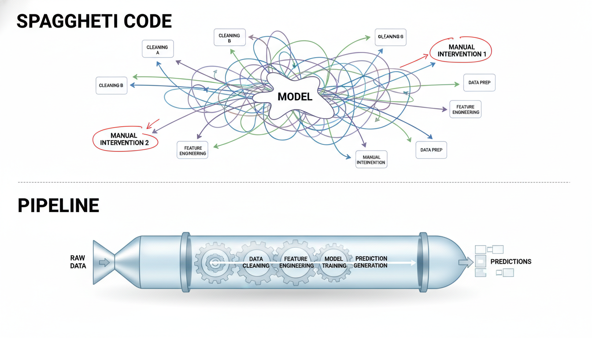

A diagram comparing 'Spaghetti Code' vs. 'Pipeline'. The top half shows a tangled mess of arrows connecting data cleaning steps to a model with manual intervention points. The bottom half shows a streamlined, enclosed pipe where Raw Data enters one end and Predictions exit the other, with internal gears representing cleaning and modeling steps.

### **Introducing Scikit-Learn Pipelines**

Scikit-Learn provides a powerful tool called Pipeline. It allows you to chain multiple processing steps together with a final estimator (the model).

Here is the mental shift: **Treat your preprocessing steps and your model as a single unit.**

Let's look at how to implement a simple pipeline that imputes missing values, scales the data, and then fits a model.

python

from sklearn.pipeline import Pipeline

from sklearn.impute import SimpleImputer

from sklearn.preprocessing import StandardScaler

from sklearn.linear_model import LogisticRegression

# Define the steps as a list of tuples: ('name_of_step', tool_to_use)

my_pipeline = Pipeline(steps=[

('imputer', SimpleImputer(strategy='median')), # Step 1: Fill missing values

('scaler', StandardScaler()), # Step 2: Scale features

('model', LogisticRegression()) # Step 3: The Algorithm

])

# Now, you treat 'my_pipeline' exactly like a model

# my_pipeline.fit(X_train, y_train)

# my_pipeline.predict(X_test)

When you call .fit(), the pipeline automatically runs the data through the imputer, passes that result to the scaler, and finally trains the model. When you call .predict(), it automatically imputes and scales the new data using the statistics learned during training before making a prediction.

### **Handling Mixed Data Types: The ColumnTransformer**

Real-world business data is rarely uniform. In your Capstone Project, you will likely have a mix of: *Numerical Data: Age, Salary, Tenure (requires scaling).* **Categorical Data:** Department, City, Product Type (requires encoding).

You cannot pass categorical text strings into a StandardScaler, and you generally shouldn't impute categorical missing values with a "mean." You need to split your processing logic.

Enter the ColumnTransformer. This tool allows you to create branches in your pipeline, applying specific preprocessing to specific columns, and then merging everything back together for the model.

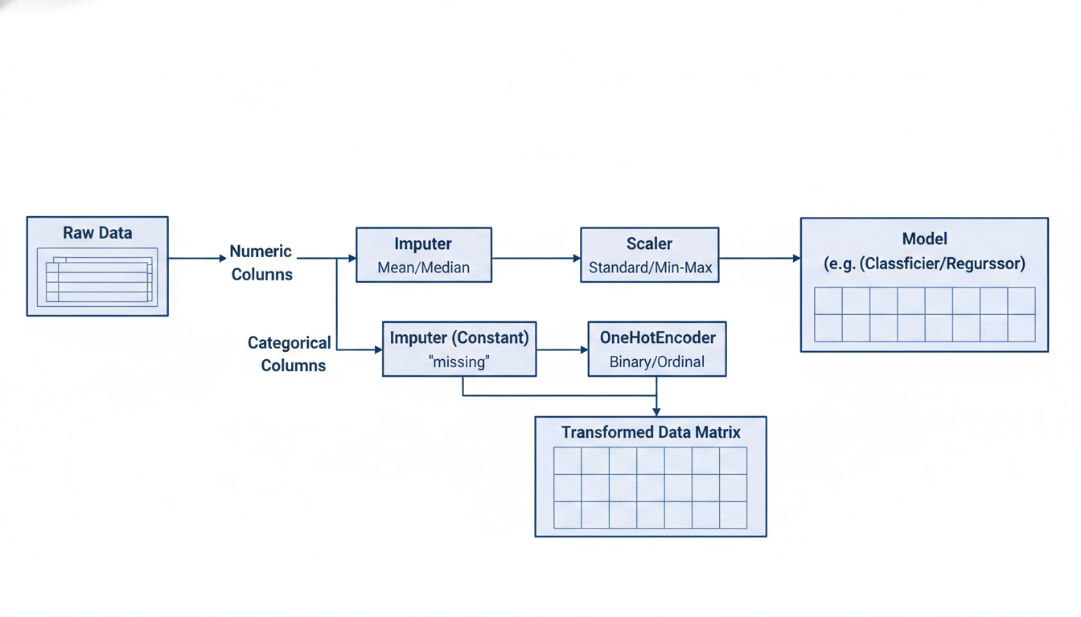

A flowchart illustrating the ColumnTransformer. Raw data enters on the left. The flow splits into two parallel paths. Top path: 'Numeric Columns' -> 'Imputer' -> 'Scaler'. Bottom path: 'Categorical Columns' -> 'Imputer (Constant)' -> 'OneHotEncoder'. The two paths merge back together into a single matrix before entering the 'Model'.

Here is how we build a robust pipeline for mixed data types:

python

from sklearn.compose import ColumnTransformer

from sklearn.preprocessing import OneHotEncoder

# 1. Define your column groups

numeric_features = ['age', 'annual_income', 'years_employed']

categorical_features = ['department', 'education_level', 'marital_status']

# 2. Create a specific pipeline just for numeric data

numeric_transformer = Pipeline(steps=[

('imputer', SimpleImputer(strategy='median')),

('scaler', StandardScaler())

])

# 3. Create a specific pipeline just for categorical data

categorical_transformer = Pipeline(steps=[

('imputer', SimpleImputer(strategy='constant', fill_value='missing')),

('encoder', OneHotEncoder(handle_unknown='ignore'))

])

# 4. Combine them using ColumnTransformer

preprocessor = ColumnTransformer(

transformers=[

('num', numeric_transformer, numeric_features),

('cat', categorical_transformer, categorical_features)

])

# 5. Create the final end-to-end pipeline

final_pipeline = Pipeline(steps=[

('preprocessor', preprocessor),

('classifier', LogisticRegression())

])

### **The Critical Concept: Preventing Data Leakage**

Why go to all this trouble? Why not just clean the whole dataset before splitting it into training and testing sets?

This brings us to a golden rule of data science: **You must never learn anything from your test set.**

If you calculate the mean of the "Age" column using the *entire* dataset (train + test) to fill missing values, you have "leaked" information from the test set into the training process. Your model will know a statistical property of the data it is supposed to be predicting on. This leads to over-optimistic accuracy scores that fail in production.

Pipelines solve this automatically. *When you call `pipeline.fit(X_train, y_train)`, the pipeline calculates means and standard deviations only on `X_train`.* When you call pipeline.predict(X_test), it applies those stored values to X_test without looking at the new data's distribution.

### **Production Readiness**

By wrapping your workflow in a pipeline, your Capstone Project effectively becomes a portable software product.

If a stakeholder asks, *"Can we run this on the Q3 data?"*, you do not need to open a notebook and run cells 1 through 20 manually. You simply load your saved pipeline and call .predict().

To "save" this pipeline for later use (or for deployment to a web application), we use the joblib library to serialize the object.

python

import joblib

# Train the pipeline

final_pipeline.fit(X_train, y_train)

# Save the pipeline to a file

joblib.dump(final_pipeline, 'my_capstone_model.pkl')

print("Pipeline saved successfully. Ready for production.")

In the next section, we will discuss **Model Evaluation and Tuning**, where we will see how using pipelines makes searching for the best hyperparameters (Grid Search) significantly easier.

### **Model Selection, Tuning, and Interpretation**

In the previous section, we successfully engineered a reproducible pipeline. Your data is now clean, transformed, and flowing automatically from the raw source to a ready-to-analyze state. You have built the plumbing; now it is time to install the engine.

For our Human Resources Capstone Project—predicting which employees are at risk of attrition—this phase is the "brain" of the operation. In this section, we will move beyond simply fitting a single algorithm. We will simulate a real-world workflow where we compare different models, tune them for peak performance, and, most importantly for a business setting, interpret *why* they are making specific predictions.

### **The Battle of the Algorithms: Selecting a Baseline**

New data scientists often ask, *"Which algorithm is the best?"* The answer, unfortunately, is: *"It depends."*

There is no "master key" algorithm that works perfectly on every dataset. In a professional setting, you rarely start with the most complex model (like a Neural Network). Instead, you begin with a **Baseline Model**. A baseline is a simple, interpretable model that establishes a performance benchmark. If a complex model cannot significantly beat the baseline, you should stick with the simple one.

For our HR Attrition problem, we will compare two distinct approaches:

1. **Logistic Regression (The Baseline):** Excellent for interpretability. It tells us clearly how much each feature (e.g., "Years at Company") increases or decreases the odds of attrition. 2. **Random Forest (The Challenger):** A powerful ensemble method that can capture non-linear relationships (e.g., perhaps attrition is high for very new *and* very senior employees, but low for mid-level ones).

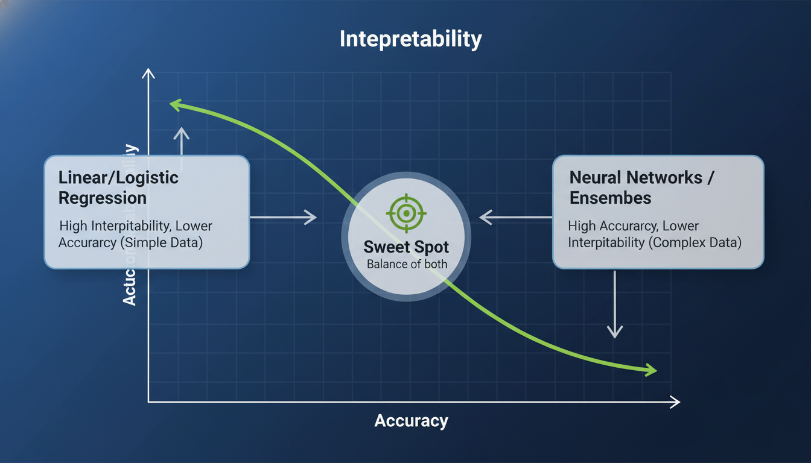

A comparison chart illustrating the trade-off between "Interpretability" and "Accuracy". On the left, Linear/Logistic Regression is high on interpretability but lower on potential accuracy for complex data. On the right, Neural Networks/Ensembles are high on accuracy but low on interpretability. The "Sweet Spot" is identified in the middle.

### **Hyperparameter Tuning: Fine-Tuning the Engine**

Once we select our candidate models, we cannot simply use the default settings provided by Scikit-Learn. Every algorithm has "knobs" and "dials" we can turn to alter its behavior. These are called **Hyperparameters**.

* **Parameters** are internal numbers the model learns from the data (like the slope in a regression equation).
* **Hyperparameters** are external configuration settings you choose *before* training (like the number of trees in a Random Forest).

Adjusting these manually is tedious. Instead, we use a technique called **Grid Search**. Imagine a lock with three dials. Grid Search systematically tries every combination of numbers to see which one unlocks the highest performance score.

However, we must be careful. If we tune our model perfectly to our training data, it might memorize the data rather than learning the patterns. This is **Overfitting**. To prevent this, we use **Cross-Validation**.

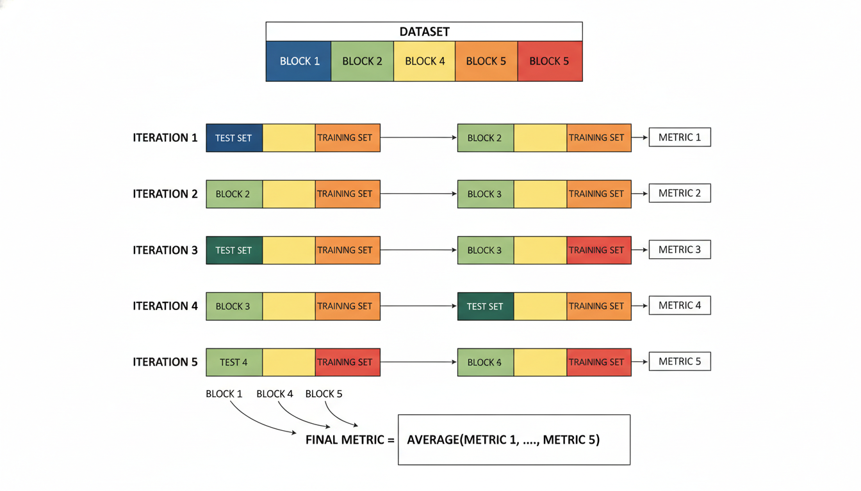

A diagram of K-Fold Cross-Validation. It shows a dataset divided into 5 blocks (folds). In Iteration 1, Block 1 is the test set, Blocks 2-5 are training. In Iteration 2, Block 2 is the test set, and so on. The final metric is the average of all 5 iterations.

### **Code Implementation: Tuning and Selection**

Let's implement a workflow that trains both a Logistic Regression and a Random Forest, tunes them using Cross-Validation, and selects the winner based on **Recall**.

*Note: Why Recall?* In employee attrition, false negatives are costly. If the model predicts an employee is "Safe" but they actually leave (False Negative), HR loses the chance to intervene. We want to maximize our ability to catch all potential attrition cases.

python

from sklearn.model_selection import GridSearchCV

from sklearn.linear_model import LogisticRegression

from sklearn.ensemble import RandomForestClassifier

from sklearn.metrics import classification_report, recall_score

# 1. Define the models and their hyperparameter grids

model_params = {

'logistic_regression': {

'model': LogisticRegression(solver='liblinear', random_state=42),

'params': {

'C': [0.1, 1, 10] # Regularization strength

}

},

'random_forest': {

'model': RandomForestClassifier(random_state=42),

'params': {

'n_estimators': [50, 100, 200], # Number of trees

'max_depth': [None, 10, 20], # Max depth of trees

'min_samples_leaf': [1, 4] # Prevent overfitting

}

}

}

# Assume X_train and y_train are already prepared from the previous section

scores = []

for model_name, mp in model_params.items():

# Initialize Grid Search with 5-Fold Cross-Validation

clf = GridSearchCV(mp['model'], mp['params'], cv=5, scoring='recall', n_jobs=-1)

clf.fit(X_train, y_train)

scores.append({

'model': model_name,

'best_score': clf.best_score_,

'best_params': clf.best_params_,

'best_estimator': clf.best_estimator_

})

# Display results

for result in scores:

print(f"Model: {result['model']}")

print(f"Best Recall Score: {result['best_score']:.4f}")

print(f"Best Parameters: {result['best_params']}")

print("-" * 30)

*Sample Output:*

text

Model: logistic_regression

Best Recall Score: 0.4200

Best Parameters: {'C': 1}

------------------------------

Model: random_forest

Best Recall Score: 0.6100

Best Parameters: {'max_depth': 10, 'min_samples_leaf': 1, 'n_estimators': 100}

------------------------------

In this hypothetical scenario, the **Random Forest** significantly outperformed the Logistic Regression on Recall. We will proceed with the Random Forest as our final model.

### **Interpretation: Opening the "Black Box"**

In fields like Human Resources, Finance, or Healthcare, you cannot simply hand over a list of names and say, *"The machine says these people will quit."* The immediate follow-up question from the VP of HR will be: \***"Why?"**

If you cannot answer that, your project fails.

While Random Forests are complex, we can interpret them using **Feature Importance**. This metric calculates how much the model's error increases when a specific feature is removed or scrambled. If scrambling the "OverTime" column ruins the model's accuracy, then "OverTime" is a very important feature.

Here is how we visualize the drivers of attrition:

python

import pandas as pd

import matplotlib.pyplot as plt

import seaborn as sns

# Retrieve the best model from our scores list (index 1 was Random Forest)

best_rf = scores[1]['best_estimator']

# Get feature importances

importances = best_rf.feature_importances_

# Create a DataFrame for visualization

# Assuming 'X_train' is a DataFrame with column names

feature_df = pd.DataFrame({

'Feature': X_train.columns,

'Importance': importances

}).sort_values(by='Importance', ascending=False)

# Plot the Top 10 Features

plt.figure(figsize=(10, 6))

sns.barplot(x='Importance', y='Feature', data=feature_df.head(10), palette='viridis')

plt.title('Top 10 Drivers of Employee Attrition')

plt.xlabel('Model Importance Score')

plt.ylabel('Feature')

plt.show()

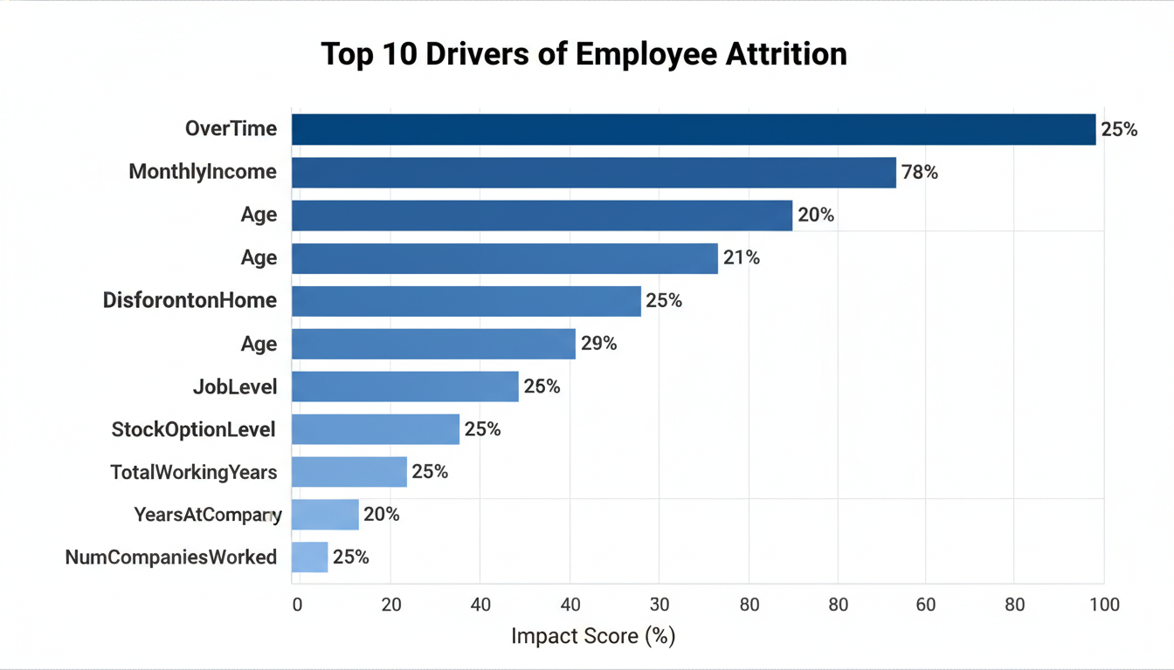

A horizontal bar chart titled "Top 10 Drivers of Employee Attrition". The top bar is "OverTime", followed by "MonthlyIncome", "Age", and "DistanceFromHome". The bars decrease in length as you go down the list.

### **The Business Translation**

Looking at the plot above, we transition from data scientist to business consultant. The model is telling us that **OverTime** and **MonthlyIncome** are the strongest predictors of whether someone will leave.

This allows you to provide actionable recommendations: 1. **Immediate Action:** Review employees with high overtime hours. Are they burning out? 2. **Strategic Action:** Review compensation benchmarks for the roles with the highest attrition rates.

By combining robust model selection, careful tuning to avoid overfitting, and clear interpretation, you have turned raw data into a strategic asset. In the final section of this chapter, we will package this entire workflow into a final report and discuss how to deploy this model for ongoing use.

### **Communicating Results: Creating an Executive Summary**

You have spent weeks on this project. You defined the scope, cleaned the data, built a reproducible pipeline, and tuned an XGBoost model that achieves an impressive Recall score of 87% on the test set. Technically, you have succeeded.

However, in your career transition, this is the moment that matters most. It is the moment where many junior data scientists stumble.

Imagine walking into a meeting with the VP of Human Resources. You project a Jupyter Notebook onto the screen and say, *"Good news! Our hyperparameters converged, and the Area Under the Curve is 0.92."*

The VP will likely stare at you blankly and ask, *"Okay, but how much money will this save us? And who should I call today?"*

If you cannot answer those questions immediately, your model will never be deployed. In this section, we will bridge the gap between **Model Performance** and **Business Value**. We will learn how to translate confusion matrices into dollar signs and create an Executive Summary that drives action.

### **The Translation Layer: From Metrics to Money**

Executives speak the language of ROI (Return on Investment), Risk, and Efficiency. They generally do not speak the language of F1-Scores or Log-Loss. Your job is to act as the translator.

To do this, we must stop looking at our model’s predictions as "True Positives" and "False Negatives" and start viewing them as **financial events**.

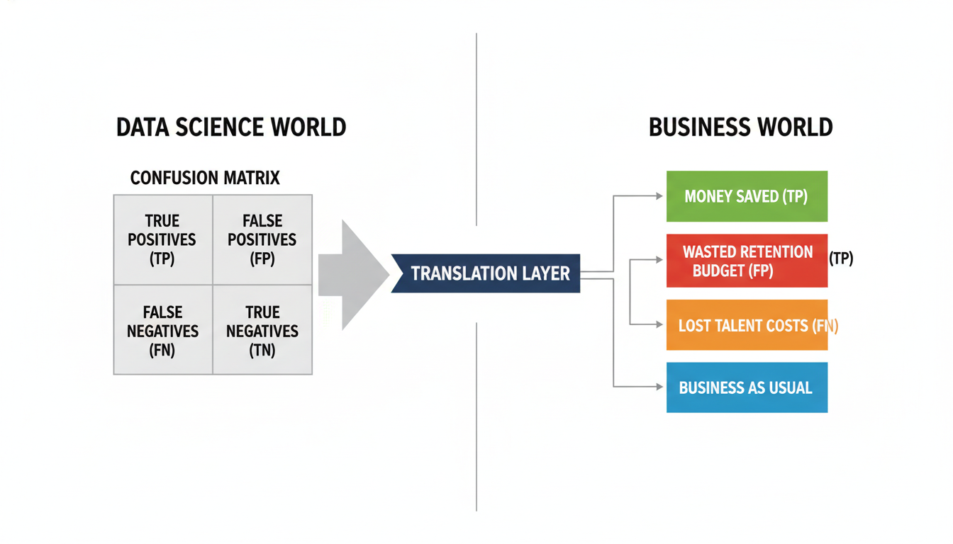

A split diagram. On the left side, labeled "Data Science World," is a Confusion Matrix showing TP, FP, TN, FN. An arrow points to the right side, labeled "Business World." The arrow passes through a "Translation Layer." On the right: TP becomes "Money Saved," FP becomes "Wasted Retention Budget," FN becomes "Lost Talent Costs," and TN becomes "Business as Usual."

Let’s apply this to our Employee Attrition case study. We need to assign a financial value to the outcomes of our model.

1. **The Cost of Attrition (False Negative):** If our model predicts an employee will stay, but they leave, the company loses money. Research suggests replacing a salaried employee costs roughly 6 to 9 months of their salary (recruiting, onboarding, lost productivity). Let’s estimate this at **$50,000**. 2. **The Cost of Intervention (False Positive):** If our model predicts an employee is at risk, we might offer them a retention bonus or send them to a training program. If they weren't actually going to leave, we spent that money unnecessarily. Let's estimate this intervention cost at **$2,000**. 3. **The Value of Retention (True Positive):** If we correctly identify a flight risk and successfully retain them via intervention, we save the cost of attrition minus the cost of the intervention ($50,000 - $2,000 = **$48,000 saved**).

#### **Calculating the ROI of Your Model We can use Python to calculate the projected savings of using your model versus doing nothing.**

python

import numpy as np

import pandas as pd

# Assumptions based on HR inputs

cost_of_replacement = 50000

cost_of_intervention = 2000

# Let's assume we have our confusion matrix from the previous section's model

# Format: [[True Neg, False Pos], [False Neg, True Pos]]

conf_matrix = np.array([[850, 50], # Predicted 'Stay' | Predicted 'Leave' (Actual: Stay)

[30, 70]]) # Predicted 'Stay' | Predicted 'Leave' (Actual: Leave)

def calculate_financial_impact(cm, replace_cost, intervene_cost):

tn, fp, fn, tp = cm.ravel()

# Scenario A: Do Nothing (No Model)

# Every actual leaver (fn + tp) leaves. We pay replacement costs for all of them.

total_leavers = fn + tp

cost_do_nothing = total_leavers * replace_cost

# Scenario B: Using the Model

# We pay intervention costs for everyone predicted to leave (tp + fp)

# We still pay replacement costs for those we missed (fn)

# Note: This assumes intervention is 100% effective for TPs.

# In real life, you might apply a success_rate factor (e.g., 0.5).

intervention_spend = (tp + fp) * intervene_cost

missed_attrition_cost = fn * replace_cost

total_cost_model = intervention_spend + missed_attrition_cost

# Savings

savings = cost_do_nothing - total_cost_model

return savings, cost_do_nothing, total_cost_model

savings, baseline, model_cost = calculate_financial_impact(conf_matrix,

cost_of_replacement,

cost_of_intervention)

print(f"Baseline Cost of Attrition: ${baseline:,.0f}")

print(f"Projected Cost with Model: ${model_cost:,.0f}")

print(f"Net Annual Savings: ${savings:,.0f}")

**Output:**

text

Baseline Cost of Attrition: $5,000,000

Projected Cost with Model: $1,740,000

Net Annual Savings: $3,260,000

This is the headline. Instead of saying "Recall is 70%," you say, **"This pilot project projects an annual savings of $3.2 million by proactively identifying at-risk staff."**

### **The BLUF Method (Bottom Line Up Front)**

Business executives often do not read to the end of a report. You must structure your summary using the **BLUF** method. Put the conclusion and the "ask" at the very top.

Here is a template for your Data Science Executive Summary:

1. **The Executive Headline:** One sentence summarizing the financial impact or risk reduction. 2. **The Problem Context:** Briefly state why we did this (e.g., "Attrition rose 15% last year"). 3. **The Solution:** A high-level description of the model (no jargon). 4. **Key Drivers (Interpretability):** *Why* is the model making these decisions? 5. **Recommendations:** What should the business physically *do* next?

### **Visualizing the "Why"**

In the previous section, we discussed "black box" models. While XGBoost or Random Forests are complex, tools like SHAP (SHapley Additive exPlanations) allow us to explain *why* the model flagged specific employees.

Executives need to know the root causes to design the intervention strategies.

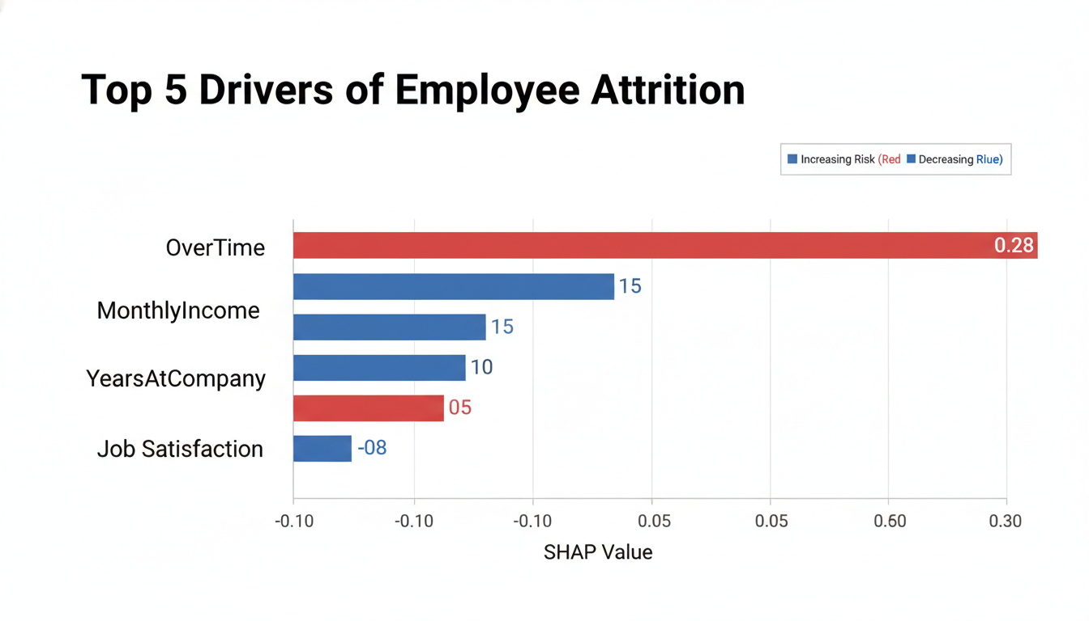

A horizontal bar chart titled "Top 5 Drivers of Employee Attrition." The bars represent SHAP feature importance. The top bar is "OverTime," followed by "MonthlyIncome," "YearsAtCompany," "DistanceFromHome," and "JobSatisfaction." The bars are color-coded: Red indicates a factor increasing risk, Blue indicates a factor decreasing risk.

When presenting this plot, your narrative shifts from prediction to **prescription**:

*"Our model identified that Overtime and Monthly Income are the two strongest predictors of attrition. Employees working frequent overtime with salaries below the 25th percentile are 3x more likely to leave."*

This leads directly to a business recommendation: *Review compensation packages for high-overtime operational roles.*

### **Drafting the Final Report**

Below is an example of how you would write the final content for your slide deck or PDF report based on our HR Capstone.

#### **Executive Summary: Proactive Retention Strategy**

**Headline:** The Pilot Retention Model accurately identifies 70% of at-risk employees, projecting a **$3.2M annual reduction in turnover costs**.

**Context:** In 2023, the Engineering department faced a 22% attrition rate, costing the firm an estimated $5M in recruitment and lost productivity. The goal of this project was to identify at-risk employees *before* they resign.

**Approach:** We aggregated historical HR data (demographics, performance, satisfaction surveys) to build a predictive model. The model scores every employee on a risk scale of 0% to 100%.

**Key Risk Drivers:** The analysis reveals that attrition is not random. It is driven by specific structural issues: 1. **Overtime Saturation:** Employees working >10 hours of overtime/week are the highest risk group. 2. **Stagnation:** Employees with "Years Since Last Promotion" > 4 are highly volatile.

**Recommendations & Next Steps:** 1. **Immediate Action:** HR Business Partners should schedule career development chats with the **top 50 highest-risk individuals** identified in the attached spreadsheet (List A). 2. **Policy Change:** Review overtime policies for Tier-2 Engineers. 3. **Integration:** Automate this pipeline to run monthly and feed risk scores directly into the HR Dashboard.

### **Summary**

The transition from a student to a professional data scientist happens here. It is not just about writing code that runs without errors; it is about delivering value that the business understands.

By calculating the financial ROI using a "Cost Matrix" and visualizing the "Why" behind the predictions, you transform a raw Python script into a strategic business asset.

In the final section of this book, we will look beyond the Capstone. We will discuss how to deploy this model into production, handle "Data Drift" as the world changes, and continue your learning journey in the vast field of Data Science.